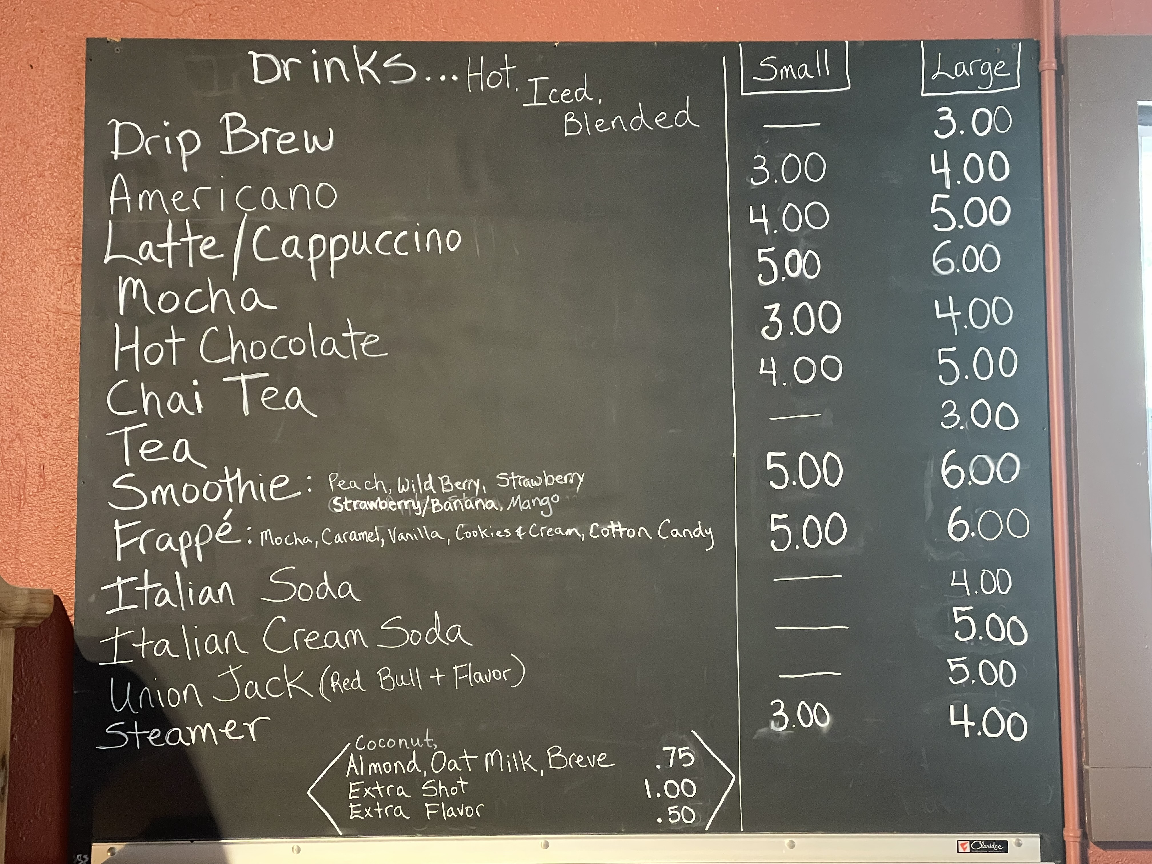

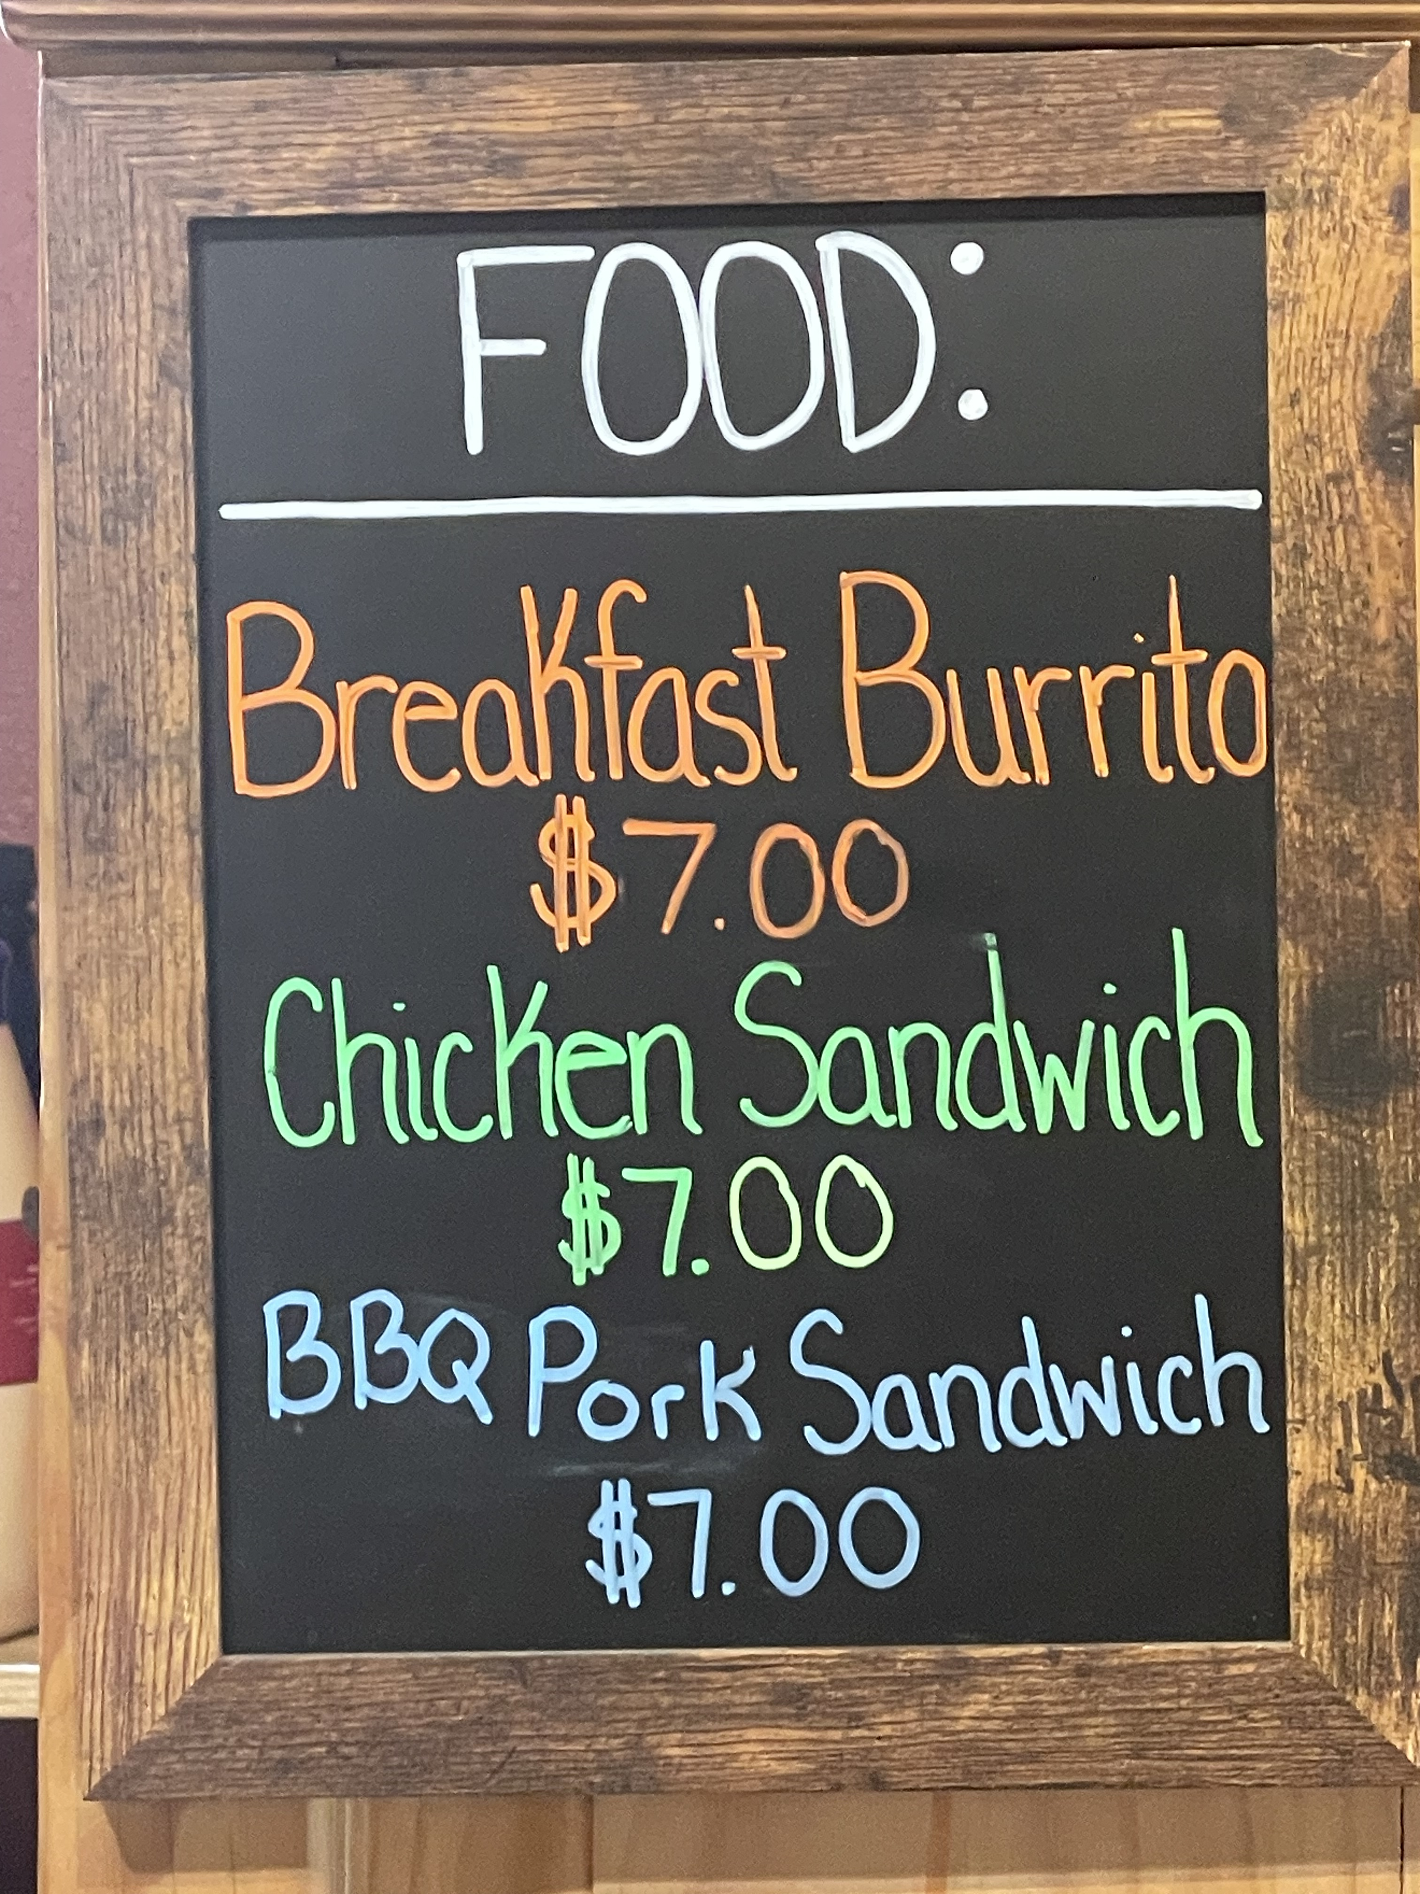

Also more food:

- Cheese quesadilla

- Bagel

- Muffin

- Cinnamon Roll

- Coffee Cake

- Scone



