Project

in DIGILOG21

Decoder Circuit  
Name: Joro Martin Cabreros  
Output: 78dE

1. Truth Table

|  |  |  |  |  |  |  |  |  |  |  |  |  |  |
| --- | --- | --- | --- | --- | --- | --- | --- | --- | --- | --- | --- | --- | --- |
| D | C | B | A |  | a | b | c | d | e | f | g |  | Out |
| 0 | 0 | 0 | 0 |  |  |  |  |  |  |  |  |  |  |
| 0 | 0 | 0 | 1 |  |  |  |  |  |  |  |  |  |  |
| 0 | 0 | 1 | 0 |  |  |  |  |  |  |  |  |  |  |
| 0 | 0 | 1 | 1 |  |  |  |  |  |  |  |  |  |  |
| 0 | 1 | 0 | 0 |  |  |  |  |  |  |  |  |  |  |
| 0 | 1 | 0 | 1 |  |  |  |  |  |  |  |  |  |  |
| 0 | 1 | 1 | 0 |  |  |  |  |  |  |  |  |  |  |
| 0 | 1 | 1 | 1 |  | 1 | 1 | 1 | 0 | 0 | 0 | 0 |  | 7 |
| 1 | 0 | 0 | 0 |  | 1 | 1 | 1 | 1 | 1 | 1 | 1 |  | 8 |
| 1 | 0 | 0 | 1 |  |  |  |  |  |  |  |  |  |  |
| 1 | 0 | 1 | 0 |  |  |  |  |  |  |  |  |  |  |
| 1 | 0 | 1 | 1 |  |  |  |  |  |  |  |  |  |  |
| 1 | 1 | 0 | 0 |  |  |  |  |  |  |  |  |  |  |
| 1 | 1 | 0 | 1 |  | 0 | 1 | 1 | 1 | 1 | 0 | 1 |  | d |
| 1 | 1 | 1 | 0 |  | 1 | 0 | 0 | 1 | 1 | 1 | 1 |  | E |
| 1 | 1 | 1 | 1 |  |  |  |  |  |  |  |  |  |  |

2. List of Expressions

a = +  + +

b =

c = + +

d = + +

e = + +

f = a

g = c

3. Kmap Simplification

For segment a and f

|  |  |  |  |  |
| --- | --- | --- | --- | --- |
|  | 00  CD | 01 | 11 | 10 |
| 00  AB | 0 | 0 | 1 | 0 |
| 01 | 0 | 1 | 0 | 1 |
| 11 | 0 | 0 | 0 | 0 |
| 10 | 0 | 0 | 0 | 1 |

For segment b

|  |  |  |  |  |
| --- | --- | --- | --- | --- |
|  | 00  CD | 01 | 11 | 10 |
| 00  AB | 0 | 0 | 0 | 0 |
| 01 | 0 | 1 | 0 | 0 |
| 11 | 0 | 0 | 0 | 0 |
| 10 | 0 | 0 | 0 | 0 |

For segment c and g

|  |  |  |  |  |
| --- | --- | --- | --- | --- |
|  | 00  CD | 01 | 11 | 10 |
| 00  AB | 0 | 0 | 0 | 0 |
| 01 | 1 | 0 | 0 | 1 |
| 11 | 0 | 0 | 0 | 0 |
| 10 | 0 | 0 | 0 | 1 |

For segment d

|  |  |  |  |  |
| --- | --- | --- | --- | --- |
|  | 00  CD | 01 | 11 | 10 |
| 00  AB | 0 | 0 | 1 | 0 |
| 01 | 0 | 0 | 0 | 1 |
| 11 | 0 | 0 | 0 | 0 |
| 10 | 0 | 0 | 0 | 1 |

For segment e

|  |  |  |  |  |
| --- | --- | --- | --- | --- |
|  | 00  CD | 01 | 11 | 10 |
| 00  AB | 0 | 0 | 1 | 0 |
| 01 | 0 | 1 | 0 | 1 |
| 11 | 0 | 0 | 0 | 0 |
| 10 | 0 | 0 | 0 | 0 |

4. List of Simplified Expressions

a = $A\overline{B}C\overline{D}$ + $\overline{A}BC\overline{D}$ + $\overline{A}B\overline{C}D$ + $\overline{A}\overline{B}CD$

b = $\overline{A}B\overline{C}D$

c = $A\overline{B}C\overline{D}$ + $\overline{A}BC\overline{D}$ + $\overline{A}B\overline{C}D$

d = + +

e = + +

f = a

g = c

5. Logic Circuit Diagram

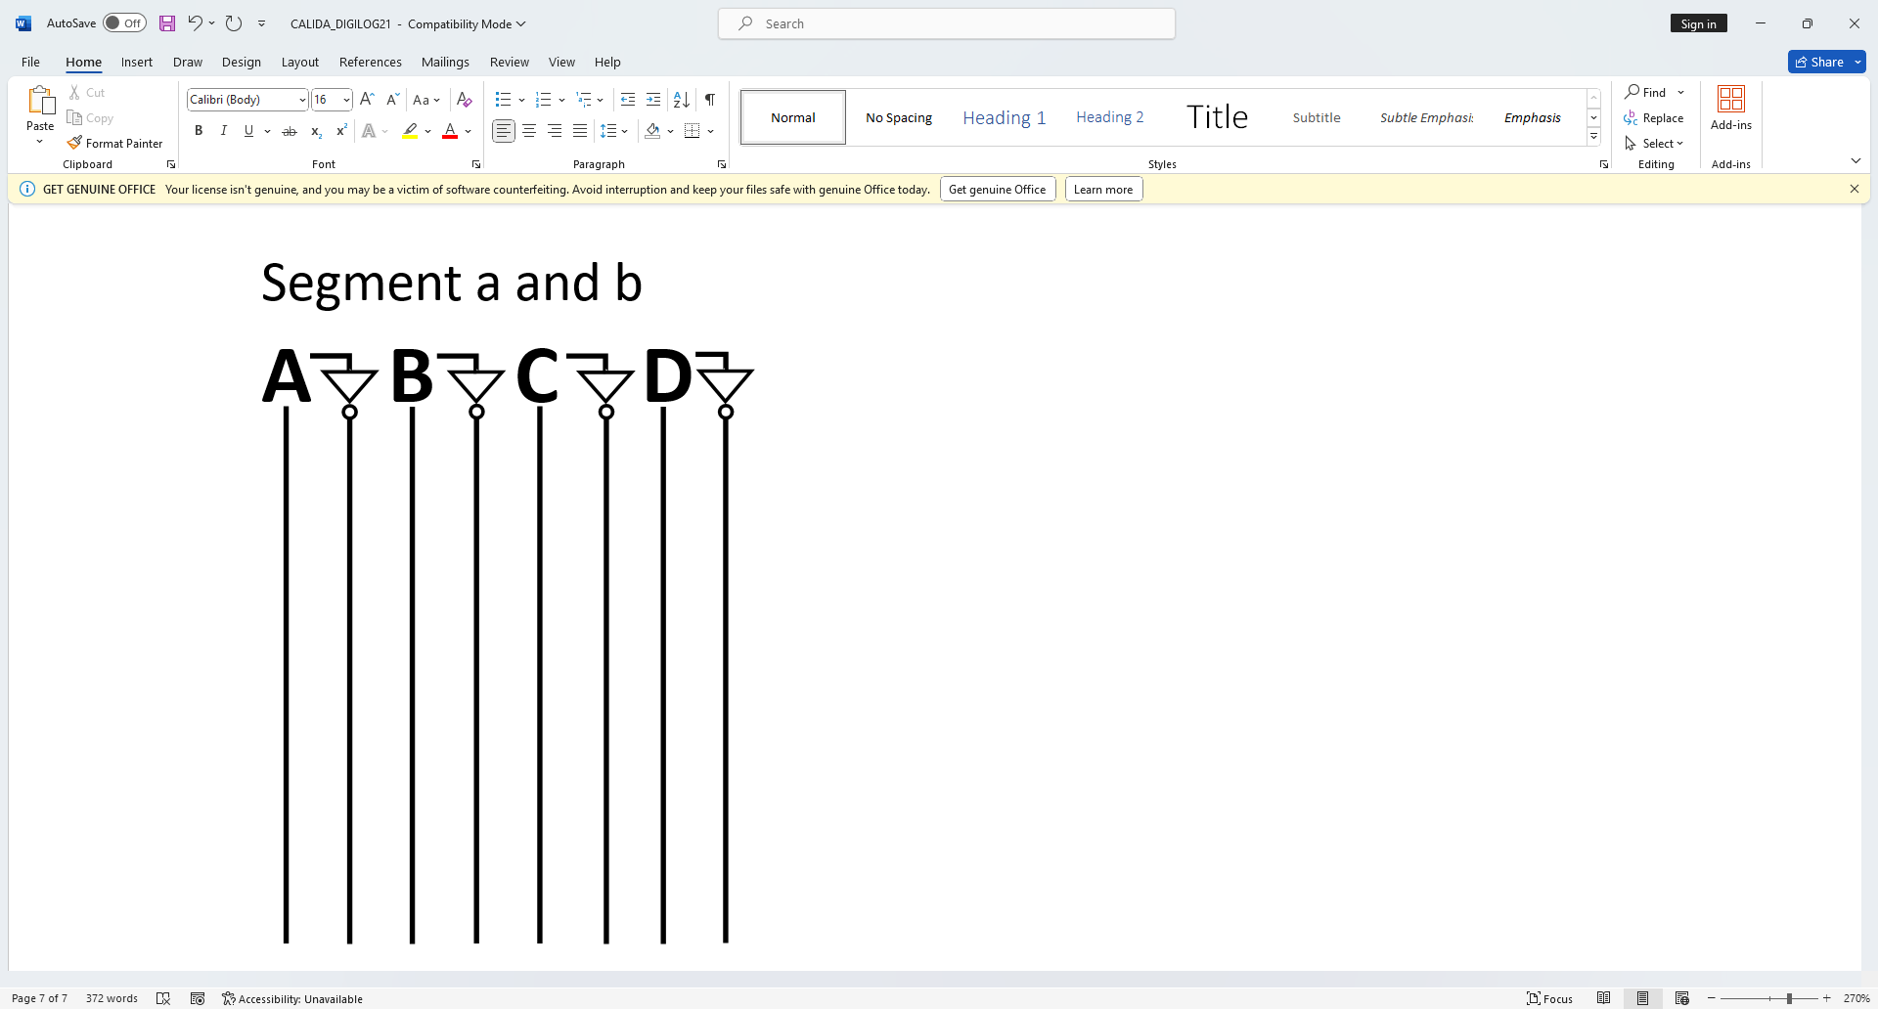  
Segment a and f

+ + +

+

+

Segment b

$\overline{A}B\overline{C}D$

$$\overline{A}B$$

$$\overline{C}D$$

Segment c and g

$A\overline{B}C\overline{D}$ + $\overline{A}BC\overline{D}$

$$\overline{A}B$$

$$\overline{A}BC\overline{D}$$

$$A\overline{B}C\overline{D}$$

$$C\overline{D}$$

$$\overline{A}B$$

$$C\overline{D}$$

$$A\overline{B}$$

$A\overline{B}C\overline{D}$ + $\overline{A}BC\overline{D}+\overline{A}B\overline{C}D$

$$\overline{A}B\overline{C}D$$

$\overline{C}D$

Segment d

$$A\overline{B}C\overline{D}+\overline{A}BC\overline{D}$$

+ $\overline{A}B\overline{C}\overline{D}$

$$\overline{A}\overline{B}$$

$$\overline{A}BC\overline{D}$$

$$A\overline{B}C\overline{D}$$

$$C\overline{D}$$

$$\overline{A}B$$

$$C\overline{D}$$

$$A\overline{B}$$

$A\overline{B}C\overline{D}+\overline{A}BC\overline{D}$ $+ \overline{A}\overline{B}CD$

$$+\overline{A}\overline{B}CD$$

$$\overline{A}\overline{B}CD$$

$CD$

Segment e

+

+

6. Actual Circuit Diagram

VCC

$A\overline{B}C\overline{D}+\overline{A}BC\overline{D}+\overline{A}B\overline{C}D+\overline{A}\overline{B}CD$

A B C D

$$\overline{A}BC\overline{D}+\overline{A}B\overline{C}D+\overline{A}\overline{B}CD$$

$$A\overline{B}C\overline{D}+\overline{A}BC\overline{D}+\overline{A}\overline{B}CD$$

$$A\overline{B}C\overline{D}+\overline{A}BC\overline{D}+\overline{A}B\overline{C}D$$

GND

$$\overline{A}B\overline{C}D+\overline{A}\overline{B}CD$$

$$A\overline{B}C\overline{D}+\overline{A}BC\overline{D}$$

$$\overline{A}\overline{B}CD$$

$$\overline{A}B\overline{C}D$$

$$CD$$

$$\overline{A}BC\overline{D}$$

$$A\overline{B}C\overline{D}$$

$$\overline{A}\overline{B}$$

$$\overline{A}B$$

$$\overline{C}D$$

D

$$\overline{A}B$$

$$C\overline{D}$$

$$\overline{D}$$

$$A\overline{B}$$

$$\overline{C}$$

C

$$\overline{B}$$

B

$$\overline{A}$$

A

**7404**

**7408**

**7432**

**7432**

**7408**

**7408**

Output: 5

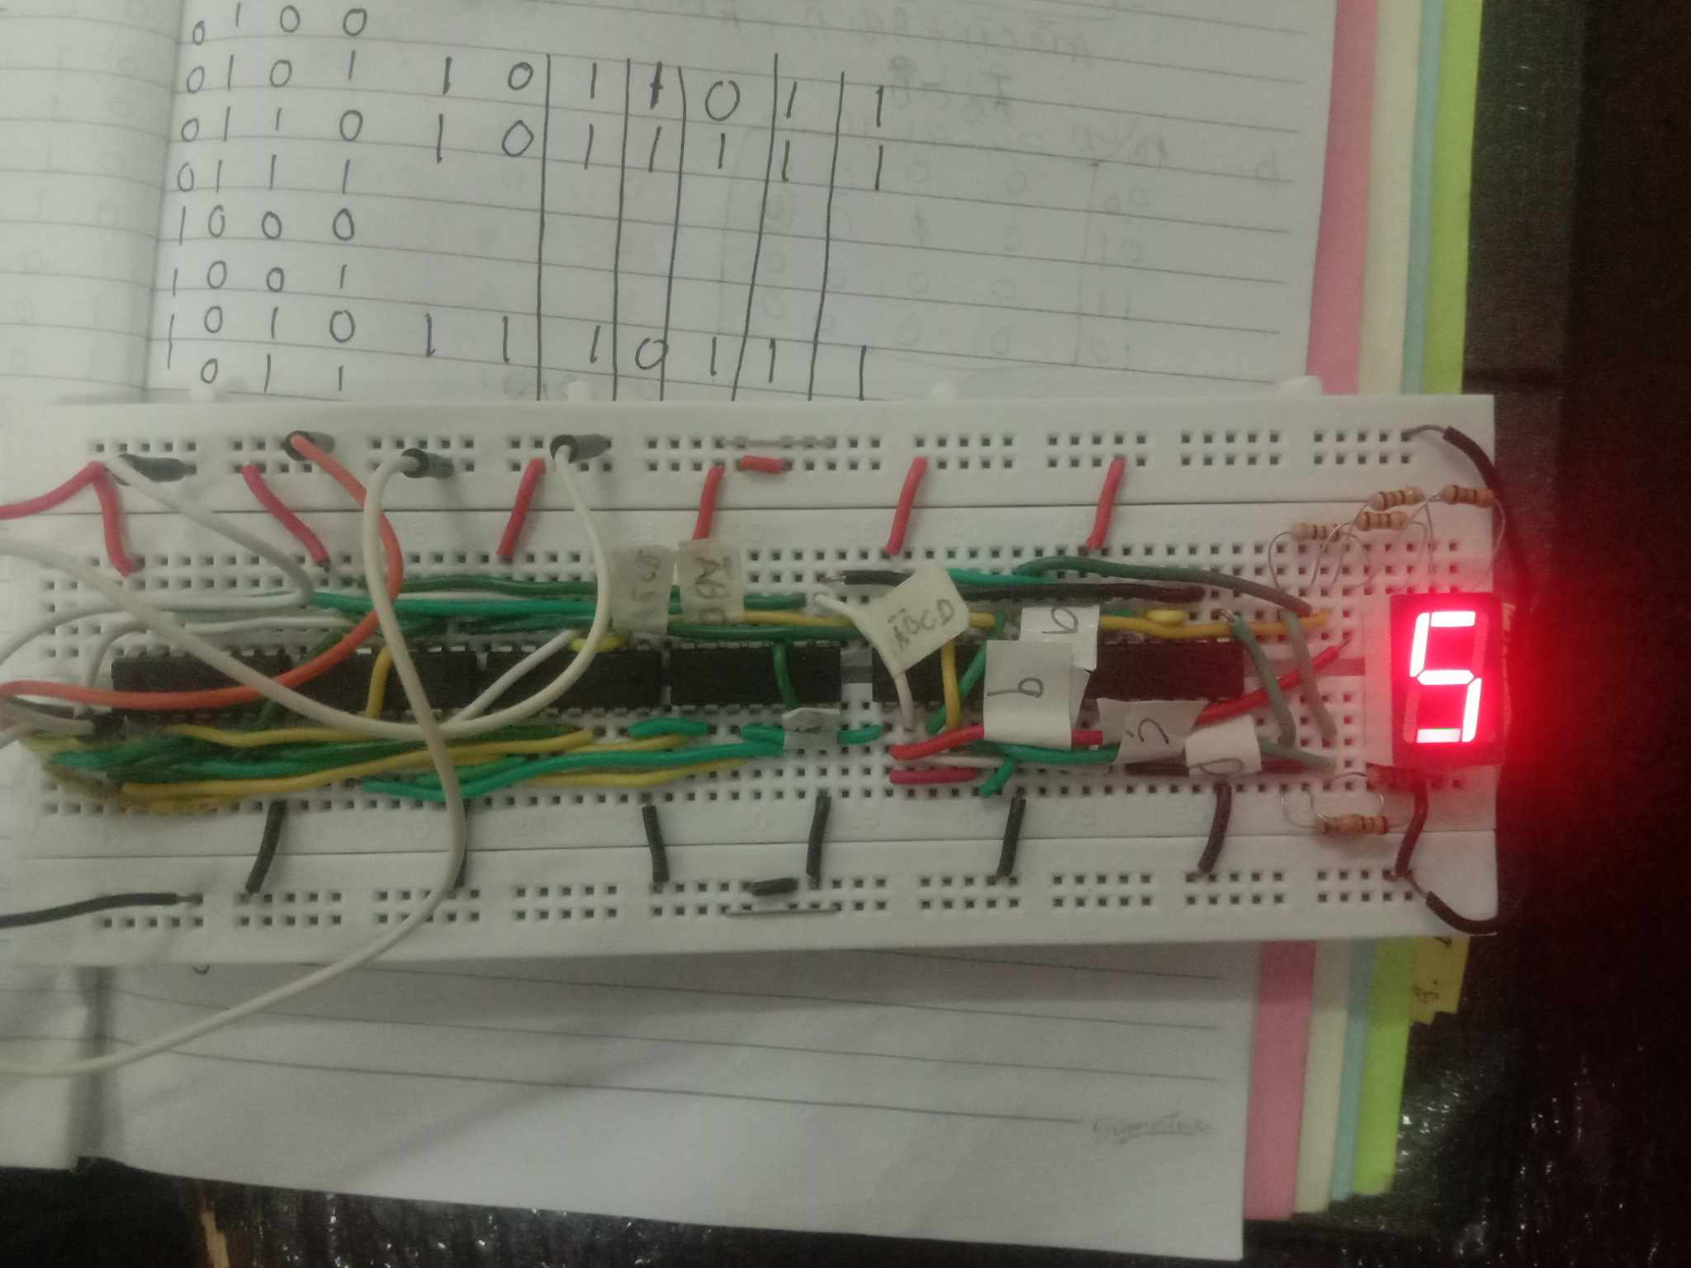

Output: 6

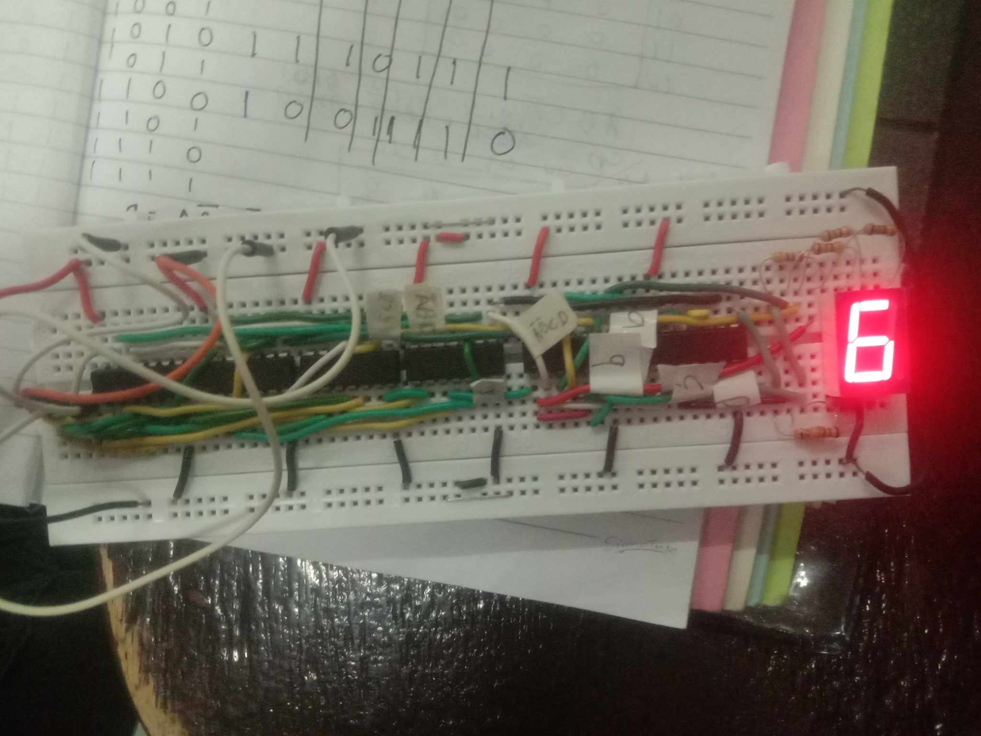

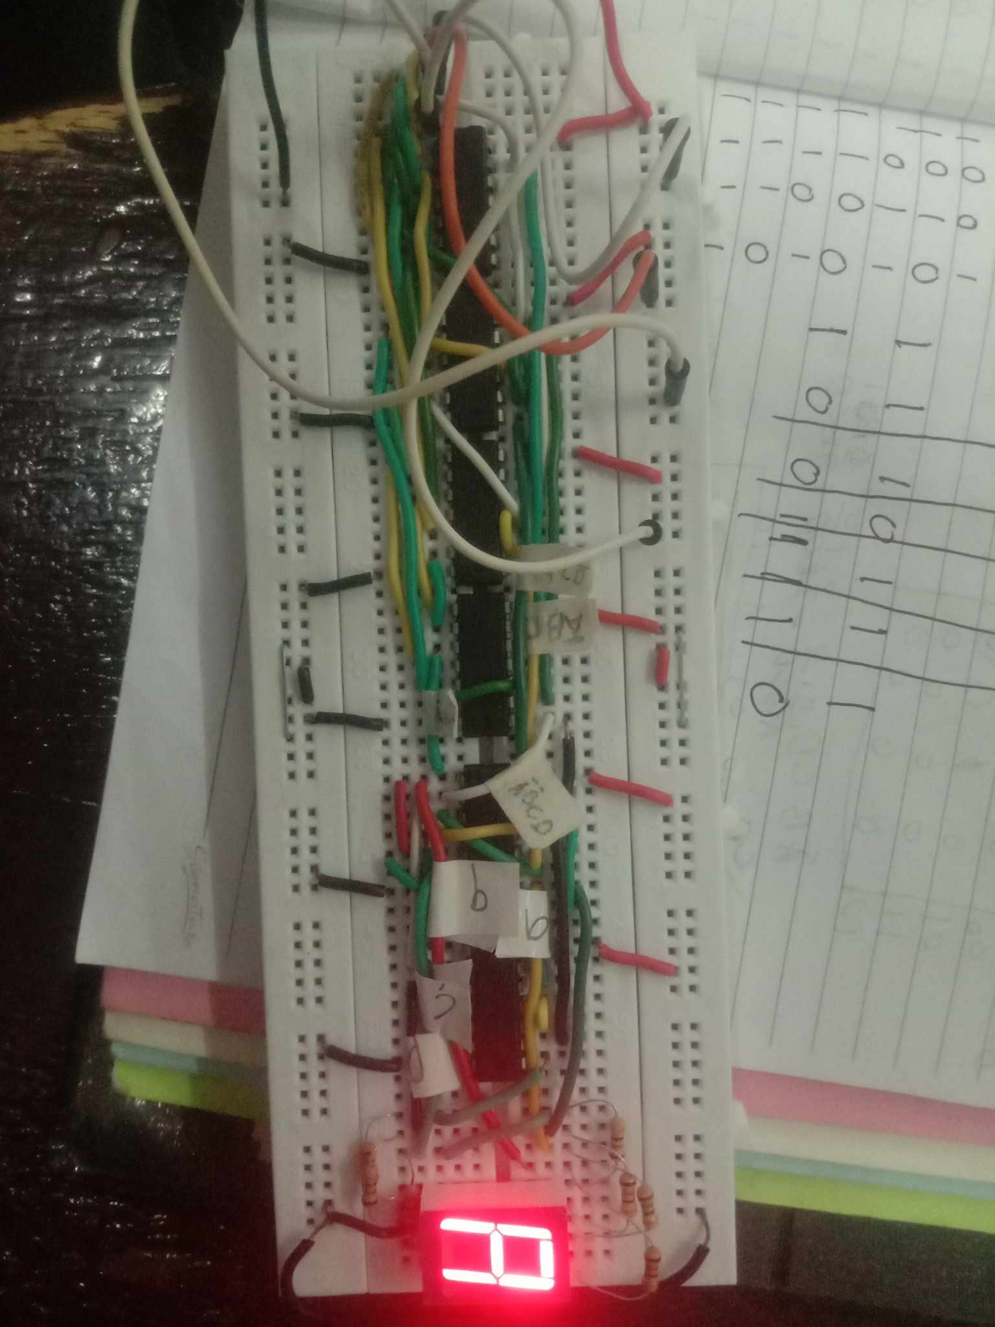

Output: A

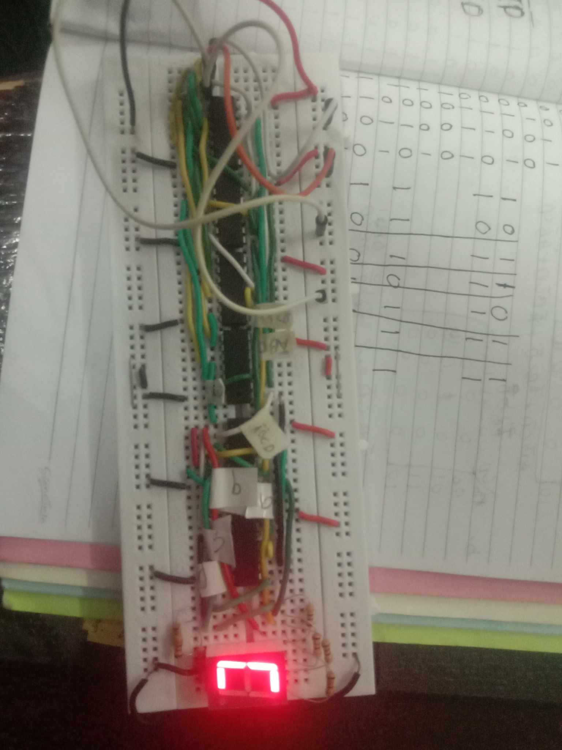

Output: C

Learning Experience  
  
  
  
 Putting together a basic decoder using a 7-segment display seemed tough at first, but it turned out to be a learning adventure. Understanding how the display shows numbers and connecting it to switches or a counter felt like a big challenge. Making sure each part was connected correctly and fixing any mistakes took time and careful work. However, by figuring out these connections, I got a better idea of how the display works with different signals.

In the end, even though it seemed hard, making this decoder taught me a lot. It showed me how important it is to be patient and careful when working with electronic circuits. Despite the initial difficulty, doing this hands-on project helped me understand how inputs directly affect what shows up on the display, teaching me important things about electronics in a practical way.