Development Document

GitHub Repository Link: https://github.com/djcezarus/ESL

# 1. Introduction

This project focuses on developing a basic payroll processing program using Python. It reads employee data from a CSV file, calculates gross pay, tax deductions, and net pay, and writes the results to an output file. This assignment is designed to demonstrate key programming concepts such as file handling, functions, and command-line interaction. The repository linked above contains all the required files for execution.

# 2. Solution Design

The main components of the solution are:  
- A Python program (`process_payroll.py`) that reads a CSV file, performs payroll calculations, and outputs the result to another CSV file.  
- A batch script (`run_payroll.bat`) that automates the execution of the Python program.  
- A sample input CSV file (`employees.csv`) containing test data.  
  
The program is modular, with a function dedicated to calculations, and another for file processing. It includes basic error handling and comments to enhance readability and maintainability.

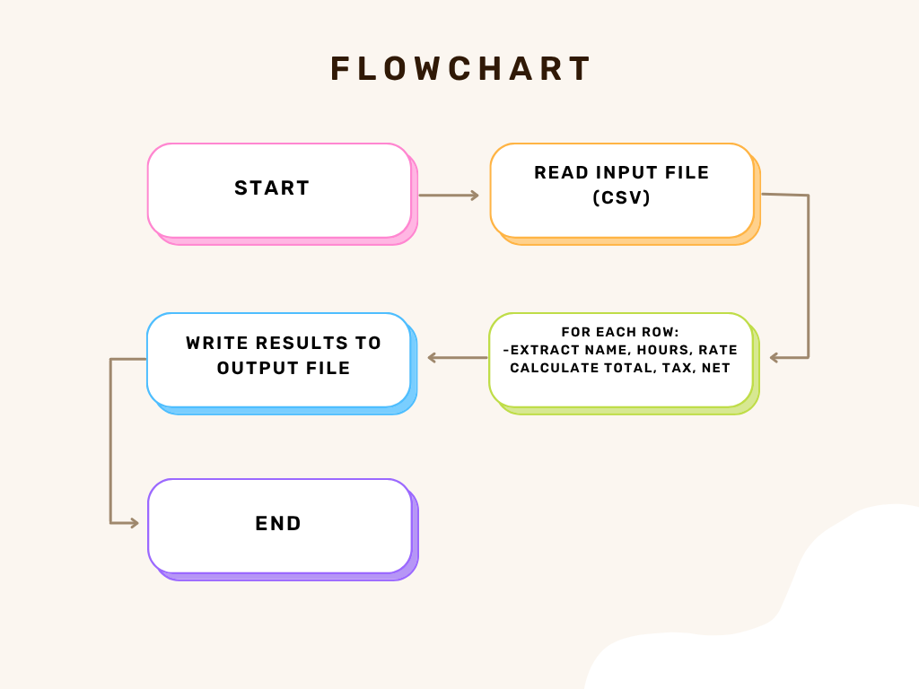

Flowchart: Logical operations of the payroll processing script.

# 3. Reflective Evaluation

This project was a valuable learning experience in understanding the basics of data processing and scripting. The most interesting part was implementing the command-line interface and automating the script with a batch file. In the future, improvements such as using external configuration files, enhancing error handling, and adding a GUI could be considered. Gaining deeper knowledge in exception handling and data validation would also be beneficial.

# 4. Appendix

Refer to the files provided in the GitHub repository for full source code.