Sous Chef AI Web App – Bug Report

Overview
The Sous Chef AI landing page on the Replit development preview (tested on 2026‑01‑25 using a Chromium‑based browser) was reviewed to identify functional and usability issues. The site markets an AI‑powered kitchen assistant with features such as natural conversation, weekly meal planning and smart shopping lists.
During the evaluation, most of the site behaved like a static marketing page; interactive functionality such as account creation or actual AI interactions were inaccessible without authentication. Several issues were noted that could negatively impact conversion and usability.

Critical Issues
# | Area | Issue/Description | Evidence
1 | Call‑to‑action (CTA) buttons | The primary “Get Started Free” button in the hero section and the “Start Cooking Smarter” button in the “Ready to simplify dinner?” section are supposed to lead visitors into the onboarding/login flow. Clicking either button triggers a call to the /api/login endpoint, but nothing happens on the page (no redirect or modal). This leaves users stranded without feedback and prevents them from trying the product. | The hero area containing the non‑functional CTA is shown here[1] and the bottom CTA is similarly affected[2].
2 | Inconsistent sign‑in flows | The top‑right “Sign In” button redirects to Replit’s OpenID Connect (OIDC) consent page. In contrast, the CTAs attempt to hit an internal /api/login route (which silently fails). Having two different mechanisms for sign‑in creates confusion: visitors using the prominent CTAs get no response, while those who notice the tiny “Sign In” button are taken off‑site to Replit. | Opening the top “Sign In” loads an external Replit login page; returning via the back button reveals the site again.
3 | Loading experience | On first load the page remained completely white for several seconds. Only after manually refreshing did the content appear. There was no loading spinner or skeleton screen, so the site looked broken until it finally rendered. This could cause visitors to abandon the page. | When returning from the Replit login page the app displays an orange pot icon with “Loading your kitchen…”; however, on the initial load no such indicator appeared.
4 | Replit development banner | A blue banner stating “This is a temporary development preview, and these links are not for public use” appears at the top of the site. Although it can be dismissed, first‑time visitors might think they are on an unfinished or unsafe site. Removing this banner in production or replacing it with a branded notice would increase trust. | The banner was visible on first load and had to be manually closed before the navigation bar was usable.
5 | Lack of feature demos | The marketing copy promises natural conversation, meal planning and smart shopping lists, but there is no interactive demo or sample conversation to showcase these features. Requiring sign‑in just to try the AI may deter users. An embedded demo or step‑through wizard would better communicate product value. | The “Faster than thinking” section lists features but offers no way to experience them[3].

Minor Issues & Observations
- Accessibility – The icons for conversation, meal plans and shopping lists use a faint peach colour on a white card, which may have low contrast for users with vision impairments.
- Responsive layout – While the layout scales down gracefully as the page is resized, the large hero artwork causes the content to push far down the page on smaller screens. Consider adding a responsive breakpoint to shorten the hero area on mobile.
- Content clarity – The tagline “Just tell it what you have, what you’re craving, or ask for help. It handles the rest.” is compelling, but users cannot test this claim without creating an account. Offering a guest mode or sample query could improve engagement.

Post‑login Experience – Kitchen Chat, Meal Planning & Cookbook
After logging in to the development environment, the internal application exposes a chat interface (“Kitchen Chat”), weekly meal planner, recipes, cookbook and calendar. The evaluation uncovered several functional bugs and usability issues in these authenticated features.

Functional Bugs
# | Area | Issue/Description | Evidence
A1 | Chat – send button unresponsive | On the “Kitchen Chat” page, clicking one of the suggested prompts (e.g., “I don’t know what to cook tonight”) populates the message input but pressing the orange send arrow does nothing—the text remains in the input and no message is sent. The only way to send a message is to hit the Enter key, which isn’t intuitive for users tapping a mobile UI. | In the chat screen, the message “I don’t know what to cook tonight” is loaded in the input and the user has clicked the send arrow. Nothing happens; the text stays in place[4]. The annotated diagram below highlights the unresponsive input box (label 1) and the send button (label 2) in red: 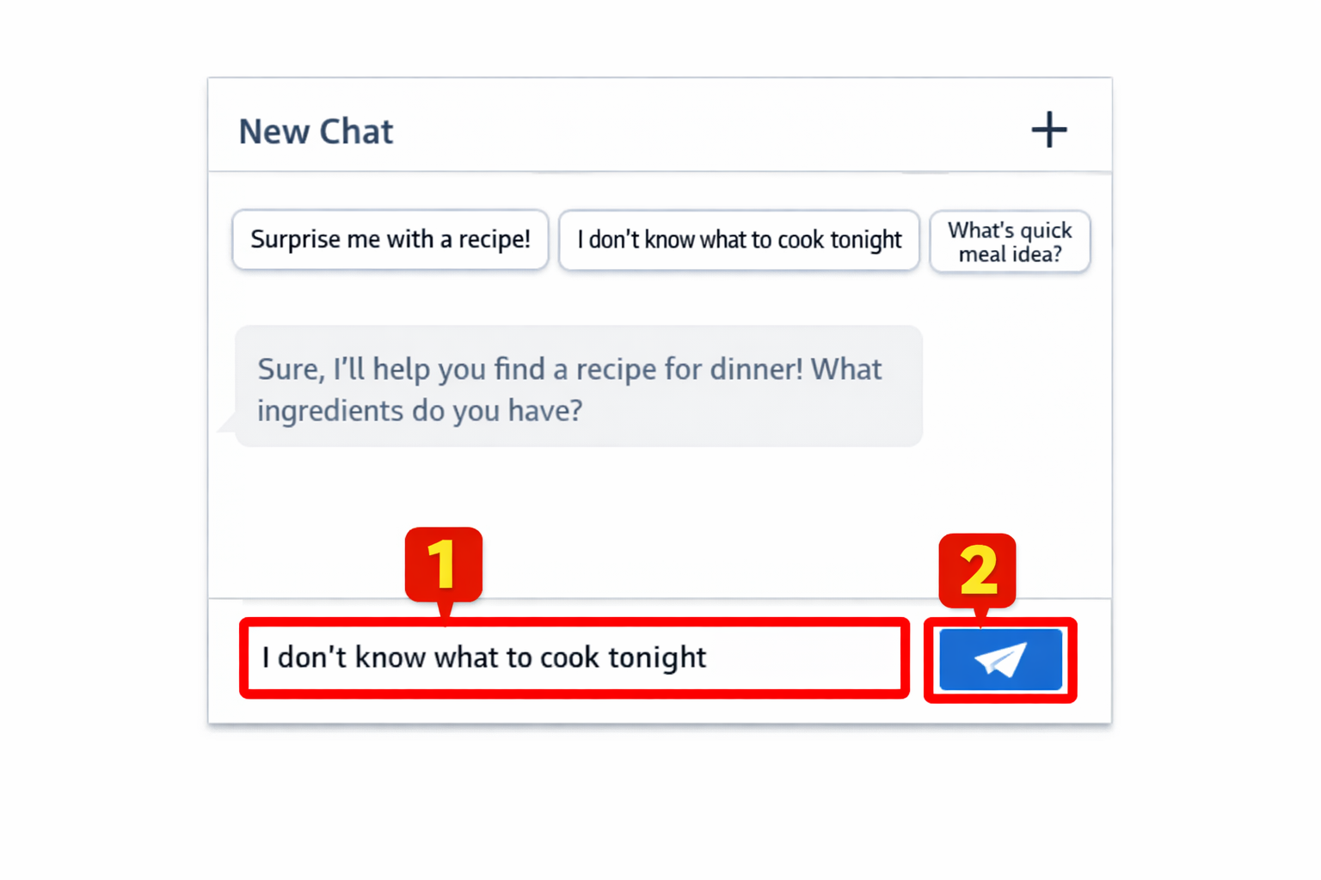  .
A2 | Chat – inconsistent replies | The AI sometimes responds to the first message but then ignores follow‑up messages. In one test, the assistant replied to “Hello” but remained silent after a second query (“I have chicken, rice, and broccoli”). In another session, the second query did receive a response. This inconsistency makes the chat feel unreliable. | A new chat showing the AI replying to the greeting and also responding to a second question is visible here[5]. Earlier tests produced no answer to the second message, indicating a non‑deterministic bug.
A3 | Meal plan generation feedback | On the Plan page the “New Plan” button generates a weekly dinner plan. In some runs the first click appears to do nothing (no loading indicator), but after clicking again a toast appears (“Meal plan created!”). This suggests the asynchronous operation either takes a while to respond or fails silently on the first attempt. A visible spinner or disabled button would make the action clearer. | During one attempt, clicking “New Plan” once did not update the UI; only after a second click did the toast display a success message and the plan refresh.
A4 | Recipe instructions mis‑numbered | When opening a recipe from the weekly plan, the “Instructions” section lists steps starting at 14 or 13 rather than at 1. The numbering continues from previous ingredients list numbers instead of resetting at the instructions section, which is confusing. | In the “Chipotle Chicken & Broccoli Rice Burritos” recipe the instructions start at step 14[6]. A simplified diagram marks the erroneous start number (label 1): 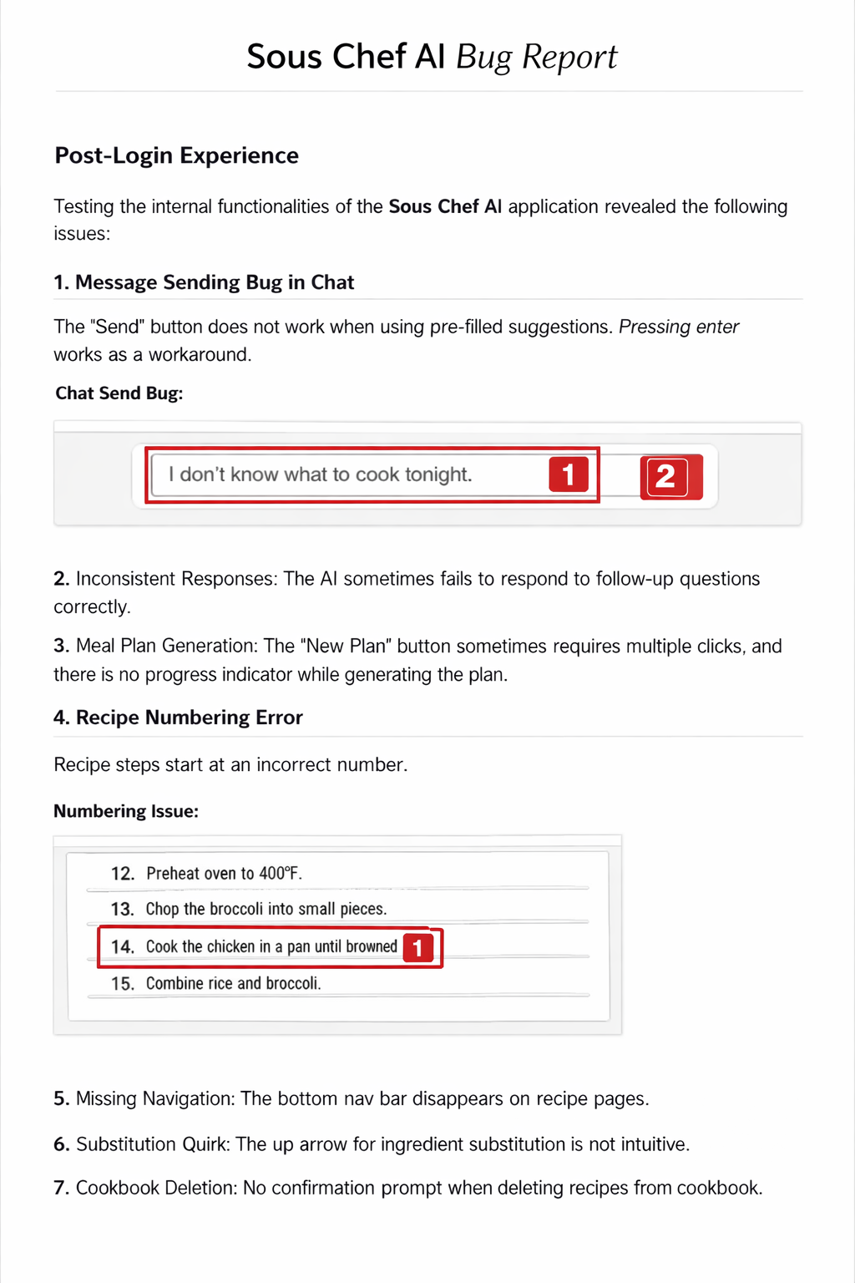  .

Usability & UX Observations
- Navigation on recipe pages – When viewing a recipe the bottom tab bar (Chat, Plan, Calendar, Cookbook, Shop) disappears. The only way back is via a small back arrow at the top left. Keeping the primary navigation visible or providing a persistent back button would improve discoverability.
- Saving to cookbook – Tapping the bookmark icon on a recipe saves it to the Cookbook with a tiny toast notification. There is no confirmation dialog or ability to organise saved recipes into categories.
- Deleting recipes – In the Cookbook tab each saved recipe has a trash icon; deleting permanently removes it without confirmation. Consider adding a confirmation modal to prevent accidental deletion.
- Shopping list appears empty – The “Shop” tab instructs users to generate a shopping list from a meal plan but there is no direct button to do so. Users may not realise that the shopping list is created implicitly from the weekly plan.
- Calendar integration – The Calendar tab offers list and calendar views. Weeks without a plan show a “Create Meal Plan” button, while weeks with a plan show the recipes. This feature works as intended but could benefit from tooltips or onboarding to explain its purpose.
These post‑login issues, particularly the unresponsive chat send button and mis‑numbered instructions, hinder the core experience promised by Sous Chef AI. Addressing these bugs and polishing the UX will make the application more intuitive and reliable.

Recommendations
- Fix the CTA buttons – Update the “Get Started Free” and “Start Cooking Smarter” buttons to either direct users to the same authentication endpoint as the “Sign In” button or open a modal prompting for sign‑up. Provide feedback (e.g., loading indicator) after the click so users know something is happening.
- Unify sign‑in and sign‑up flows – Decide whether sign‑in should occur via Replit OIDC or through a custom endpoint. Ensure that all entry points (CTAs, nav buttons, etc.) behave consistently, and test them in the deployed environment to avoid silent failures.
- Improve initial loading – Add a loading spinner or skeleton UI on first load so that users are aware the site is loading. This will prevent the perception that the page is blank or broken.
- Remove development banners in production – Configure Replit deployment to disable the preview banner for end‑user environments. Use a custom banner only if necessary, styled to match the brand.
- Add interactive demos – Provide a short conversational demo or sandbox where visitors can ask a sample question (e.g., “I have chicken and rice—what can I cook?”) without signing in. This will showcase the AI’s value and encourage users to register.
- Enhance accessibility – Review icon and text colours for WCAG contrast compliance. Ensure buttons have descriptive aria‑labels and alt text so screen readers convey their purpose.

Conclusion
The current version of Sous Chef AI’s landing page looks polished and clearly communicates the product’s value proposition. However, major onboarding blockers—namely non‑functional CTAs and inconsistent login flows—prevent users from accessing the AI experience. Addressing these critical issues, improving the initial loading behaviour and adding an interactive demo would greatly enhance user trust and conversion.

[1] [2] [3] [4] [5] Sous Chef AI - Your Kitchen Assistant
https://bb3946a4-bf1e-4d70-803a-90e3d15a126e-00-2q2tktjyxkffq.spock.replit.dev/
[6] Recipe - Sous Chef AI
https://bb3946a4-bf1e-4d70-803a-90e3d15a126e-00-2q2tktjyxkffq.spock.replit.dev/recipe/352

