Description of Program Code:

Area.java

The source code starts by importing all of the modules required: awt, awt.event, and swing.

import java.awt.*;
import java.awt.event.*;
import javax.swing.*;

I then make the global class, also including JFrame and the ActionListener.

public class Area extends JFrame implements ActionListener

I declare my four text fields. These are used as the x, y, and width and height JLabels in my program. X and Y are for the positioning of the shapes on the screen, width and height are for the shape. There are two buttons for each shape, oval and rectangle respectively. These are known as submitRect and submitOval, as they're submitting the user choice.

// TextFields, Labels, Buttons
JTextField numb1, numb2, numb3, numb4; // for the 4 numbers
JTextField area; // for the area
JLabel Number1, Number2, Number3, Number4, title, whatshape, areal; // my labels
JButton submitRect, submitOval; // buttons for each shape

The next block is for my integers. These are for the shapes. Since they're entered into textfields, these are strings by default, I then later convert them to ints in the program. I also have areas (area of my shapes) as a double since pi is a float, not an integer.

// Integers for shapes, I later convert strings to ints
int in1, in2, in3, in4;
String n1, n2, n3, n4;
int shape; // either 1 or 2: rectangle or oval
double areas; // area of shapes

in the public Area block I delcare my GUI components and properties, such as the size and location of my window frame, and it's title. I chose to use a flowlayout to organise my program as I am not dealing with many components.

public Area()
{
// Declare all GUI components
// Can alter fonts & sizes later
setSize(650,500); // Size of the window
setLocation(400,300); // Where window is drawn on desktop
setTitle("Calculate Shape Areas"); // Window title
setLayout(new FlowLayout(FlowLayout.CENTER, 20, 10));
title = new JLabel ("Calculate Shape Area");

I then assigna all of the labels and textfields with variables and the text I want to display, such as "Enter x" for the x positioning. The parameter (3) limits the textfield to 3 characters, anything bigger would not fit on the screen very well.

// Assign GUI components with variables
Number1 = new JLabel("Enter x");
numb1 = new JTextField(3);
Number2 = new JLabel("Enter y");
numb2 = new JTextField(3);
Number3 = new JLabel("Enter width");
numb3 = new JTextField(3);
Number4 = new JLabel("Enter height");
numb4 = new JTextField(3);
whatshape = new JLabel("Choose Shape");
whatshape.setFont(new Font("Courier", Font.BOLD, 30));
submitRect = new JButton("Rectangle");
submitOval = new JButton("Oval");
area = new JTextField(3); // for the area
areal = new JLabel("Shape Area");

I then add all my components to the screen with getContentPane().add(<name of component>), and set the default close operation (so closing the program works properly), and set the visibility of the components I've added to true.

// Add them all to screen
getContentPane().add(title);
getContentPane().add(Number1);
getContentPane().add(numb1);
getContentPane().add(Number2);
getContentPane().add(numb2);
getContentPane().add(Number3);
getContentPane().add(numb3);
getContentPane().add(Number4);
getContentPane().add(numb4);
getContentPane().add(whatshape);
getContentPane().add(submitRect);
submitRect.addActionListener(this);
getContentPane().add(submitOval);
getContentPane().add(areal);
getContentPane().add(area);
submitOval.addActionListener(this);
setDefaultCloseOperation(EXIT_ON_CLOSE);
setVisible(true); // Display the components
}

The next block is the event handler. I then get the text (via get.Text) for all of the integers (the textfields from user input), and proceed to parse them into new variables (in1-4, where "in" is short for integer).

public void actionPerformed(ActionEvent ev)
{
// What happens when button is clicked
n1 = numb1.getText();
n2 = numb2.getText();
n3 = numb3.getText();
n4 = numb4.getText();

// Convert the strings to ints
in1 = Integer.parseInt(n1);
in2 = Integer.parseInt(n2);
in3 = Integer.parseInt(n3);
in4 = Integer.parseInt(n4);

The action event handler then proceeds to do some checking. It checks whether the rectangle or oval button was pressed. Once it does this, I run some error checking, so the user hasn't put in numbers too large for the window to display the shape.The errors are displayed as message dialog boxes, that try to give the user an idea of their error. After deciding what shape button was pressed, the screen is repaint via repaint();, and the areas variable calculates the area for either rectangles or ovals, and writes these into a non-editable textfield.

if (ev.getSource() == submitRect)
{
// Validation, so as to not go off the screen
if(in1 > 285)
{JOptionPane.showMessageDialog(null, "Value for x is too big!");}
else if (in2 > 245)
{JOptionPane.showMessageDialog(null, "Out of range value for y!");}
else if (in2 < 170)
{JOptionPane.showMessageDialog(null, "Please enter bigger number for y!");}
else if (in3 > 400)
{JOptionPane.showMessageDialog(null, "Height is too big!");}
else if (in4 > 400)
{JOptionPane.showMessageDialog(null, "Width is too big!");}
else
shape = 1; // Rectangle
repaint();
areas = in3 * in4; // work out the area
area.setText(""+areas); // write into the textfield
}

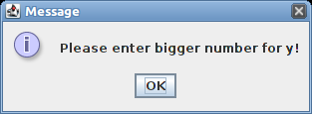

The program is then called via the main class name. The next block of code, paint, uses the super.paint method for safety, as this is needed to draw on some operating systems.

public static void main(String args[])
{
new Area(); // Calling main prog
}

This paint section operates on the two cases, either for rectangle or ovals, and draws both for each respectively, as well as using the integer variables the user gave it. The break statement allows the program to accept the condition as complete and move on to the next, and the final default and break statement do the same but for the whole program.

public void paint(Graphics graf)
{
super.paint(graf);
switch (shape)
{
// Rectangle
case 1:
graf.setColor(Color.blue);
graf.fillRect(in1,in2,in3,in4);
break;

// Oval
case 2:
graf.setColor(Color.red);
graf.fillOval(in1,in2,in3,in4);
break;
default:
break; // What happens when run
}
}
}

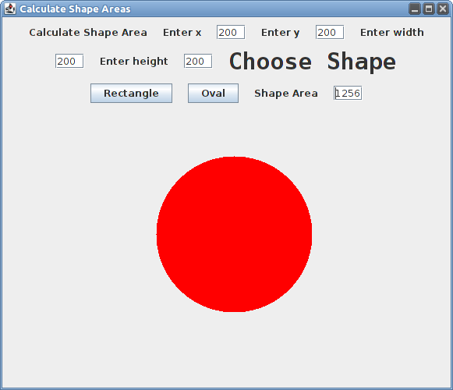Illustration 1: Full program, showing the oval/circle
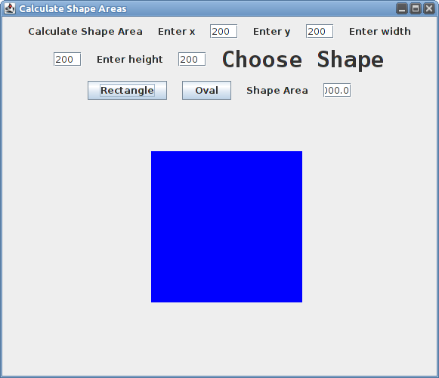Illustration 2: For the rectangle, full program

