David J DeBonis

Dan Klie

Intro to Statistics

Final Project

RESEARCH QUESTION:

Is there a statistically significant difference between the mean selling price of a 2008 Jeep Liberty and a 2008 Subaru Outback in The United States?

HYPOTHESIS:

The mean selling price of a 2008 Subaru Outback will be higher than the mean selling price of a 2008 Jeep Liberty on CarGuru.com because they have a lower depreciation rate and they hold their value well (there *will be* a statistically significant difference).

DATA:

2008 Jeep Liberty Prices ($)

* Sample Mean: 8,169
* Sample Median: 8,067
* Sample Standard Deviation: 1,112.19

2008 Subaru Outback Prices ($)

* Sample Mean: 9,382
* Sample Median: 9,257
* Sample Standard Deviation: 1591.47

OTHER DATA: (not directly relevant)

2008 Jeep Liberty Odometer (miles)

* Sample Mean: 104,627
* Sample Standard Deviation: 16,026
* Average Dollars/Mile—0.078

2008 Subaru Outback Odometer (miles)

* Sample Mean: 109, 269
* Sample Standard Deviation: 22,372
* Average Dollars/Mile—0.086

PROCESS:

I will offer a brief summary of the complex process that went into collecting this data—this will all be described in my presentation, but I figure I will mention it anyway:

1. It began with 2005 Subaru Outbacks and Jeep Libertys, but I soon discovered that these were difficult to find online, so I moved the year up to 2008.
2. SRS(WR): I assigned each of the fifty states a number in alphabetical order. I then used the random number generator on my calculator to pull 30 random numbers—if there were any repeats, I simply did another 1-50 SRS until I found a number/state that hadn’t yet been selected.
3. I soon discovered that Carmax locations did not have sufficient 2008 Subaru Outbacks and Libertys to conduct the study. I searched through other used-car websites, but most of them require a specific zip code to narrow the search.
   1. I did not want to do an SRS of every zip code in each state, so I decided I would use the Carmax locations (that are often in major cities) as my origin zip code on CarGuru. When there were multiple Carmax locations per state, I would do a quick SRS between the stores. I would then plug in the zip code of that Carmax with a 50mile radius to CarGuru, and chose the first car that came up that was relevant to the criteria:
      1. The criteria was: any 2008 Jeep Liberty or any Subaru Outback (besides the XT models because the turbo gives an unfair advantage) that was between 80,000🡪120,000 miles. If there were none listed in that odometer range, I would pick the next closest (i.e. 74,000 would be picked over 145,000).
         1. Because this was not extremely consistent, I made sure to record the odometer reading of every car. In the end the mean odometer readings of the samples were within 5,000 miles of each other, which seemed like a reasonable margin of error.
4. If there were no Carmax locations in a specific state, I would do another 1-50 SRS until I pulled up another state that had a Carmax location and was not already mentioned in the sample.

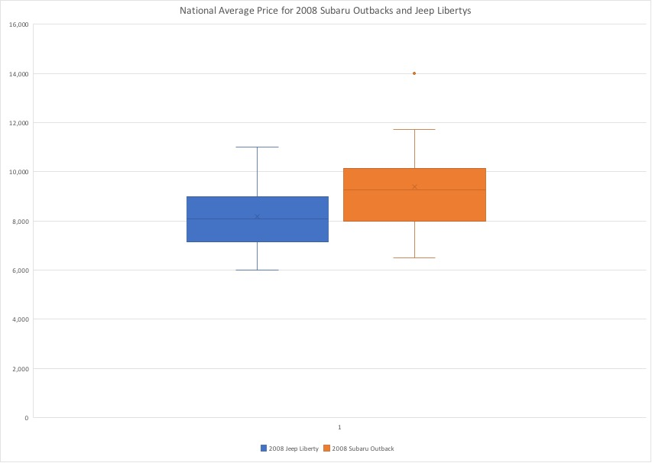

I believe that used Subaru Outbacks are worth more than used Jeep Libertys. A survey of 30 2008 Subaru Outbacks had a sample mean of $9,382 and a sample standard deviation of $1591.47. A survey of 30 2008 Jeep Libertys had a sample mean of $8,169 and a sample standard deviation of $1,112.19. The data was collected using Car Guru; one 2008 Jeep Liberty and one 2008 Subaru Outback was selected from 30 randomly selected (chosen by SRSWR) states throughout the country, and the selling values were recorded. Is there enough data to conclude that used 2008 Subaru Outbacks are worth more used 2008 Jeep Libertys at a=0.05?

2008 Jeep Liberty: 2008 Subaru Outback: