Results – SwinE-Net

Exp | Loss function | Epochs | Description | mDice | mIoU | Accuracy
1 | BCEwithLogitsLoss | 6 | Metrics for Training only
2 | BCEwithLogitsLoss | 6 | Split Train:Test::9:1
3 | Weighted Loss Function | 5 | Added weighted loss function

Exp 1:
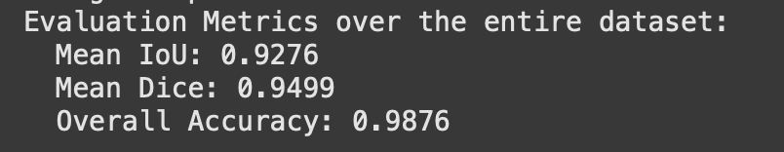

Exp 2:
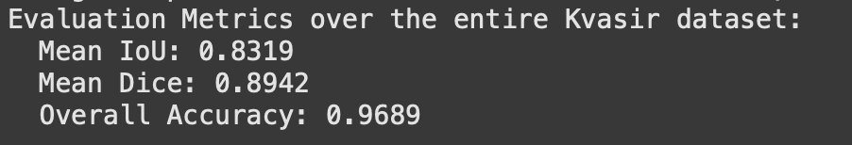

Exp 3:
