# **ITEC 2100 Project 5: Implementation Sprint 1**

Dina, Carson, Danielle, Trent, Adrienne

**Main Webpage Visualisation:**

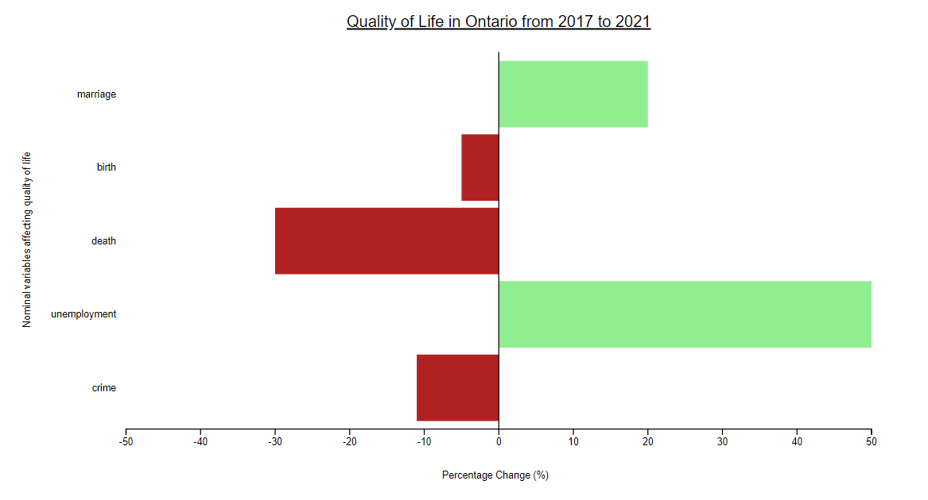

**Coded Drop Down Menu GIF:**



**Coded buttons + animated bars GIF:**



**Current Individual Static Charts For Each Category:**

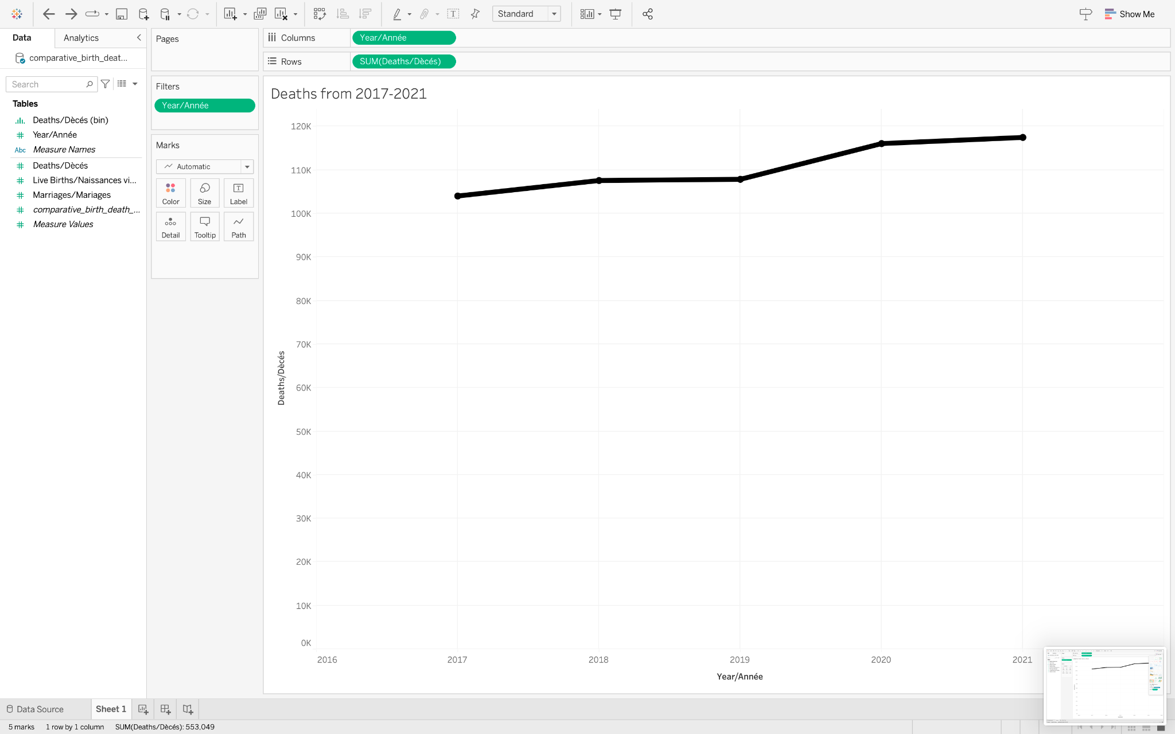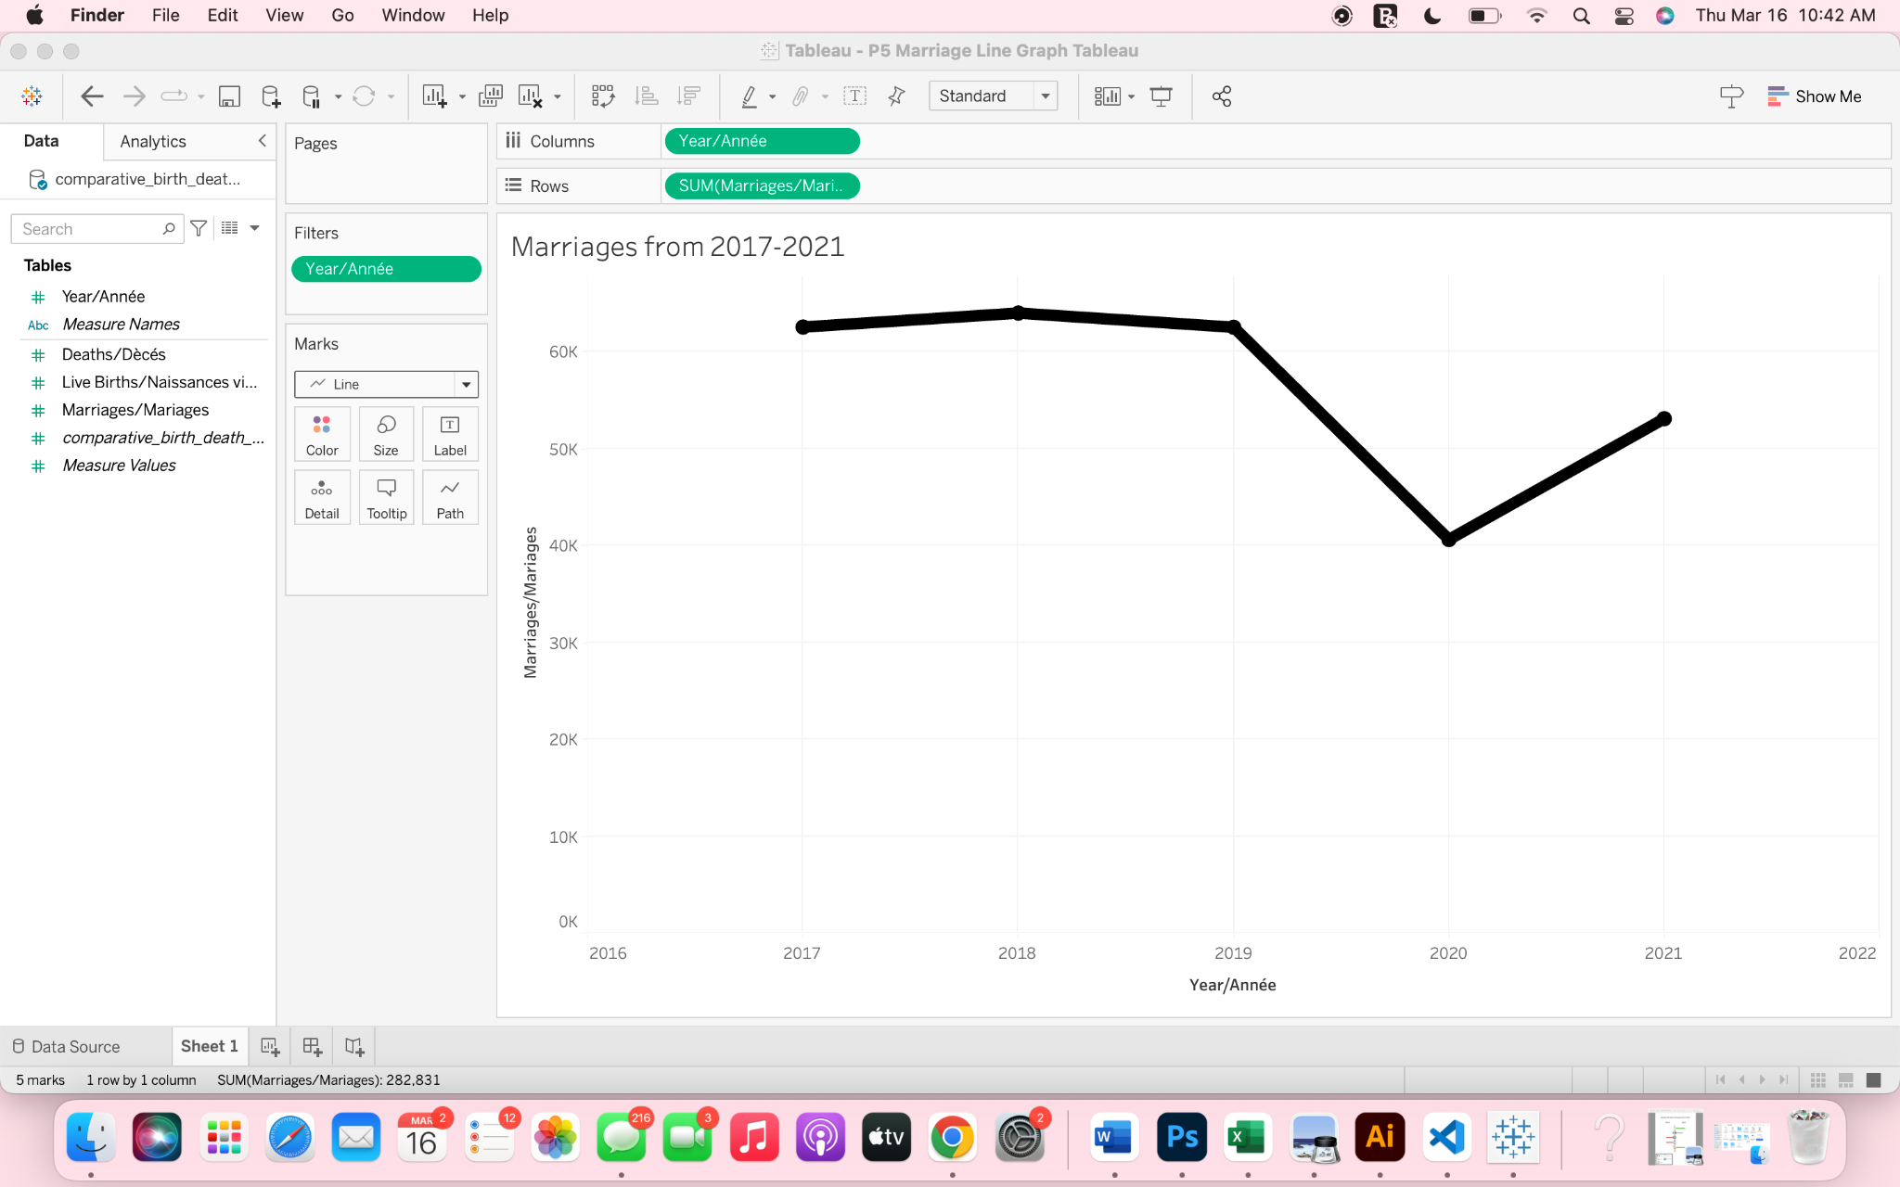

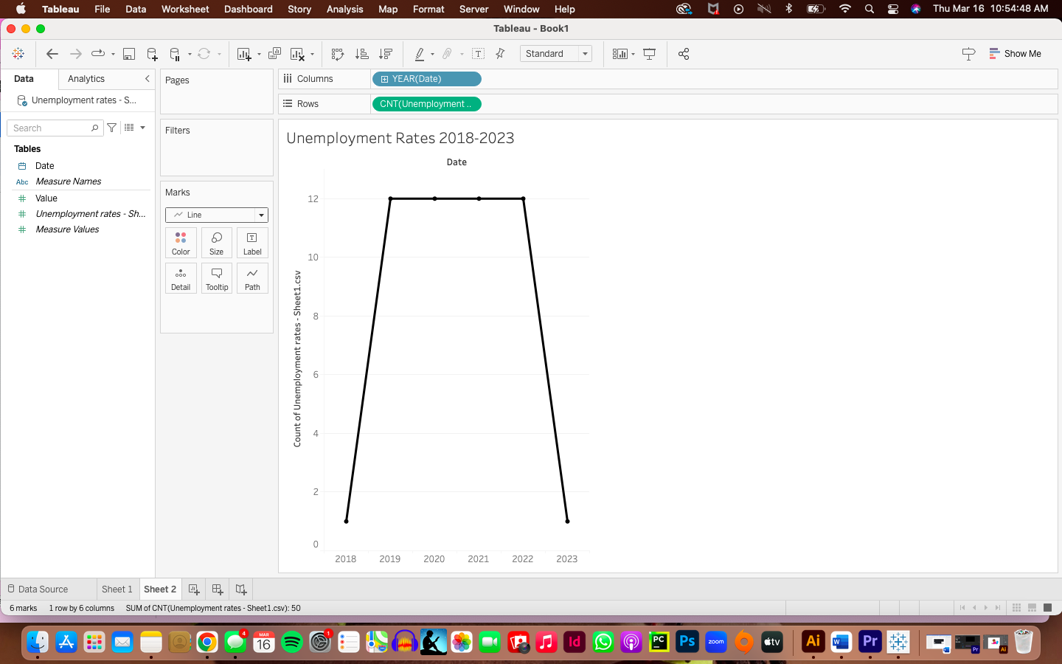

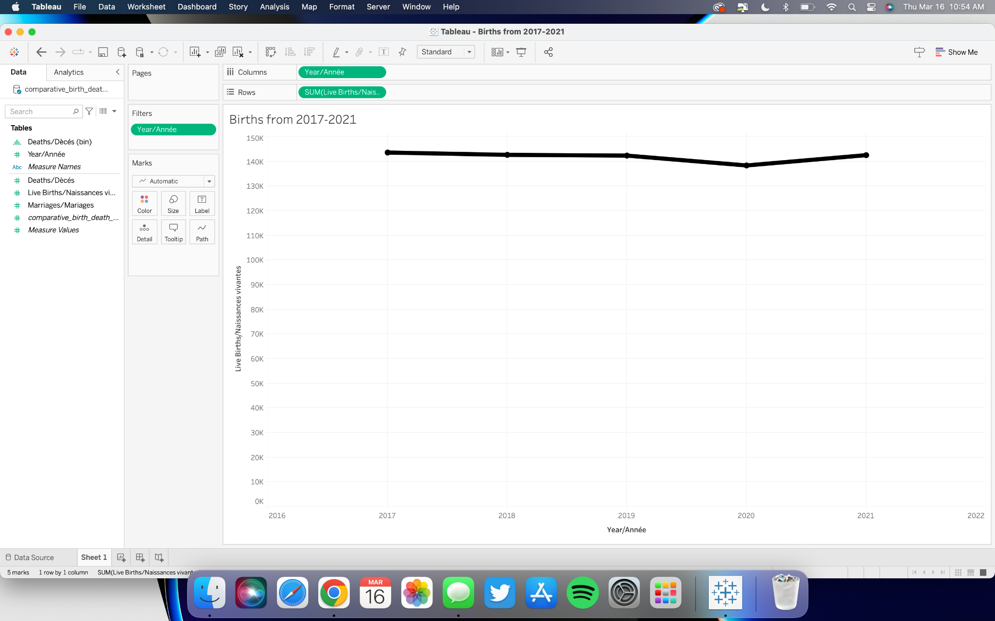

**Instructions:**

When first observing the webpage, the first thing the user will notice is a butterfly chart that has details on demand when hovering over the individual bars. These details will show the exact percentage change over a time period that the user will be able to select themselves by using the interactive drop-down menu located at the top of the webpage. The user will also be able to access on-click data for the individual categories, where there will be a pop-up static chart showing more in-depth data on the selected category. The user will be able to repeat these steps for each category by either hovering or clicking on each categories’ bar.

1. Open webpage
2. Hover over each bar
3. Read information that the bar provides
4. Filter through years
5. Click on bars for total year data
6. Repeat

Using our visualisation, users will be able to assess the quality of life in Ontario from 2017-2021. Users will use drop down functions to specify which two years they want to compare. They will then be presented with a butterfly chart comparing the two years. The data shown will focus on suicides, marriages, births, unemployment and deaths in Ontario from 2017-2021. When users hover over a bar, it will show the percentage change value for that category. There will be on click features for the user to interact with to analyse the data of each category more in depth. Users will be shown a line graph based on the category chosen and all the data from 2017-2021.

**TO DO completed:**

* ~~Build basic butterfly chart~~

<https://d3-graph-gallery.com/graph/barplot_button_data_simple.html>

<https://stackoverflow.com/questions/38969051/how-do-i-centre-the-y-axis-in-a-d3-tornado-chart>

* + Basic code completed for the main visualisation (tornado map)
  + This main visualisation includes code a simplistic tornado map, including bars on both the left and right side, colours, and titles
  + Completed code for a dropdown menu that selects different options changes the data displayed in a visualisation. This now just need to be implemented into the main visualisation
* ~~Add credits for every source~~
* ~~Can images be in the middle?? (centre y axis)~~
* ~~Change colours of bars (left red, green right)~~
* ~~Create visualisations for each dataset~~
* ~~Tableau projects have been started for each visualisation and a rough graph has been completed outline the specifics of each category.~~
* ~~Learn how to create shared directory on Github/Onedrive~~
  + A Github repository where all code can be shared
* ~~Create context/instructions on how to use visualisation~~
* ~~Copy all tasks completed this sprint~~

**TO DO for final visualisation:**

* Find hex codes for colours (light green, dark red for accessibility/diff luminosity)
* Code dropdown options linked to data

<https://d3-graph-gallery.com/graph/line_select.html>

* Create hover function which shows the exact percentage of each bar
* Create images for y axis using illustration software which best represents each icon for each category
* Add images to y axis
* Add data into butterfly chart (vardata1, vardata2, vardata3… for each year)

<https://docs.google.com/spreadsheets/d/1lsH-E8SYnGRAzhYgTNann2vgL9AwE7oPMSWkQ_9SJHc/edit?usp=sharing>

* Create interaction on click feature which brings up the individual charts for each category
* Allow for an on-close action which allows users to close these popup images
* Polish of the webpage and create a visually appealing display to be publicly presented

**Github Link To All The Code:**

<https://github.com/dje1066/ITEC2100_GroupProject.git>

**Main Viz (In JsFiddle):**

<https://jsfiddle.net/05mqw6v7/>

**Calculated Percentage Change of each category for every year combination (Missing 2021 for suicides):**

<https://docs.google.com/spreadsheets/d/1lsH-E8SYnGRAzhYgTNann2vgL9AwE7oPMSWkQ_9SJHc/edit#gid=0>