 |  | 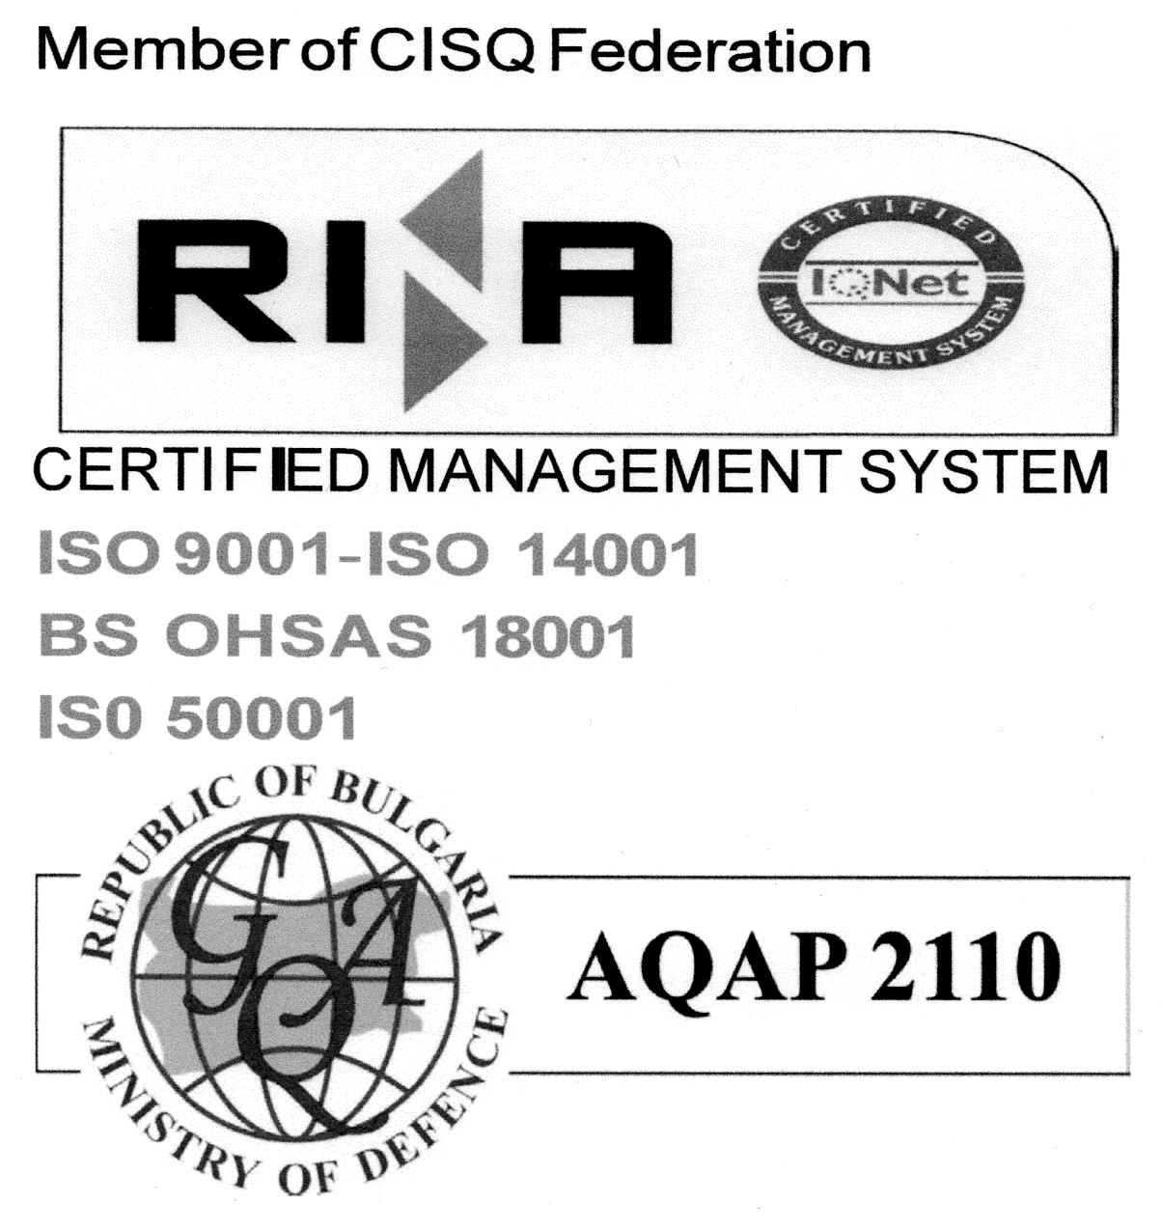
EQUIPMENT ACCEPTANCE FOR REPAIR PROTOCOL
{{TEMPLATE_LANGUAGE:en}}
Protocol No. | {{DOCUMENT_NUMBER}}
Date | {{ACCEPTANCE_DATE}}
Repair reference | {{REPAIR_REFERENCE}}
Linked return | {{SOURCE_RETURN_REFERENCE}}
Equipment | {{MACHINE_NAME}} · №{{MACHINE_NUMBER}} · {{BRAND}} {{MODEL}} · S/N {{SERIAL_NUMBER}}
Ownership | {{OWNERSHIP}}
Reported problem
{{REPORTED_PROBLEM}}
Condition on acceptance
{{CONDITION_BEFORE}}
Required repair
{{REQUIRED_WORK}}
A) Disassembly and preparation
{{REMOVED_PARTS}}
Cleaning during diagnosis
{{DIAGNOSTIC_CLEANING}}
B) Findings after disassembly, cleaning and inspection
{{DIAGNOSIS}}
C) Parts required for repair
{{REQUIRED_PARTS}}
Actual disassembly, cleaning, diagnosis and inspection time | {{DIAGNOSIS_DURATION}}
Disassembly / diagnosis performed by
{{TABLE:REPAIR_PARTICIPANTS}}
Equipment handed over by | {{HANDED_OVER_NAME}}
Equipment accepted by | {{ACCEPTED_BY_NAME}}

COMPLETED REPAIR PROTOCOL
Protocol No. | {{DOCUMENT_NUMBER}}
Date | {{COMPLETION_DATE}}
Repair reference | {{REPAIR_REFERENCE}}
Equipment | {{MACHINE_NAME}} · №{{MACHINE_NUMBER}} · {{BRAND}} {{MODEL}} · S/N {{SERIAL_NUMBER}}
Ownership | {{OWNERSHIP}}
Repair work performed
{{WORK_PERFORMED}}
Removed parts
{{REMOVED_PARTS}}
Actual assembly and repair time | {{REPAIR_DURATION}}
Actual testing time | {{TESTING_DURATION}}
Repair performed by
{{TABLE:REPAIR_PARTICIPANTS}}
Spare parts used
{{TABLE:PARTS_USED}}

Actual labour time
Repair start | {{REPAIR_START}}
Repair end | {{REPAIR_END}}
Total actual time | {{TOTAL_WORK_DURATION}}
Total participant labour time | {{PARTICIPANT_TOTAL_DURATION}}
Tests and result
{{TEST_RESULT}}
Condition after repair
{{CONDITION_AFTER}}
Final result
{{FINAL_RESULT}}
Repair case attachments
{{TABLE:REPAIR_ATTACHMENTS}}
Repair performed by | {{REPAIRER_NAMES}}
Repair accepted by | {{APPROVED_BY_NAME}} · {{APPROVED_BY_JOB_TITLE}}
Date | {{COMPLETION_DATE}}
Signature | {{LEFT_SIGNATURE}}
Signature status | {{SIGNATURE_STATUS}}
Prepared by | {{PREPARER_NAME}} · {{PREPARER_JOB_TITLE}}

