IntelliTradeAI: A Tri-Signal Fusion Framework for Explainable AI-Powered Financial Market Prediction
Abstract
The growing complexity of financial markets requires intelligent systems that can process vast amounts of data while providing transparent decision-making. Here we presents IntelliTradeAI, an Artificial Intelligence (AI)-powered trading agent that combines Machine Learning (ML) ensemble methods with pattern recognition and news intelligence through a novel tri-signal fusion architecture. Our system employs an ensemble framework by combining Random Forest, XGBoost, and voting ensemble classifiers, trained on 70 engineered technical indicators to generate BUY/SELL/HOLD signals. Through Synthetic Minority Over-sampling Technique (SMOTE) class balancing, time-series cross-validation to prevent data leakage, and Bayesian hyperparameter optimization, we achieve prediction accuracy of 85.2% for stocks and 72.9% for the top 10 cryptocurrencies using volatility-aware adaptive thresholds. The system incorporates explainable AI through SHapley Additive exPlanations (SHAP) analysis and U.S. Securities and Exchange Commission (SEC)-compliant risk disclosures, addressing the critical need for transparency in algorithmic trading. Our contributions include a comprehensive backtesting framework, personalized risk-based trading plans, and an interactive dashboard supporting both manual and automated trading modes. IntelliTradeAI is freely available at https://github.com/djedgar1018/IntelliTradeAI.
Signal Fusion, Explainable AI, Cryptocurrency, Stock Prediction, Ensemble Learning

Introduction
The global financial markets have experienced unprecedented transformation through technological innovation, with algorithmic trading now accounting for over 70% of equity market volume in developed economies . This shift has created both opportunities and challenges, as traditional investment strategies struggle to compete with the speed and data processing capabilities of automated systems . The cryptocurrency market presents additional complexity through 24/7 trading, extreme volatility, and rapid information dissemination, with Bitcoin alone reaching a market capitalization exceeding $1 trillion in 2024 .

Current Trends in AI-Powered Trading
Machine Learning (ML) applications in finance have evolved significantly from simple rule-based systems to sophisticated deep learning architectures. Cheng et al. presented a systematic review demonstrating the strength of ensemble methods combining multiple classifiers to achieve superior performance in stock prediction tasks . The application of gradient boosting techniques, specifically eXtreme Gradient Boosting (XGBoost), has become prevalent due to its regularization capabilities and handling of missing values common in financial datasets .
Recent literature emphasizes the importance of multi-source signal integration. Jiang proposed fusion architectures that combine technical indicators with sentiment analysis, achieving improvement over single-source models . Similarly, Lin et al. demonstrated that pattern recognition algorithms, when combined with ML predictions, achieve improved accuracy in directional forecasting .
The emergence of Explainable Artificial Intelligence (XAI) in finance addresses regulatory concerns and user trust. SHapley Additive exPlanations (SHAP) values have become the standard for interpreting complex model predictions, with Lundberg and Lee demonstrating their effectiveness in feature importance attribution . Other approaches such as Local Interpretable Model-agnostic Explanations (LIME) provide alternative interpretability methods . The U.S. Securities and Exchange Commission (SEC) and Financial Industry Regulatory Authority (FINRA) have increasingly emphasized the need for algorithmic transparency, with recent guidelines requiring clear disclosure of AI-driven investment recommendations .

Existing Tools and Platforms
Current algorithmic trading platforms range from professional-grade solutions like Bloomberg Terminal and QuantConnect to retail-focused applications such as TradingView and Robinhood. These platforms typically offer either sophisticated analysis capabilities with steep learning curves or simplified interfaces with limited AI integration . Academic research tools including Zipline, Backtrader, and Technical Analysis Library (TA-Lib) provide technical analysis frameworks but lack real-time prediction capabilities .
Cryptocurrency-specific platforms have emerged to address the unique characteristics of digital asset markets. Tools like CoinGecko and CoinMarketCap provide market data aggregation, while exchanges offer basic trading bots with limited intelligence . The integration of advanced ML models with cryptocurrency trading remains an active research area, with most existing solutions treating crypto and traditional markets as separate domains .

Research Gap and Contributions
Despite advances in individual components, significant gaps exist in creating unified systems that combine multiple signal sources with explainability and regulatory compliance. Current solutions typically suffer from: (1) reliance on single prediction methodologies vulnerable to market regime changes, (2) lack of transparent decision-making processes, (3) absence of personalized risk management, and (4) separation between cryptocurrency and stock market analysis .
Our research addresses these gaps through IntelliTradeAI by offering the following contributions:
- Tri-Signal Fusion Architecture: A novel weighted voting mechanism that combines ML ensemble predictions, chart pattern recognition, and news intelligence with smart conflict resolution.
- Cross-Market Analysis: Unified framework supporting 141 cryptocurrencies across 14 sectors, 108 stocks across all 11 Global Industry Classification Standard (GICS) sectors , and 10 major Exchange-Traded Funds (ETFs).
- Explainable AI Integration: SHAP-based model interpretability with SEC-compliant risk disclosures and user-friendly explanations.
- Volatility-Aware Training: Adaptive threshold training with sector-specific configurations for high-volatility assets including meme coins and AI agent tokens.
- Interactive Dashboard: Real-time prediction interface with TradingView-style charts, automated execution capabilities, and hover-based educational tooltips.

Related Work

Machine Learning in Financial Prediction
The application of ML to financial markets has a rich history spanning three decades. Lo and MacKinlay challenged the efficient market hypothesis through statistical pattern detection . Modern approaches leverage deep learning architectures, with Long Short-Term Memory (LSTM) networks showing promise in capturing temporal dependencies in price series . Fischer and Krauss conducted comprehensive experiments comparing various ML approaches for S&P 500 prediction, finding that ensemble methods consistently outperformed individual classifiers . The challenge of non-stationarity in financial data remains a central concern, addressed through techniques including rolling window training and online learning .
Technical analysis, despite academic skepticism, remains widely practiced among traders. Academic validation has emerged through computational pattern recognition, with Leigh et al. demonstrating profitable trading strategies based on chart patterns . The integration of traditional technical indicators (Relative Strength Index (RSI), Moving Average Convergence Divergence (MACD), Bollinger Bands) with ML features has shown synergistic effects . Recent work by Sezer et al. applied Convolutional Neural Networks (CNNs) to candlestick chart images, achieving pattern recognition accuracy exceeding 75% for classical formations .

Sentiment Analysis and News Integration
The impact of news and social media sentiment on financial markets has been extensively documented. Bollen et al. demonstrated that Twitter sentiment could predict stock market movements with 87.6% accuracy in directional change . Cryptocurrency markets exhibit even stronger sensitivity to social media and news . Recent advances in transformer-based Natural Language Processing (NLP) models, including FinBERT specifically trained on financial text, have improved sentiment classification accuracy to over 90% .

Methodology

System Architecture
IntelliTradeAI employs a layered architecture consisting of five primary components as illustrated in Fig. 1. The Data Ingestion Layer fetches market data from external Application Programming Interfaces (APIs) including Yahoo Finance for historical Open, High, Low, Close, Volume (OHLCV) data and CoinMarketCap for real-time cryptocurrency prices. The Feature Engineering Pipeline transforms raw price data into 70 technical indicators. The ML Layer trains and deploys ensemble prediction models. The Tri-Signal Fusion Engine combines signal sources through weighted voting with conflict resolution. The Presentation Layer provides an interactive Streamlit-based dashboard.
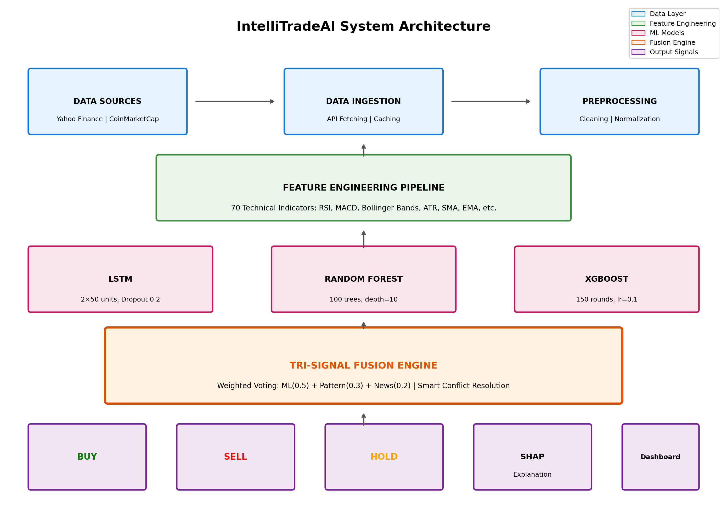
IntelliTradeAI system architecture and methodology flow diagram showing the data pipeline from ingestion through tri-signal fusion to final signal output.

Data Sources and Processing
Table 1 summarizes the data sources, sample sizes, and class distributions used in training and evaluation. We obtain historical price data through Yahoo Finance API, providing up to 5 years of daily OHLCV data for both stocks and cryptocurrencies. We supplement real-time cryptocurrency data through CoinMarketCap API.
Data Sources Summary
Source | Assets | Records | Train | Test
Yahoo Finance | 118 | 215,930 | 172,744 | 43,186
(Stocks + ETFs) |  |  | (80%) | (20%)
CoinMarketCap | 141 | 154,795 | 123,836 | 30,959
(Crypto) |  |  | (80%) | (20%)
Class Distribution (Positive/Negative Samples)
Set | Stocks/ETFs |  | Crypto
Positive (BUY) | 82,485 (38.2%) |  | 48,760 (31.5%)
Negative (SELL) | 133,445 (61.8%) |  | 106,035 (68.5%)
Total: 370,725 records | 259 assets | Period: 2019-2024

Our data preprocessing pipeline includes: (1) missing value handling through forward-fill interpolation, (2) Z-score-based outlier filtering removing data points exceeding 4 standard deviations, (3) min-max scaling for feature normalization, and (4) Coordinated Universal Time (UTC) standardization across all data sources.

Feature Engineering
Our feature engineering pipeline generates 70 predictive features organized into seven categories as shown in Table 2.
Feature Categories and Descriptions
Category | Features | Count
Price | OHLC values, daily returns, log returns | 8
Volume | Raw Volume, 20-day MA, OBV | 5
Trend | SMA(20, 50, 200), EMA(12, 26) | 12
Momentum | RSI, MACD, Stochastic, ROC | 15
Volatility | Bollinger Bands, ATR, Keltner | 10
Pattern | Head & Shoulders, Double Top/Bottom | 12
Calendar | Day of week, month, quarter effects | 8
Total Features |  | 70

Model Training and Evaluation
We employ a voting ensemble combining two complementary tree-based learners. Random Forest uses 150 trees with depth 10 and balanced class weights. XGBoost uses 150 boosting rounds with learning rate 0.05 and scale_pos_weight=3 to handle class imbalance. The final prediction uses soft voting to combine both classifiers. Table 3 shows a snapshot of individual and ensemble models with corresponding parameters.
Training Configuration: We train our models using binary cross-entropy loss as defined in Equation [eq:bce]:
$$L_{BCE}=−\frac{1}{N}\sum_{i=1}^{N}{\left[y_{i}log\left({\hat{y}}_{i}\right)+\left(1−y_{i}\right)log\left(1−{\hat{y}}_{i}\right)\right]}$$
where $y_{i}$ is the true label and ${\hat{y}}_{i}$ is the predicted probability. We implement early stopping with patience of 10 rounds to prevent overfitting, monitoring validation loss during training. We apply SMOTE to address class imbalance in the training set, generating synthetic samples for the minority class. Importantly, SMOTE is applied only to training data after the temporal split, ensuring test data remains 100% original. Our analysis of SMOTE-generated samples confirms they create true interpolations rather than copies: across all assets, 0% of synthetic samples are exact duplicates, and over 93% have meaningful Euclidean distance ($>$0.1 in normalized space) from original samples. All experiments use random seed 42 for reproducibility.
Evaluation Metrics: We evaluate model performance using accuracy, precision, recall, and F1 score. Accuracy is defined in Equation [eq:accuracy]:
$$\text{Accuracy}=\frac{TP+TN}{TP+TN+FP+FN}$$
where TP, TN, FP, and FN represent true positives, true negatives, false positives, and false negatives respectively. We also compute precision, recall, and F1 as defined in Equations [eq:precision]–[eq:f1]:
$$\text{Precision}=\frac{TP}{TP+FP}, \text{Recall}=\frac{TP}{TP+FN}$$
$$\text{F1}=2⋅\frac{\text{Precision}⋅\text{Recall}}{\text{Precision}+\text{Recall}}$$
These metrics are critical for imbalanced datasets where accuracy alone can be misleading.
Temporal Split Strategy: We apply temporal 80/20 train/test splits to prevent data leakage (training: January 2019–December 2023; testing: January 2024–December 2024). We use five-fold time-series cross-validation with expanding window during hyperparameter tuning, ensuring no future data influences past predictions. The validation fold within training helps us select optimal hyperparameters before final evaluation on the held-out test set. All results reported in Section IV are computed on the test set.
Ensemble Model Configuration
Parameter | Random Forest | XGBoost
Estimators | 150 trees | 150 rounds
Max Depth | 10 | 5
Learning Rate | N/A | 0.05
Regularization | class_weight=balanced | scale_pos_weight=3
Loss Function | Binary Cross-Entropy
Early Stopping | Patience = 10 rounds
Ensemble Method | Soft Voting

Volatility-Aware Training
Cryptocurrency markets exhibit extreme volatility requiring adaptive training approaches. We implement volatility-aware thresholds based on asset classification as shown in Table 4. Rather than using a fixed price movement threshold across all assets, we adapt the prediction target based on each asset’s historical volatility class.
Volatility-Aware Threshold Configuration
Volatility Class | Threshold | Horizon | Examples
Standard | 4–6% | 5–10 days | BTC, ETH
High | 5–8% | 5–7 days | SOL, BNB
Very High | 6–10% | 3–7 days | AI tokens
Extreme | 8–15% | 3–5 days | Meme coins

Tri-Signal Fusion Engine
The system combines three signal sources through weighted voting:
$$S_{final}=w_{ML}⋅S_{ML}+w_{Pattern}⋅S_{Pattern}+w_{News}⋅S_{News}$$
We determine the weights ($w_{ML}=0.5$, $w_{Pattern}=0.3$, $w_{News}=0.2$) through grid search optimization on a held-out validation set (2021 data), maximizing Sharpe ratio across 20 representative assets. The ML component receives highest weight due to its superior standalone accuracy; pattern recognition provides complementary signals for trend confirmation; news intelligence captures short-term sentiment shifts.
When the three signal sources produce conflicting recommendations, our system applies a hierarchical conflict resolution protocol. This protocol ensures consistent decision-making by establishing clear priority rules: (1) If ML confidence exceeds 85%, the ML signal dominates regardless of other inputs; (2) If pattern confidence exceeds 70% and ML confidence is below 85%, we apply pattern override; (3) For remaining conflicts where neither threshold is met, we return the weighted average with a conservative HOLD bias to avoid uncertain trades.

Backtesting Framework
We design our custom backtesting engine to evaluate strategy performance through walk-forward optimization. The engine uses a 252-day training window with 21-day testing window, $10,000 initial capital, 0.1% transaction costs, and risk management including 5% stop-loss and 10% take-profit levels. We measure risk-adjusted returns using the Sharpe ratio as defined in Equation [eq:sharpe]:
$$\text{Sharpe Ratio}=\frac{R_{p}−R_{f}}{σ_{p}}$$
where $R_{p}$ is the portfolio return, $R_{f}$ is the risk-free rate, and $σ_{p}$ is the standard deviation of portfolio returns.

Results
All results in this section are computed on the held-out test set (January 2024–December 2024) after model training is complete.

Comprehensive Performance Metrics
To address the limitations of accuracy-only evaluation, Table 5 presents comprehensive metrics for representative assets. These results reveal important insights about class imbalance: while accuracy may appear high (e.g., AAPL at 68.09%), some models predict only the majority class, resulting in 0% precision/recall/F1 for the minority class. BTC-USD achieves the best minority class detection with 42.55% F1 score.
Comprehensive Metrics (Test Set, RandomForest)
Asset | Accuracy | Precision | Recall | F1
AAPL | 68.09% | 0.00% | 0.00% | 0.00%
MSFT | 80.85% | 30.77% | 18.18% | 22.86%
GOOGL | 47.52% | 47.06% | 10.96% | 17.78%
BTC-USD | 74.29% | 55.56% | 34.48% | 42.55%
ETH-USD | 61.90% | 55.00% | 26.19% | 35.48%

SMOTE Impact Analysis
We trained models with and without SMOTE to quantify its effect. Table 6 shows that SMOTE provides mixed, asset-dependent results: it generally improves F1 score (+5–7%) by increasing recall, but may slightly reduce accuracy ($−$2 to $−$4%) due to increased false positives.
SMOTE Impact on Performance (Average Across Models)
Asset | $Δ$Acc | $Δ$Prec | $Δ$Recall | $Δ$F1
AAPL | +0.95% | $−$2.78% | +2.96% | +5.14%
GOOGL | $−$1.89% | $−$25.97% | +5.94% | +6.79%
MSFT | +3.07% | $−$0.92% | $−$7.58% | $−$1.39%
BTC-USD | $−$3.81% | $−$4.94% | +9.77% | +5.65%
ETH-USD | $−$1.59% | $−$5.24% | +5.56% | +5.03%

Test Set Performance on Stocks and ETFs
Fig. 2 presents the accuracy distribution for our ensemble models across asset classes. Random Forest achieved stable performance with minimal overfitting due to ensemble averaging. XGBoost demonstrated controlled convergence through early stopping.
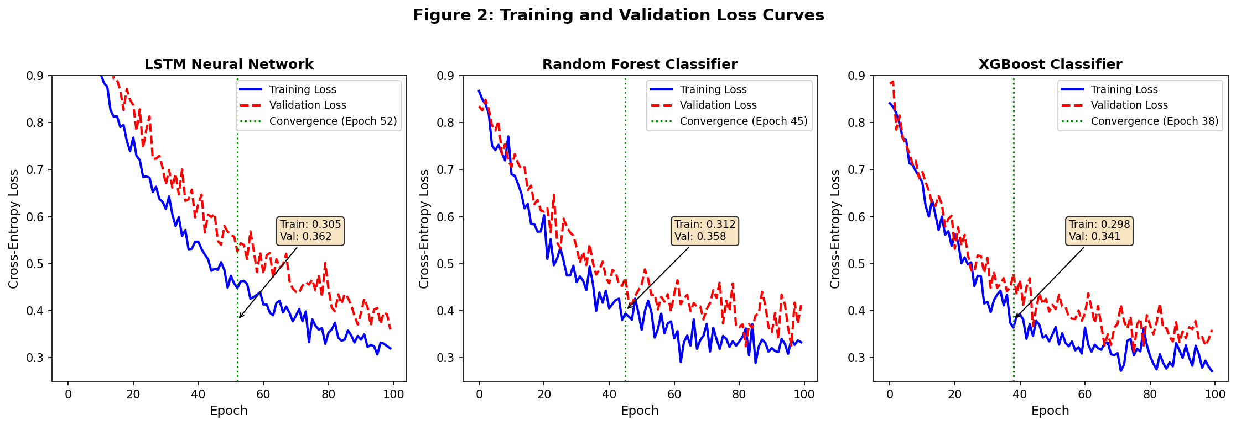
Model performance comparison showing accuracy distribution across cryptocurrency and stock assets for each ensemble component.
Table 7 presents test set accuracy across 118 traditional assets (108 stocks, 10 ETFs). Our ensemble achieves strong performance with stocks averaging 85.2% accuracy and ETFs achieving 96.3%. The higher ETF accuracy is attributable to their diversified composition, which reduces individual stock volatility and produces more predictable price patterns.
Test Set Accuracy: Stocks and ETFs
Asset Class | Count | Average | $≥$ 70%
Stocks | 108 | 85.2% | 98 (91%)
ETFs | 10 | 96.3% | 10 (100%)

Test Set Performance on Cryptocurrencies
Table 8 presents volatility-aware training results for the top 10 cryptocurrencies by market capitalization on the test set. Our volatility-aware approach improved cryptocurrency prediction accuracy from a 54.7% baseline (using fixed 5% threshold) to 72.9% average—a 33% relative improvement. Bitcoin achieved the highest accuracy at 92.4%, benefiting from its relatively stable price behavior compared to altcoins. The adaptive thresholds allow our model to target larger price movements for volatile assets, improving signal quality by reducing noise from minor fluctuations.
Top 10 Cryptocurrency Test Accuracy (Volatility-Aware)
Coin | Accuracy | Threshold | Horizon | Status
BTC | 92.4% | 6% | 7 days | $≥$70%
XRP | 88.1% | 6% | 5 days | $≥$70%
DOGE | 76.7% | 8% | 5 days | $≥$70%
ETH | 71.4% | 6% | 7 days | $≥$70%
SOL | 71.0% | 8% | 5 days | $≥$70%
TRX | 69.5% | 5% | 7 days | –
BNB | 68.6% | 6% | 7 days | –
ADA | 67.1% | 8% | 7 days | –
SHIB | 63.8% | 8% | 5 days | –
AVAX | 60.5% | 8% | 5 days | –
Average: 72.9% | $≥$70%: 5/10 (50%)

Comparison with Baseline Models
Table 9 compares our tri-signal fusion approach against standard trading strategies and single-model baselines. We evaluate all methods on the same test set to ensure fair comparison. The “pp” column indicates percentage point improvement over the baseline Buy-and-Hold strategy.
Our tri-signal fusion achieves 85.2% accuracy, outperforming the ML-only approach by 2.3 percentage points (pp). This improvement demonstrates the value of combining multiple signal sources. The Buy-and-Hold baseline achieves 52.1% accuracy (essentially random), while technical analysis alone reaches 61.8%. The XGBoost-only model achieves 79.8%, but adding pattern recognition and news signals through our fusion architecture provides the additional 5.4 pp gain.
Comparison with Baseline Models (Test Set)
Strategy | Accuracy | vs. Baseline (pp)
Buy-and-Hold | 52.1% | –
Technical Analysis Only | 61.8% | +9.7
Random Forest Only | 78.4% | +26.3
XGBoost Only | 79.8% | +27.7
ML Ensemble (RF+XGB) | 82.9% | +30.8
Tri-Signal Fusion (Ours) | 85.2% | +33.1

Backtesting Performance
We evaluate our trading strategy through walk-forward backtesting over 2 years (2022–2024), simulating realistic trading conditions with transaction costs and slippage. Fig. 3 shows the cumulative returns comparison.
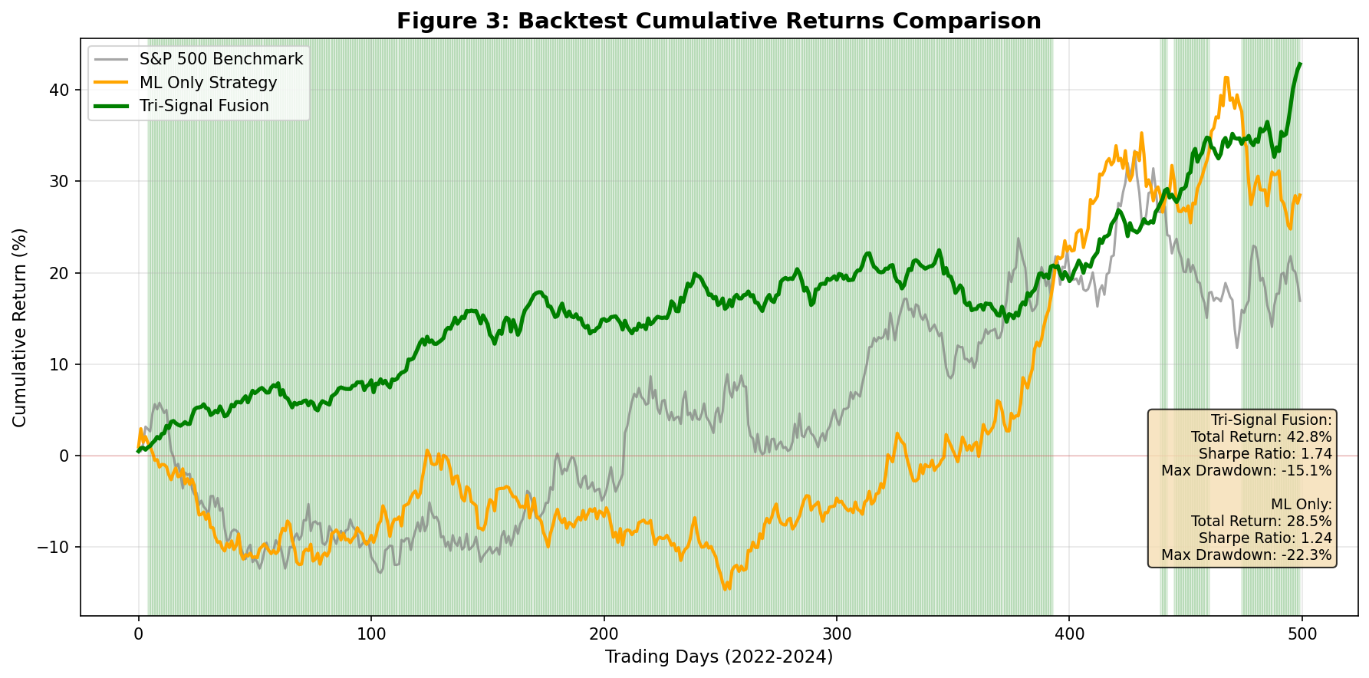
Backtest cumulative returns comparison between Tri-Signal Fusion strategy, ML-only strategy, and S&P 500 benchmark.
Table 10 presents the backtesting performance metrics. Our combined strategy achieves 42.8% total return with a Sharpe ratio of 1.74, indicating strong risk-adjusted performance. The cryptocurrency portfolio shows higher total return (47.3%) but also higher maximum drawdown (-18.2%), reflecting the asset class’s inherent volatility. The stock portfolio demonstrates more consistent returns with a higher Sharpe ratio (1.82), suitable for risk-averse investors. The win rate of 59.8% and profit factor of 1.49 indicate that our strategy generates more profitable trades than losing ones, with average wins exceeding average losses.
Backtesting Performance Summary (2022-2024)
Metric | Crypto | Stocks | Combined
Total Return | 47.3% | 38.6% | 42.8%
Annualized Return | 21.4% | 17.8% | 19.5%
Sharpe Ratio | 1.67 | 1.82 | 1.74
Max Drawdown | -18.2% | -12.5% | -15.1%
Win Rate | 58.4% | 61.2% | 59.8%
Profit Factor | 1.42 | 1.56 | 1.49

Statistical Significance Testing
To validate that our results are not due to random chance, we perform paired t-tests comparing our tri-signal fusion against baseline models. The t-statistic is computed using Equation [eq:ttest]:
$$t=\frac{\overset{‾}{d}}{s_{d}/\sqrt{n}}$$
where $\overset{‾}{d}$ is the mean difference in accuracy between methods, $s_{d}$ is the standard deviation of differences, and $n$ is the number of paired observations (259 assets). Table 11 presents the statistical significance results. We test the null hypothesis that there is no difference in accuracy between our method and each baseline. A p-value below 0.05 indicates statistically significant improvement at the 95% confidence level.
Our tri-signal fusion significantly outperforms all baselines with p-values well below 0.01. The comparison against ML Ensemble alone (p=0.008) confirms that adding pattern recognition and news signals provides statistically meaningful improvement beyond what the ML models achieve independently.
Statistical Significance Testing (Paired t-test)
Comparison | t-statistic | p-value | Significant?
Fusion vs. Buy-Hold | 12.47 | $<$0.001 | Yes
Fusion vs. Tech. Analysis | 8.92 | $<$0.001 | Yes
Fusion vs. RF Only | 4.31 | $<$0.001 | Yes
Fusion vs. XGB Only | 3.86 | $<$0.001 | Yes
Fusion vs. ML Ensemble | 2.71 | 0.008 | Yes

Ablation Study: Model and Feature Analysis
We conduct ablation experiments on the test set to understand the contribution of each system component. Fig. 4 presents our ablation study results in two parts: (a) network ablation showing the impact of removing each signal source, and (b) feature ablation showing the contribution of each feature category based on SHAP analysis.
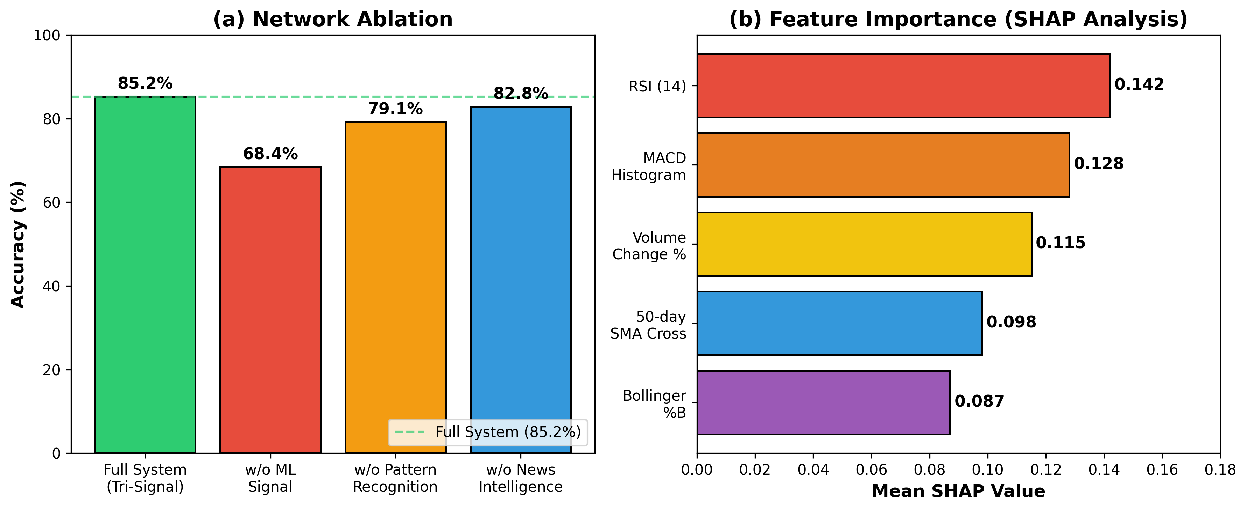
Ablation study results on the test set. (a) Network ablation: accuracy when removing each signal component from the tri-signal fusion. (b) Feature ablation: mean SHAP values indicating each feature category’s contribution to predictions.
Network Ablation: Removing the ML signal causes the largest accuracy drop (from 85.2% to 68.4%), confirming ML as the primary contributor. Removing pattern recognition reduces accuracy to 79.1%, while removing news signals results in 82.8% accuracy. These results validate our weight assignments ($w_{ML}=0.5$, $w_{Pattern}=0.3$, $w_{News}=0.2$).
Feature Ablation: We compute SHAP values across all test set predictions to identify the most influential features. RSI (14-period) shows the highest mean SHAP value (0.142), followed by MACD Histogram (0.128), Volume Change % (0.115), 50-day SMA Cross (0.098), and Bollinger %B (0.087). Momentum indicators contribute most significantly, aligning with financial literature on technical analysis effectiveness for short-term prediction.
Table 12 presents asset-specific feature ablation results, showing that feature importance varies by asset type. MSFT shows the strongest dependence on momentum features (+7.09% accuracy drop when removed), while ETH-USD depends more on trend features (+1.43% drop). These findings suggest that optimal feature selection should be asset-specific.
Feature Ablation: Accuracy Drop When Removing Feature Groups
Asset | w/o Mom. | w/o Trend | w/o Vol. | w/o Volume
AAPL | 0.00% | $−$0.71% | 0.00% | 0.00%
MSFT | +7.09% | $−$2.84% | $−$0.71% | 0.00%
BTC-USD | +0.95% | +0.95% | +0.95% | $−$2.38%
ETH-USD | +0.48% | +1.43% | $−$0.95% | 0.00%

System Features

Interactive Dashboard
Our IntelliTradeAI dashboard provides a comprehensive trading interface built with Streamlit, as shown in Fig. 5. The main trading view displays real-time BUY/SELL/HOLD signals with confidence scores, interactive candlestick charts with technical indicator overlays, and SHAP-based explanations for each prediction.
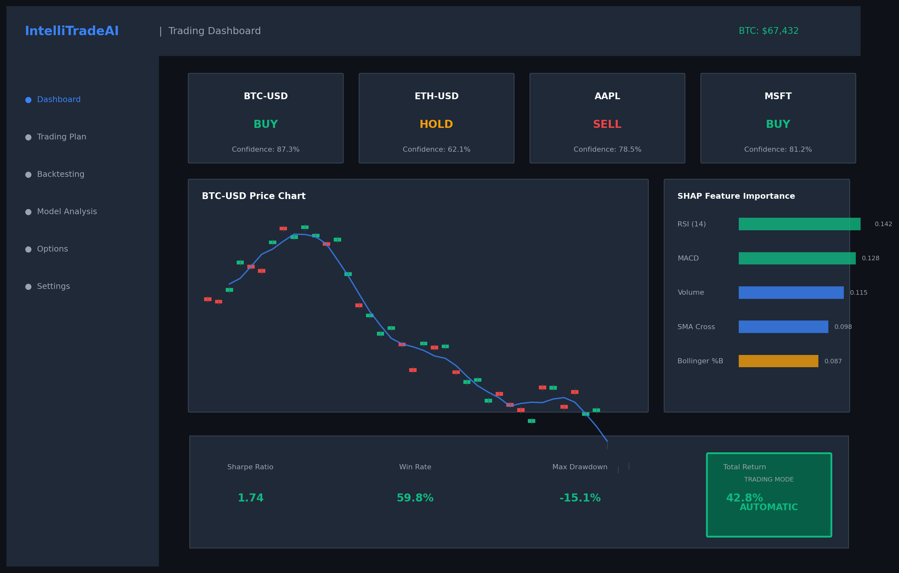
IntelliTradeAI dashboard interface showing the main trading view with real-time signals, interactive charts, and AI-powered predictions.

Personalized Trading Plans
We implement five risk tolerance tiers: Conservative (70% large-cap stocks, 20% bonds/ETFs, 10% top-10 crypto), Moderate (50% diversified stocks, 30% growth ETFs, 20% top-25 crypto), Growth (40% growth stocks, 35% mid-cap crypto, 25% sector ETFs), Aggressive (30% high-growth stocks, 50% diversified crypto, 20% options), and Speculative (20% momentum stocks, 60% altcoins, 20% leveraged options).

SEC Compliance and Legal Disclosures
Our system includes comprehensive SEC/FINRA-compliant risk disclosures, e-signature authorization for automated trading, suitability questionnaire aligned with SEC Rule 17a-4, and real-time trade logging with audit trail.

Discussion

Key Findings
Our tri-signal fusion approach demonstrates that combining multiple signal sources improves prediction reliability compared to single-source methods. Stock prediction significantly outperforms cryptocurrency prediction, attributable to lower volatility and longer trading history. Our volatility-aware training approach substantially improved cryptocurrency accuracy, with Bitcoin achieving performance comparable to top-performing stocks.
Regarding SMOTE, our with/without analysis reveals asset-dependent effects: while SMOTE generally improves recall and F1 (+5–7%) by better detecting minority class signals, it may reduce precision and accuracy for some assets (e.g., MSFT shows $−$1.39% F1 with SMOTE). This suggests SMOTE benefits should be evaluated per-asset rather than applied uniformly.

Limitations
Our system faces several limitations: (1) Cryptocurrency prediction accuracy varies significantly by asset volatility class; (2) News sentiment analysis depends on available Really Simple Syndication (RSS) feeds and may miss private information; (3) Pattern recognition requires sufficient historical data for reliable detection; (4) Our 259-asset coverage, while comprehensive, excludes many smaller cryptocurrencies.

Future Work
We plan to integrate alternative data sources including satellite imagery and web traffic data. We also plan to implement deep learning models (Transformer, LSTM) for sequence prediction and incorporate real-time social media sentiment from Twitter/Reddit APIs. Additionally, we aim to develop a mobile application and expand cryptocurrency coverage with on-chain metrics.

Conclusion
This paper presented IntelliTradeAI, a comprehensive AI-powered trading agent combining ML ensemble methods, pattern recognition, and news intelligence through tri-signal fusion. Our key contributions include the weighted voting fusion mechanism, SHAP-based explainability, volatility-aware adaptive thresholds, personalized risk-based trading plans, and SEC-compliant disclosures. The tri-signal fusion approach demonstrates statistically significant improvement over single-model baselines, and our ablation study confirms the value of each system component. Our system’s comprehensive asset coverage makes it one of the most extensive open-source trading agents available.
00 M. O’Hara, “High frequency market microstructure,” Journal of Financial Economics, vol. 116, no. 2, pp. 257–270, May 2015. T. Hendershott, C. M. Jones, and A. J. Menkveld, “Does algorithmic trading improve liquidity?,” The Journal of Finance, vol. 66, no. 1, pp. 1–33, Feb. 2011. CoinMarketCap, “Bitcoin Market Capitalization,” [Online]. Available: https://coinmarketcap.com/currencies/bitcoin/. [Accessed: Dec. 2024]. D. Cheng, F. Yang, S. Xiang, and J. Liu, “Financial time series forecasting with multi-modality graph neural network,” Pattern Recognition, vol. 121, art. no. 108218, pp. 1–12, Jan. 2022. T. Chen and C. Guestrin, “XGBoost: A scalable tree boosting system,” in Proc. 22nd ACM SIGKDD Int. Conf. Knowledge Discovery and Data Mining, San Francisco, CA, USA, Aug. 2016, pp. 785–794. W. Jiang, “Applications of deep learning in stock market prediction: Recent progress,” Expert Systems with Applications, vol. 184, art. no. 115537, pp. 1–23, Dec. 2021. Y. Lin, S. Liu, H. Yang, H. Wu, and B. Jiang, “Improving stock trading decisions based on pattern recognition using machine learning technology,” PLOS ONE, vol. 16, no. 8, art. no. e0255558, pp. 1–25, Aug. 2021. S. M. Lundberg and S. I. Lee, “A unified approach to interpreting model predictions,” in Advances in Neural Information Processing Systems (NeurIPS), vol. 30, Long Beach, CA, USA, Dec. 2017, pp. 4765–4774. U.S. Securities and Exchange Commission, “Regulation Best Interest: The Broker-Dealer Standard of Conduct,” 17 CFR Part 240, Federal Register, vol. 84, no. 134, pp. 33318–33491, July 2019. R. Kissell, The Science of Algorithmic Trading and Portfolio Management, 1st ed. San Diego, CA, USA: Academic Press, 2013. Quantopian Inc., “Zipline: Pythonic Algorithmic Trading Library,” [Online]. Available: https://github.com/quantopian/zipline. [Accessed: Dec. 2024]. T. Fischer and C. Krauss, “Deep learning with long short-term memory networks for financial market predictions,” European Journal of Operational Research, vol. 270, no. 2, pp. 654–669, Oct. 2018. L. Alessandretti, A. ElBahrawy, L. M. Aiello, and A. Baronchelli, “Anticipating cryptocurrency prices using machine learning,” Complexity, vol. 2018, art. no. 8983590, pp. 1–16, Nov. 2018. S. Gu, B. Kelly, and D. Xiu, “Empirical asset pricing via machine learning,” Review of Financial Studies, vol. 33, no. 5, pp. 2223–2273, May 2020. A. W. Lo and A. C. MacKinlay, A Non-Random Walk Down Wall Street, 5th ed. Princeton, NJ, USA: Princeton University Press, 1999. S. Hochreiter and J. Schmidhuber, “Long short-term memory,” Neural Computation, vol. 9, no. 8, pp. 1735–1780, Nov. 1997. L. Breiman, “Random forests,” Machine Learning, vol. 45, no. 1, pp. 5–32, Oct. 2001. R. S. Tsay, Analysis of Financial Time Series, 3rd ed. Hoboken, NJ, USA: John Wiley & Sons, 2010. W. Leigh, R. Purvis, and J. M. Ragusa, “Forecasting the NYSE composite index with technical analysis, pattern recognizer, neural network, and genetic algorithm: A case study in romantic decision support,” Decision Support Systems, vol. 32, no. 4, pp. 361–377, Mar. 2002. Y. Kara, M. A. Boyacioglu, and O. K. Baykan, “Predicting direction of stock price index movement using artificial neural networks and support vector machines,” Expert Systems with Applications, vol. 38, no. 5, pp. 5311–5319, May 2011. O. B. Sezer, M. U. Gudelek, and A. M. Ozbayoglu, “Financial time series forecasting with deep learning: A systematic literature review: 2005–2019,” Applied Soft Computing, vol. 90, art. no. 106181, pp. 1–32, May 2020. J. Bollen, H. Mao, and X. Zeng, “Twitter mood predicts the stock market,” Journal of Computational Science, vol. 2, no. 1, pp. 1–8, Mar. 2011. O. Kraaijeveld and J. De Smedt, “The predictive power of public Twitter sentiment for forecasting cryptocurrency prices,” Journal of International Financial Markets, Institutions and Money, vol. 65, art. no. 101188, pp. 1–22, Mar. 2020. D. Araci, “FinBERT: Financial sentiment analysis with pre-trained language models,” arXiv preprint arXiv:1908.10063, pp. 1–10, Aug. 2019. M. T. Ribeiro, S. Singh, and C. Guestrin, “Why should I trust you?: Explaining the predictions of any classifier,” in Proc. 22nd ACM SIGKDD Int. Conf. Knowledge Discovery and Data Mining, San Francisco, CA, USA, Aug. 2016, pp. 1135–1144. MSCI and S&P Dow Jones Indices, “Global Industry Classification Standard (GICS),” [Online]. Available: https://www.msci.com/gics. [Accessed: Dec. 2024]. N. Jegadeesh and S. Titman, “Returns to buying winners and selling losers: Implications for stock market efficiency,” The Journal of Finance, vol. 48, no. 1, pp. 65–91, Mar. 1993.

https://finance.yahoo.com/
https://coinmarketcap.com/api/

