Homework 2

Name______________

**Problem 1**:

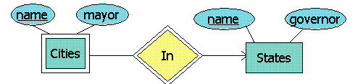

Which of the following is necessarily true about the City and State entity sets and their relationship In? (**Single Choice**)

a) No person can be the mayor of Cities In two different States.

b) No person can be the mayor of two different cities.

c) No two States can have governors with the same name.

d) No two Cities In the same State can have the same name

**Problem 2**: Suppose we want to design a registrar's database to store information about students, courses, the courses students have taken, and the grades students have gotten in these courses. Courses have a number, a major, and a title, for example, "CS317: Files and Database Systems" has major = CS, number = 317, and title = "Files and Database Systems." Numbers are assigned by majors, and different majors may use the same number. Major has attributes name and department. Students are represented by their (unique) student ID, and have first name and last name in the database. "Enrollments" can be a relationship that consist of a course, a student who took that course, and the grade the student got in the course.

2.1 Draw the E/R diagram that represents this database structure correctly. You should select appropriate key for each entity set. Weak entity set shall be used when necessary.

2.2 Indicate which of the following might be found in a correct E/R diagram. (**Single Choice**)

a) Entity set Students with attribute ID not underlined and name underlined.

b) Entity set Courses is a weak entity set.

c) Entity set Courses with attribute major underlined and attributes number and title not underlined.

d) Entity set Students with attributes ID and name underlined.

2.3 Convert the E/R diagram in problem 2 to relations. Denote your relations with relation schemas.