1. D
2. Registrar Database:

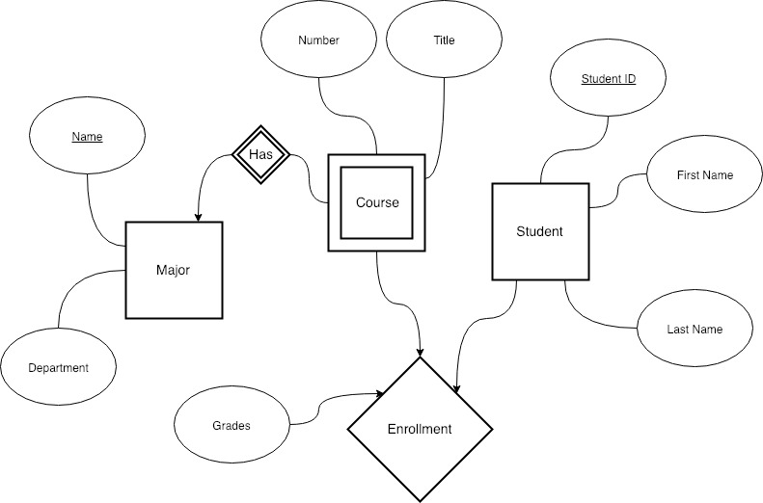

* 1. B
  2. Enrollment(Student_ID, FirstName, LastName, Grade, Course)

Course(Number, Title, Name)