INF3500_C1
Conception Web 1

Devoir prepare par:

NOM:CESAR
PRENOM: Djelissa

- Capture de test html
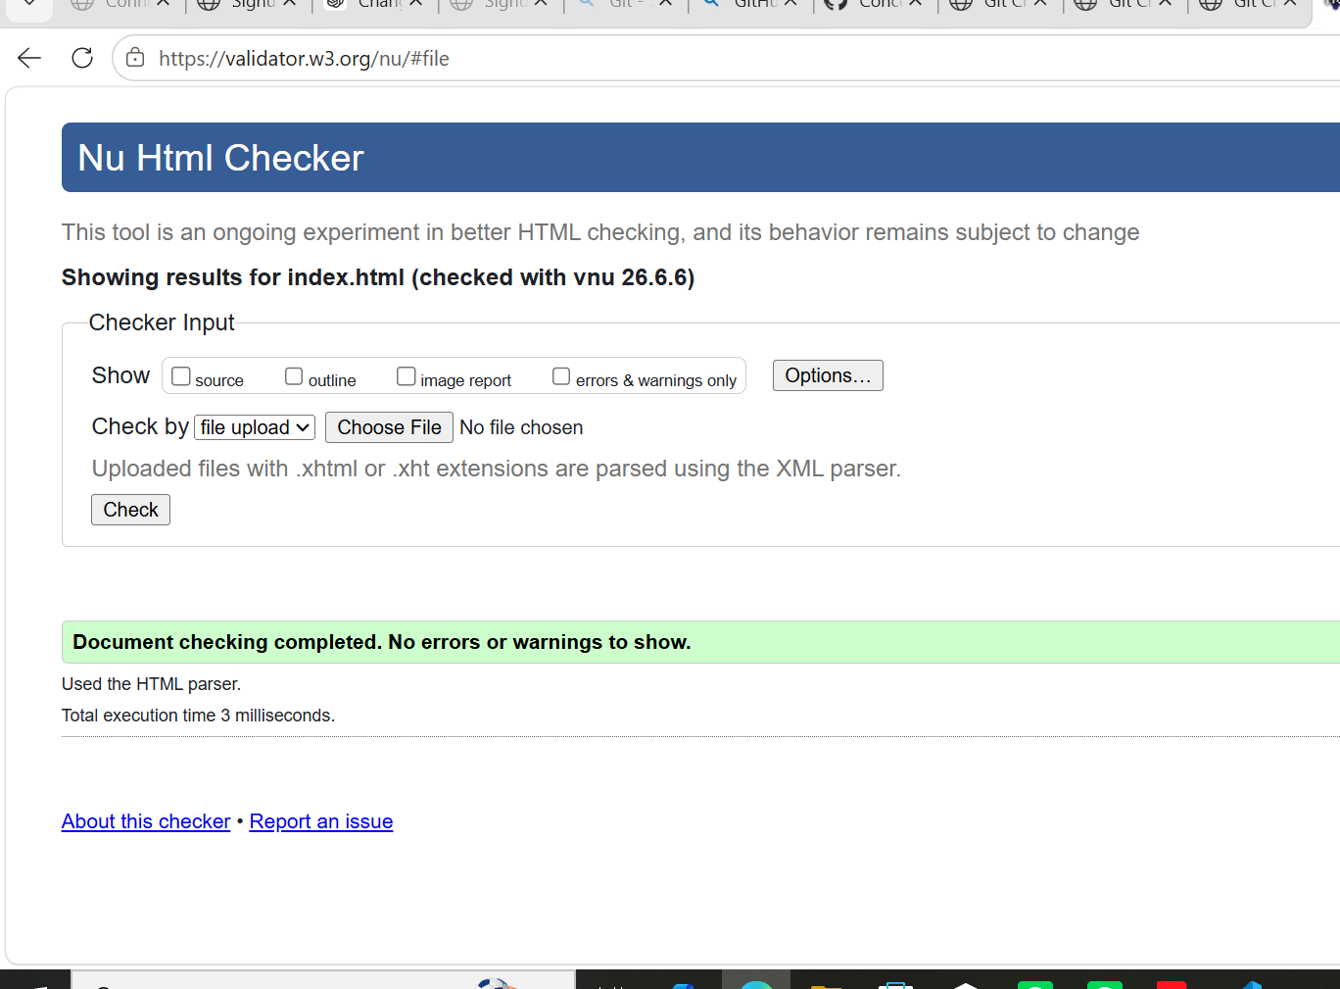

- Capture de test css
