

Salix Live
Startup Guide

The purpose of this manual is to help users easily install Salix Live.

Table of Contents
1. Salix Features 3
2. Installation Mode 3
3. Salix Repositories & Package Management 4
4. Install Salix 4
Requirements 4
Boot from DVD 4
Boot from USB flash drive 4
5. Prepare to install Salix 6
5.1 How to install Salix on computer with UEFI 6
5.2 Installation complete 12
6. How to install Salix to a USB stick 12
6.1 Using the Salix Live Installer (sli) 12
6.2 Using the instonusb gui tool. 13
7. Multibootusb tool 15
8. Install – upgrade kernel on internal disks. 18
9. Install – upgrade kernel on external ssd disk or USB stick. 19
10. Finding help 20

Salix Features
- One application per task rationale
- Fully backwards compatible with Slackware
- Optimized for desktop usage
- With Salix and Salix tools to assist system management
- High quality package repositories with dependency support

Installation Mode

Salix offers three software installation options:
- Full,
- Basic
- Core, to meet your demands!
Performing a Full mode installation is the recommended way of installing Salix for most users. It includes a fully configured desktop environment with a complete selection of applications to fit the needs of most people, including office related software, multimedia applications, Internet applications, all the Salix system configuration tools and more. We feel that the collection of software that accompanies each respective desktop environment will cover most user's needs but, of course, any user can tailor the software selection through the Salix package management tools as required.
A Basic mode installation is mostly targeted at advanced users. It includes the respective desktop environment of each edition, and a very minimal selection of software on top, namely the Salix system configuration tools and a web browser. WiFi connection tools or drivers are not present and only wired network connections are supported out of the box. The user is expected to know how to install extra software and tailor the installation to his/her needs.
A Core mode installation does not provide any graphical environment. It only installs a command line system, including the Salix command line system and package management tools. It is intended for expert users who know how to use the command line tools to administer their systems. It is most commonly used to set up types of server such as web-servers and e-mail servers. The servers that host the Salix websites are hosted on, run Salix installed using the Core mode method. Expert users can of course use this mode to install the X window system and any graphical environment on top of it if desired.

Salix Repositories & Package Management

- slapt-get and its graphical interface Gslapt are used for package management, including slapt-src and Sourcery for even wider selection of software to choose from!
- A wide range of packages from Slackware, Slackbuild and Salix repositories
- The Salix repositories offer dependency resolution support and are the largest third party software package repositories for Slackware offered to date
- The Salix repositories are offered for both the 32-bit and 64-bit architectures

Install Salix

Requirements
You'll need to consider the following before starting the installation:
- Connect your laptop to a power source.
- Ensure you have at least 25GB of free storage space, or 5GB for a minimal installation.
- Have access to either a DVD or a USB flash drive containing the version of Salix you want to install.
- Make sure you have a recent backup of your data. While it's unlikely that anything will go wrong, you can never be too prepared.

Boot from DVD
It's easy to install Salix from a DVD. Here's what you need to do:
- Burn the Salix iso image to a DVD
- Put the Salix DVD into your optical/DVD drive.
- Restart your computer.

Boot from USB flash drive
After downloading the Salix ISO, you need to create a bootable USB to install from it.
There's many way to do that, in windows 10, you can use the Rufus USB creator, which exists in iso in boot folder to transfer the iso to a USB stick under windows system. Be sure to name the usb label "LIVE" without quotes.
Also can download Rufus from here.
If you run another linux distribution can use Unetbootin to create a bootable USB. In this case the usb label has to be named LIVE. If it is named differently then booting from usb has to pass the parameter medialabel=your_usb_label_name. To do this press Tab and type in the end for example for a usb named myusb type medialabel=myusb
You can also use the script install_on_usb.sh existed in iso in boot folder to create the usb in any distribution. Read the respective instructions in this file: README_INSTALL_ON_USB.TXT
You can also boot with Salix DVD and run the instonusb gui tool developed in house to create a Salix live bootable USB.
Most computers will boot from USB automatically. Simply insert the USB flash drive and either power on your computer or restart it. You should see the same welcome window we saw in the previous ‘Install from DVD' step, prompting you to choose your language and either install or try the Salix desktop.
If your computer doesn't automatically boot from USB, try holding F12 when your computer first starts. With most machines, this will allow you to select the USB device from a system-specific boot menu.

F12 is the most common key for bringing up your system's boot menu, but Escape, F2 and F10 are common alternatives. If you're unsure, look for a brief message when your system starts - this will often inform you of which key to press to bring up the boot menu.

Prepare to install Salix

5.1 How to install Salix on computer with UEFI

Some Information:
You can install salix on internal ssd disk or external ssd disk or to a usb stick.
If you have created a live usb to boot system for installation then while on live environment, you need to plug in another usb or ssd disk for installation. Procedure is the same. In case of installing to an external ssd or usb an initrd image will be created needed to boot the system.

- Unified Extensible Firmware Interface (UEFI) is a modern replacement over the BIOS for booting up operating systems. In most BIOS settings, you can choose whether you want UEFI enabled or disabled.
- If you are only installing Salix on a computer or you have Windows 7 or older on it then you can disable UEFI in the BIOS settings and proceed to install Salix with a / partition and a swap partition.
- However, if you already have Windows 8 or 10 installed on the computer, it will be using UEFI to boot and so UEFI cannot be disabled. Also, if you intend to install and dual boot with Windows in the future, it may be a good idea to keep UEFI enabled.
- If you do not have Windows, but want to keep UEFI enabled, then you will need to create a 300-500MB partition and pick its type as boot EFI while installing Salix. The rest of the partitions for Salix are the same. Just remember to create an EFI partition.
- If you forgot to create an EFI partition on a UEFI enabled computer and installed Salix, then the installer will fail at the end.

Run the installer from Desktop or from "System" -> "Salix live installation"
IMPORTANT NOTICE: You will be asked for user one password. Type one for password.

First click on "Partitions" button in the Salix Live Installer (SLI) and gparted will appeared. Then there are two options:
If your computer supports UEFI then:
- create a gpt partition table. Select your hard-disk in case your machine has more than one disks, hit New Partition Table button and click on msdos and change it to gpt in order to create the GPT partition table.
- create a 300 - 500 MB VFAT (fat32) partition and signed bootable (esp, boot) (EF00)
- create a Linux EXT4 partition to hold the system (/)
- Optional create another Linux EXT4 partition to hold the /home
- Finally create a swap – 4098MB (or 2*RAM)
- Optionally, to enable BIOS / legacy boot, an additional BIOS boot partition (EF02) and an hybrid MBR are required before installing GRUB. Create a vfat (fat32) 34MB partition and signed bios_grub (EF02)
- All partitions should be Primary
If your computer does not support UEFI then:
- create a MSDOS partition table
- create a Linux EXT4 partition to hold the system
- Optional create another Linux EXT4 partition to hold the /home
- Finally create a swap – 4098MB (or 2*RAM)
Close the gparted tool and return to SLI
Click in the combo box "Install Location" and pick up your root partition (/). Usually first partition (/dev/sda1) is the EFI partition. So the second partition created above it will be ( /dev/sda2). In a non UEFI computer you have to pick up /dev/sda1 for root (/) partition.
Next pick up the third partition (/dev/sda3) for /home partition which created above.
If your computer has other OS installed and has grub installed and you like to boot to your other OS later to run grub-update so Salix will shown in grub and can boot then do not check "Install Grub". Do not check "Install Lilo". In this case no boot loader will be installed.
If you have created a /home partition, check "Format Home" if want /home partition to be formatted. Otherwise do not check it.

Choose the file system type. EXT4 is the default.
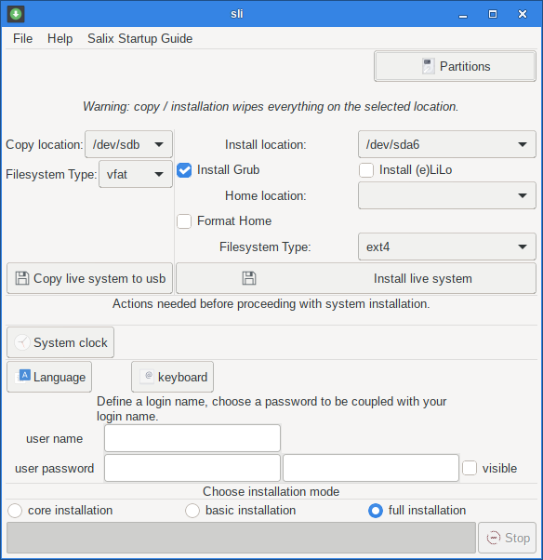

Click on "System clock". In next window check "keep clock synchronized with Internet servers". click on OK button

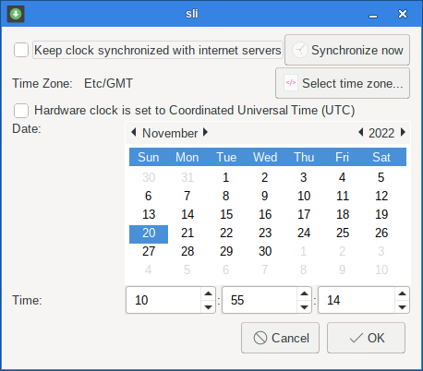

Click on "Language" button and in next window choose you system locale. click on OK button.
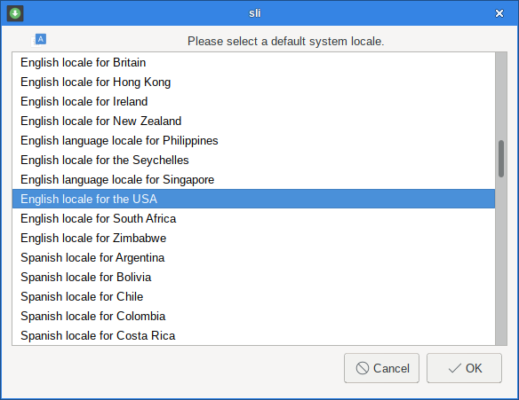

click on "keyboard" button and in next window choose your "keyboard type" and your "keyboard map". Click on OK button.
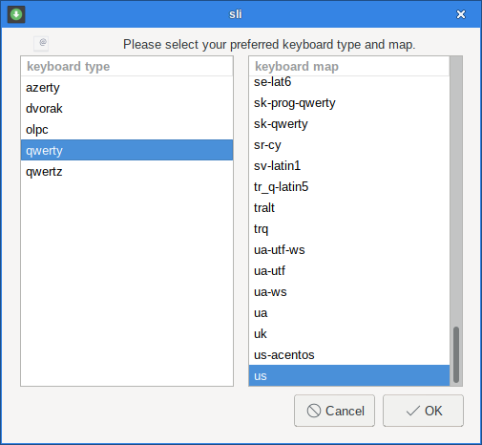

Type your "user name" and user password twice. Click on visible check button so user password shown.
choose your "installation mode". "full installation" is the default.
Finally click on "Install live system" button to begin the installation in hard disk.
The installer will now complete in the background. Installation should only take a few minutes.
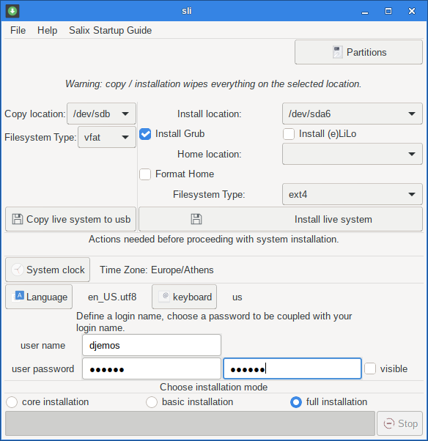

5.2 Installation complete
After everything has been installed and configured, a small window will appear telling you installation is complete.
Close the Salix live installer and reboot your computer.
Congratulations! You have successfully installed Salix Linux operating system!
It's now time to start enjoying Salix!

6. How to install Salix to a USB stick

6.1 Using the Salix Live Installer (sli)
If you want to install the system in a USB as frugal installation then plug in your USB stick in your computer and pick up your USB from "Copy location:" combo box. USB will be shown as /dev/sdb1 or /dev/sdc1 etc
Choose the Filesystem Type USB stick will be formatted. VFAT is the default. IMPORTANT: USB stick will be formatted and signed bootable and all previous existed data will be lost.

Then click on "Copy live system to usb" button to begin the installation on USB.
If you use SLI to create a Salix Live USB then you cannot create later a persistent file or directory to keep your changes in USB e.g. installing new applications.

6.2 Using the instonusb gui tool.
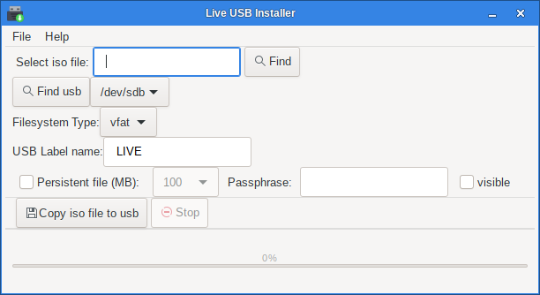

instonusb is a gui tool written in c to install Salix, Salix 32 and 64 bit live iso's to usb stick. Can also create an encrypted persistent file.
package (binary and source code) can be found on Salix repositories or can download it from here

If you want a persistent file then can use instonusb gui tool.
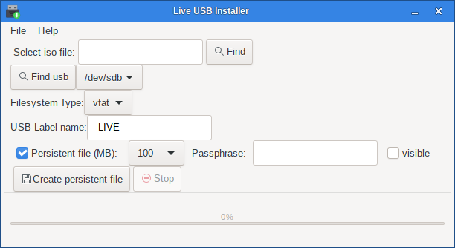
- Plug in your USB.
- Click on "System" -> "Install live iso to usb".
- Click on "Find" button and choose your location where Salix iso is downloaded in your hard disk.
- Click on "Find usb" to find your USB in case you plug it after running the instonusb gui tool.
- USB label is set to LIVE so Salix can be found and boot.
- click on "Copy live iso to usb" to begin the installation.

After installation complete, its time to create the persistent file
- check "persistent file"
- choose persistent file size in MB (for vfat choose from 100 MB to 3998 MB, for ext3 choose from 100MB to 14436 MB.
- Optional can type the passphrase to encrypt your persistent file.
- Click on visible check button to see your passphrase"
- click on "Create persistent file" to create your persistent file. Note that if persistent size is big the creation will take a long time. so make a coffee.

Suggestion. I usually format the usb stick to VFAT and create a 3998 (4GB, cannot be more because of vfat) so can use the left space in a 14 GB usb to store other data and also can use the usb as a common usb in any pc.
If you format the usb in EXT3 then the persistent file can be as big you like 14GB or more.
If you format the usb in ext3 there is another option. You do not have to create a persistent file but booting from usb with option "Salix Live [persistent]" from menus, then a directory named persistent (default) will be created where you can keep your changes between reboots. All USB remaining size will be used.
Note: Using a directory for persistent changes cannot use encryption.
Attention: Never create the folder by hand (persistence will not work).

7. Multibootusb tool
multibootusb is a gui tool written in c to create a live usb including 32 and 64 bit live editions of Salix and salix and at boot time to choose the one to boot in live environment. This tool cannot be used to boot other distro's. It has been written for Salix, salix live iso editions.
How to use:
Download the Salix, salix iso 32 and 64 bit editions.
Create a folder and move all images in the folder. Plug in your usb. Then run multibootusb clicking on "Find" button and choose the folder where the images exist
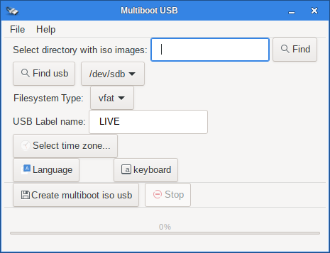

choose your time zone to boot the live isos
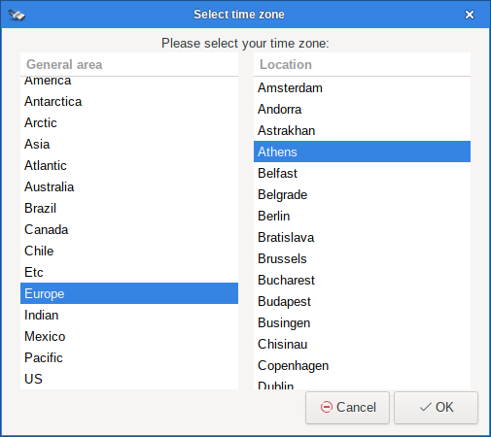

choose your language locale to boot the live isos
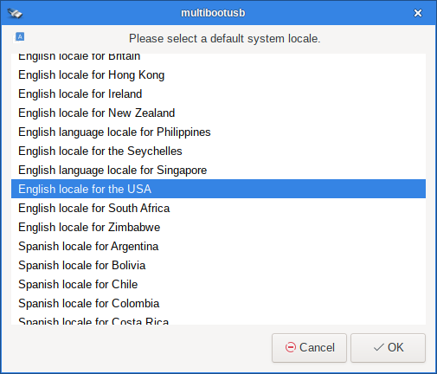

choose your keyboard type and keyboard map to boot the live isos
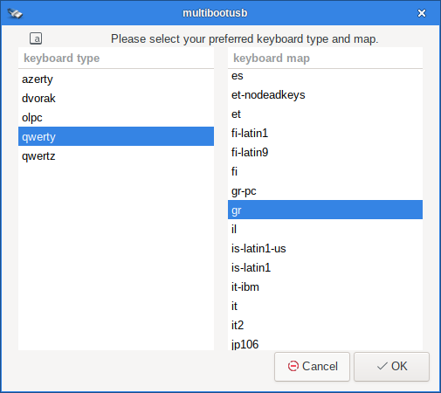

and click on OK button to create the multibootusb.
Then boot and pick up from the menus the iso you like to boot.
source and binaries

8. Install – upgrade kernel on internal disks.
install-upgrade-kernel-gtk is a gui tool of the script that make easy to install kernel packages without removing the previous kernel packages and upgrading grub menus boot loader. It is written in C using glade and gtk2.
It is used for installations of Salix on internal disks.
install-upgrade-kernel-gtk can be used on any slackware or slackware based system.
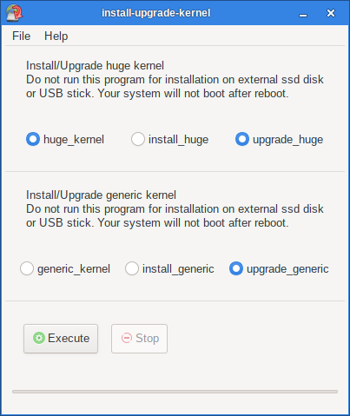

9. Install – upgrade kernel on external ssd disk or USB stick.
install-upgrade-kernel-ext-usb is a script that make easy to install kernel packages without removing the previous kernel packages and upgrading grub menus boot loader. It is written in c using glade and gtk2.
It is used for installations of Salix on external SSD disks or USB sticks.
install-upgrade-kernel-ext-usb-gtk can be used on any slackware or slackware based system.
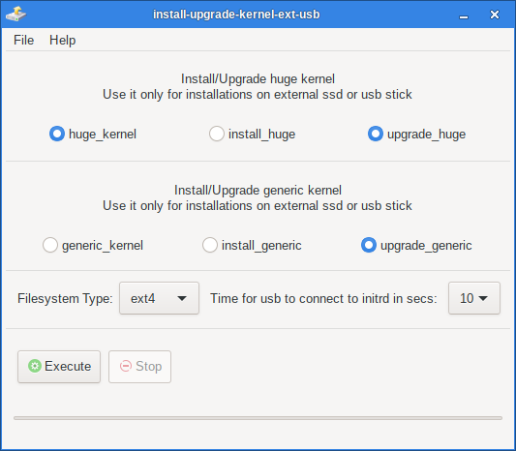

10. Finding help
If you get stuck, help is always at hand.
- Ask in Salix forum
- Wiki
- Documentation

Standard user login is “one” with password: "one" (no quotation marks).
For installation and for all work required administration privileges the super user "one" with password "one" is used.

