Case 1: Sales Performance Analysis
Company Background
TechSupply Co. is a regional distributor that sells electronics, office supplies, and office furniture to both retail and business customers. Management wants to better understand sales trends, customer purchasing behavior, and regional performance to improve future sales strategies.
You have been hired as a junior data analyst to explore the sales dataset and provide insights. Your task is to use Excel filtering and sorting tools to answer business questions and provide recommendations.
Dataset: use the techsupply_dataset.xlsx
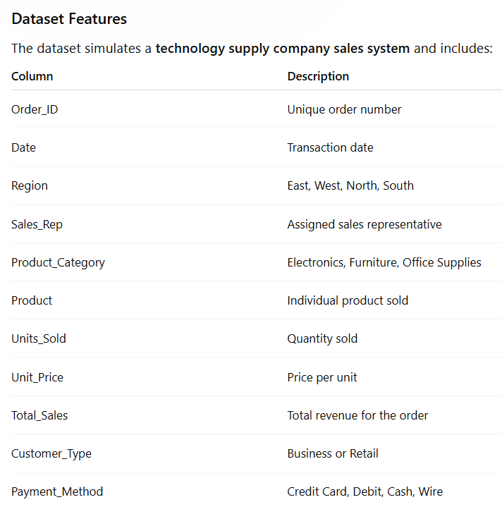

Complete the following 5 tasks.
REGIONAL PERFORMANCE ANALYSIS
Task 1: Use filters to explore sales by region.
- Filter by Region = East
- Sort Total_Sales from Largest to Smallest
Questions:
- What is the largest sale in the East region?
52 950
- Which product category appears most frequently?
Electronics
- Which sales representative appears most often?
Brown and Johnson.
CUSTOMER BEHAVIOR ANALYSIS
Task 2: Filter by
- Customer_Type = Business
Questions
- Which product category do business customers purchase most often?
Office Supplies
- What is the largest business transaction?
63 646.2
- Which sales rep handles the most business orders?
Brown and Garcia.
PRODUCT PERFORMANCE
Task 3: Use filters to analyze Product_Category.
Analyze each category separately:
- Electronics
- Furniture
- Office Supplies
Questions
- Which category appears to generate the highest total sales?
Electronics
- Which specific product appears most frequently?
Filing Cabinet, Notebooks and Printer Paper.
- Which category tends to have the largest individual transactions?
Office Supplies
PAYMENT PATTERN ANALYSIS
Task 4: Filter by Payment_Method
Analyze:
- Credit Card
- Debit
- Cash
- Wire
Questions
- Which payment method is used most frequently?
Credit card
- Do business customers prefer a specific payment type?
Debit
- Which payment type is associated with larger purchases?
Wire
TOP SALES REPRESENTATIVES
Task 5: Sort by:
- Sales_Rep
- Total_Sales(Largset > Smallest)
Questions
- Which sales rep appears to handle high-value transactions?
Gracia
- Which rep appears most frequently in the dataset?
Brown
- Which region do they appear to sell in most often?
East
ANALYST RECOMMENDATION
Imagine you are presenting your findings to management.
Answer the following:
- Which region appears to be the strongest market?
East, because it is the region with the highest recorded transactions, and it generates the highest total sales.
- Which product category should the company promote more?
The company should promote Electronics more because it has the lowest number of sales. However, the differences between the categories are relatively small.

- Are business customers or retail customers more valuable?
Although business customers account for more transactions, retail customers are more valuable because they generate higher total sales ($1,101,169.19) than business customers ($1,063,718.90), a difference of $37,450.29.

- What two recommendations would you give the sales manager?
- The sales manager should focus more on business customers, as they account for more transactions (161) than retail customers (139), but generate $37,450.29 less in total sales. The company should find a strategy to make better use of the higher number of transactions from business customers to increase total sales.

- The sales manager should focus on improving sales in the West and North regions. The West generates the lowest total sales ($485,985.49), while the North has the lowest number of transactions (69) and generates slightly less revenue than the East and South regions. However, the differences in the number of transactions between regions are relatively small.

Bonus
Build
- Bar Chart – Sales by Product Category
- Pie Chart – Customer Type Distribution
- Column Chart – Sales by Region
What story does the data tell?
According to the data, Business customers make more transactions than Retail customers. Office Supplies is the most purchased product category, and the East region has the highest number of transactions.
Based on these findings, one assumption we can make is that Business customers are the ones purchasing Office Supplies more frequently, which makes sense given their business needs.
However, the available data does not provide enough information to explain why the East region has the highest number of transactions.

