1. Weak prompt: "Explain regression"
a) Improved prompt
Explain regression in simple English for a beginner learning Data Analytics. Describe what regression is used for, and provide a practical example using sales data. Organize your answer with headings.

b) Screenshot of the AI response
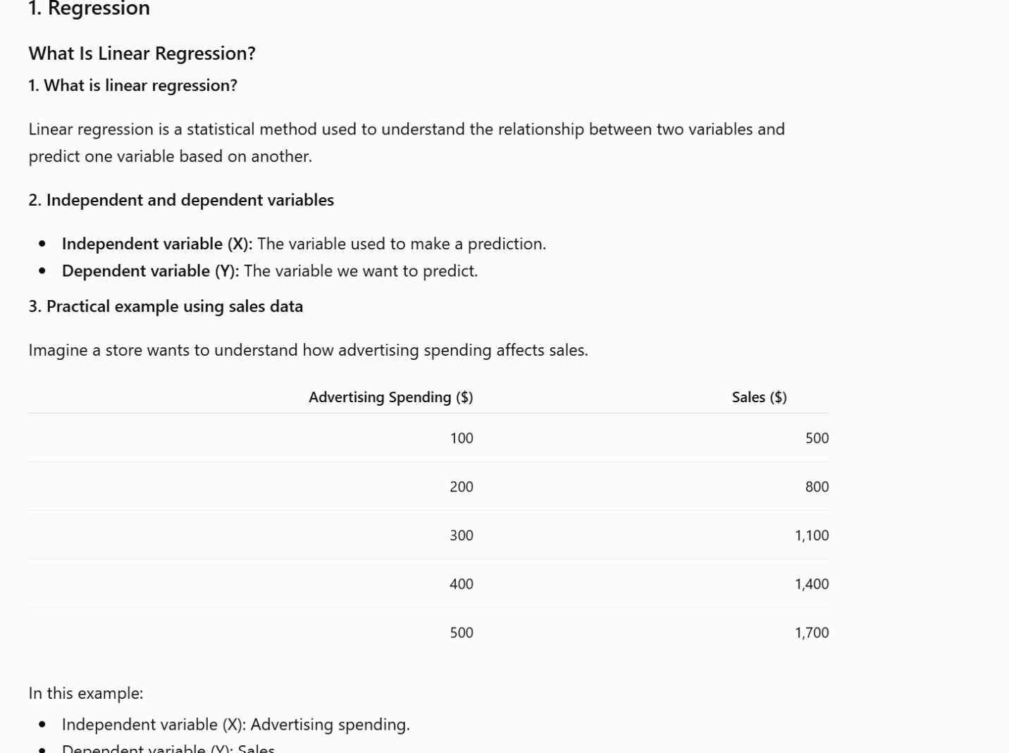

c) Why is the revised prompt stronger?
The revised prompt specifies the topic, the audience, and the level of detail needed. It requests a practical example and explains what the response should include, making the answer easier to understand.

2. Weak prompt: "Help me understand SQL"
a) Improved prompt
Teach me the basics of SQL as a beginner in Data Analytics. Explain what SQL is used for and introduce the SELECT, FROM, WHERE, and ORDER BY statements. Provide a simple example using a student enrollment database, explain each line of the query, and give me two practice questions to test my understanding.

b) Screenshot of the AI response
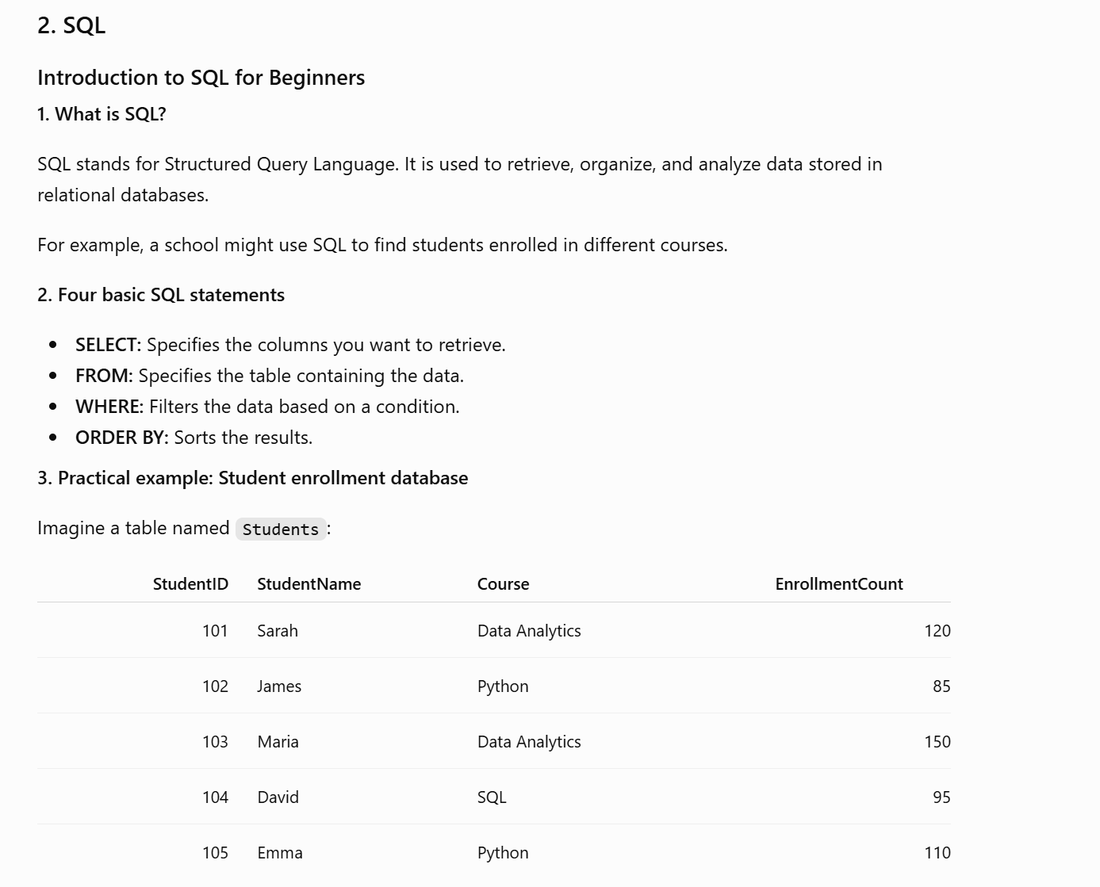

c) Why is the revised prompt stronger?
The revised prompt identifies specific SQL concepts and requests explanations with examples. It also asks for practice questions, allowing me to apply what I learn and check my understanding.

3. Weak prompt: "Create a dataset"
a) Improved prompt
Create a dataset with 12 rows showing Course Name, Enrollment Count, and Average
Rating. Enrollment Count should range between 50 and 500. Average Rating should range
between 3.0 and 5.0. Format as a table.
b) Screenshot of the AI response
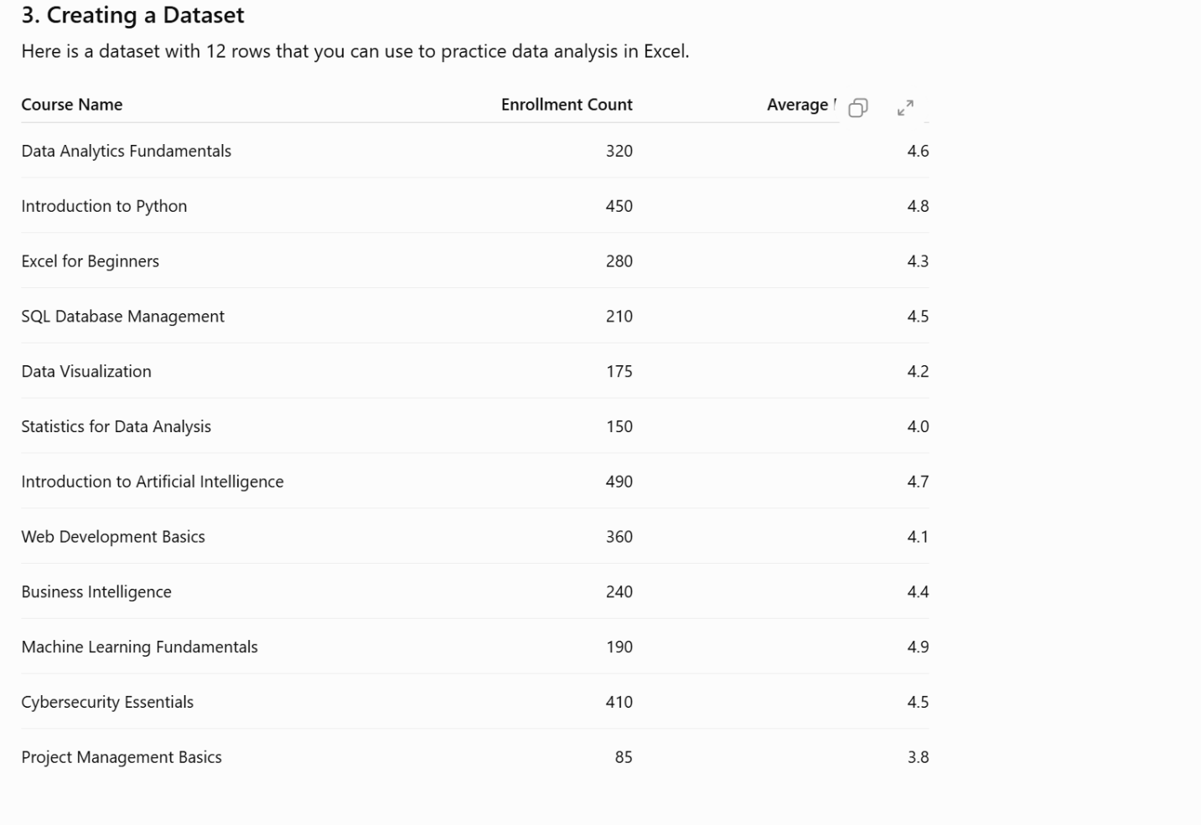

c) Why is the revised prompt stronger?
This revised prompt specifies the number of rows, column names, acceptable value ranges, and output format. These constraints help make the result clear and better match the expected output.

