|  |
| --- |
| 10349680 – Deirdre Flaherty |
| CA04 Assignment Report  B8IT105 Programming for Big Data  May 1, 2017 |

Contents

Statistical Analysis Conclusions 2

1. Active Days 2

2. Active Hours 3

3. Commits by Author 4

4. Changes by Author 5

# Statistical Analysis Conclusions

## Active Days

From analyzing at the number of commits by day, I can see that;

1. There are no commits on either Saturdays or Sundays, so these must be the days off for this development team.
2. The fact that there are no commits on Saturdays or Sundays is good as it indicates that the developers are not working on their days off (if they were, it might indicate a problem).
3. Thursday appears to be the busiest day for this development team, while Monday appears to be the quietest day.

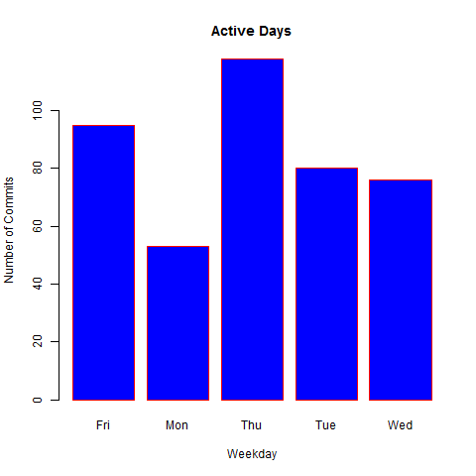

Fig 1: Bar chart of Active Days

## Active Hours

From analyzing the number of commits by hour, I can see that;

1. Most code commits occur between the hours of 8am and 5pm, with a little extra work taking place slightly earlier or later than that. This tells me that the team is putting in a normal working week and that developers are not having to do much overtime to accomplish their daily tasks.
2. By far the most code commits take place between 2pm and 3pm. This might indicate a policy within the team of committing code to the central repository at 2pm each day.

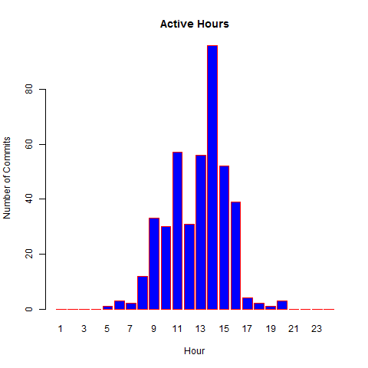

Fig 2: Bar chart of Active Hours

## Commits by Author

From analyzing at the total number of commits by author, I can see that;

1. Thomas and Jimmy would appear to be the most productive developers within the team since they have committed the most changes to the codebase.
2. These two developers appear to be carrying the team, since they have performed considerably more commits that the other developers. In fact, all of the other developers except for Vincent have less than 10 total commits each. One possible explanation for this may be that some of the developers are new to the team and are not yet fully up to speed. Otherwise, it could indicate that the workload within the team is unfairly balanced.

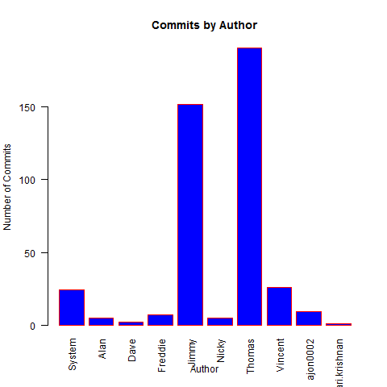

Fig 1: Bar chart of Commits by Author

## Changes by Author

From analyzing at the number of changes by author, I can see that;

1. Thomas has performed the most modifications and the most deletions. Whereas, Jimmy has performed the most additions.
2. Vincent has also performed quite a lot of additions and is second to Jimmy in this respect.
3. It may take longer to add code than to delete or modify it, so Vincent & Jimmy are not necessarily less productive than Thomas. These three developers do appear to be more productive that the other developers within the team however.

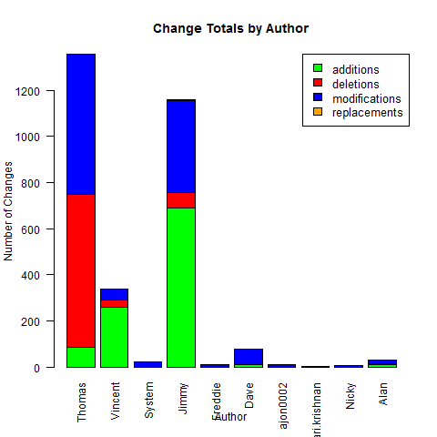

Fig 3: Stacked bar chart of Changes by Author