EECS 448 Final Exam

Team 2: Audrey Evans, Hari Ramanan, Alan Wang, John McCain

User’s Manual

Percussion Pal User’s Manual

**Table of Contents**

1 Introduction

1.1 Mission statement…………………………………………………..…………………2

1.2 What is Percussion Pal? ………………………………………………………………2

1.3: Open Source License…………………………………………………………………2

2 Getting started: the basics

2.1 Simple beat with one instrument………………………………………………………2

2.2 Adding more instruments………………………………………...……………………4 2.3 Change tempo…………………………………………………………………………4

2.4 Change volume…………………………………………………………………..……5

2.5 Reset………………………………………………………………..…………………5

3 Intermediate Instrument controls

3.1 Defining tone, decay, tuning, and snappy……………………………………………5

3.2 Using instrument knobs………………………………………………………………6

3.3 Instrument switches……………………………………...………………...…………6

4 Advanced Percussion Pal features

4.1 TAP………………………………………………………………..…………………7

4.2 Rhythms A, B, and AB………………………………………………………………7

4.3 Pattern saving………………………………………………………...………………8

**1 Introduction**

**1.1: Mission Statement**

Welcome to the Percussion Pal! The purpose of this product is to provide a free, easy, and online drum machine to all users. Beatluvers Inc hopes that in providing a music resource to students, teachers, and musicians alike, we can encourage the growth of users through music.

**1.2: What is Percussion Pal?**

Percussion Pal is a virtual drum machine based off the classic TR808. A drum machine is a way to create beats and rhythms that imitate a real drum set as closely as possible. With our product, you can select a number or real life sounds that a drum set contains, such as a base drum, snare drum, or cymbals, and compose rhythms from that.

**1.3: Open Source License**

This product uses LGPL, the lesser general public license.

**2 Getting started: the basics**

**2.1: Creating a simple beat with one instrument**

Let’s begin with something simple: creating a beat with one instrument. The first step is to select an instrument. As you can see, there are eleven instrument buttons, with abbreviations as the following:

|  |  |
| --- | --- |
| BD…………. | Base drum |
| SD…………. | Snare drum |
| LT…………. | Low tom |
| MT…………. | Mid Tom |
| HT ………… | High Tom |
| RS…………. | Rim Shot |
| CP…………. | Hand Clap |
| CB…………. | Cow Bell |
| CY…………. | Cymbal |
| OH…………. | Open Hihat |
| CH…………. | Closed Hihat |

We will begin with the first on the list, a base drum. Click on the BD button to select base drum:

Figure 1: Click on the base drum button.

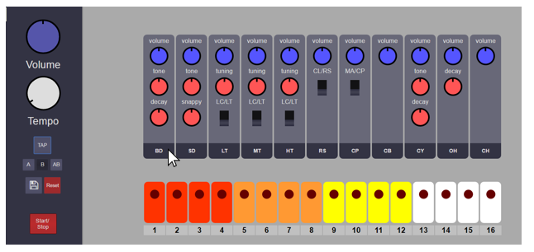

Next, we have to create the rhythm that we wish. Use the multicolored buttons on the bottom of the Percussion Pal to select a simple beat. The lights on the buttons will shine when you have selected that beat.

Figure 2: Use the rhythm buttons to select a beat.

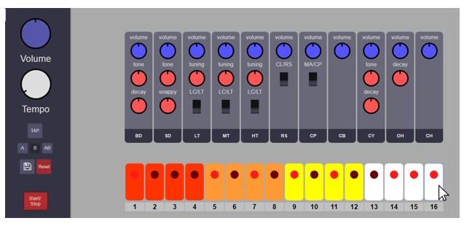

Now, all you have to do is press the start/stop button to listen to your beat.

Figure 3: The start/stop button

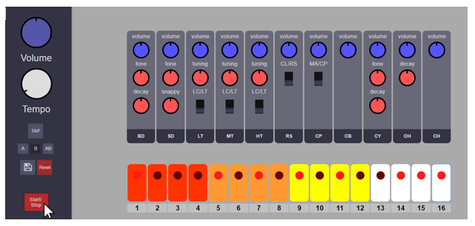

**2.2: Creating a more complicated beat with multiple instruments.**

We have learned how to create a rhythm with a single instrument. Now, we will learn how to use more than one instrument. Using the existing rhythm that we made in section 2.1, let’s add another instrument.

Figure 4: Select another instrument. We will select the snare drum.

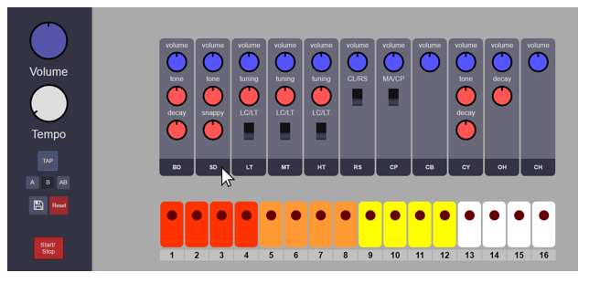

Now, repeat the process from section 2.1. Select the unique rhythm that you would like for your second instrument. You will notice that the lighted buttons will be blank for each new instrument that you select. Add as many instruments as you would like! You have now learned how to make rhythms with multiple instruments.

**2.3: Changing the tempo**

One feature of Percussion Pal is the ability to change the tempo of your beat. Using the rhythm that you created in section 2.2, experiment with the tempo knob. As you will notice, the far right position of the knob indicates a faster tempo, the far left position indicates a slow tempo. In order to control the knob, you must click on the knob and drag your mouse vertically up or down in order to make the knob turn right or left, respectively.

Figure 5: Using the tempo knob

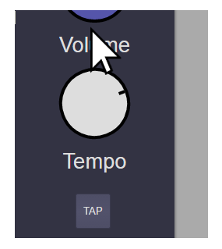

**2.4: Changing the volume.**

This feature is self-explanatory. The large blue volume knob on the upper left-hand corner controls the master volume for the entire rhythm.

**2.5: Using the reset button.**

If you would like to make a new rhythm, use the reset button.

Figure 6: The reset button

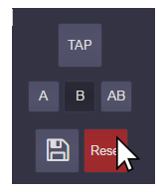

**3 Intermediate Instrument controls**

**3.1: Defining tone, decay, tuning, and snappy**

As you can see on the Percussion Pal, many of the instruments have multiple knobs, labeled tone, decay, tuning, and snappy. In this section we will define these terms.

|  |  |
| --- | --- |
| Tone | A musical sound of definite pitch. This knob will make your instrument sound more or less distinct. |
| Decay | This knob will adjust the reverberation of your instrument. |
| Tuning | This knob will adjust the pitch of your instrument. |
| Snappy | This knob is for the snare. Less snappy makes the snare sound more like a tom, and more snappy makes the snare sound more like a sharp clap. |

**3.2: Using the Instrument knobs**

In section 3.1 we defined what tone, decay, tuning, and snappy mean. Now we can apply these different knobs to our rhythms.

Figure 7: Using the different instrument knobs.

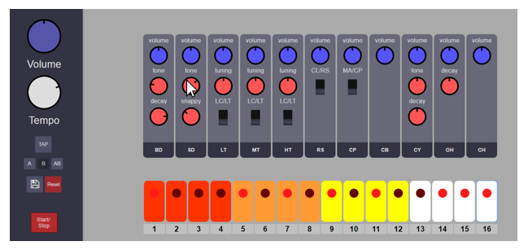

**3.3: Using the Instrument switches**

There are five instrument switches. These switches flip that particular instrument button between the two instruments indicated.

Figure 8: Using the instrument switches.

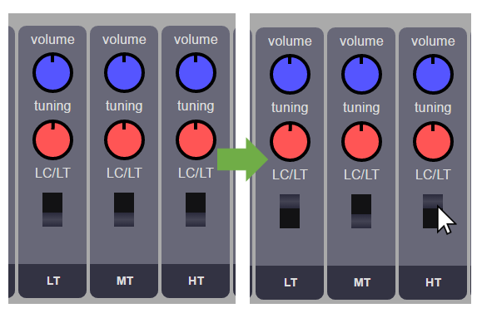

**4 Advanced Percussion Pal features**

**4.1: TAP**

The tap tempo feature of the Percussion Pal is useful for musicians who do not have a specific tempo to work with for their project, but rather would like to “tap” out their own tempo. By tapping the “tap” button four times at a certain rate, musicians can set the tempo of their beat to the tempo of their clicks of the “tap” button. The feature is convenient in that it can be used to alter the tempo of a beat sequence at any time that it is already playing. Create your own tempo and watch the LEDs on the sequence buttons speed up or slow down according to your custom tempo.​

**4.2: Using the pattern buttons**

One feature of Percussion Pal is the pattern buttons. You can locate them on the left-hand side of the drum machine. With this feature, you can switch between two different rhythms A and B, or combine the two rhythms with the AB button.

Figure 9: Using the pattern buttons.

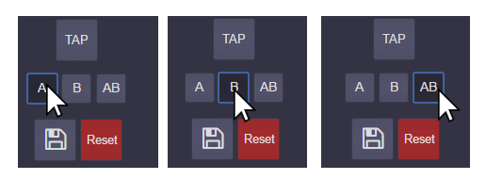

**4.3: Pattern saving**

Want to keep the rhythm you created forever? No problem! Percussion Pal uniquely offers the opportunity to save your work. Simply use the save button (indicated by the save icon) next to the reset button.

Figure 10: The save button.

