**5 Creative Online Business Ideas – Ecommerce Inspiration**

It’s true. The online business market is oversaturated with the most popular and trendy products on the market – but what about those entrepreneurs that didn’t jump on the “just a fad” bandwagon? These brilliant innovators are the reasons you ask yourself: Why didn’t I think of that?

I want to introduce you to 5 creative online business ideas – ecommerce inspiration – for those hungry for imagination and innovation. After all, we live in a world where bringing a business to life is simple, once you find that big idea.

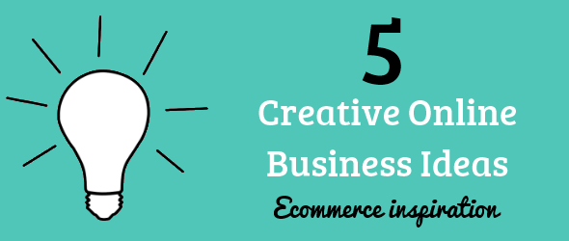

<!--more-->

Of course, just coming up with a product to sell isn’t going to guarantee success. Put your idea to the test when you read my on How to Find the Right Products to Sell Online. <http://www.prestashop.com/blog/en/how-to-find-the-right-products-to-sell-online/>

Now, let’s meet 5 online businesses that transformed their genius ideas into a successfully running PrestaShop online store.

**Madame Choup**

***“When fashion invites itself in the kitchen”***

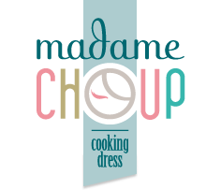

**What they sell:** **Madame Choup** sells unique 1950’s inspired cooking aprons. Aprons are a timeless product meaning that they aren’t just a trend. They took a unique approach by creating fashion forward aprons that women love to wear. Madame Choup is a PrestaShop award winning site with 8,000 Facebook fans. <http://www.madamechoup.com/>

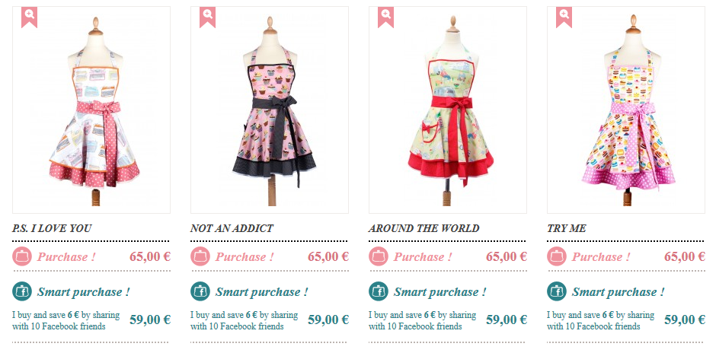

**Draw me a Song**

***“Fusion between music and visual art”***

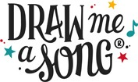

**What they sell:** **Draw Me a Song** sells colorful and original illustrations of some of the most famous song lyrics in the music industry. They are the winners of the Deutsche Bank Creative Award in February 2011 and semi-finalist in the MIT Business Plan Competition (Pan Arab Region) in February 2012. <http://drawmeasong.com/>

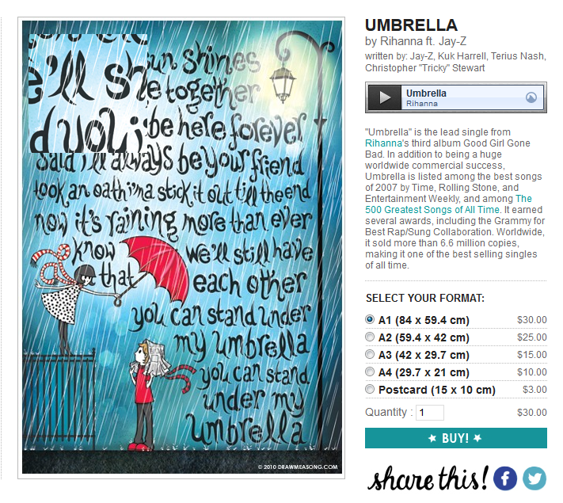

**The Phobia Shop**

***“Laugh at your fears and embrace them”***

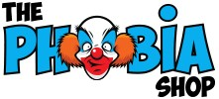

**What they sell:** **The Phobia Shop** sells original t-shirts designed with your funkiest fears in mind. Since every human can relate to phobias, the purpose of this online store is for people to have fun and laugh at their own fears. The concept was created by the company President, Power Capote, a nurse who realized that there was a huge market for this product and believed that the world could use some extra smiles and cool t-shirts. <http://www.thephobiashop.com/>

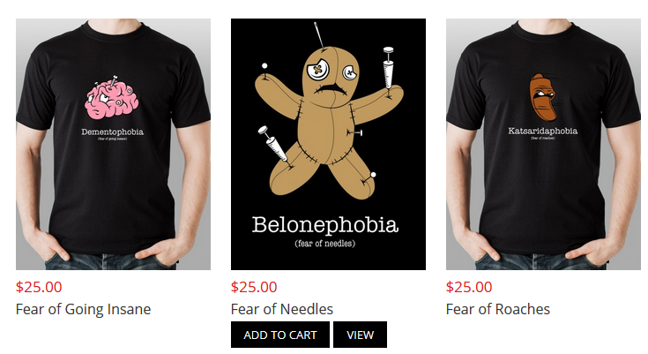

**Eatingtools**

***“eat. cook. explore.”***

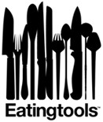

**What they sell:** **Eatingtools**, based in Brooklyn, is an online store for the food-loving visionaries selling top quality eating and cooking tools. Many are handmade, some are one-of-a-kind creations and others come from some of the world’s top production companies. Their unique and modern site makes perfect use of beautiful, large imagery. <http://www.eatingtools.com/>

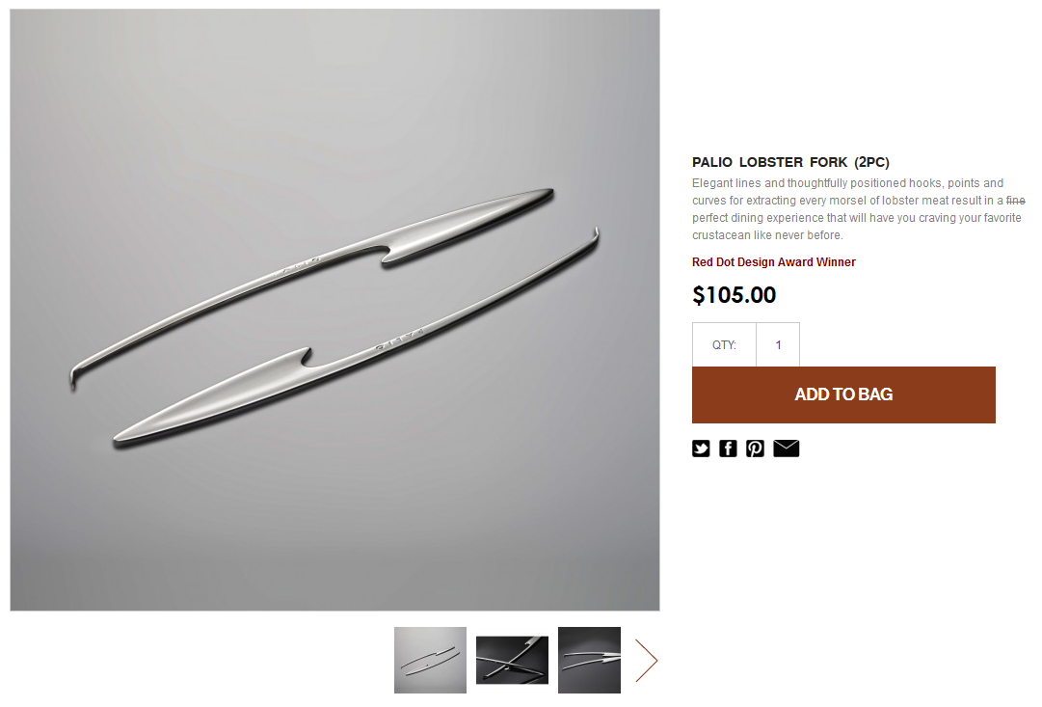

**My Little Party**

***“Your Perfect Party”***

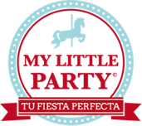

**What they sell:** **My Little Party** sells original and stylish party products to add that extra festive touch. The shop is based in Spain and sells everything from decorations to utensils bringing unique products from the United States, UK and Australia. My Little Party has been featured in Elle, Marie Clair and Vogue. <http://www.mylittleparty.es/> 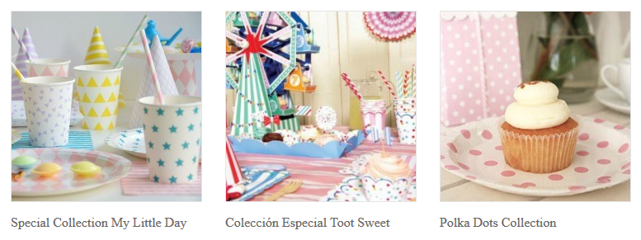

**Feeling Inspired?**

Set your online store up for success with our **10 Steps to Writing an Ecommerce Business Plan**. <http://www.prestashop.com/blog/en/how-to-create-an-online-store-10-steps-to-write-your-business-plan/>

Then, take advantage of PrestaShop’s beautiful default template and brilliant back-end to grow a booming business like the stores above! **Download PrestaShop** for free today or try out the **demo**.