**APPENDIX 1**



**Mark 1 BrachySeed Oscillation System**

**User Manual and Troubleshooting Guide**

Device Operation

# Operating the Probe Transducer

1. The rectal probe transducer produces electromagnetic fields to induce brachyseed oscillations. To avoid this field causing interference with cell phones, computers, or other electronic devices, the probe should be properly placed BEFORE turning on the device
2. To place the probe, insert the probe rounded-end first into the patient’s rectum. Take care to ensure that the side of the transducer is as close to the prostate as possible

# Turning on the Device

1. To turn on the device, plug the extension cord into a standard 120V 60Hz wall outlet. Then, turn the power switch on the device to the “On” position.
2. The LCD will turn on, and display several startup screens, showing the device name and logo

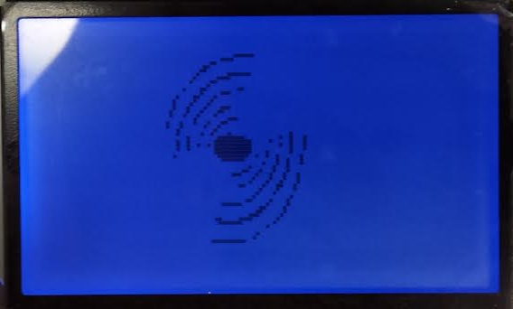

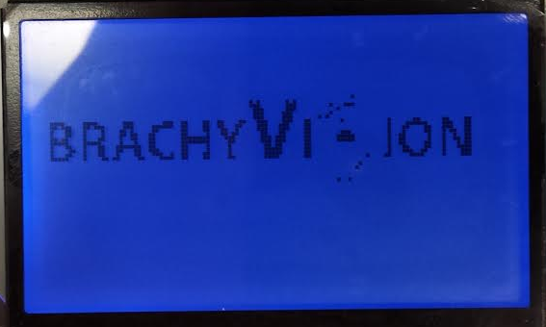

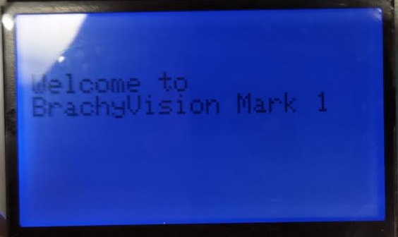

# Adjusting the Brightness

1. The first menu to appear will be the backlight menu. This menu controls the brightness of the LCD screen backlight. The menu consists of 3 menu items: “Up”, “Down”, and “Finished”, as well as a graphical representation of menu brightness

Cursor

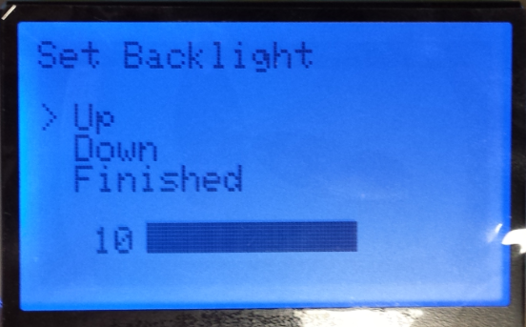

Menu items

Brightness Value

Menu title

Graphical brightness representation

1. The bar at the bottom of the screen displays the current backlight brightness in relation to the maximum and minimum values. The greater the brightness of the backlight, the more filled in the bar will be. At the left of the bar is the number correlated to the backlight brightness: there are 11 levels of backlight brightness, ranging from 0 to 10. A backlight brightness of 10 is the maximum brightness of the backlight.
2. To adjust the backlight brightness, use the buttons to navigate the screen. The “UP” button moves the cursor upwards on the screen by one menu item, while the “DOWN” button moves the cursor downwards on the menu. The “SELECT” button is responsible for accessing the functionality of that menu item. For example, to increase the brightness of the backlight, use the “UP” and “DOWN” buttons to navigate to the “UP” menu item, and press “SELECT”. Doing so will increase the backlight brightness by one increment.
3. Adjust the backlight until the screen brightness allows for easy screen visibility in the current lighting conditions.
4. To exit this menu, navigate to the “Finished” menu item, and press select. Note that this is the only opportunity to change the backlight brightness.

# Changing the Frequency and Amplitude

1. After exiting the backlight menu, the main menu will appear. This menu displays frequency and amplitude menu items, along with visual representations of the current frequency and amplitude settings in relation to the maximum and minimum values, similar to the one seen in the backlight menu.

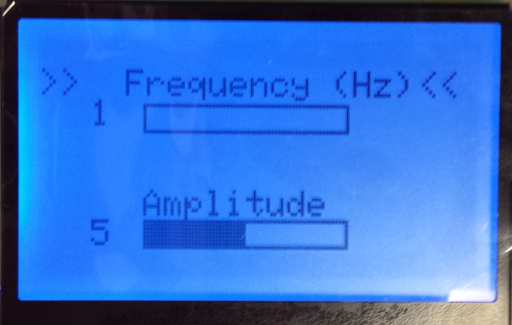

Amplitude and Frequency Values

Graphical Representations

Menu items

Cursor

1. The frequency can vary from 0 to 50 Hz in increments of one Hertz. The amplitude has arbitrary units, and can vary from 0 to 10 in increments of 1. The frequency has a default value of 1 Hz, and the amplitude has a default value of 5. The frequency setting controls the rate at which the transducer will cause the brachyseeds to oscillate. The amplitude setting controls the strength of the magnetic field producing the oscillations: higher amplitudes should lead to larger oscillations that penetrate deeper into the tissue.
2. To adjust the Frequency or Amplitude, use the buttons to navigate the screen. Pressing the “Select” button moves to select the other menu item than the one the cursor is at currently. So for example, if the cursors are next to the “Frequency” menu item, then pressing the select button will move the cursor next to the “Amplitude” menu item. The “UP” and “DOWN” buttons are responsible for increasing and decreasing the value of that menu item by one increment. For example, to increase the frequency, use the “SELECT” button to navigate to the “Frequency” menu item, and press the “UP” button. Doing so will increase the Frequency by one increment.

# Sending output to Transducer

1. Once the main menu is reached, the Mark 1 system will be constantly outputting the specified frequency and amplitude settings! So once the desired settings are set in the device, no further action is required!

Troubleshooting guide

# Q: The LCD screen won’t turn on

# A: Possible solutions:

# Make sure that the power cord is plugged firmly into a standard 120V 60Hz wall outlet.

# Make sure that the power switch is turned to the “ON” position.

# Check to see if there are breaks in any of the power cords: if there are, then they may need to be replaced.

# If the device will still not turn on, then there may be some loose or damaged circuitry within the device. Please contact BrachyVision product support at 303-815-2195.

# Q: The screen turns on, but I can’t see any oscillations on my ultrasound

# A: Possible solutions:

# Make sure that the Frequency and Amplitude settings are both non-zero. If either setting is zero, then no oscillations will occur.

# Increase the Amplitude incrementally, as it is possible that the brachyseeds require a larger magnetic field in order for movement to occur.

# Sweep through the frequency range incrementally. Brachyseed movement is frequency dependent, so certain frequencies will allow for visualization with the ultrasound. If you are using Doppler, then the frequency should be set at or above 40 Hz for optimal visualization.

1. Make sure that the ultrasound probe is directed towards the prostate. Ensure that ultrasound gel is applied to the area of probe contact to ensure optimal ultrasound conduction.
2. Ensure that the rectal probe is inserted correctly into the patient’s rectum, and that the distance from the prostate to the side of the probe is minimized.
3. Check to see if there are any loose wires going from the control box of the device to the transducer. If there are, discontinue use of the device immediately and contact BrachyVision product support at 303-815-2195.

# Q: The cursor is not moving in response to button presses

# A: Possible solutions:

1. Make sure that the buttons are being pressed down firmly, until you can hear them “click”.
2. Turn the device off and then back on. The Arduino powering the device is working really hard, and so sometimes it can get tired. In these cases, a restart is required.

**APPENDIX 2**

Code Flowcharts

# General Code FlowC:\Users\Michael\Documents\MARK\Flowcharts\jpeg images of flowcharts\general flowchart.PNG

# In Depth Code Descriptions

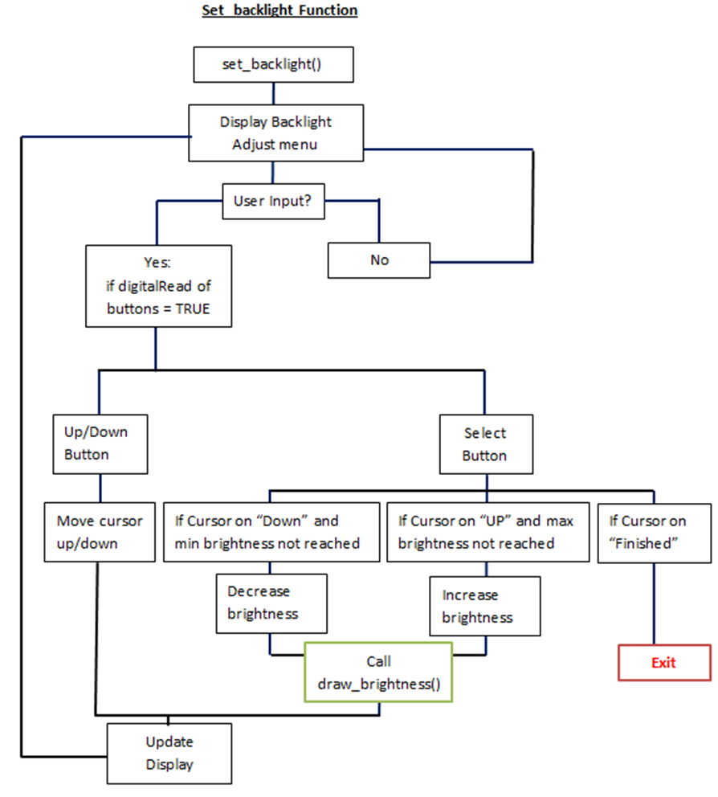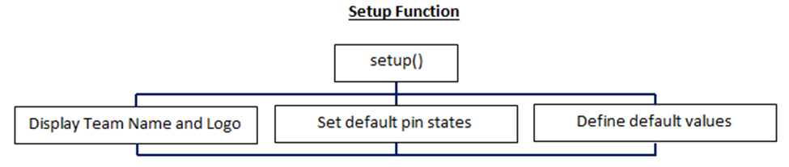

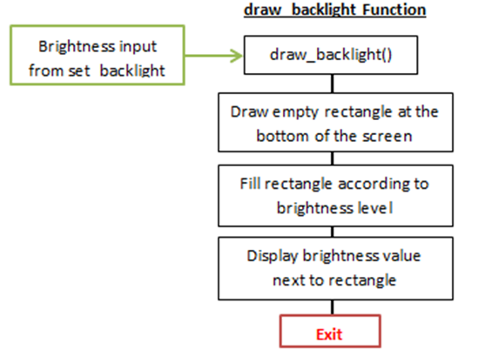

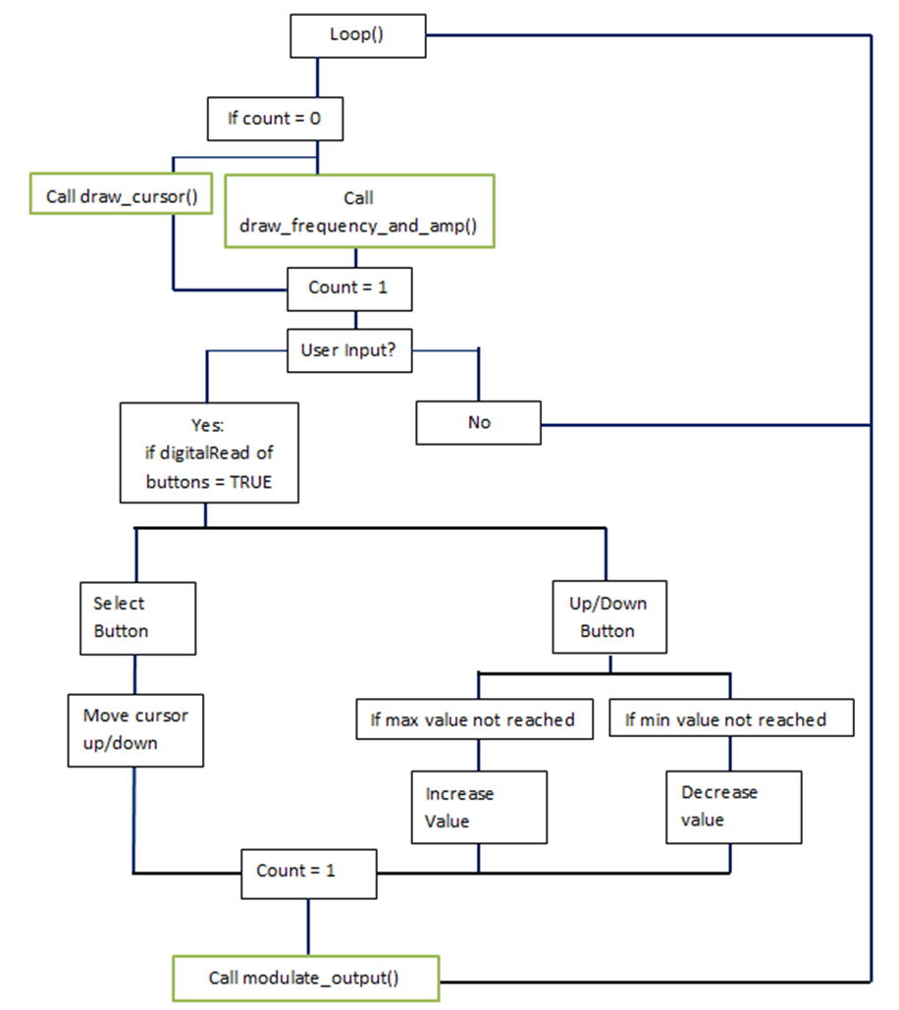**Loop Function**

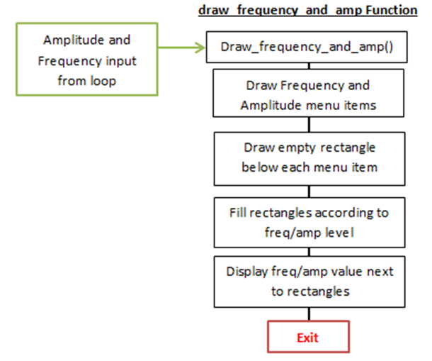

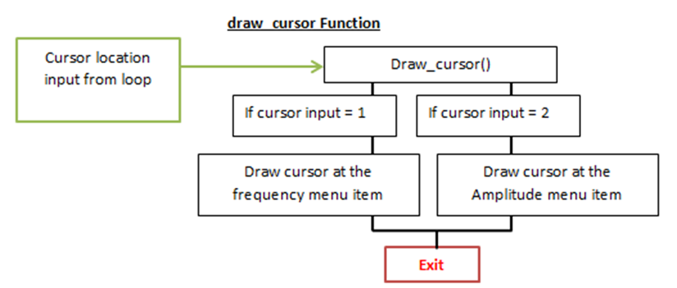

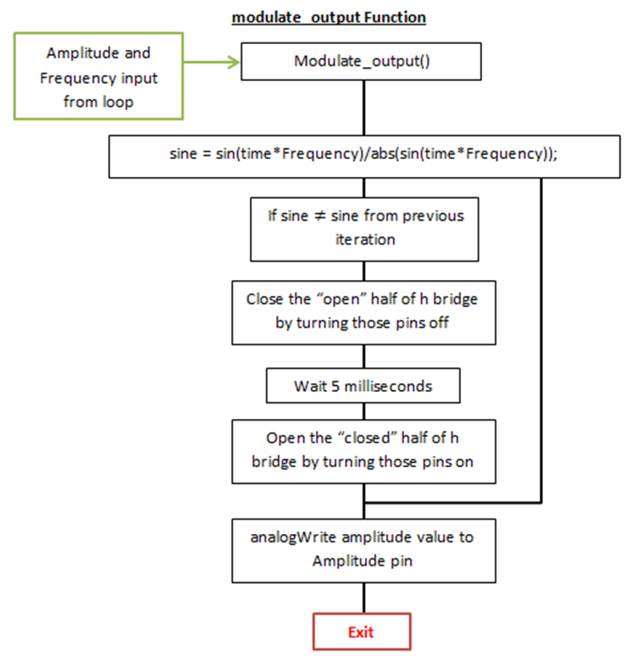

**APPENDIX 3**

The BrachyVision team invites you to check out our website for more information about our MARK 1 device. Visit us as: