

(Autonomous)

A Community Service Project Report on

SMARTROOF: AUTOMATIC ROOF CONTROL IN EXTREME WEATHER CONDITION
By

DARSHAN KUMAR - 22BQ1A4724

Under the Guidance of

P. Satish Kumar
Assistant Professor, CSE (CIC)

Department of Computer Science & Engineering (IoT, Cybersecurity including Block Chain Technology)

VASIREDDY VENKATADRI INSTITUTE OF TECHNOLOGY
Permanently affiliated to JNTUK Kakinada, Accredited by NBA and NAAC with A Grade, Approved by AICTE, ISO 9001:2008 Certified Nambur, Pedakakani Mandal, Guntur Dt. 522508



CERTIFICATE

This is to certify that the Community Service Project report titled “Smartroof: Automatic Roof Control In Extreme Weather Condition” is being submitted by Darshan kumar bearing 22BQ1A4724 in IV B. Tech II semester Computer Science & Engineering (IoT, Cybersecurity including Blockchain Technology) is a record bonafide work carried out by them. The results embodied in this report have not been submitted to any other University for the award of any degree.

P. Satish Kumar Dr M R N Tagore
Internal Guide Head of the Department

Signature of External Examiner with Date

DECLARATION

I, Darshan kumar hereby declare that the Community Service Project Report entitled “Smartroof: Automatic Roof Control In Extreme Weather Condition” done by us under the guidance of P. Satish Kumar at Vasireddy Venkatadri Institute of Technology is submitted in partial fulfilment of the requirements for the award of degree in Computer Science and Engineering (IoT, Cybersecurity including Blockchain Technology).

DATE :
PLACE :

SIGNATURE OF THE CANDIDATE

ACKNOWLEDGEMENT

With deep sense of gratitude, I acknowledgment the guidance, help & active cooperation rendered by the following people whose guidance had submitted the effort, which led to the successful completion of this project.

I express my profound gratitude to Chairman Sri Vasireddy Vidya Sagar of the college for providing me the opportunity to do the project work.

I would also like to extend my gratitude to Dr. Y Mallikarjuna Reddy, Principal, for providing me with all the facility that was required.

I would also like to extend my gratitude to Dr. M. R. N. Tagore, Head of the department of Computer Science & Engineering (IoT, Cybersecurity including Blockchain Technology) for providing me with all the facility that was required.

I would like to thank to P. Satish Kumar, project guide in charge who gave me this opportunity to undergo industrial in this organization.

My utmost thanks to the Community Service Project Coordinator P. Satish Kumar and all the Faculty members and Non-Teaching Staff of the Department of Computer science & Engineering (IoT, Cybersecurity including Blockchain Technology) for their support throughout our project work.

My Family Members and Friends receive my deepest gratitude and love for their support throughout our academic year.

Name of the Candidate
DARSHAN KUMAR SALECHA – 22BQ1A4724

S. No. | Contents | Page No.
 | Overview of CSP | 1
1. | Introduction  - Empathy  - Definition  - Objective  - Procedure  - Expected Outcome  - Scope  - Conventional System | 2  2  2  3  3  4  5  6
2. | Literature Survey | 7
3. | Technical Aspects  - Project Overview  - Technology / Software & Hardware Used  - Components | 10  10  11  12
4. | Implementation | 16
5. | Results | 19
 | Conclusion & Future Enhancements | 22
 | References | 23
 | Appendix | 24
 | Bibiliography | 27
 | Data Collection Photos | 28

Index

OVERVIEW OF COMMUNITY SERVICE PROJECT

Community Service Project Report
Submitted in accordance with the requirement for the degree of B. Tech

Name of the College : Vasireddy Venkatadri Institute of Technology
Department : Computer Science and Engineering
Name of the Faculty Guide | : P. Satish Kumar
Duration of the CSP | : 8 Weeks | From: 04/06/2025 | To: 30/07/2025
(IoT, Cybersecurity including Blockchain Technology)
Name of the Student(s) : Darshan kumar salecha
Programmer of Study : B. Tech
Year of Study : 4th
Register Number(s) : 22BQ1A4724
Date of Submission :

CHAPTER - 1

INTRODUCTION

EMPATHY

Firstly, we have visited nearby villages from our college namely CHILUVURU and THUMMAPUDI, started on 04-06-2025 with our faculty. On reaching the village, we have stopped by in order to visit the secretariat for the permission to survey the people of village and to know about their issues/problems they are currently facing. After getting the permission, the faculty had instructed us on how to visit and survey the people of the village in a defined manner. They have instructed us well which has led to this success.

When we have surveyed the people of the village, we noticed that the village is in good condition with primary facilities but needed only a few improvements in the facilities at some parts of the village. We noticed some areas have dirty roads that leads to lack of cleanliness of roads and in some areas we have noticed problem with water resources as well. We also noticed that the villages have primary health care centers but not fully equipped hospitals, this leaded to Improper Health Care.

When we are discussing about the issues/problems we realized that most of the people in the village are dependent on agriculture, it’s like agriculture is the major source of income in the villages. While enquiring about the crop harvesting, we came to a conclusion that the harvested crops need to be protected from rain and they also need sunlight as well. During our discussion we came up with the plan; what if, there is a roof that automatically opens and closes based on weather.

After the surveys, I discussed all of this with my father, he got excited and wanted to know more, then I explained everything and he said he also needed a similar solution for his business. So I discussed with my teammates and made changes according to the requirement and made my dad as our client. This is where we got the motivation to provide a solution for the problem that our client is facing.

DEFINITION
Community Service Project is an experiential learning strategy that integrates meaningful community service with instruction, participation, learning and community development. Community Service Project involves students in community development and service activities and applies the experience to personal and academic development. Community Service Project is meant to link the community with the college for mutual benefit. The community will be benefited with the focused contribution of the college students for the village/ local development. The college finds an opportunity to develop social sensibility and responsibility among students and also emerge as a socially responsible institution.

OBJECTIVES

Community Service Project should be an integral part of the curriculum, as a part of the 2 months of Summer Internships / Apprenticeships / On the Job Training, whenever there is an exigency when students cannot pursue their summer internships.
The specific objectives are:
    - To sensitize the students to the living conditions of the people who are around them,
    - To help students to realize the stark realities of the society.
    - To bring about an attitudinal change in the students and help them to develop societal consciousness, sensibility, responsibility and accountability
    - To make students aware of their inner strength and help them to find new /out of box solutions to the social problems.
    - To make students socially responsible citizens who are sensitive to the needs of the disadvantaged sections.
    - To help students to initiate developmental activities in the community in coordination with public and government authorities.
    - To develop a holistic life perspective among the students by making them study culture, traditions, habits, lifestyles, resource utilization, wastages and its management, social problems, public administration system and the roles and responsibilities of different persons across different social systems.

PROCEDURE

    - A group of students or even a single student could be assigned for a particular habitation or village or municipal ward, as far as possible, in the near vicinity of their place of stay, so as to enable them to commute from their residence and return back by evening or so.
    - The Community Service Project is a twofold one –
      - A group of the habitation, if necessary, in terms of their own domain or subject area. For ex., a student of Arts will focus on socio-economic conditions, social survey and about the Government’s social security schemes. A student of Sciences could take up a survey on the health and hygiene conditions of that habitation, similarly, with other subject areas too. Or it can even be a general survey, incorporating all the different areas. A common survey format could be designed. This should not be viewed as a duplication of work by the Village or Ward volunteers; rather, it could be another primary source of data.
      - Secondly, the student/s could take up a project work related to their domain or subject area.
    - The different areas, could be like –
      - Agriculture
      - Health
      - Marketing and Cooperation
      - Animal Husbandry
      - Horticulture
      - Fisheries
      - Sericulture
      - Revenue and Survey
      - Natural Disaster Management
      - Irrigation
      - Law & Order
      - Excise and Prohibition
      - Mines and Geology
      - Energy

EXPECTED OUTCOMES

Learning Outcomes
    - Positive impact on students’ academic learning
    - Improves students’ ability to apply what they have learned in “the real world”
      - Positive impact on academic outcomes such as demonstrated complexity of understanding, problem analysis, problem-solving, critical thinking, and cognitive development
      - Improved ability to understand complexity and ambiguity

Personal Outcomes
    - Greater sense of personal efficacy, personal identity, spiritual growth, and moral development
    - Greater interpersonal development, particularly the ability to work well with others, and build leadership and communication skills

Social Outcomes
    - Reduced stereotypes and greater inter-cultural understanding
    - Improved social responsibility and citizenship skills
    - Greater involvement in community service after graduation

Career Development
    - Connections with professionals and community members for learning and career opportunities
    - Greater academic learning, leadership skills, and personal efficacy can lead to greater opportunity

Relationship with the Institution
    - Stronger relationships with faculty
    - Greater satisfaction with college
    - Improved graduation rates

SCOPE

The scope of the Smart Roof: Automatic Roof Control in Extreme Weather Condition project is to design and implement an automated roof control system that operates based on real-time environmental conditions. The system uses a rain sensor to detect rainfall and an Arduino microcontroller to process the input and control a motor mechanism for opening and closing the roof. It eliminates the need for manual operation by providing an immediate response to weather changes, thereby protecting infrastructure and materials from damage caused by rain.

This project is limited to the development of a functional prototype that demonstrates automatic roof operation using embedded system components such as sensors, motor drivers, and a microcontroller. It focuses on achieving reliable and efficient automation in small-scale applications like residential areas, terraces, and storage spaces, ensuring ease of use, safety, and reduced human effort.

CONVENTIONAL SYSTEM
In the conventional system, roof operation is performed manually without the use of automation or intelligent control mechanisms. Users are required to physically monitor weather conditions and manually open or close the roof based on their observation. In applications such as residential terraces, agricultural storage areas, and parking spaces, this method depends entirely on human intervention and timely action.
This manual approach has several limitations. During sudden weather changes, especially unexpected rainfall, there can be delays in closing the roof, leading to potential damage to stored materials, vehicles, or infrastructure. Additionally, continuous monitoring of weather conditions is inconvenient and not always practical. The conventional system lacks real-time responsiveness, efficiency, and reliability, which highlights the need for an automated solution like the Smart Roof system.

CHAPTER - 2

LITERATURE SURVEY
Joshi, S., Patel, J., & Padhiyar, H. (2018). [1] This research presents an automatic smart roof system designed using Arduino and rain drop sensors. The system automatically closes the roof when rain is detected in order to protect agricultural crops from unexpected weather changes. The authors describe the working mechanism in detail, including sensor data acquisition, signal processing, and motor control using a microcontroller. The study highlights how real-time sensing and automation significantly reduce manual effort and improve system efficiency. Furthermore, the system is designed to be cost-effective and easy to implement, making it suitable for rural and agricultural applications. The research clearly demonstrates how sensor-based automation can be applied to solve real-world environmental problems.
Dewi, A. K., Hadi, M. S., & Anwar, S. (2017). [2] This study discusses the development of an automatic roof system within a smart home environment. The system uses light sensors and environmental inputs along with an Arduino microcontroller to control roof movement. The authors explain how automation enhances indoor comfort by regulating sunlight and ventilation. In addition, the system contributes to energy efficiency by reducing dependency on artificial lighting and cooling systems. The integration of embedded systems and control logic is highlighted as a key factor in achieving reliable performance. This work demonstrates the growing importance of automation in modern residential infrastructure.
Divakar, V., Chithritha, G. R., & Darshan, V. (2021). [3] This paper introduces a rain detection system integrated with an automatic roofing mechanism for large-scale applications such as stadiums and open structures. The system uses rain sensors, Arduino controllers, and DC motor mechanisms to automatically respond to environmental changes. The authors emphasize the importance of quick response time in preventing damage to infrastructure and ensuring user safety. The study also discusses scalability and adaptability, showing how similar systems can be implemented in different environments with minor modifications. This work highlights the practical importance of automated systems in real-time environmental control.
Priya, A. R., Vineetha, B., & Clarinda, S. S. (2025). [4] This research focuses on an IoT-enabled automated rain-sensing roof system designed for smart infrastructure applications. The system integrates rain sensors with IoT platforms to enable remote monitoring and control. The authors explain how IoT enhances system functionality by allowing users to monitor environmental conditions and control the system from remote locations. Additionally, the study highlights the advantages of data collection and analysis in improving system performance. The integration of IoT technologies significantly increases the scalability, flexibility, and intelligence of automated systems.
Nagaraju, V. S., Bhargavaram, K., Charansai, P., & Chathurya, A. (2024). [5] This paper presents an IoT-based weather monitoring system using Arduino Uno and multiple environmental sensors. The system continuously collects data such as temperature, humidity, and rainfall conditions and processes it for real-time analysis. The authors emphasize the importance of accurate environmental monitoring as a foundation for automation systems. The study demonstrates how sensor data can be used to trigger automated actions, making it highly relevant to smart roof systems. It also highlights the reliability and efficiency of microcontroller-based monitoring systems.
Chakra, A., Khatun, R., Majhi, D., Swain, S. M., & Swain, S. (2022). [6] This study proposes an IoT-based automated irrigation system that minimizes human intervention by using sensors and control units. The system automatically activates pumps and motors based on soil moisture and environmental conditions. The authors discuss how automation improves efficiency, reduces resource wastage, and enhances system reliability. The principles used in this system, such as sensor-based decision-making and automated control, are directly applicable to smart roof systems. This study reinforces the importance of IoT in developing intelligent automation solutions.
Malau, J., Lubis, S. A., & Satria, B. (2024). [7] This research presents the implementation of an automatic drying roof system using Arduino, rain sensors, and light sensors. The system detects weather conditions and adjusts the roof position accordingly to protect drying materials from environmental factors. The authors highlight the importance of using multiple sensors to improve system accuracy and responsiveness. The study also emphasizes the role of automation in increasing productivity and reducing manual labor. This work is closely related to smart roof automation and provides valuable insights into system design and implementation.
Asif, M. J., Saqib, S., Ahmad, R. F., & Khan, H. (2025). [8] This study explores the application of wireless sensor networks and IoT technologies for real-time environmental monitoring and control in industrial environments. The system uses distributed sensors to collect data and transmit it to control units for automated decision-making. The authors highlight the advantages of integrating communication technologies with automation systems, including improved efficiency, scalability, and safety. This research demonstrates how advanced technologies can be used to enhance automation systems in complex environments.
Kumar, R., & Kumar, P. (2019). [9] This research presents the design and implementation of a smart weather monitoring system using Arduino and IoT technologies. The system collects environmental data and transmits it to cloud platforms for analysis and monitoring. The authors emphasize the importance of continuous data collection and analysis in developing intelligent automation systems. The study highlights how real-time data can be used to improve system performance and decision-making, which is essential for applications such as automatic roof control.
Patel, H., Shah, M., & Patel, D. (2020). [10] This study focuses on the design and development of an automatic roof control system using rain sensors and microcontroller technology. The system automatically operates a motorized roof to protect outdoor spaces from rainfall and harsh weather conditions. The authors explain the working principle, including sensor input processing and motor control logic. The study demonstrates how simple automation systems can be effectively implemented in both residential and commercial applications. It highlights the practicality and efficiency of automated roof control systems.
SUMMARY OF LITERATURE
From the above studies, it is evident that automation systems based on sensors, microcontrollers, and IoT technologies are widely used in modern infrastructure. Most of the existing systems focus on environmental monitoring, automatic control, and real-time response to changing conditions. The integration of Arduino-based systems with sensors such as rain, light, and humidity sensors plays a crucial role in enabling intelligent decision-making. These studies collectively highlight the importance of automation in improving efficiency, reducing manual effort, and enhancing system reliability.

CHAPTER - 3

TECHNICAL ASPECTS

Project Overview
With the rapid advancement of Internet of Things (IoT) technologies, automation systems are increasingly being integrated into everyday infrastructure to improve efficiency, safety, and convenience. One common challenge faced in residential buildings, agricultural storage areas, parking spaces, and terrace structures is the need to manually open or close roofs in response to environmental conditions such as rainfall or excessive sunlight. Manual operation can lead to delays, inconvenience, and potential damage to stored materials or infrastructure when sudden weather changes occur. Recognizing this problem and aiming to provide an intelligent and practical solution, our team developed a Smart Roof Automation System as part of our Community Service Project.
The primary objective of this project is to design and implement an automated roof control system that can respond intelligently to environmental conditions without requiring manual intervention. The system continuously monitors environmental parameters using sensors and automatically operates the roof mechanism when specific conditions are detected. By integrating sensors, microcontrollers, and motor control systems, the proposed solution ensures real-time response to weather changes, thereby protecting infrastructure and improving operational convenience.
The Smart Roof Automation system utilizes sensors such as rain sensors and light sensors to detect weather conditions. These sensors continuously collect environmental data and send signals to a microcontroller, which acts as the central processing unit of the system. Based on the sensor readings, the microcontroller determines whether the roof should remain open or closed. When rainfall is detected or when environmental conditions require protection, the controller automatically activates a motor mechanism that closes the roof. Similarly, when favorable conditions return, the system reopens the roof automatically.
This project demonstrates the practical application of IoT and embedded system technologies in developing smart infrastructure solutions. The system integrates hardware components such as sensors, motors, and microcontrollers with software logic to enable automated decision-making and real-time operation. The proposed system not only reduces manual effort but also increases efficiency, reliability, and safety by ensuring that the roof responds immediately to environmental changes.
Through this project, we aim to highlight how intelligent automation systems can be implemented in real-world environments to improve infrastructure management. The Smart Roof Automation system represents a simple yet effective example of how IoT-based technologies can enhance convenience, reduce human dependency, and contribute to the development of smart and sustainable living environments.

Technology / Software & Hardware Used

S. No | Software | System Requirement
1. | Operating System | Windows 7 (or) 8 (or) 10 (or) MAC Ox  10.8,10.9, (or) 10.11, LINUX
2. | Development Environment | Arduino IDE
3. | Editor | Arduino IDE editor(.ino file) or Notepad

S. No | Hardware | System Requirements
1. | Micro - Controller | Arduino UNO
2. | Motor Driver | L298N motor driver
3. | Sensor | Rain Sensor (for Detection)
4. | Motor | DC Motor
5. | Batteries | Lithium - ion Batteries (18650)
6. | Battery Holder | Battery Holder (2 capacity)
7. | Jumper Wires | Female to Male, Female to Female
8. | Model Build | Sun Board Sheets / Cardboard

. COMPONENTS

Arduino UNO x 1

Motor Driver L298N x 1

Rain Sensor x1

12V DC Motor x 1

Battery Holder x 1

Jumper Wires

18650 Batteries x 2

Sun Board Sheets/Cardboard
- Arduino Uno:
Arduino Uno is a circuit board with ATmega328 built in it, the Arduino Uno which we are using consists of 14 digital input/output pins (where the 6 pins can be used as PWM output pins), 6 of them are analogue, there is also USB connecting port, a power jack, and reset button. This microcontroller is very basic and simple for the demonstration purpose. We can power the Board by AC-to-DC adapter or battery and by USB cable through the computer. One of the other best thing about this microcontroller is that it has CPU which comprise a significant amount of RAM, ROM and some other components as well.
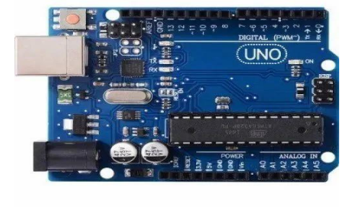

- Motor Driver L298N:
The L298N is a dual H-Bridge motor driver module used to control DC motors and
stepper motors.

Features:
- Dual H-Bridge: Controls two DC motors or one stepper motor.
- Current Handling: Up to 2A per channel (peak 3A).
- Voltage Range: 5V to 35V.
- Protection: Built-in diodes for back EMF protection.
Pin Configuration:
- VCC: Motor power supply.
- GND: Ground.
- 12V: Power for the motor driver.
- IN1, IN2: Control Motor A direction.
- IN3, IN4: Control Motor B direction.
- ENA, ENB: Enable pins for speed control via PWM.
- OUT1, OUT2, OUT3, OUT4: Motor outputs.
Usage:
- Direction Control: IN1/IN2 for Motor A, IN3/IN4 for Motor B.
- Speed Control: Use ENA and ENB with PWM.
Connection to Arduino:
- IN1, IN2: Digital pins (e.g., 8, 9).
- IN3, IN4: Digital pins (e.g., 10, 11).
- ENA, ENB: PWM pins (e.g., 5, 6).
- VCC, 12V, GND: Connect to power supply and ground.
The L298N is perfect for projects requiring motor control, like automatic roof systems.
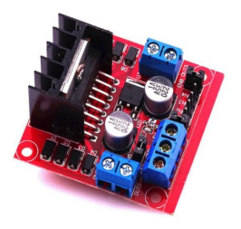

- Rain Sensor:
The rain sensor is a simple yet effective device used to detect the presence of rain. It is widely used in automatic systems such as rain-sensing wipers, automatic roof systems, and
irrigation systems.
Features:
- Rain Detection: Detects the presence and intensity of rain.
- Output Types: Provides both digital and analog outputs.
- Easy to Use: Simple interface for integration with microcontrollers.
Usage:
- Digital Output: Provides a high signal when rain is detected, can be read by a digital pin on a microcontroller.
- Analog Output: Provides a variable signal proportional to the amount of rain, can be read by an analog pin on a microcontroller.
Connection to Arduino:
- VCC: Connect to 5V on the Arduino.
- GND: Connect to GND on the Arduino.
- DO: Connect to a digital pin (e.g., pin 7) on the Arduino.
- AO: Connect to an analog pin (e.g., A0) on the Arduino.
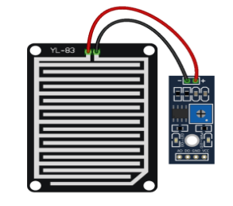

The rain sensor is ideal for projects that require rain detection, such as an automatic roof control system, providing timely response to weather conditions.
- 12V DC Motor:
Drives the mechanism to open and close the roof.

- Battery Holder:
Holds and connects the batteries to power the motor and other components.
- 18650 Batteries x 2:
Provides power to the system. Two 18650 batteries are typically connected in series to provide the required 12V for the motor.
- Jumper Wires:
Used to make the necessary electrical connections between components.

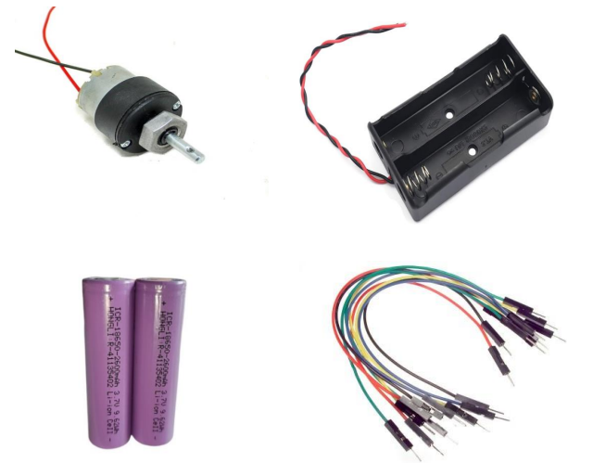

CHAPTER - 4

IMPLEMENTATION

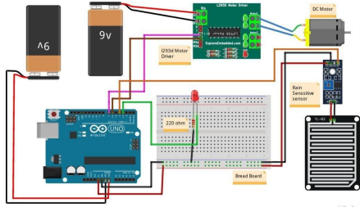
The following image shows the circuit diagram of the Arduino based AutomaticRoof control using Rain Sensor, a Motor Driver and a DC Motor. For the circuit design follow the following procedure.

Connect Rain Sensor to Arduino:

Connect the rain sensor to the Arduino using the analog input pins. Typically, connect the signal pin of the rain sensor to the A0 pin of the Arduino, and the VCC and GND pins to the 5V and GND pins of the Arduino, respectively.

Connect Motor Driver to Arduino:

Connect the motor driver to the Arduino. Use digital pins for control signals. For example, connect the IN1 and IN2 pins of the motor driver to digital pins 8 and 9 on the Arduino. Connect the motor terminals to the motor output pins of the motor driver. Also, connect the motor driver’s VCC and GND to the Arduino's 5V and GND.

Connect Motor to Motor Driver:

- Connect the motor that will open and close the roof to the output terminals of the motor driver.

The architecture ensures that the rain sensor detects rain, and based on the sensor input, the Arduino sends control signals to the motor driver to operate the motor, which in turn opens or closes the roof.

Detailed Procedure:

1. Connect the Rain Sensor:
- Signal pin of the rain sensor to A0 on Arduino
- VCC of the rain sensor to 5V on Arduino
- GND of the rain sensor to GND on Arduino
2. Connect the Motor Driver:
- IN1 of the motor driver to digital pin 8 on Arduino
- IN2 of the motor driver to digital pin 9 on Arduino
- VCC of the motor driver to 5V on Arduino
- GND of the motor driver to GND on Arduino
3. Connect the Motor:
- Connect the motor terminals to the output terminals of the motor driver.

By following these connections, the system will be able to detect rain and automatically control the roof mechanism.

Working:

After completing the circuit design and connecting the components including the rain sensor, Arduino Uno, L298N motor driver, 12V DC motor, and power supply, follow these steps to automate the roof control system based on rain detection:
- Power On:
      - Turn on the power supply to the circuit.

- Rain Detection:
- The rain sensor detects the presence of rain. It sends a signal to the Arduino.
- Arduino Processing:
- The Arduino processes the signal from the rain sensor to determine whether it is raining or not.
- Motor Control:
- If rain is detected:
    - The Arduino sends control signals to the L298N motor driver.
    - The motor driver activates the 12V DC motor connected to the roof mechanism.
    - The motor closes the roof to prevent rain from entering.
- If no rain is detected:
    - The Arduino keeps the motor driver inactive or sends signals to open the roof if it was closed due to rain.

Automatic Operation:
  - The system operates autonomously based on the rain sensor's input.
  - When rain is detected, the Arduino triggers the motor to close the roof.
  - Conversely, when rain stops (no detection), the Arduino can instruct the motor to open the roof.

This setup ensures that your automatic roof control system responds effectively to weather conditions without requiring direct user input or Bluetooth voice commands. It operates seamlessly based on the rain sensor's real-time feedback and Arduino's programmed logic.

CHAPTER - 5

RESULTS
OUTPUT:
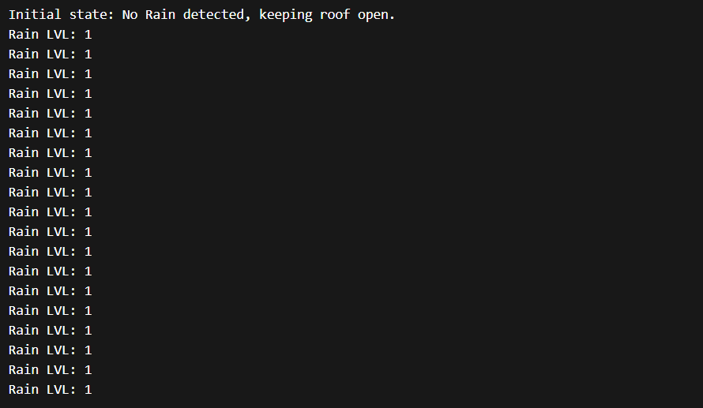
- System Startup – No Rain Detected:
Meaning: System starts and keeps monitoring weather conditions.
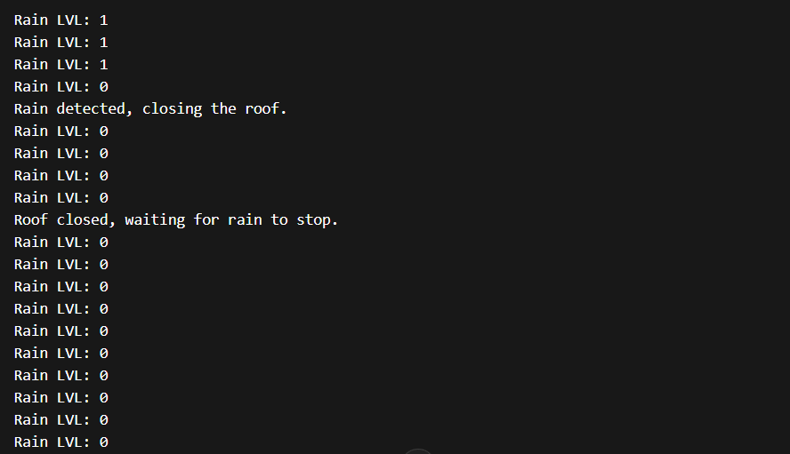
- Rain Starts – Roof Closing:
Meaning: Rain sensor triggered → motor closes roof.

- Continuous Rain – Roof Remains Closed:
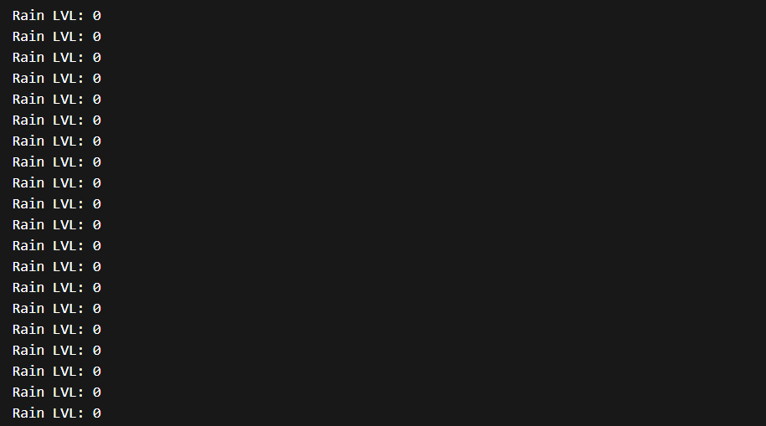

Meaning: System keeps monitoring, roof remains closed.

- Rain Stops – Roof Opening:
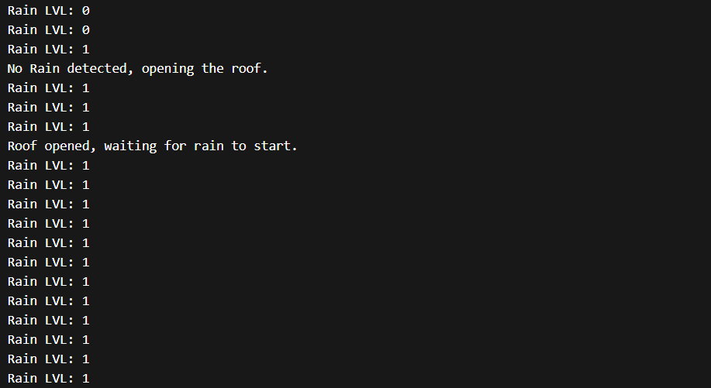
Meaning: Rain stopped → roof opens automatically.

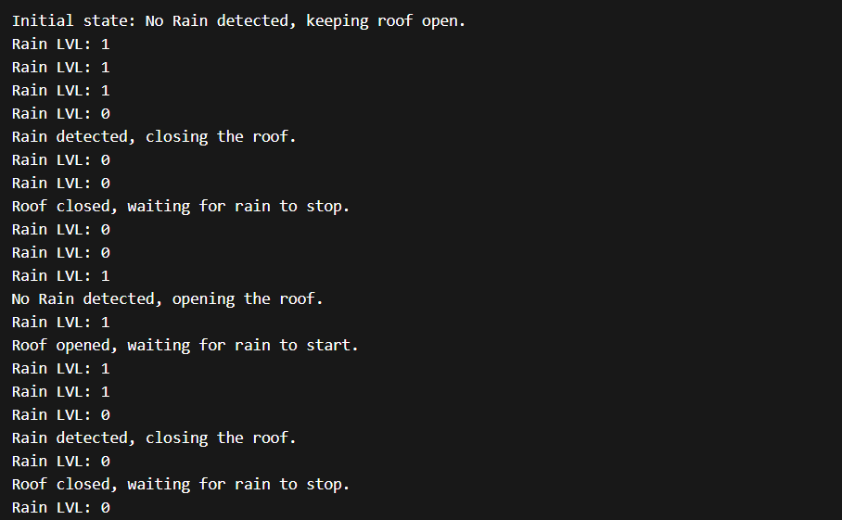
- Multiple Weather Changes (Full System Test):

Meaning: Demonstrates full automation cycle.

CONCLUSION
The Smart Roof Automation system developed in this project demonstrates how Internet of Things (IoT) and embedded system technologies can be used to automate infrastructure based on environmental conditions. The system successfully integrates a rain sensor, Arduino microcontroller, and motor control mechanism to automatically open and close a roof structure depending on weather conditions. When rainfall is detected, the system automatically closes the roof to protect the area beneath it, and when the rain stops, the roof reopens without requiring manual intervention. The implementation of this project shows the practical application of sensor-based automation and real-time monitoring systems. The use of embedded programming and hardware interfacing enables the system to respond quickly and efficiently to environmental changes. This automation reduces manual effort, increases convenience, and helps protect equipment or materials stored in open spaces from unexpected weather conditions. Through this project, we gained practical knowledge in microcontroller programming, sensor integration, motor control systems, and IoT-based automation technologies. The project also highlights how simple automation systems can contribute to smarter infrastructure and improve everyday living environments. Overall, the Smart Roof Automation system serves as a reliable and cost-effective solution for automated roof management in residential, agricultural, and industrial applications.

FUTURE ENHANCEMENTS
Although the Smart Roof Automation system performs its basic function effectively, several improvements can be made to enhance its capabilities and efficiency in the future. One possible enhancement is the integration of wireless communication technologies such as Wi-Fi or Bluetooth to allow remote monitoring and control of the roof through a mobile application. This would enable users to monitor the system status and manually override the automation when required. Another improvement would be the addition of multiple environmental sensors such as temperature sensors, humidity sensors, and light sensors. These sensors can help the system make more intelligent decisions based on various weather conditions rather than relying only on rainfall detection. The system can also be integrated with cloud-based IoT platforms for real-time data logging, monitoring, and predictive weather analysis. This would allow users to track environmental patterns and system performance over time. Further mechanical improvements can be implemented to make the roof structure stronger, more durable, and capable of operating in larger installations such as greenhouses, parking areas, and agricultural storage facilities.

REFERENCES

[1] S. Joshi, J. Patel, and H. Padhiyar, “Automatic Smart Roof System Using Arduino and Rain Drop Sensor,” International Conference on Engineering Research, 2018.

[2] A. K. Dewi, M. S. Hadi, and S. Anwar, “Automatic Home Roof System on Smart Home by Using Arduino,” Journal of Technology and Computer Systems, 2017.

[3] V. Divakar, G. R. Chithritha, and V. Darshan, “Rain Detector with Alarm and Automatic Roofing System,” International Advanced Research Journal in Science, Engineering and Technology, vol. 8, no. 6, 2021.

[4] A. R. Priya, B. Vineetha, and S. S. Clarinda, “IoT-Enabled Automated Rain-Sensing Roof Using Arduino,” International Conference on Intelligent Sustainable Systems, 2025.

[5] V. S. Nagaraju, K. Bhargavaram, P. Charansai, and A. Chathurya, “IoT Based Weather Monitoring System Using Arduino Uno,” International Journal of Engineering Research & Technology (IJERT), vol. 13, 2024.

[6] A. Chakra, R. Khatun, D. Majhi, S. M. Swain, and S. Swain, “Solar Based Automatic Irrigation System Using IoT,” International Journal for Research in Applied Science and Engineering Technology (IJRASET), 2022.

[7] J. Malau, S. A. Lubis, and B. Satria, “Implementation of Automatic Drying Roof Design Using Arduino Microcontroller,” International Conference on Industrial Engineering Proceedings, 2024.

[8] M. J. Asif, S. Saqib, R. F. Ahmad, and H. Khan, “Wireless Sensor Networks for Real-Time Monitoring and Control of Industrial Environments,” arXiv Research Paper, 2025.

[9] R. Kumar and P. Kumar, “Design of Smart Weather Monitoring System Using Arduino and IoT,” International Journal of Computer Applications, 2019.

[10] H. Patel, M. Shah, and D. Patel, “Automatic Roof Control System Using Rain Sensor and Microcontroller,” International Journal of Engineering Research and Applications, 2020.

APPENDIX:

#define ena 5

#define in1 6

#define in2 7

#define r_lvl 2

unsigned long m_start = 0;

unsigned long m_thresh =1230;

bool m_Running = false;

bool r_Detected = false;

bool roof_Closed = false; // Track the state of the roof

void setup() {

Serial.begin(9600);

pinMode(ena, OUTPUT);

pinMode(in1, OUTPUT);

pinMode(in2, OUTPUT);

pinMode(r_lvl, INPUT);

// Ensure the motor is stopped initially

analogWrite(ena, LOW);

digitalWrite(in1, LOW);

digitalWrite(in2, LOW);

// Read the initial state of the rain sensor

int r = digitalRead(r_lvl);

if (r == HIGH) {

r_Detected = false;

roof_Closed = false;

Serial.println("Initial state: No Rain detected, keeping roof open.");

} else {

r_Detected = true;

roof_Closed = true;

Serial.println("Initial state: Rain detected, keeping roof closed.");

}

}

void loop() {

int r = digitalRead(r_lvl);

Serial.print("Rain LVL: ");

Serial.println(r);

// When rain is detected and roof is open

if (r == LOW && !r_Detected) {

m_start = millis();

m_Running = true;

r_Detected = true;

roof_Closed = true;

Serial.println("Rain detected, closing the roof.");

digitalWrite(in1, LOW);

digitalWrite(in2, HIGH);

}

// When no rain is detected and roof is closed

if (r == HIGH && r_Detected) {

m_start = millis();

m_thresh=1480;

m_Running = true;

r_Detected = false;

roof_Closed = false;

Serial.println("No Rain detected, opening the roof.");

digitalWrite(in1, HIGH);

digitalWrite(in2, LOW);

}

// If the motor is running, keep it running for the threshold time

if (m_Running && millis() - m_start < m_thresh) {

analogWrite(ena, 255);

} else if (m_Running) {

analogWrite(ena, LOW);

m_Running = false;

if (roof_Closed) {

Serial.println("Roof closed, waiting for rain to stop.");

} else {

Serial.println("Roof opened, waiting for rain to start.");

}

}

delay(500);

}

BIBILIOGRAPHY:



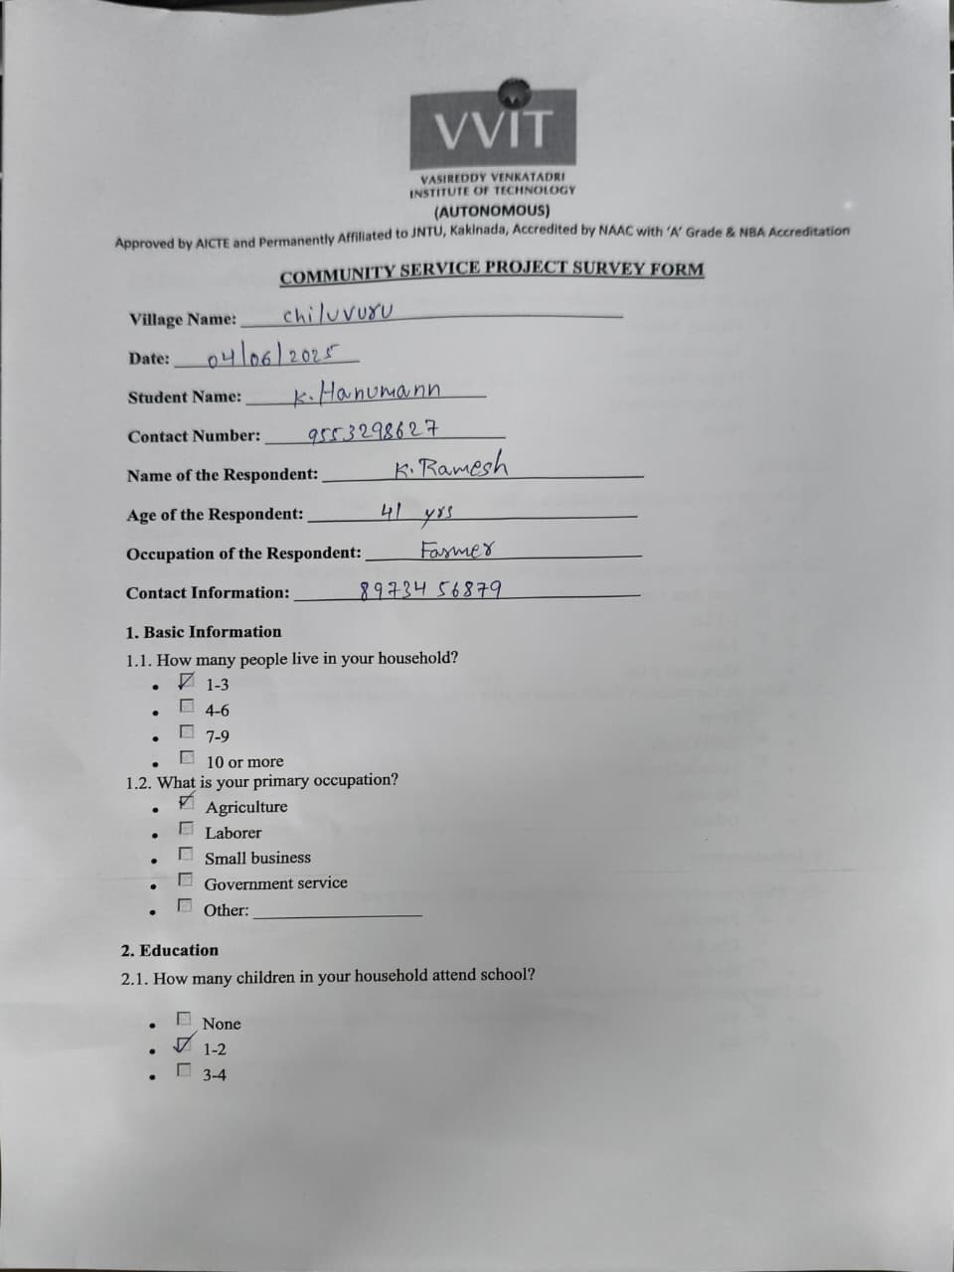
Sample Survey Form Data:

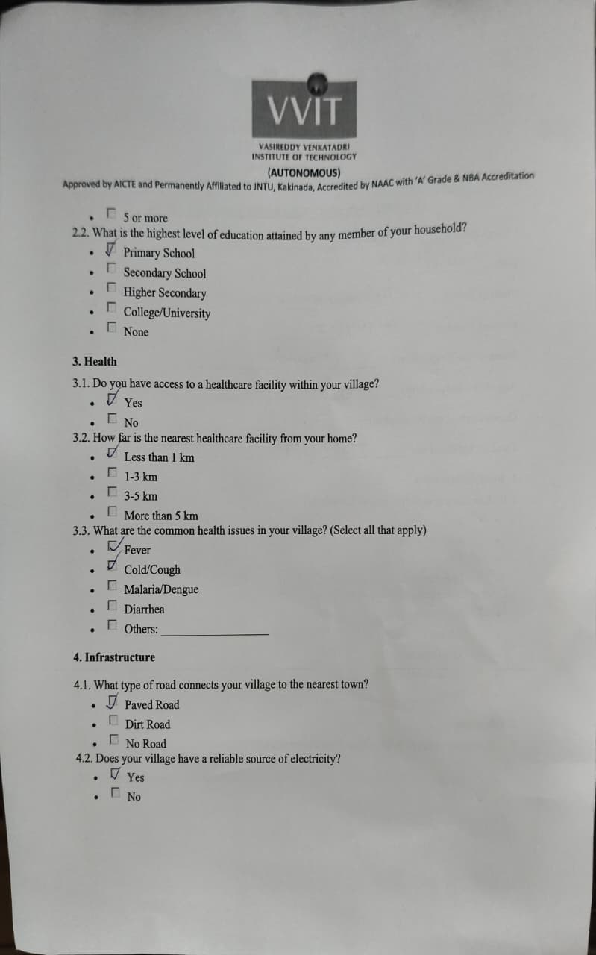

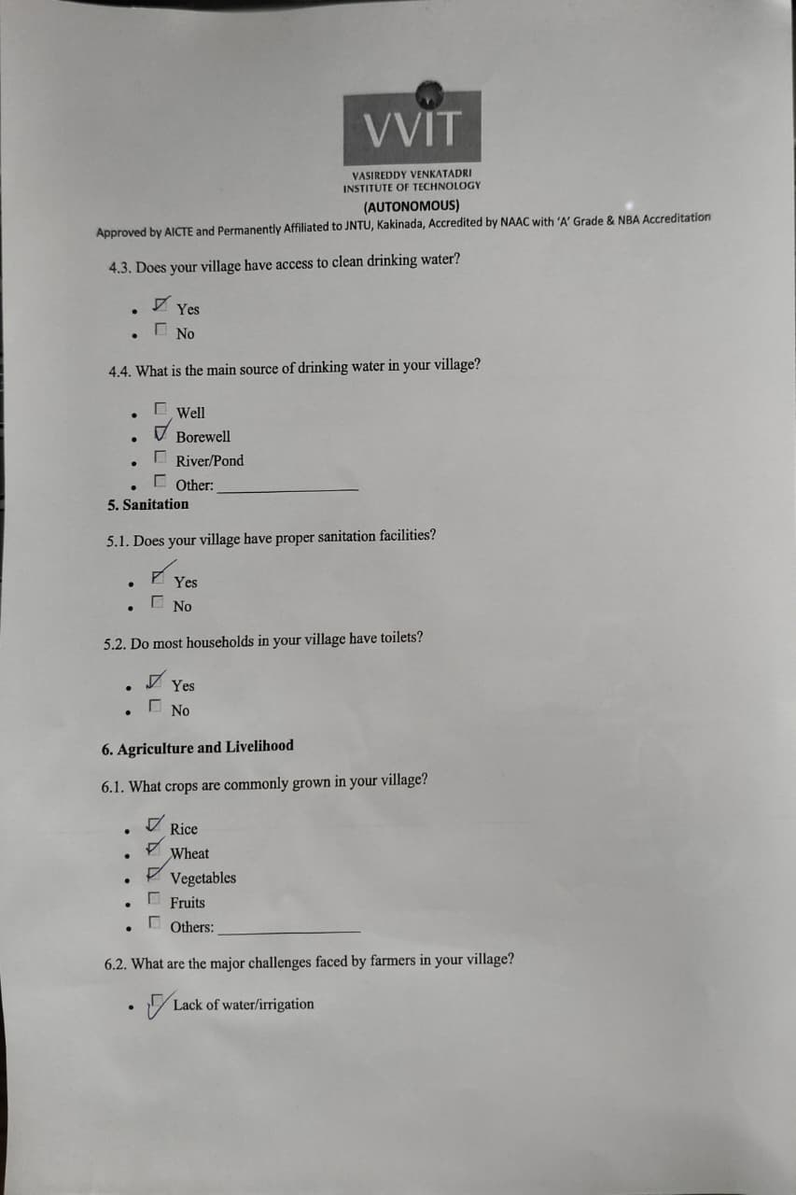
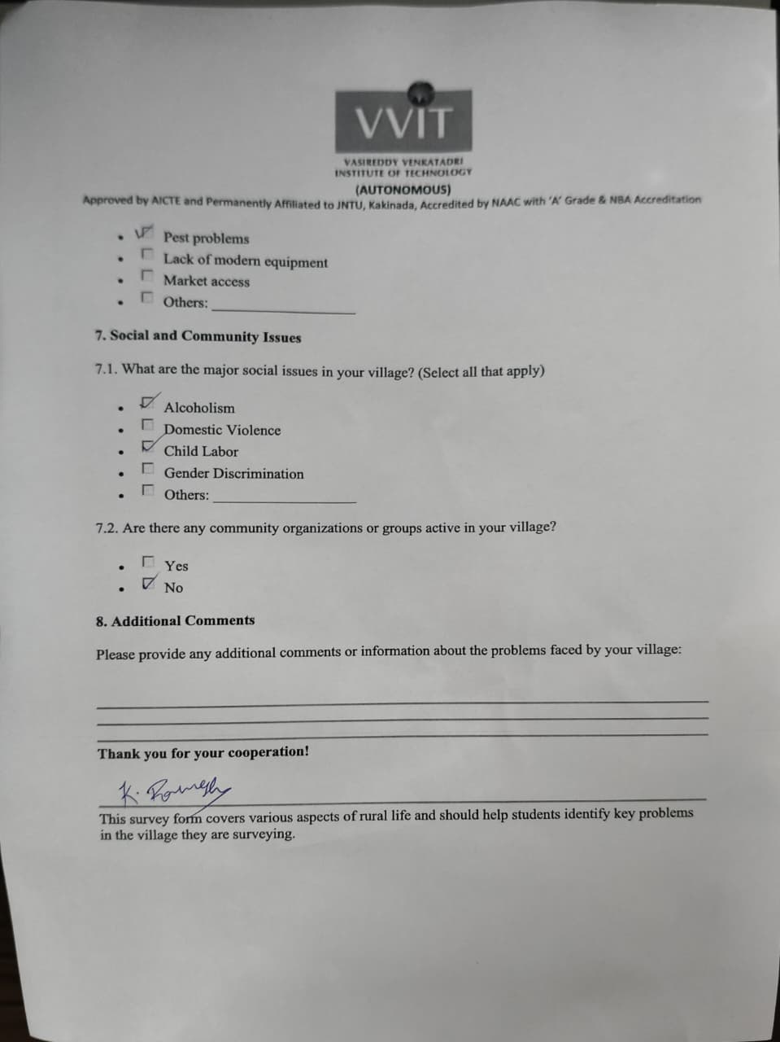

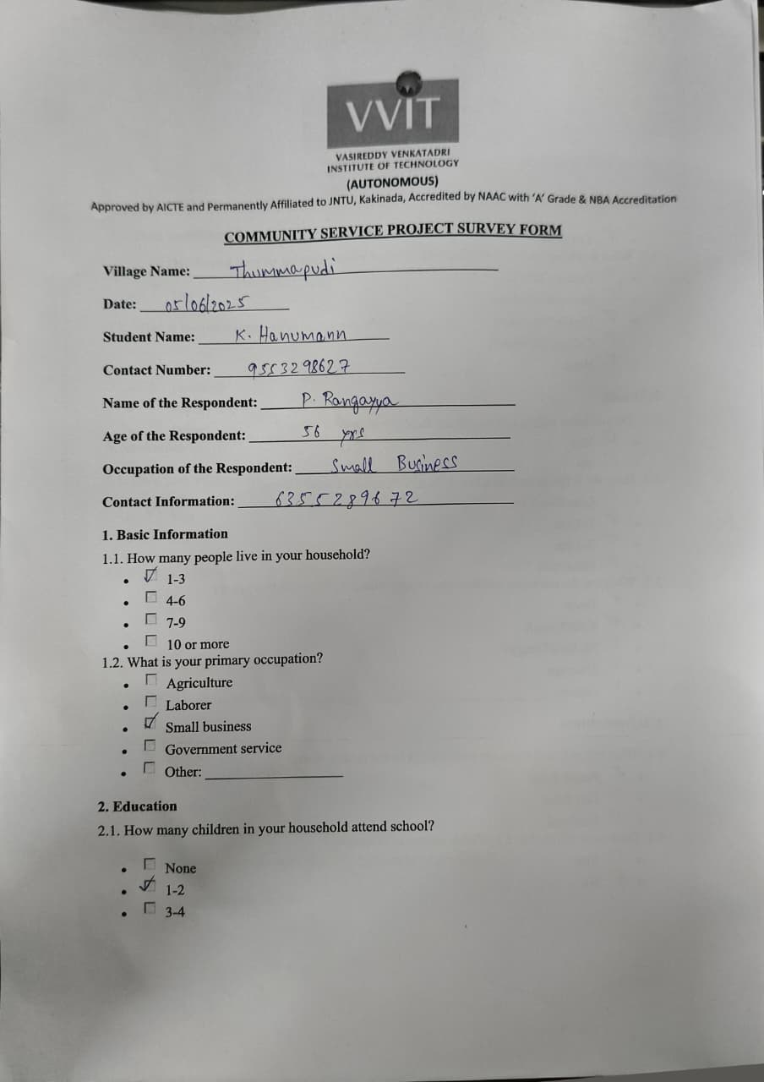

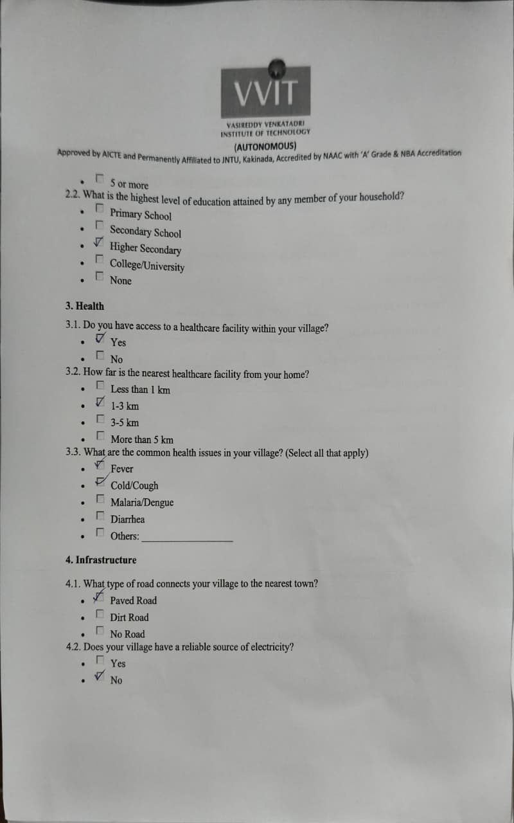

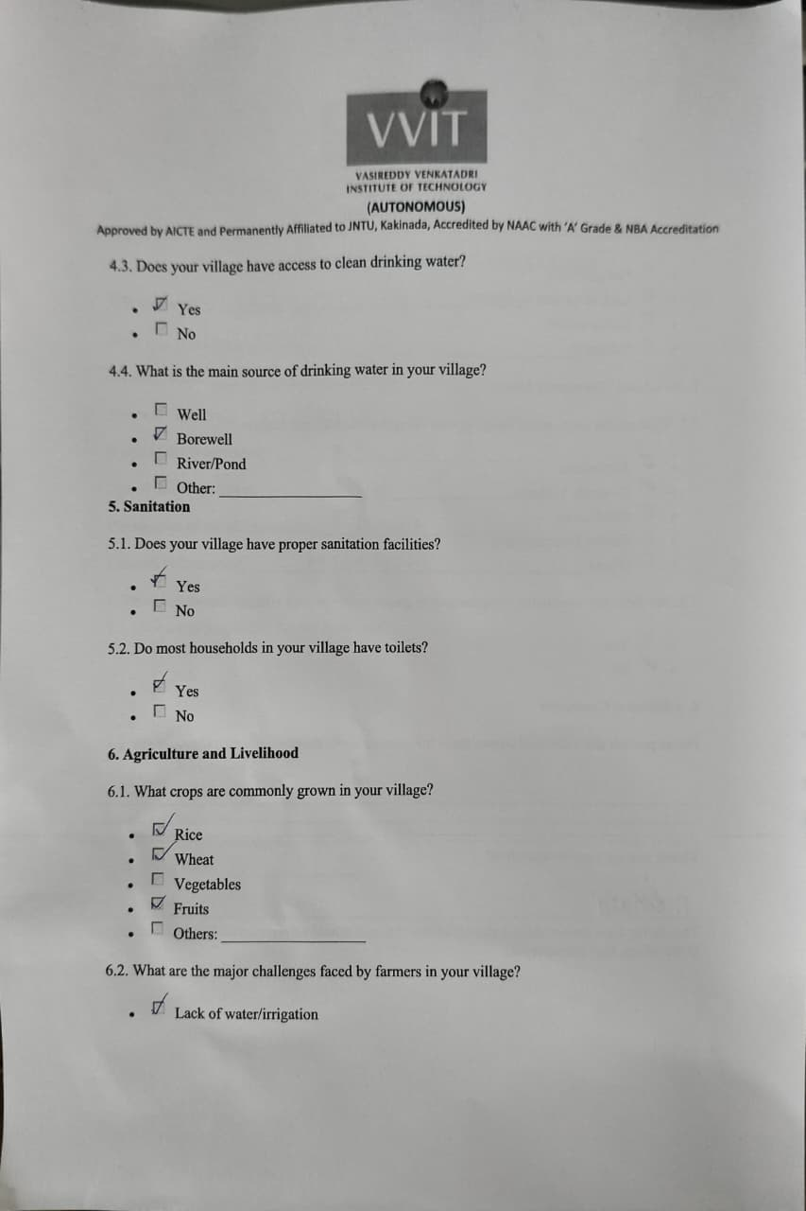



Data Collection Photos:

Date : 05/06/2025
Respondents Name : Kucka Yuvaam
Age : 45
Education : N/A
Major Source of Income : Farming
Children : 1 Daughter, 1 Son
Family Details : 2 male and 2 female
Family Income : below. 1 lakhs Notable Issues in the village : Improper Health Care

Photo with the Respondent :

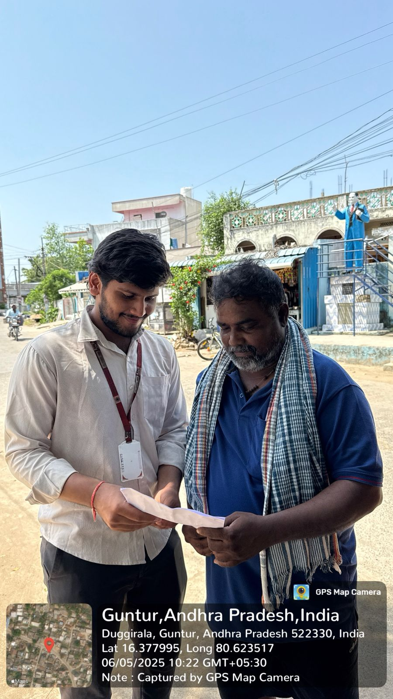

Date : 05/06/2025
Respondents Name : Ram Krishna Reddy
Age : 46
Education : N/A
Major Source of Income : Farming
Children : 1 Daughter
Family Details : 1 male and 2 female
Family Income : below. 1.5 lakhs Notable Issues in the village : Improper Health Care
Photo with the Respondent :

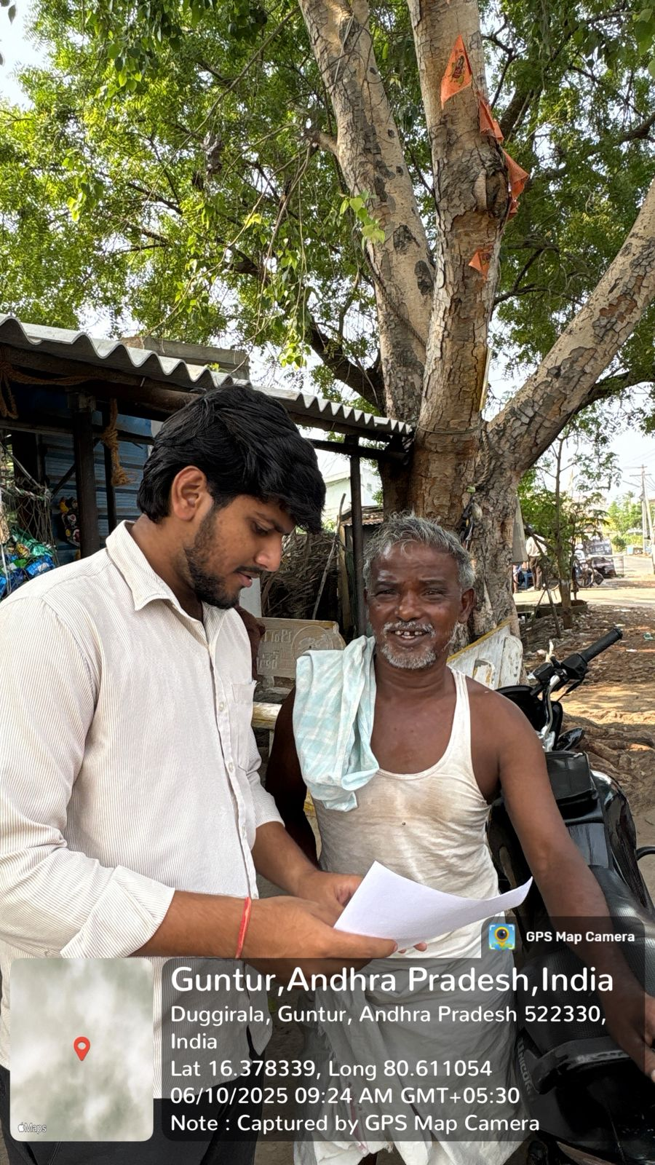

Date : 11/06/2025
Respondents Name : Ramarao Narra
Age : 78
Education : N/A
Major Source of Income : Farming
Children : 1 Daughter
Family Details : 1 male and 2 female
Family Income : approx. 1.5 lakhs Notable Issues in the village : Lack of Water Resources
Photo with the Respondent :

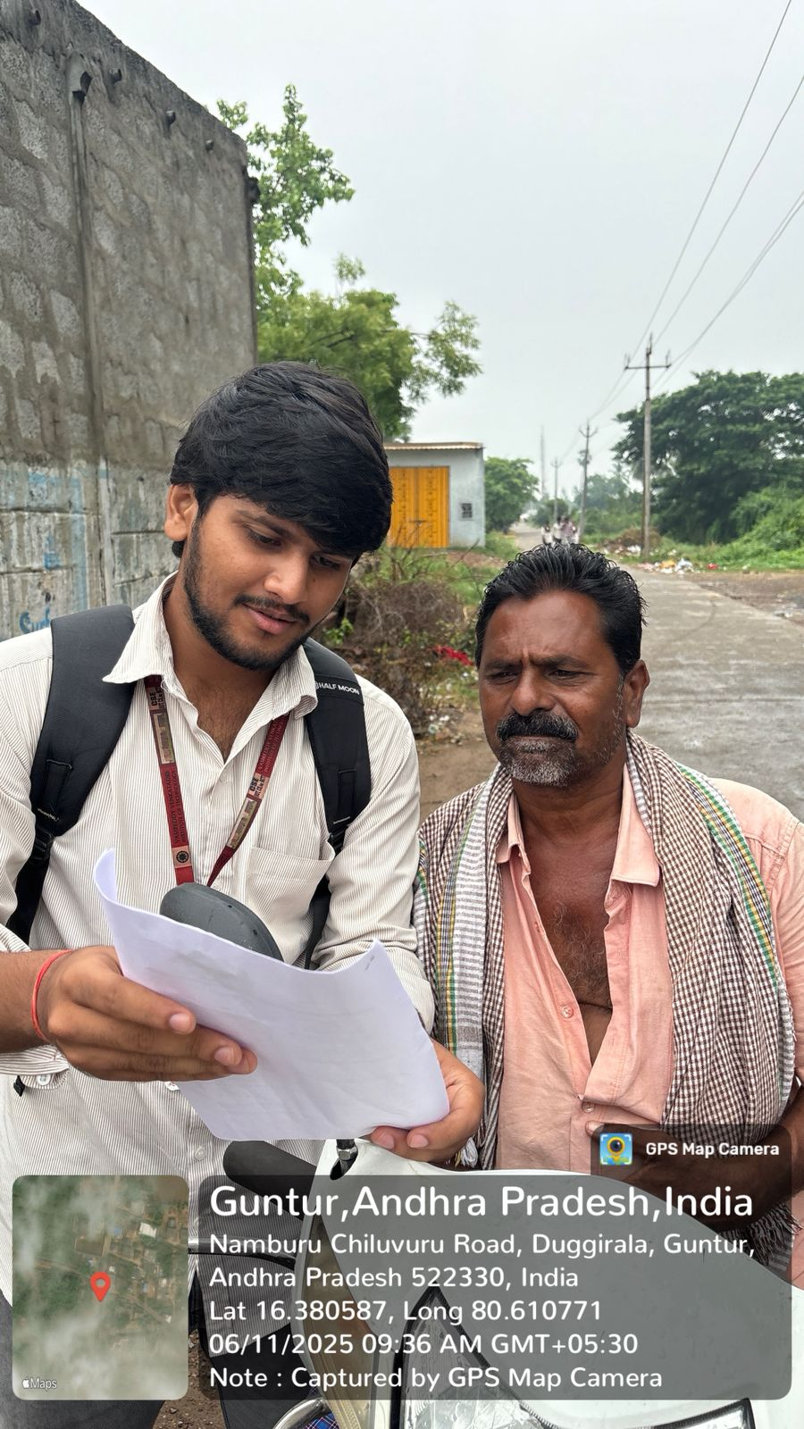
Date : 11/06/2025
Respondents Name : P.Anjamma
Age : 43
Education : N/A
Major Source of Income : Labor at Spinning Mill
Children : 1 Daughter, 1 Son
Family Details : 2 male and 2 female
Family Income : below 1.5 lakh
Notable Issues in the village : Cleanliness of Roads
Photo with the Respondent :

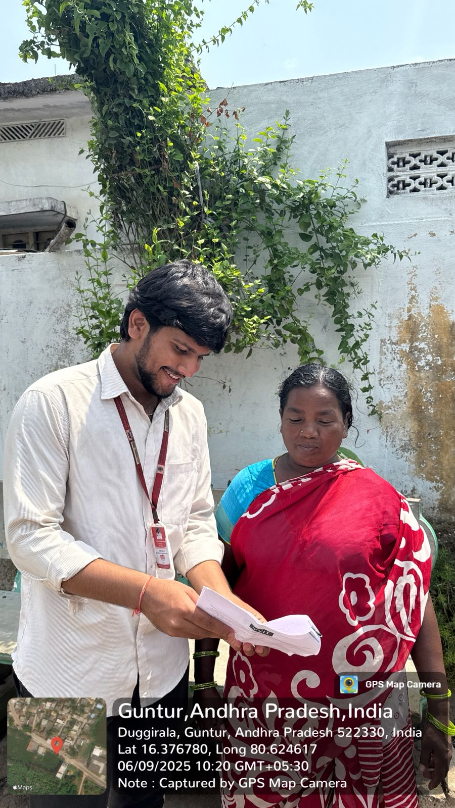

Project Submission to Client:
