**NAME:**

**EES:1030:BBB Take home lab (Lab #2)**

**Plate Tectonics & Earthquakes**

**HANDED OUT: The week of August 27th for labs the week of September 3rd, 2018**

**DUE: The week of September 10th**

This assignment is designed to familiarize you with plate tectonics: specifically with the plate boundaries closest to your home OR a place of interest. We want you to understand the general effects of plate boundaries on your life (if there are any). This assignment should be completed INDEPENDENTLY. Choose either your hometown OR a place of interest (whichever you prefer) and use it throughout the entire assignment. Fill this out DIRECTLY in this word document-please do not change the numbers on any of these questions. You will submit this assignment electronically on ICON/Canvas by 11:59 PM on the day of your lab during the week of September 10th.

1. What is the nearest tectonic plate boundary to your location? Paste an image from Google Maps/Google Earth with your location and the plate boundary both labeled below. Also label the names of the major plates. If you’re unsure where the boundaries are or what they would look like, I recommend page 41 of your textbook.

PASTE IMAGE HERE!

1. Are there any obvious features associated with this plate boundary? See if you can find any features on Google Maps/Google Earth. You can look for ridges/mountain ranges/linear features/trenches/etc.
2. What kind of plate boundary is it (divergent, convergent, transform)?
3. How fast is it moving? One good source to find this information is this site: <http://www.unavco.org/software/geodetic-utilities/plate-motion-calculator/plate-motion-calculator.html> -all you need to fill out is the latitude and longitude, then ignore all of the other boxes, scroll to the bottom of the form, and hit “submit”. To get your latitude and longitude, locate your location of choice on GoogleMaps, right click on any place on the map, and select “What’s Here?”. This will make the latitude and longitude of your selected spot pop up in the search bar. I would like the speed in mm/year.

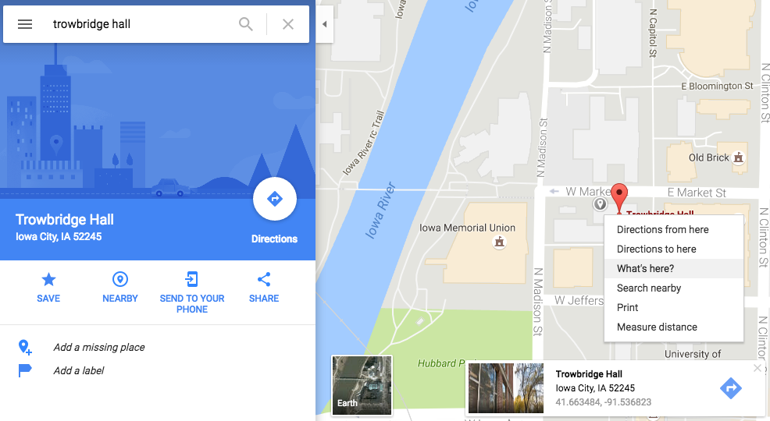

Here’s a screen shot of me right clicking on the map-“What’s here?” is highlighted. Note that the coordinates pop up on the bottom of the screen,

Here is the UNAVCO plate motion calculator. You ONLY need to fill out these top two boxes that I have filled out with latitude and longitude and can ignore everything else. For output, go with the top selection from the drop down menu. We only want “Speed mm/yr”-you can ignore the rest of the table.

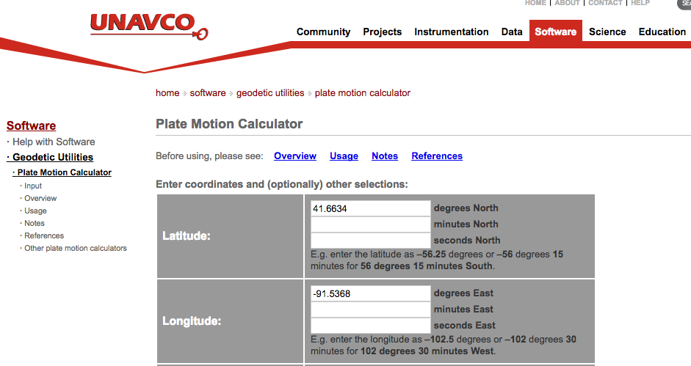

1. Have you ever felt an earthquake? (Yes/No).
2. Let’s see if there have been any earthquakes near your location!

To locate an earthquake near your location, go to: <https://earthquake.usgs.gov/earthquakes/search/>

You will use the top “Basic Options” for your search. The values you should fill in are Magnitude (set your minimum at 2.5+) Date & Time (I went back about 30 years for my search-I recommend going back approximately this far), and Geographic Region (select “Custom” and click “Draw Rectangle on Map” to choose your area). You can play with input data until you find an earthquake-lower your magnitude (raise it if you get a lot of earthquakes), lengthen your time range, or increase your rectangle size. See what I filled in below:

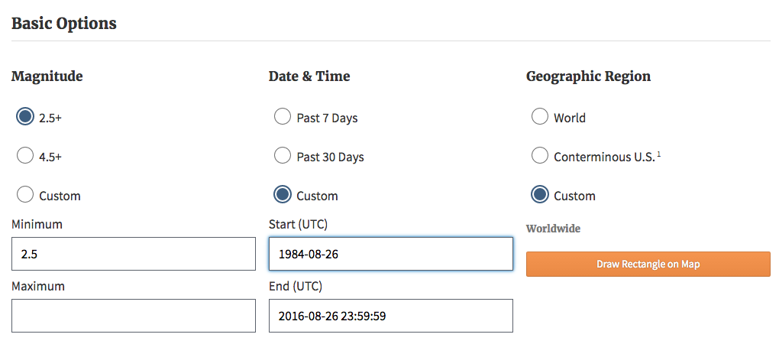

The search button is at the bottom of the page below your other search options.

**Your input**

Magnitude:

Date & Time:

1. What is the magnitude, location (latitude/longitude) and date of the most recent earthquake?
2. What is the BIGGEST earthquake on record for that location (magnitude, location, and date)?
3. If you look at the location of the biggest earthquake into Google Maps, does it look like it is on a plate boundary? If so, what kind?