|  |
| --- |
| Frostburg State University |
| COSC 470 Compiler Project: User Manual |
| *PL/SQL Scripting Language Compiler* |
|  |
| **Daniel Herold** |
| **5/17/2014** |

|  |
| --- |
| Version 2 of my compiler project for COSC 470 in the Spring 2014 semester. |

Contents

List of Tables 2

List of Figures 2

Introduction 4

How to Start 4

Data Types 5

Operators 5

Condition Statements 6

Loops 6

Print Statements 7

User Input 7

Comments 7

Appendix A: Syntax Diagram i

Block i

Declarations i

Declare_rest i

Default i

Data_type ii

Characters ii

Size ii

Size_option ii

Numbers iii

Compound_statement iii

Optional_statements iii

Statement_list iii

Statement iv

Lefthandside iv

Righthandside v

Expression v

Simple_expression v

Term v

Factor vi

Relop vii

Addop vii

Mulop viii

Appendix B: Error Messages viii

Type Mismatch Exception viii

End of File Exception viii

Max ID Size Error viii

Max INT Size Exception viii

Max SMALLINT Size Exception viii

Index ix

# List of Tables

Table 1: Data Types 5

Table 2: Arithmetic Operators 5

Table 3: Relational Operators 5

Table 4: Print Statements 7

# List of Figures

Figure 1: block i

Figure 2: declarations i

Figure 3: declare_rest i

Figure 4: default i

Figure 5: data_type ii

Figure 6: characters ii

Figure 7: size ii

Figure 8: size_option ii

Figure 9: numbers iii

Figure 10: compound_statement iii

Figure 11: optional_statements iii

Figure 12: statement_list iii

Figure 13: statement iv

Figure 14: lefthandside iv

Figure 15: righthandside v

Figure 16: expression v

Figure 17: simple_expression v

Figure 18: term v

Figure 19: factor vi

Figure 20: relop vii

Figure 21: addop vii

Figure 22: mulop viii

# Introduction

In order to complete the course COSC 470, Compiler Design and Implementation, we were tasked with creating a compiler for a LALR grammar for a PL/SQL scripting language. I used the Java programming language to implement my compiler. I made use of the following: a lexical analyzer, a semantic analyzer, and an intermediate code generator. The code generator output is sent through the Intermediate Code mini-Assembler, which was written in Java, written by Truman Parks Boyer in June 2003. This program translates mini-assembler instruction files into a file of raw integer quadruples. The output from mini is sent through the mini-Intermediate Code Engine (mICE), also developed by Truman Parks Boyer. mICE runs the code and runs all the commands from the source program.

# How to Start

The first thing one must do to use my compiler, is unzip the file *Compiler_Working_djherold0.zip*. Then import the source files into a Java-based IDE, preferably Netbeans. Now a program must be written to put through the compiler. The following is a simple example of the syntax of the language:

DECLARE

my_int NUMBER() := 2;

BEGIN

DBMS_OUTPUT.PUT_LINE(my_int)

END;

$

The DECLARE section is where all variables are declared. They are case sensitive. Variables cannot be declared in the body of the code. Variables are declared as follows:

identifier TYPE ;

or they can be declared and assigned:

identifier TYPE assignment_op value ;

The maximum size of an identifier is 20 characters. Identifiers may contain underscores (_), letters, and digits, and must start with a letter.

BEGIN starts a block and END terminates a block. The last statement in a block does not need a semi-colon at the end of it. Anywhere NULL is placed, a semi-colon must follow (i.e. NULL;).

The body of the code, DBMS_OUTPUT.PUT_LINE(my_int), tells the system to output the value of the variable my_int to the screen and also write to a new line. The program must end with a dollar sign ($).

# Data Types

This scripting language supports 6 data types:

|  |  |  |
| --- | --- | --- |
| BOOLEAN | True/false |  |
| INT | Numbers go here | Do not need to declare size, cannot be more than 8 digits |
| NUMBER | This type is for a number | Do not need to declare size |
| SMALLINT | Integers of small sizes | Cannot be more than 4 digits |
| POSITIVE | Positive numbers only | Cannot be negative |
| CHAR | Single characters | Single characters, in apostrophes (‘ ‘) |

Table : Data Types

Size is the maximum number of digits that variable can hold. If variables do not have a size declared, the parentheses must still follow, as in the above example program.

# Operators

The following operators are supported for arithmetic operations on INT, NUMBER, SMALLINT, and POSITIVE data types:

|  |  |
| --- | --- |
| + | Addition |
| - | Subtraction |
| * | Multiplication |
| / | Division |
| MOD | Modulus |

Table : Arithmetic Operators

The Following relational operators are supported:

|  |  |
| --- | --- |
| < | Less than |
| <= | Less than or equal to |
| = | Equal to |
| >= | Greater than or equal to |
| > | Greater than |
| <> | Not equal to |

Table : Relational Operators

The reserved word NOT negates numbers or Boolean values.

# Condition Statements

Conditional statements are supported by my compiler and have the form:

IF condition THEN

Statement

END IF

Condition represents a Boolean relation (e.g. a < b), and statement is the thing to carry out if the condition is true. If there is only 1 statement, BEGIN and END reserved words are not required surrounding the statement, and a semi-colon is not needed at the end of the statement. However, if the block contains more than 1 statement, it requires the reserved words BEGIN and END, following the form:

IF condition THEN

BEGIN

Statement1;

Statement2

END;

END IF

# Loops

This language supports WHILE loops, which check the condition at the beginning of each loop and execute the statements if the condition is true. Loops have the following form:

WHILE condition LOOP

Statement

END LOOP

As with conditional statements, if there are multiple statements in the body of a loop they must have the BEGIN and END reserved words, as follows:

WHILE condition LOOP

BEGIN

Statement1;

Statement2

END;

END LOOP

# Print Statements

The language allows several print statements to be made:

|  |  |
| --- | --- |
| DBMS_OUTPUT.PUT | Prints a value and stays on the line |
| DBMS_OUTPUT.PUT_LINE | Prints a value and moves to a new line |
| DBMS_OUTPUT.NEW_LINE | Moves to a new line |

Table : Print Statements

# User Input

The language supports user input: wherever an ampersand (&) appears before variables, it represents user input. For example, &my_num means my_num will be a variable whose value is determined by user input.

# Comments

My compiler supports 2 forms of comments:

|  |  |
| --- | --- |
| -- | Single line comments; only last for the remainder of the line the where they appear |
| /* */ | Multiple line comments; start at the opening (/*) and continue until the terminator is reached (*/) |

# Appendix A: Syntax Diagram

## Block



Figure : block

Block ::= declarations compound_statment '$'

## Declarations

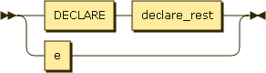

Figure : declarations

declarations ::= DECLARE declare_rest

| e

## Declare_rest

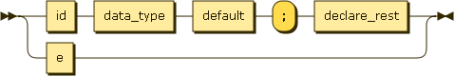

Figure : declare_rest

declare_rest ::= id data_type default ';' declare_rest

| e

## Default

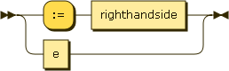

Figure : default

default ::= ':=' righthandside

| e

## Data_type

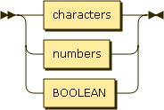

Figure : data_type

data_type ::= characters

| numbers

| BOOLEAN

## Characters



Figure : characters

characters ::= CHAR

## Size

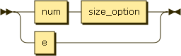

Figure : size

size ::= num size_option

| e

## Size_option

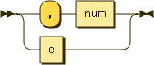

Figure : size_option

size_option ::= ',' num

| e

## Numbers

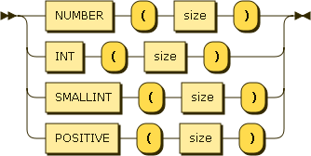

Figure : numbers

numbers ::= NUMBER '(' size ')'

| INT '(' size ')'

| SMALLINT '(' size ')'

| POSITIVE '(' size ')'

## Compound_statement



Figure : compound_statement

compound_statement ::= BEGIN optional_statements END ';'

## Optional_statements

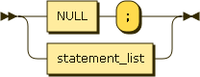

Figure : optional_statements

optional_statements ::= NULL ';'

| statement_list

## Statement_list

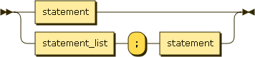

Figure : statement_list

statement_list ::= statement

| statement_list ';' statement

## Statement

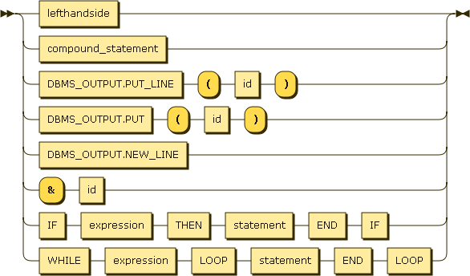

Figure : statement

statement ::= lefthandside

| compound_statement

| DBMS_OUTPUT.PUT_LINE '(' id ')'

| DBMS_OUTPUT.PUT '(' id ')'

| DBMS_OUTPUT.NEW_LINE

| '&' id

| IF expression THEN statement END IF

| WHILE expression LOOP statement END LOOP

## Lefthandside



Figure : lefthandside

lefthandside ::= id ':=' righthandside

## Righthandside

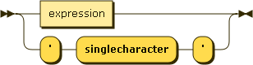

Figure : righthandside

righthandside ::= expression

| "'" 'singlecharacter' "'"

## Expression

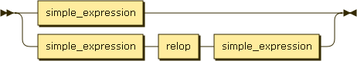

Figure : expression

expression ::= simple_expression

| simple_expression relop simple_expression

## Simple_expression

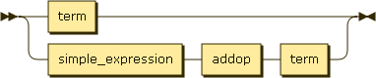

Figure : simple_expression

simple_expression ::= term

| simple_expression addop term

## Term

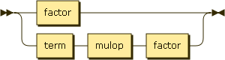

Figure : term

term ::= factor

| term mulop factor

## Factor

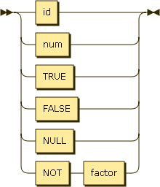

Figure : factor

factor ::= id

| num

| TRUE

| FALSE

| NULL

| NOT factor

## Relop

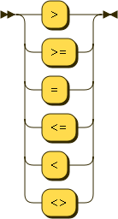

Figure : relop

relop ::= '>'

| '>='

| '='

| '<='

| '<'

| '<>'

## Addop

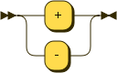

Figure : addop

addop ::= '+'

| '-'

## Mulop

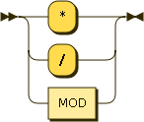

Figure : mulop

mulop ::= '*'

| '/'

| MOD

# Appendix B: Error Messages

## Type Mismatch Exception

This error is thrown when a variable is not assigned the correct type, or if TRUE is trying to be added to 5.

## End of File Exception

This error is thrown when scanning in the source file and reaching the end of file before seeing the dollar sign ($).

## Max ID Size Error

This error is thrown when an identifier is used that is more than 20 characters long.

## Max INT Size Exception

This error is thrown when an INT has more than 8 digits in it.

## Max SMALLINT Size Exception

This error is thrown when a SMALLINT has more than 4 digits.

# Index

Comments, 7

Conditional Statements, 6

Data Types, 5

Error Messages, viii

Loops, 6

Operators, 5

Print Statements, 7

Syntax Diagrams, i

User Input, 7