30 October 2013

Dear Dr. Chris Lortie,

I am submitting a revision of the manuscript, “Comparing influence of ecology journals using citation-based indices: making sense of a multitude of metrics” for consideration in the Future of Publishing section of Ideas in Ecology and Evolution. The changes and responses to reviewers are detailed below.

Response to Reviewer 1: Ethan White
Because of potential confusion with comparisons, I changed all correlations to Spearman correlations. This should avoid problems with comparisons between Pearson and Spearman correlations. Spearman was appropriate for all pairwise comparisons because it assumes monotonic, but not necessarily linear relationships. This was clarified in the text (methods and results) and in figure 1. It did not change any of the interpretation in the discussion.

I added a Principal Components Analysis as suggested by Dr. White. The methods are described on lines 85-88. The results are presented on lines 112-115 and in figure 2. The results are discussed on lines 122-132 at the beginning of the discussion and around line 209.

Upon rereading what I wrote, I see Dr. White was correct in suggesting that I was unclear about the primary focus of the San Francisco DORA. I clarified this as suggested near the end of the discussion in lines ~280-285. I also included reference to Garfield 2006 where the creator of the JIF indicates that it should not be used to evaluate researchers based on the journals they publish in.

Table 2. clarified the Eigenfactor and Article influence background trends as stable based on examination of data from Eigenfactor.org.

I made all of the minor wording and grammatical corrections suggested by Dr. White.

Response to Reviewer 2: Carl Bergstrom
I relation to the PCA added in response to Dr. White’s suggestions, I also include discussion of the Bollen et al. 2009 paper suggested by Dr. Bergstrom.

I added the reference to the West et al. 2010 paper that was apparently missing, most notably from the first sentence of the discussion. The reference was likely lost during a previous revision, because my interpretation of the correlations was influenced significantly by this paper.

My attempt to generalize the interpretation of the network metrics led to a misinterpretation with respect to Molecular Ecology and American Naturalist, as Dr. Bergstrom noted. I have modified the language and interpretation as per the suggestions around lines 147-154.

This manuscript represents original research performed by the stated author and I agree with the contents of the manuscript. No part of the manuscript has been published elsewhere, nor is it in consideration for publication elsewhere, although I did archive a draft on the PeerJ preprint server: https://peerj.com/preprints/43/ . All research not carried out by the author is duly cited. I hope that this manuscript is well received and deemed appropriate for Ideas in Ecology and Evolution.

Sincerely,

Daniel J. Hocking

Comparing the influence of ecology journals using citation-based indices: making sense of a multitude of metrics

Daniel J. Hocking

Daniel J. Hocking (dhocking@unh.edu), Department of Natural Resources and the Environment, University of New Hampshire, Durham, New Hampshire 03824 USA

Abstract
The links among scholarly citations creates a network that reveals patterns of influence and flows of ideas. The systematic evaluation of these networks can be used to create aggregate measures of journal influence. To understand the citation patterns and compare influence among ecology journals, I compiled 11 popular metrics for 110 ecology journals: Journal Impact Factor (JIF), 5-year Journal Impact Factor (JIF5), Eigenfactor, Article Influence (AI), Source-Normalized Impact per Paper (SNIP), SCImago Journal Report (SJR), h-index, h_{c}-index, e-index, g-index, and AR-index. All metrics were positively correlated among ecology journals; however, there was still considerable variation among metrics. Annual Review of Ecology, Evolution, and Systematics, Trends in Ecology and Evolution, and Ecology Letters were the top three journals across metrics on a per article basis. Proceedings of the Royal Society B, Ecology, and Molecular Ecology had the greatest overall influence on science, as indicated by the Eigenfactor. There was much greater variability among the other metrics because they focus on the mostly highly cited papers from each journal. Each influence metric has its own strengths and weaknesses, and therefore its own uses. Researchers interested in the average influence of articles in a journal would be best served by referring to AI scores. Despite the usefulness of citation-based metrics, they should not be overly emphasized by publishers and they should be avoided by granting agencies and in personnel decisions. Finally, citation-based metrics only capture one aspect of scientific influence, they do not consider the influence on legislation, land-use practices, public perception, or other effects outside of the publishing network.

Keywords: Citation metrics, impact factor, Article Influence, h-index, bibliometrics, scientometric indices

Introduction
Citations serve as a link to previously published materials and provide credit for original ideas. Citation-based metrics can indicate the influence of ideas from particular papers and in aggregate act as a proxy for influence of specific scholars and journals (e.g. Garfield 1955, Garfield 1972, Davis 2008). The competitive nature of academia and scientific publishing further increases the interest in metrics of influence, impact, and prestige. The perceived importance of journals, as indicated by citation metrics, can influence the choice of publication venue for scientists. Some researchers may even make submission decisions based on a cost-benefit analysis, where financial cost or journal rejection rate trade-off against the benefit of publishing in highly prestigious or influential journals (Aarssen et al. 2008). In addition to the general interest in objective metrics of influence, these metrics are increasingly used for hiring decisions and promotion and tenure evaluation, although journal-level metrics should not be used to evaluate researchers (Garfield 2006, Hoppeler 2013). Metrics are also used by librarians to inform journal subscription decisions, which was one of the primary goals of early metric development. Use by librarians may become increasingly important with the rising number of journals and challenges of funding higher education. Publishers use metrics to promote their journals and understand their influence over time and in relation to other publishers. Citation-based metrics have even been extended to compare the productivity and influence of universities and departments (Fogg 2007).
The most widely know metric of journal influence is the Thompson Reuters Journal Impact Factor (JIF). The JIF is published annually in the Journal Citations Report (JCR) and made available through Web of Science. The JIF represents the mean number of citations per article for a given journal over a two-year time frame (Table 1). Many publishers highlight the JIF on the websites for their journals, including Ecology Letters, which advertises a JIF of 17.557 and a ranking of 1/134 among ecology journals (http://onlinelibrary.wiley.com; retrieved 25 May 2013). However, being the most prominent influence metric comes with the cost of frequent and widespread criticisms (e.g. Colquhoun 2003, Smith 2008, Wilcox 2008, Pendlebury 2009). Criticisms of the JIF include 1) limitations of the citable materials in the Thompson Reuters ISI Web of Science database (i.e. books and not all journals are included in the database; Harzing and van der Wal 2007, Pendlebury 2009), 2) free citations from letters and editorials that are included in the citation count (numerator) but not included in the denominator number of substantial articles (Seglen 1997, Cameron 2005), 3) insufficient time period biased to rapid production journals (McGarty 2000, Cameron 2005), 4) inappropriate distributional representation by using a mean from a skewed distribution (Seglen 1997, Falagas and Alexiou 2008), 5) excessive influence of review articles that biases metrics among some journals (Cameron 2005), 6) inflation of the JIF over time (Neff and Olden 2010), 7) over simplification of journal influence (Pendlebury 2009), 8) difficulty of comparing journals across disciplines and the influence of multidisciplinary journals (Cameron 2005, Pendlebury 2009), 9) exclusion of many journals from the database (Cameron 2005, Pendlebury 2009), and 10) ease of manipulation by publishers to increase their JIF through altered publication practices (Falagas and Alexiou 2008).

Table 1. Definitions of journal influence metrics

Influence Metric | Basic Definition | Reference
Journal Impact Factor (JIF) | Number of citations in the current year to items published in the previous 2 years divided by number of substantive articles published in the same 2 years | Garfield 2006
Five-year Journal Impact Factor (JIF5) | Same as the JIF but calculated using articles published over a 5 year time frame | http://wokinfo.com/essays/impact-factor/
Eigenfactor | Percent of citations across all journals linked to each journal through network using eigenvector centrality methods | Bergstrom 2007, West et al. 2010a
Article Influence (AI) | Eigenfactor divided by number of articles published by the journal, scaled by multiplying by 0.01 | West and Bergstrom 2008
Source Normalized Impact per Paper (SNIP) | Corrects for differences in publications characteristics across fields by dividing the impact factor by the database citation potential within each field of study | Colledge et al. 2010, Waltman et al. 2013
SCImago Journal Rank (SJR)* | Influence of journals based on network of citations on a per article basis, weighing citations from prestigious and similar journals | Colledge et al. 2010, Guerrero-Bote and Moya-Anegón 2012
h-index | Number of papers that have at least h citations | Hirsch 2005, Harzing and van der Wal 2009
Contemporary h-index (h_{c}-index) | Age-adjusted version of the h-index † | Sidiropoulos et al. 2007
e-index | Square-root of the number of citations above the h-index | Zhang 2009
g-index | Number of papers that have at least g² citations | Egghe 2006
AR-index ‡ | Square-root of the sum of citations divided by the age of the article for all articles contributing to the h-index | Jin 2007, Jin et al. 2007
*Adjustment to the original SJR sometimes referred to as SJR2
†gamma=4 and delta=1 for this study.
‡Reported as AW-index by Publish or Perish Software

In response to these criticisms, numerous other citation-based metrics have been proposed. These range from slight adjustments to address some of the JIF limitations to metrics based on different conceptual frameworks. Here I compare 11 strictly citation-based metrics for ecology journals: Journal Impact Factor (JIF), 5-year Journal Impact Factor (JIF5), Eigenfactor, Article Influence (AI), h-index, contemporary h-index (h_{c}-index), e-index, g-index, AR-index, Source-Normalized Impact per Paper (SNIP), and SCImago Journal Factor (SJR). Brief definitions are found in Table 1, characteristics are found in Table 2. Inference related to influence and citation patterns among ecology journals varies by metric. I explore the relationships among these metrics, discuss their interpretation, and make suggestions related to the use of each metric for ecologists. All the metrics I considered are still citation based and do not consider other forms of influence or impact. There are alternative metrics (Altmetrics; www.altmetric.com) that include article downloads, ratings on websites, and Internet links via websites, blog posts, and even Twitter. These Altmetrics are beyond the scope of this paper but may be useful for appreciating the full reach of particular papers and for inclusion in grant reports.

Table 2. Characteristics of journal influence metrics
Influence Metric | Database | Time Frame | Adjusted per Article | Age-adjusted | Network Weight | Closeness Weight | Journal Self Citations | Background Trend
JIF | Web of Science | 2 years | ✓ |  |  |  | Included | Increasing
JIF5 | Web of Science | 5 years | ✓ |  |  |  | Included | Increasing
AI | Web of Science | 5 years | ✓ |  | ✓ |  | Excluded | Stable
Eigenfactor | Web of Science | 5 years |  |  | ✓ |  | Excluded | Stable
SNIP | Scopus | 3 years | ✓ |  |  |  | Included | Increasing
SJR | Scopus | 3 years | ✓ (rate) |  | ✓ | ✓ | Limited | Stable
h-index | Google Scholar | 5 years |  |  |  |  | Included | Increasing
h_{c}-index | Google Scholar | 5 years |  | ✓ |  |  | Included | Increasing
e-index | Google Scholar | 5 years |  |  |  |  | Included | Increasing
g-index | Google Scholar | 5 years |  |  |  |  | Included | Increasing
AR-index | Google Scholar | 5 years |  | ✓ |  |  | Included | Increasing

Methods
I identified 134 ecology-related journals based on the Web of Science (WoS) Journal Citation Reports (JCR) Ecology category. For these journals, I downloaded the Journal Impact Factor, 5-year journal impact factor, EigenfactorTM, and Article Importance from WoS (retrieved 05 April 2013, http://admin-apps.webofknowledge.com.libproxy.unh.edu/JCR/JCR?RQ=HOME). I used Publish or Perish software (Harzing 2007) to search Google Scholar and calculate the h-index, h_{c}-index, g-index, e-index, and AR-index (reported as AW-index by Publish or Perish). I removed all results from Google Scholar for articles with incorrectly identified journals or other errors. All metrics of importance were calculated for articles published in the 5-year interval from 2007 – 2011. The metrics derived from Google Scholar include citations from the date of publication until the date of the query (05 – 25 April 2013). I downloaded the 2011 SNIP and SJR metrics from www.journalmetrics.com (retrieved 13 May 2013) for these same journals. To examine relationships among metrics, I calculated the pairwise correlations among all metrics using Spearman correlations to account for pairs exhibiting deviations from linearity. Three journals with fewer than 50 articles identified in Google Scholar searches and journals with incomplete data (i.e. inability to calculate 1 or more metrics) were excluded from the analyses. To further evaluate multidimensional covariance relationships among the 11 metrics, I conducted a Principal Components Analysis (PCA) on the Spearman rank correlations between each pairwise metric rankings (sensu Bollen et al. 2009). I conducted the PCA in R (R Core Team 2013) using the FactoMineR package (Husson et al. 2013).

Results
I compiled 1,084,169 citations for 63,868 articles from 131 ecology journals from Google Scholar searches for articles published from 2007 – 2011. These were combined with data from the 2011 Thompson Reuters Journal Citations Report (JCR) accessed on the Web of Science, and data from the Scopus database. From these sources, I had sufficient data to estimate all metrics for 110 journals. The scale and range of values differed considerably among metrics. From the JCR, the mean JIF was 2.93 (range: 0.043 – 17.557), with Ecology Letters having the highest JIF. The mean JIF5 was 3.31 (range: 0.134 – 18.007), the Article Influence mean was 1.28 (range: 0.049 – 9.273), and Eigenfactor mean was 0.0148 (range: 0.00026 – 0.09614). From the results of Google Scholar searches, I estimated mean values for h-index, hc-index, g-index, e-index, and AR-index of 35.1 (range: 5 – 103), 28.3 (range: 5 – 84), 50.3 (range: 6 – 151), 29.2 (range: 3.46 – 91.10), and 37.2 (range: 6.61 – 90.05), respectively. For the SNIP and SJR metrics, I estimated means of 1.28 (range: 0.094 – 5.483) and 1.48 (range: 0.111 – 8.702), respectively.
All five of the influence metrics calculated on a per-article basis (JIF, JIF5, AI, SNIP, SJR) were highly linearly correlated (Spearman correlation ≥ 0.90; Figure 1). The Eigenfactor was nonlinearly correlated with all other metrics. The Google-derived indices (h, h_{c}, g, e, AR) were highly linearly correlated to each other and nonlinearly correlated to the other metrics. All metrics had correlations greater than 0.75 (Figure 1). Despite the high correlation, individual journals moved up to 95 positions in relative rank (out of 110) depending on the metric used. The distribution of scores among journals was highly skewed, with most journals having low scores and few journals having very high scores. The Google-based metrics had more evenly distributed scores than the other metrics (Figure 1, diagonal histograms). The SNIP had the most even distribution among the metrics calculated on a per article basis.
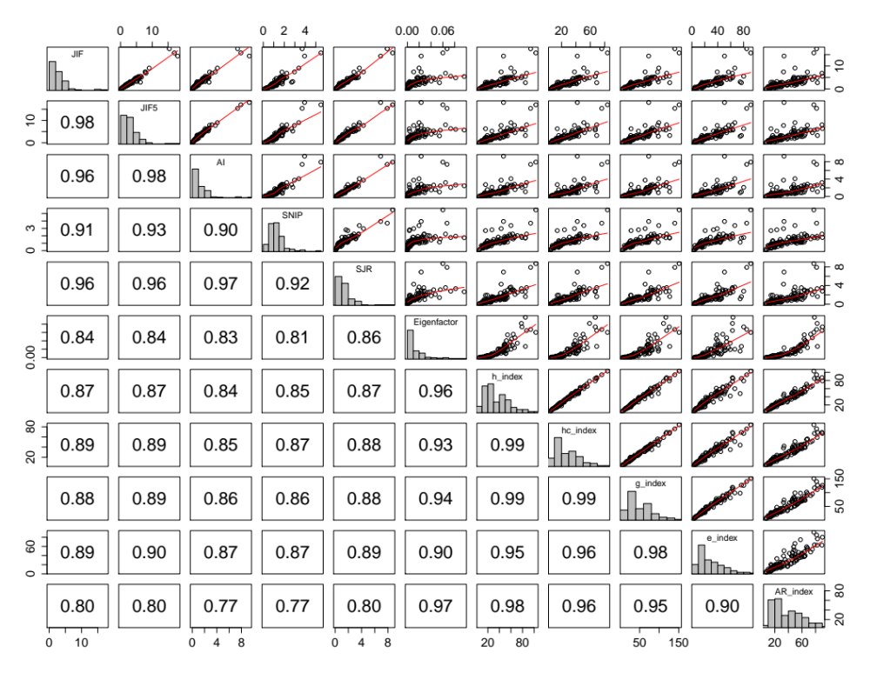
Figure 1. Scatterplot and correlation matrix of journal influence metrics with histograms on the diagonal. The top half of the panels are scatterplots showing the relationship between each pair of influence metrics with a smoothing spline through the points to help review linear and nonlinear patterns. The bottom half of the panels are Spearman correlations.

The PCA components were ranked according to the amount of variance they explained in the Spearman rank correlation matrix. The Principle Components (PC) explained 81.8%, 11.5%, 4.2%, 1.2% and <1% for the remaining PC, with 93.3% of the variance explained by the first two PC. I plotted the 11 metrics on the first two PC to produce a 2-dimensional map with a heatmap of metric clustering to visually represent the similarity of these citation-based metrics for ecology journals (Figure 2).
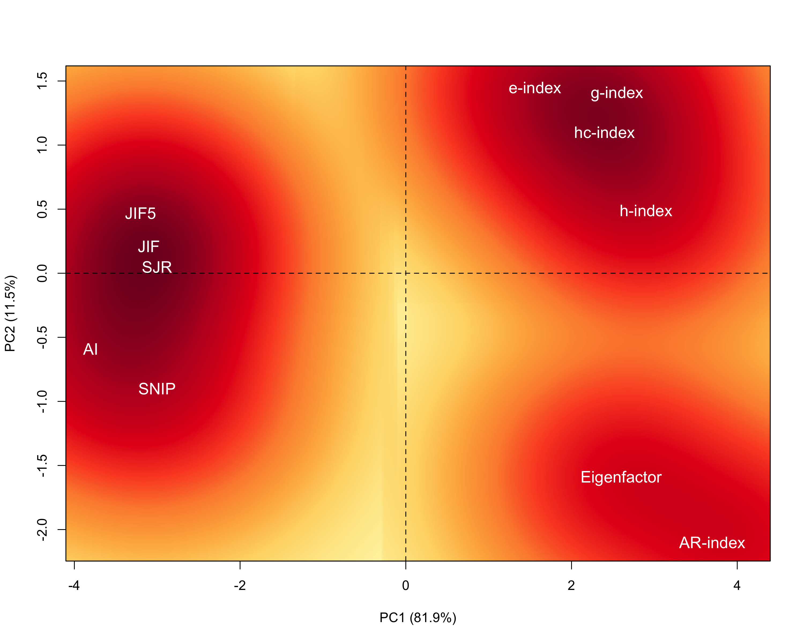
Figure 2. Correlations between 11 citation-based metrics projected on the first two Principal Components from a PCA. The color reveals the amount of clustering among metrics with red representing the highest clustering and yellow the least clustering.

Discussion
All metrics were highly correlated for ecology journals, but there was still considerable variation in the rank and relative influence of journals among metrics (West et al. 2010b). The PCA results showed that these metrics split strongly along PC1, which explained 81.9% of the variance. PC1 clearly separates metrics based on whether they are on a per article basis (JIF, JIF5, AI, SNIP, and SJR) or represent an accumulation of citations among highly cited papers (h, h_{c,} g, e, AR indices) or all papers in the journal (Eigenfactor). Metrics stratify more uniformly along PC2, but there is no clear interpretation of this axis, which does not explain a large portion of the variance (11.5%). Interestingly, metrics do not cluster by the database from which they were calculated. Previous research across all subjects suggests that JIF and JIF5 are more measures of popularity compared with PageRank metrics such as Eigenfactor and AI, which are better measures of prestige because they weight the citing journals in the network (Bollen et al. 2009). This could be a potential interpretation of PC2 with the exception of the AW-index, which is positioned closer to the Eigenfactor than any of the other metrics. The metrics of ecology journal influence do not appear to cluster strongly based on immediacy, database, self-citations, or other obvious factor. Future research could include additional metrics of total citations, citation rates, and usage statistics (views, Mendeley downloads, social media sharing, etc.) that could help separate journals based on interpretable traits.
Rankings of journals in ecology on a per article basis using JIF, JIF5, AI, SNIP, and SJR corresponded well (Table 3). The top 3 journals based all 5 metric rankings were Annual Review of Ecology, Evolution, and Systematics, Trends in Ecology and Evolution, and Ecology Letters. The Ecological Society of America’s journals ranked well, with Frontiers in Ecology and the Environment, Ecology, Ecological Monographs, and Ecological Applications all ranked in the top 20 ecology journals on a per article basis. Ecology Letters was the top ranked journal that does not focus solely on review articles, although many review articles are published in Ecology Letters. Review articles tend to be highly cited and one limitation of all the metrics considered herein is that the influence of review articles and commentary are not separated from original research articles (Supp and White 2010). All of the top five ranked journals by AI, JIF, SNIP, and SJR publish a high percentage of review articles and should not be compared directly to journals primarily publishing original research articles (Supp and White 2010).

Table 3. Comparison of journal influence per article using 5 metrics for the top 20 journals based on the Article Influence score. Rank by each metric is noted parenthetically following the metric score.
Journal | AI | JIF | JIF5 | SNIP | SJR
ANNU REV ECOL EVOL S | 9.273 (1) | 14.373 (3) | 18.007 (1) | 3.932 (2) | 6.901 (3)
TRENDS ECOL EVOL | 7.913 (2) | 15.748 (2) | 16.981 (2) | 5.483 (1) | 8.702 (1)
ECOL LETT | 7.380 (3) | 17.557 (1) | 15.389 (3) | 3.701 (3) | 7.898 (2)
FRONT ECOL ENVIRON | 4.085 (4) | 9.113 (4) | 9.023 (4) | 3.383 (4) | 3.664 (5)
ECOL MONOGR | 3.745 (5) | 7.433 (5) | 7.750 (7) | 2.966 (5) | 4.292 (4)
GLOBAL CHANGE BIOL | 3.188 (6) | 6.862 (7) | 8.036 (5) | 2.233 (9) | 3.557 (6)
ISME J | 2.812 (7) | 7.375 (6) | 7.850 (6) | 1.778 (19) | 2.851 (13)
GLOBAL ECOL BIOGEOGR | 2.729 (8) | 5.145 (11) | 6.629 (8) | 1.915 (14) | 3.009 (11)
B AM MUS NAT HIST | 2.722 (9) | 2.905 (41) | 6.281 (10) | 2.694 (7) | 1.909 (28)
ECOLOGY | 2.637 (10) | 4.849 (17) | 6.007 (12) | 1.941 (13) | 3.336 (8)
AM NAT | 2.61 (11) | 4.725 (19) | 5.280 (19) | 1.677 (23) | 3.098 (10)
P ROY SOC B-BIOL SCI | 2.454 (12) | 5.415 (9) | 5.670 (15) | 1.744 (21) | 2.668 (16)
EVOLUTION | 2.431 (13) | 5.146 (10) | 5.613 (16) | 1.589 (27) | 3.111 (9)
J ECOL | 2.385 (14) | 5.044 (15) | 6.020 (11) | 2.198 (10) | 3.537 (7)
CONSERV BIOL | 2.293 (15) | 4.692 (20) | 5.940 (13) | 2.026 (11) | 2.529 (18)
ECOL APPL | 2.234 (16) | 5.102 (12) | 5.380 (18) | 1.994 (12) | 2.615 (17)
METHODS ECOL EVOL | 2.205 (17) | 5.093 (13) | 5.093 (22) | NA | NA
J APPL ECOL | 2.171 (18) | 5.045 (14) | 5.804 (14) | 2.239 (8) | 2.851 (12)
ECOGRAPHY | 2.165 (19) | 4.188 (24) | 5.535 (17) | 1.603 (26) | 2.395 (19)
PERSPECT PLANT ECOL | 2.112 (20) | 3.208 (31) | 5.229 (20) | 2.806 (6) | 1.634 (33)

Among the top 20 journals, the biggest difference in rank by metric was Molecular Ecology, which was ranked 9th by the JIF5 but dropped to 21st by the AI score and 20th by the SNIP. This suggests that while the average Molecular Ecology article was highly cited, a large fraction of those citations come from molecular journals. Citations from such journals are worth less in the network algorithm than are citations from ecology journals, because of differing citation practices in the different fields Althouse et al. 2009). The American Naturalist also differs considerably between the metrics, where it was ranked 19th by the JIF5, 11th by AI score, 23rd by SNIP, and 10th by SJR. The AI and SJR, which account for the scientific citation network, both rank the American Naturalist higher than the JIF5 or SNIP, which only account for the number of citations to a given journal directly. This suggests a large portion of the citations to American Naturalist come from areas of science that are weighed highly in the network, such as Ecology and Evolution. Surprisingly, the ISME Journal, with a focus on microbial ecology, was ranked more highly by the JIF5 and AI compared with the SNIP and SJR. This is unexpected because the AI and SJR are similar in theoretical foundation; therefore, the differences may be due to differences in the databases than differences in the metrics.
The ranking of journals shifts considerably when evaluated on total scientific influence rather than influence on a per article basis. The top three journals based on Eigenfactor rank were Proceedings of the Royal Society B: Biological Sciences, Ecology, and Molecular Ecology (Table 4).

Table 4. Ecology journal influence for six citation-based metrics. These metrics do not correct for the number of articles published by each journal. The top 20 journals ranked by Eigenfactor are included with the rank (of 110 ecology journals) by each metric in parentheses to the right of the metric value. A full list is included in the appendix.
Journal | Eigenfactor | h-index | h_{c}-index | e-index | g-index | AR-index
P ROY SOC B-BIOL SCI | 0.09614 (1) | 85 (4) | 67 (5) | 63.55 (7) | 117 (6) | 78.31 (6)
ECOLOGY | 0.08167 (2) | 78 (7) | 59 (7) | 62.81 (8) | 111 (7) | 82.37 (4)
MOL ECOL | 0.07334 (3) | 79 (6) | 67 (5) | 80.15 (3) | 126 (4) | 90.05 (1)
ECOL LETT | 0.06713 (4) | 94 (2) | 76 (2) | 84.81 (2) | 140 (2) | 81.56 (5)
GLOBAL CHANGE BIOL | 0.06455 (5) | 87 (3) | 69 (3) | 62.80 (9) | 119 (5) | 89.42 (2)
TRENDS ECOL EVOL | 0.06008 (6) | 103 (1) | 84 (1) | 91.10 (1) | 151 (1) | 77.42 (7)
EVOLUTION | 0.05569 (7) | 64 (11) | 50 (12) | 47.86 (19) | 89 (13) | 72.78 (9)
MAR ECOL-PROG SER | 0.05428 (8) | 54 (17) | 40 (25) | 38.64 (33) | 73 (24) | 63.42 (15)
BIOL CONSERV | 0.04727 (9) | 67 (9) | 52 (10) | 53.8 (13) | 95 (12) | 75.23 (8)
AM NAT | 0.04448 (10) | 61 (13) | 46 (13) | 37.74 (36) | 78 (20) | 63.21 (16)
OECOLOGIA | 0.04034 (11) | 52 (20) | 39 (28) | 39.85 (30) | 72 (28) | 64.73 (13)
ECOL APPL | 0.03761 (12) | 59 (15) | 46 (13) | 53.59 (14) | 89 (13) | 67.11 (11)
CONSERV BIOL | 0.03440 (13) | 71 (8) | 55 (9) | 59.26 (11) | 102 (8) | 66.82 (12)
J EVOLUTION BIOL | 0.03224 (14) | 49 (26) | 37 (31) | 43.97 (24) | 73 (24) | 59.29 (20)
OIKOS | 0.03049 (15) | 49 (26) | 37 (31) | 39.96 (29) | 70 (31) | 57.54 (23)
BIOL LETTERS | 0.02992 (16) | 51 (21) | 40 (25) | 36.91 (38) | 69 (32) | 59.9 (19)
ECOL MODEL | 0.02928 (17) | 48 (29) | 37 (31) | 43.93 (25) | 72 (28) | 60.39 (18)
J APPL ECOL | 0.02866 (18) | 63 (12) | 46 (13) | 48.58 (18) | 87 (15) | 63.86 (14)
J ECOL | 0.02782 (19) | 58 (16) | 45 (16) | 42.56 (26) | 79 (18) | 59.11 (21)
J BIOGEOGR | 0.02782 (20) | 53 (19) | 44 (17) | 45.46 (22) | 77 (21) | 60.41 (21)

A journal like Proceedings might have a higher total influence than other ecology journals because it publishes many papers in more areas of biology than most of the journals on this list, but it is included as it is not as broad as the general science giants, Nature, Science, and Proceedings of the National Academic of Sciences. Of those journals in the top 20 of the JIF or AI indices, only 12 were also in the top 20 in Eigenfactor rank. Ecology was ranked second in total scholarly influence, as indicated by the Eigenfactor, which in combination with the high scores for all other metrics indicates that Ecology published a large number of moderate to highly cited papers. One extreme case was the Bulletin of the American Museum of Natural History, which was ranked 9th and 10th by AI and JIF, respectively. The Bulletin was only ranked 75th by the Eigenfactor and 92nd by the H-index. The discrepancy between the first two metrics and the second two metrics (rank per article and rank on overall scientific influence) is likely a function of a few very highly cited articles and few articles published per year. All else being equal, journals that publish more articles are likely to receive more citations and have greater total influence on scholarly thought. A publisher may try to maximize total influence by increasing publication output through increased frequency and accepting a greater number of articles. Similarly, librarians may be interested in the subscription price of journals relative to their total influence rather than on the per article influence. Researchers, in contrast, are likely to be primarily interested in the average article influence and therefore focus on AI, JIF, JIF5, SNIP, and SJR. Ecology Letters and Trends in Ecology and Evolution were two of the only journals that ranked among the top in all metrics. This indicates they published a large number of highly influential articles. Those articles tended to be highly cited and had influence that spread through scientific networks. As such, they are likely to be highly influential on scholarly thought with regards to ecology and related fields.
One journal that made a surprise entry into the top ecology journals was the new comer, Methods in Ecology and Evolution. This is a relatively new journal (first published 23 February 2010), particularly in relation to the 2007 – 2011 time period of this study. The rise of a methodological ecology journal reveals the increasing complexity and sophistication of ecological studies and analyses. Increasing use of hierarchical models, Bayesian methods, Random Forests, Network Theory, and similarly complex analyses require a specialty journal where authors can explain challenging mathematical concepts in a form accessible to applied ecologists. This new outlet facilitates the use of novel methods, as evidenced by the high citation metrics, by helping ecologists better understand complex and dynamic aspects of nature that could previously only be examined qualitatively.
While journal ranks are interesting, the various metrics show different patterns of distribution in scores among journals. Most journals have relatively low values across all metrics, whereas a few journals have much higher values. The top three ranked journals had scores well above the others for most metrics on a per article basis. The Annual Review of Ecology, Evolution, and Systematics, Trends in Ecology and Evolution, and Ecology Letters had AI, JIF, JIF5, and SJR metrics greater than 50% higher than the 4th ranked journal for each metric (Table 3). By design, the SNIP does not have this separation due to the normalization process of adjusting the journal citation potential (denominator of the SNIP calculation). Depending on the fields of study covered, journals have different citation potentials. Ecology is an integrative discipline and journals focus on various aspects of ecology, giving them different citation potential within science as a whole. The SNIP values suggest that Trends in Ecology and Evolution was the clear leader in influence once corrected for citation potential of the fields. However, it is unclear if the citation potential distinction is precise enough for use among journals within similar fields, such as the top ecology journals. The Eigenfactor, h-index, h_{c}-index, g-index, e-index, and AR-index did not show the same clear separation of these, or any, ecology journals (Table 4). The difference in pattern compared with the AI, JIF, JIF5, and SJR is because they measure influence without correcting for the volume of publications from a journal. Therefore, journals that publish large numbers of papers will improve the likelihood of having high h-index and related metrics.
Comparing metrics is less about which metric is best, but rather which is the most useful metric, or metrics, for a specific purpose. As indicated by PCA, no one metric captures all the multidimensionality of journal influence (Figure 2, Bollen et al. 2009). Each metric provides particular information about a journal’s influence on the scientific community, or at least on the scientific community’s citation habits (Moed et al. 2012). However, given the numerous, valid criticisms of the JIF, I recommend avoiding much inference based on this particular metric. The JIF5 is probably a better metric for most purposes than the JIF, unless speed of citations and popularity are of primary interest (Bollen et al. 2009). The AI, SNIP, and SJR all have qualities that are superior to the JIF5. The process of citing previous research creates a massive network of scientific documents (Garfield 1955). As such, network-based metrics (Eigenfactor, AI, SJR) are best suited for understanding the flow of ideas through science and the influence of particular journals. The AI, as well as the Eigenfactor, currently suffer from some of the limitations of the JIF because they are calculated using the same Thompson Reuter’s database; however, in theory they could be calculated from other databases. The SNIP and SJR are calculated from the Scopus database, which is larger and more inclusive than the Thompson Reuter’s database, but these metrics also have their own limitations and therefore appropriate uses. The SNIP is useful for comparing among diverse fields of study. However, the database potential used in the denominator of the SNIP calculation may not match the field of study as accurately as desired, potentially leading to bias for some fields. The weighting of the journals differentiates the SJR and the AI, but whether increased weighting for citations from similar journals, as done in the SJR, is desirable is unclear. The theory behind closeness weighting is that researchers in the same field are better able to critically choose the papers to cite within that field. The closeness weighting relates more to journal quality than to overall scientific influence. This also creates less intuitive and interpretable values for the SJR compared with the AI.
One appealing aspect of the Eigenfactor, and the associated AI, is the relational interpretation both within and among fields. For example, Ecology Letters with an Eigenfactor of 0.06713 can be interpreted to have 32 times the influence on science compared with Pedobiologia (Eigenfactor = 0.00209), a smaller more specialized ecology journal. Similarly, Ecology Letters (AI: 7.38) has 52 times the influence per article compared with the more specialized Journal of Freshwater Ecology (AI: 0.143). That is not to say that Pedobiologia and Journal of Freshwater Ecology are not good journals, in fact, I selected them for comparison because they are generally high-quality journals, but with a smaller audience and narrower scope. As such, they have less total influence on science (Eigenfactor) and less influence per article (AI).
The h-index has a less clear interpretation than the Eigenfactor or AI. The h-index was designed for evaluation of researcher influence. While it can be used to evaluate journal influence and has a reasonably high correlation to other influence metrics, it is even more problematic for journals than for researchers. Researchers have limits to the number of articles they can publish. Journals, in contrast, have vastly different publishing capacities and the number of highly cited articles, representing the h-index, is not necessarily representative of the general citation structure of the journal as a whole. For journals, the h-index and its variations may better represent prestige than influence, because they are metrics of the number of highly cited papers, but do not indicate the average influence per article or the total influence on the scientific field. The h-index, h_{c}-index, e-index, g-index, and AR-index can be useful to complement the other indices and add nuance to the understanding of a journal’s citation patterns. For journals with similar scores based on other metrics of influence, the h-index and g-index can help understand whether a journal’s influence comes from many moderately cited papers or from just a few very highly cited papers. However, these indices are still best suited for examining the influence of individual researchers (with caution). Dividing the h-index by the number of papers published to create the normalized h-index has been proposed to standardize the h-index for journal comparison (Sidiropoulos et al. 2007, Alonso et al. 2009). However, the normalized h-index does not have the intuitive interpretation of the JIF or full network inference of the Eigenfactor, AI, or SJR metrics.
All the metrics compared in this paper have limitations and all evaluate slightly different aspects of journal influence. As such, different indices may be more appropriate for different purposes. Librarians and publishers may be interested in the total influence of particular journals, making the Eigenfactor the primary metric of interest. This can help inform decisions regarding subscriptions and purchasing. Of course, librarians listen to faculty member recommendations and make strategic decisions based on costs, database bundles, departmental representation, and other criteria, but citation metrics and journal influence can help further distinguish subscription purchasing decisions. This is increasingly important given the rising costs of higher education outstripping revenue.
In contrast, researchers may be interested in the chance of their article being highly influential (read and cited). When choosing among journals as an outlet for research and scientific ideas, researchers consider numerous factors. These include overall fit, intended audience, cost, publishing speed, novelty of research, open-access options, and perceived journal quality or influence. Although, I frequently hear colleagues criticize impact factors and other metrics as irrelevant, these metrics do play some role in how many scientists select journals for manuscript submission. With so many papers published, these metrics can also serve as a filter to narrow the selection of potential readings (Bergstrom 2010), although journals with low rankings should not be dismissed as irrelevant or unimportant (Fitzsimmons and Skevington 2010). As such, the AI score may be of most interest to researchers because it is a per article representation of the Eigenfactor score. In ecology, the JIF5 is highly correlated with the AI score and could be used as an accurate estimate of a journal’s per article influence. However, this is not always true. In economics, mathematics, and medicine, the relationship between the JIF5 and AI score is different than for ecology (www.eigenfactor.org/stats.php, retrieved 01 May 2013). It is possible that the relationship between the two metrics will change within ecology over time or for particular journals. The AI score currently suffers from some of the same limitations as the JIF5, including a limited, albeit large, database of journals, limited inclusion of citations from books, and free citations because not all communications are included in the number of published articles. However, given the conceptually superior calculation of influence throughout scholarly publications, I recommend scholars focus on the AI score rather than either the 2-year or 5-year impact factors. When interested in comparing widely disparate fields, the SJR might be superior to even the AI.
Familiarity, complexity, and scale are the biggest challenges for moving scientists away from the JIF and to other metrics, particularly the Eigenfactor, AI, and SJR. The Journal Impact Factor has been part of the scientific lexicon for half a century (Garfield 2006) and most scholars are aware of its use even if they do not consider it as part of their publication process. The JIF is so ingrained in the scientific community that it is possible that the view of journal hierarchy within ecology is based as much on JIFs as it is on the content of the journal. Even those scholars frustrated with the limitations of JIFs might have trouble with a paradigm shift to Eigenfactors, AI, or SJR because of the complexity of these calculations. Most researchers are not experts in network theory and may be confused by the calculation of these metrics, making researchers dubious of them. Finally, the JIF is on a scale that is easy to remember and talk about. Journals with JIFs below 1 are generally smaller, specialty journals with lower reach and readership. Many good journals in the field of ecology fall in the range of 3-6 and the very top ecology journals are between 10 and 20. Eigenfactors for ecology journals, in contrast, range from 0.00014 - 0.08167. Although they represent the percent influence on scientific citations as a whole (i.e. all Eigenfactor scores sum to 100), these are not numbers that are easy to remember or discuss in casual conversations. Using a scaled Eigenfactor value might enable Eigenfactors to gain greater traction in the ecological community. The AI and SJR metrics do not suffer this limitation, as they are on scales similar to the more familiar JIF.
Finally, citations and scholarly influence play a part in promotion and tenure decisions. While adjustments to these metrics and new metrics are proposed regularly, there has recently been pushback in opposition to the increasing use of these metrics (e.g. Campbell 2008, Brumback 2009). In response to what is viewed as misuse of citation-based metrics, researchers recently put forth the San Francisco Declaration on Research Assessment (DORA) calling for an end to the use of these metrics for evaluating researchers (Hoppeler 2013). The signatories of this declaration call for researchers, publishers, administrators, and granting agencies to apply a more holistic approach to evaluating research outputs. In particular, the DORA states that the impact or prestige of the journal researchers publish in should not be used for evaluating researchers, because high quality and high impact papers can be published in journals with low influence metrics and papers that receive little attention can be published in high influence journals. The latter is particularly true because in all journals few papers get most of the citations. Even the original developer of the JIF states, “The use of journal impacts in evaluating individuals has its inherent dangers” (Garfield 2006). The DORA signatories additionally call on organizations supplying metrics to be more open in sharing the methods and data used, and specifically to, “Provide the data under a licence that allows unrestricted reuse, and provide computational access to data, where possible” (Hoppeler 2013). The grievances highlighted in this Declaration cannot be ignored. Citation-based metrics provide valuable information about the publishing and citation patterns among researchers, journals, research fields, and publishers. While useful, this information should not be weighted excessively when considering publishing research or evaluating researchers for hiring, promotion, tenure, or funding. A more inclusive approach in evaluating subscription decisions, publishing outlets, and researchers is necessary.

Acknowledgments
Thanks to W. Peterman, R. Rowe, R. Stephens, C. Daehler, and L. Hocking for providing feedback on earlier versions of this manuscript. Additional thanks to R. Rowe, A. Kovach, and their lab groups for early discussions and encouragement in developing this research and to A. Sween for allowing time to work on this project. The manuscript was improved by reviewer suggestions from C. Bergstrom and E. White.

References
Aarssen, L. W., T. Tregenza, A. E. Budden, C. J. Lortie, J. Koricheva, and R. Leimu. 2008. Bang for your buck: rejection rates and impact factors in ecological journals. Open Ecology Journal 1:14-19.
Alonso, S., F. J. Cabrerizo, E. Herrera-Viedma, and F. Herrera. 2009. h-Index: A review focused in its variants, computation and standardization for different scientific fields. Journal of Informetrics 3:273-289.
Althouse, B. M., J. D. West, T. C. Bergstrom, and C. T. Bergstrom. 2009. Differences in impact factor across fields and over time. Journal of the American Society for Information Science and Technology, 60:27-34
Bergstrom, C. T. 2007. Eigenfactor: Measuring the value and prestige of scholarly journals. C&RL News May 2007:314-316.
Bergstrom, C. T. 2010. How to improve the use of metrics. Nature 465:870-871.
Brumback, R. A. 2009. Impact factor wars: Episode V—the empire strikes back. Journal of child neurology 24:260-262.
Cameron, B. D. 2005. Trends in the usage of ISI bibliometric data: uses, abuses, and implications. Libraries and the Academy 5:105-125.
Campbell, P. 2008. Escape from the impact factor. Ethics in Science and Environmental Politics(ESEP) 8:5-7.
Colledge, L., F. de Moya Anegón, V. Guerrero-Bote, C. López Illescas, M. h. El Aisati, and H. Moed. 2010. SJR and SNIP: two new journal metrics in Elsevier's Scopus. Serials: The Journal for the Serials Community 23:215-221.
Colquhoun, D. 2003. Challenging the tyranny of impact factors. Nature 423.
Davis, P. M. 2008. Eigenfactor: Does the principle of repeated improvement result in better estimates than raw citation counts? Journal of the American Society for Information Science and Technology 59:2186-2188.
Egghe, L. 2006. Theory and practise of the g-index. Scientometrics 69:131-152.
Falagas, M. and V. Alexiou. 2008. The top-ten in journal impact factor manipulation. Archivum Immunologiae et Therapiae Experimentalis 56:223-226.
Fitzsimmons, J. M. and J. H. Skevington. 2010. Metrics: don’t dismiss journals with a low impact factor. Nature 466:179.
Fogg, P. 2007. A new standard for measuring doctoral programs. The Chronicle of Higher Education 53:A8.
Garfield, E. 1955. Citation indexes for science: a new dimension in documentation through association of ideas. Science 122:108-111.
Garfield, E. 1972. Citation analysis as a tool in journal evaluation. Science 178:471-479.
Garfield, E. 2006. The history and meaning of the Journal Impact Factor. Journal of the American Medical Association 295:90-93.
Guerrero-Bote, V. P. and F. Moya-Anegón. 2012. A further step forward in measuring journals’ scientific prestige: The SJR2 indicator. Journal of Informetrics 6:674-688.
Harzing, A. 2007. Publish or Perish, available from http://www.harzing.com/pop.htm
Harzing, A. and R. van der Wal. 2007. A Google Scholar H-Index for journals: A better metric to measure journal impact in economics & business. Proceedings of the Academy of Management Annual Meeting.
Harzing, A. and R. van der Wal. 2009. A Google Scholar h-index for journals: An alternative metric to measure journal impact in economics and business. Journal of the American Society for Information Science and Technology 60:41-46.
Hirsch, J. E. 2005. An index to quantify an individual's scientific research output. Proceedings of the National Academy of Science 102:16569.
Hoppeler, H. 2013. The San Francisco declaration on research assessment. The Journal of experimental biology 216:2163-2164.
Francois Husson, Julie Josse, Sebastien Le and Jeremy Mazet (2013). FactoMineR: Multivariate Exploratory Data Analysis and Data Mining with R. R package version 1.25. http://CRAN.R-project.org/package=FactoMineR
Jin, B. 2007. The AR-index: complementing the h-index. ISSI newsletter 3:6.
Jin, B., L. Liang, R. Rousseau, and L. Egghe. 2007. The R- and AR-indices: Complementing the h-index. Chinese Science Bulletin 52:855-863.
McGarty, C. 2000. The citation impact factor in social psychology: A bad statistic that encourages bad science? Current Research in Social Psychology 5:1-16.
Moed, H. F., L. Colledge, J. Reedijk, F. Moya-Anegón, V. Guerrero-Bote, A. Plume, and M. Amin. 2012. Citation-based metrics are appropriate tools in journal assessment provided that they are accurate and used in an informed way. Scientometrics 92:367-376.
Neff, B. D. and J. D. Olden. 2010. Not So Fast: Inflation in Impact Factors Contributes to Apparent Improvements in Journal Quality. Bioscience 60:455-459.
Pendlebury, D. A. 2009. The use and misuse of journal metrics and other citation indicators. Archivum Immunologiae et Therapiae Experimentalis 57:1-11.
R Core Team. 2013. R: A language and environment for statistical computing. R Foundation for Statistical Computing, Vienna, Austria. http://www.R-project.org/.
Seglen, P. O. 1997. Why the impact factor of journals should not be used for evaluating research. BMJ: British Medical Journal 314:498.
Sidiropoulos, A., D. Katsaros, and Y. Manolopoulos. 2007. Generalized Hirsch h-index for disclosing latent facts in citation networks. Scientometrics 72:253-280.
Smith, R. 2008. Beware the tyranny of impact factors. Journal of Bone and Joint Surgery - British Volume 90:125-126.
Supp, S.R. and E.P. White. 2010. Measures of Journal Quality Should Separate Reviews from Original Research. Ideas in Ecology and Evolution 3:16-19.
Waltman, L., N. J. van Eck, T. N. van Leeuwen, and M. S. Visser. 2013. Some modifications to the SNIP journal impact indicator. Journal of Informetrics 7:272-285.
, J. D. and C. T. Bergstrom. 2008. Pseudocode for calculating Eigenfactor Score and Article Influence Score using data from Thomson-Reuters Journal Citations Reports. Pages 1-15.
West, J. D., T. C. Bergstrom, and C. T. Bergstrom. 2010a. The Eigenfactor MetricsTM: A network approach to assessing scholarly journals. College & Research Libraries 71:236-244.
West, J. D., T. C. Bergstrom, C. T. Bergstrom. 2010b. Big Macs and Eigenfactor Scores: Don't Let Correlation Coefficients Fool You, Journal of the American Society for Information Science & Technology. 61:1800-1807
Wilcox, A. J. 2008. Rise and fall of the Thomson impact factor. Epidemiology 19.
Zhang, C. 2009. The e-Index, Complementing the h-Index for Excess Citations. PLoS ONE 4:e5429.

