Table 1a. Description of parameters used in the model. See Materials and Methods for relevant equations and detailed descriptions.

|  |  |
| --- | --- |
| **Parameter** | **Description** |
| Overall |  |
|  | Mean abundance at time *t* and site *s* |
|  |  |
|  |  |
|  | Offset: relative length of stream sampled to standardize abundance to fish per 100 m |
|  | Vector of fixed-effect coefficients for |
| Detection |  |
|  | Capture probability per fish for pass in year dependent on the number captured in previous passes |
|  | Mean probability of capturing and individual given that it is present at site *s* and time *t* |
|  | Variation in detection probability among sites and years |
|  | Variance of |
| Spatial |  |
|  | Spatial contribution (component?, variation?) to abundance following an Ornstein-Uhlenbeck process |
|  | Spatially-explicit variance between each parent and child node following an OU process |
|  | Exponential spatial decay rate in the correlation between parent and child nodes |
|  | Variation in the spatial OU process |
|  | Spatial correlation between each parent and child node, resulting from an OU process |
| Temporal |  |
|  | Temporal variation in abundance resulting from AR1 autoregressive process |
|  | Temporal correlation in the annual AR1 process |
|  | Variance describing the temporal AR1 process |
| Spatio-temporal | |
|  | Spatio-temporal variation in abundance resulting from OU process |
|  | Spatio-temporal covariance matrix |
|  | Spatio-temporal variance between each parent and child node |
|  | Off diagonal correlation in the spatio-temporal covariance matrix |
|  | Spatio-temporal correlation between each parent and child node, resulting from an OU process |
|  | Exponential decay rate describing the spatio-temporal OU process |
|  | Variance describing the spatio-temporal OU process |
| Independent |  |
|  | Random log-normal variation beyond Poisson expectation (also termed overdispersion or nugget) |
|  | sigmaIID |

Table 1b

Table 2. Covariate Summary for W. Susquehanna by Stream Reach

|  |  |  |  |
| --- | --- | --- | --- |
| Variable | Mean | Min | Max |
| Percent forest cover (%) | 79.15 | 0 | 100 |
| Percent surficial coarseness (AB?) | 6.62 | 0 | 100 |
| Previous summer mean temperature (C) | 17.74 | 15.21 | 21.66 |
| Previous fall mean temperature (C) | 3.49 | -0.09 | 7.3 |
| Winter mean temperature (C) | -1.77 | -7.99 | 2.87 |
| Spring mean temperature (C) | 14.63 | 10.31 | 17.31 |
| Previous summer mean precipitation (mm) | 3.78 | 1.59 | 8.92 |
| Previous fall mean precipitation (mm) | 2.99 | 1.29 | 5.01 |
| Winter mean precipitation (mm) | 2.58 | 1.1 | 4.73 |
| Spring mean precipitation (mm) | 2.91 | 1.42 | 6.9 |

Table 3. Description of models compared with AIC for adult and YOY Brook Trout populations in the West Susquehanna watershed.

|  |  |  |
| --- | --- | --- |
| Num | Model | Model components |
| 1 | Basic |  |
| 2 | Spatial (S) |  |
| 3 | Temporal (T) |  |
| 4 | S + T |  |
| 5 | Spatio-temporal (ST) |  |
| 6 | S + ST |  |
| 7 | T + ST |  |
| 8 | S + T + ST |  |

Table 4. Comparison of adult Brook Trout models using AIC.

|  |  |  |  |
| --- | --- | --- | --- |
| M_num | Model | AIC | delta_AIC |
| 4 | Spatiotemporal | 9408 | 0.0 |
| 5 | Temporal + ST | 9408 | 0.3 |
| 7 | Spatial + Temporal | 9583 | 174.9 |
| 3 | Spatial | 9588 | 180.2 |
| 2 | Temporal | 9783 | 375.3 |
| 1 | Obs | 9794 | 386.5 |

Table 5. Comparison of YOY Brook Trout models using AIC.

|  |  |  |  |
| --- | --- | --- | --- |
| M_num | Model | AIC | delta_AIC |
| 5 | Temporal + ST | 9592 | 0 |
| 6 | S+T+ST | 9596 | 4 |
| 4 | Spatiotemporal | 9663 | 71 |
| 8 | Spatial + ST | 9666 | 74 |
| 7 | Spatial + Temporal | 9739 | 147 |
| 3 | Spatial | 9801 | 209 |
| 2 | Temporal | 9925 | 333 |
| 1 | Obs | 10048 | 456 |

Table 6. Summary of parameter estimates from the model including temporal and spatiotemporal components for adult Brook Trout in the West Susquehanna watershed.

|  |  |  |  |  |
| --- | --- | --- | --- | --- |
| Parameter | Estimate | Std..Error | z.value | Pr...z.2.. |
| mean_N | 36.686 | 4.051 | 9.1 | 1e-19 |
| mu (alpha/intercept) | 0.086 | 0.011 | 7.5 | 5e-14 |
| sigmaIID | 0.360 | 0.036 | 10.0 | 2e-23 |
| rhot | 0.592 | 0.255 | 2.3 | 2e-02 |
| sigmat | 0.158 | 0.059 | 2.7 | 7e-03 |
| log_theta_vec | -1.845 | 0.199 | -9.3 | 2e-20 |
| theta_st | 0.158 | 0.032 | 5.0 | 5e-07 |
| SDinput_st | 0.588 | 0.059 | 10.0 | 1e-23 |
| rho_st | 0.974 | 0.008 | 128.2 | 0e+00 |
| forest | 0.822 | 0.116 | 7.1 | 1e-12 |
| surfcoarse | 0.013 | 0.064 | 0.2 | 8e-01 |
| temp_mean_summer_1 | -0.263 | 0.052 | -5.1 | 4e-07 |
| temp_mean_fall_1 | 0.092 | 0.032 | 2.9 | 4e-03 |
| temp_mean_winter | -0.009 | 0.031 | -0.3 | 8e-01 |
| temp_mean_spring | -0.159 | 0.051 | -3.1 | 2e-03 |
| prcp_mean_summer_1 | -0.018 | 0.014 | -1.3 | 2e-01 |
| prcp_mean_fall_1 | 0.049 | 0.016 | 3.1 | 2e-03 |
| prcp_mean_winter | 0.043 | 0.020 | 2.1 | 4e-02 |
| prcp_mean_spring | 0.045 | 0.022 | 2.1 | 4e-02 |

Table 7. Summary of parameter estimates from the model including temporal and spatiotemporal components for YOY Brook Trout in the West Susquehanna watershed.

|  |  |  |  |  |
| --- | --- | --- | --- | --- |
| Parameter | Estimate | Std..Error | z.value | Pr...z.2.. |
| mean_N | 44.398 | 7.786 | 5.7 | 1e-08 |
| mu | 0.033 | 0.010 | 3.3 | 9e-04 |
| sigmaIID | 0.527 | 0.042 | 12.7 | 6e-37 |
| rhot | -0.053 | 0.208 | -0.3 | 8e-01 |
| sigmat | 0.763 | 0.132 | 5.8 | 7e-09 |
| log_theta_vec | -2.052 | 0.188 | -10.9 | 9e-28 |
| theta_st | 0.129 | 0.024 | 5.3 | 1e-07 |
| SDinput_st | 0.653 | 0.065 | 10.0 | 1e-23 |
| rho_st | 0.981 | 0.006 | 168.8 | 0e+00 |
| forest | 1.120 | 0.155 | 7.2 | 5e-13 |
| surfcoarse | 0.042 | 0.083 | 0.5 | 6e-01 |
| temp_mean_fall_1 | 0.022 | 0.113 | 0.2 | 8e-01 |
| temp_mean_winter | 0.054 | 0.106 | 0.5 | 6e-01 |
| temp_mean_spring | -0.679 | 0.161 | -4.2 | 2e-05 |
| prcp_mean_fall_1 | 0.005 | 0.041 | 0.1 | 9e-01 |
| prcp_mean_winter | -0.011 | 0.046 | -0.2 | 8e-01 |
| prcp_mean_spring | -0.060 | 0.058 | -1.0 | 3e-01 |

**Figures**

Figure 1. Diagram of network structure with parent-child relationships

Figure 2. Parameter estimates across different values of theta from the spatial simulation study varying theta and sigma. Parameter estimates, abundance estimates, and abundance accuracy (RMSE) were compared for the spatial model and a non-spatial model. Variation in the boxplots represents the combined uncertainty from 200 simulations and variation in simulated levels of sigma.

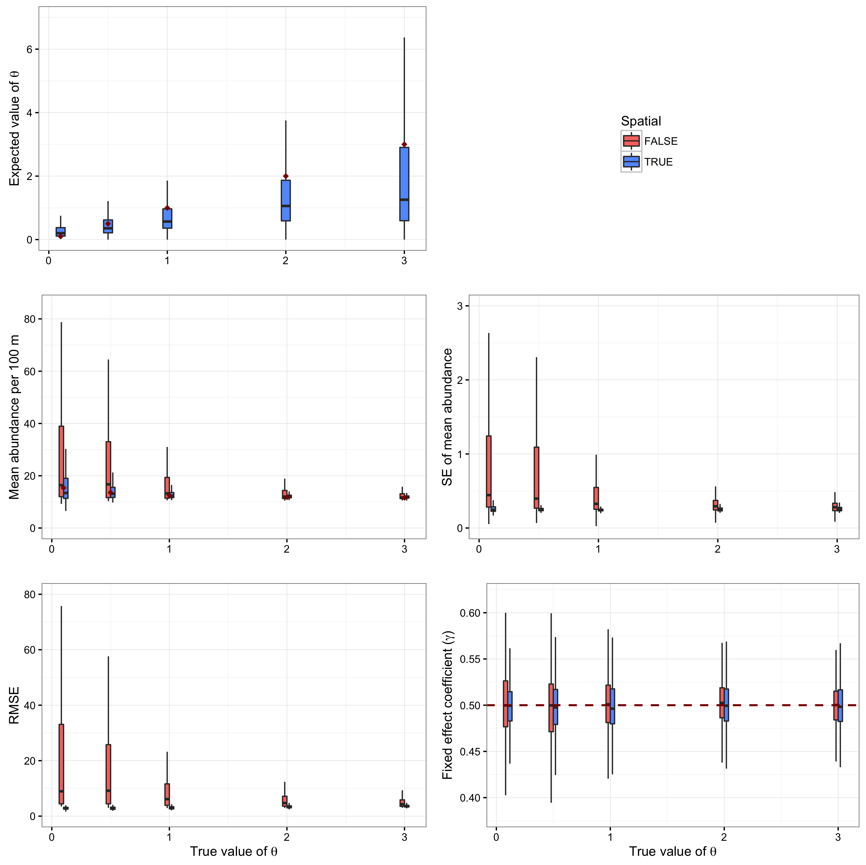

Figure 3. Parameter estimates across different values of sigma from the spatial simulation study varying theta and sigma. Parameter estimates, abundance estimates, and abundance accuracy (RMSE) were compared for the spatial model and a non-spatial model. Variation in the boxplots represents the combined uncertainty from 200 simulations and variation in simulated levels of theta.

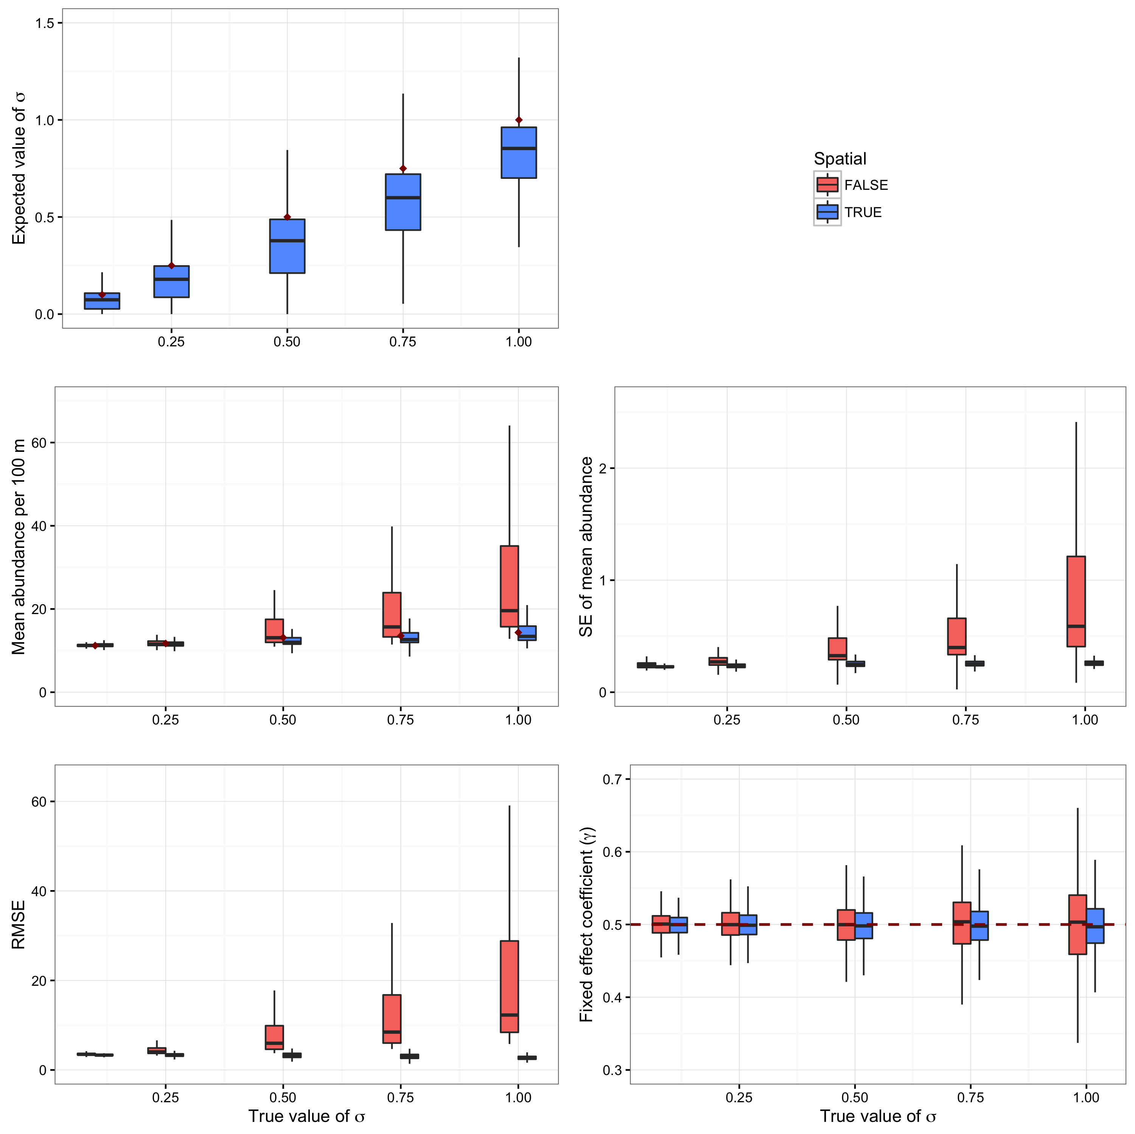

Figure 4. Results from the power analysis simulations showing the effect of varying the number years each site is surveyed. Variation described by each boxplot results from the 200 simulations and varying the number of sites (while holding the number of years constant).

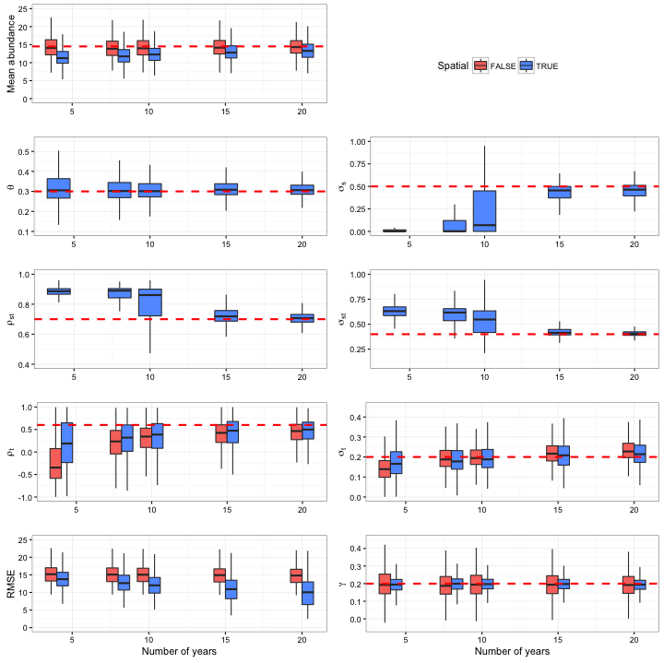

Figure 5. Results from the power analysis simulations showing the effect of varying the number sites surveyed. Variation described by each boxplot results from the 200 simulations and varying the number of years each site was surveyed (while holding the number of sites constant).

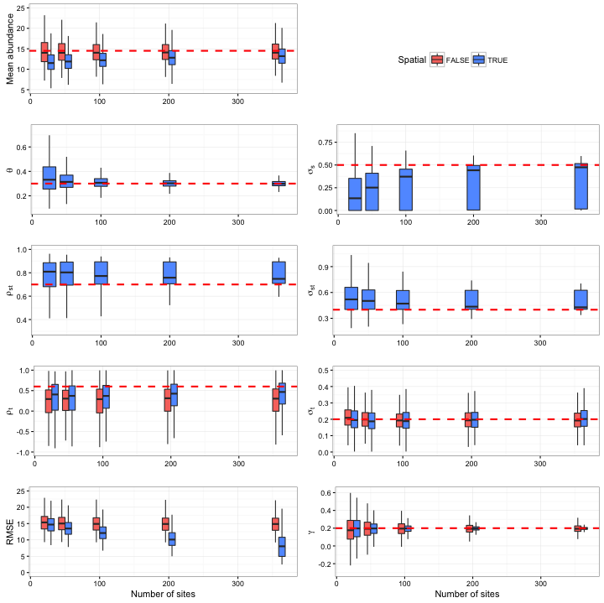

Figure 6 (low res). Example of a spatiotemporal simulation of the abundance along a stream network over time. The top row shows the true (simulated) abundances and the middle row depicts the mean expected abundance based on the matching spatiotemporal model. The bottom row shows the mean expected abundance for a model with temporal autocorrelation but no spatial and spatiotemporal correlations. The simulation used values of theta, sigma, theta_st, sigma_st, AR1, sampled at N_sites = 50 in N_years = 8.

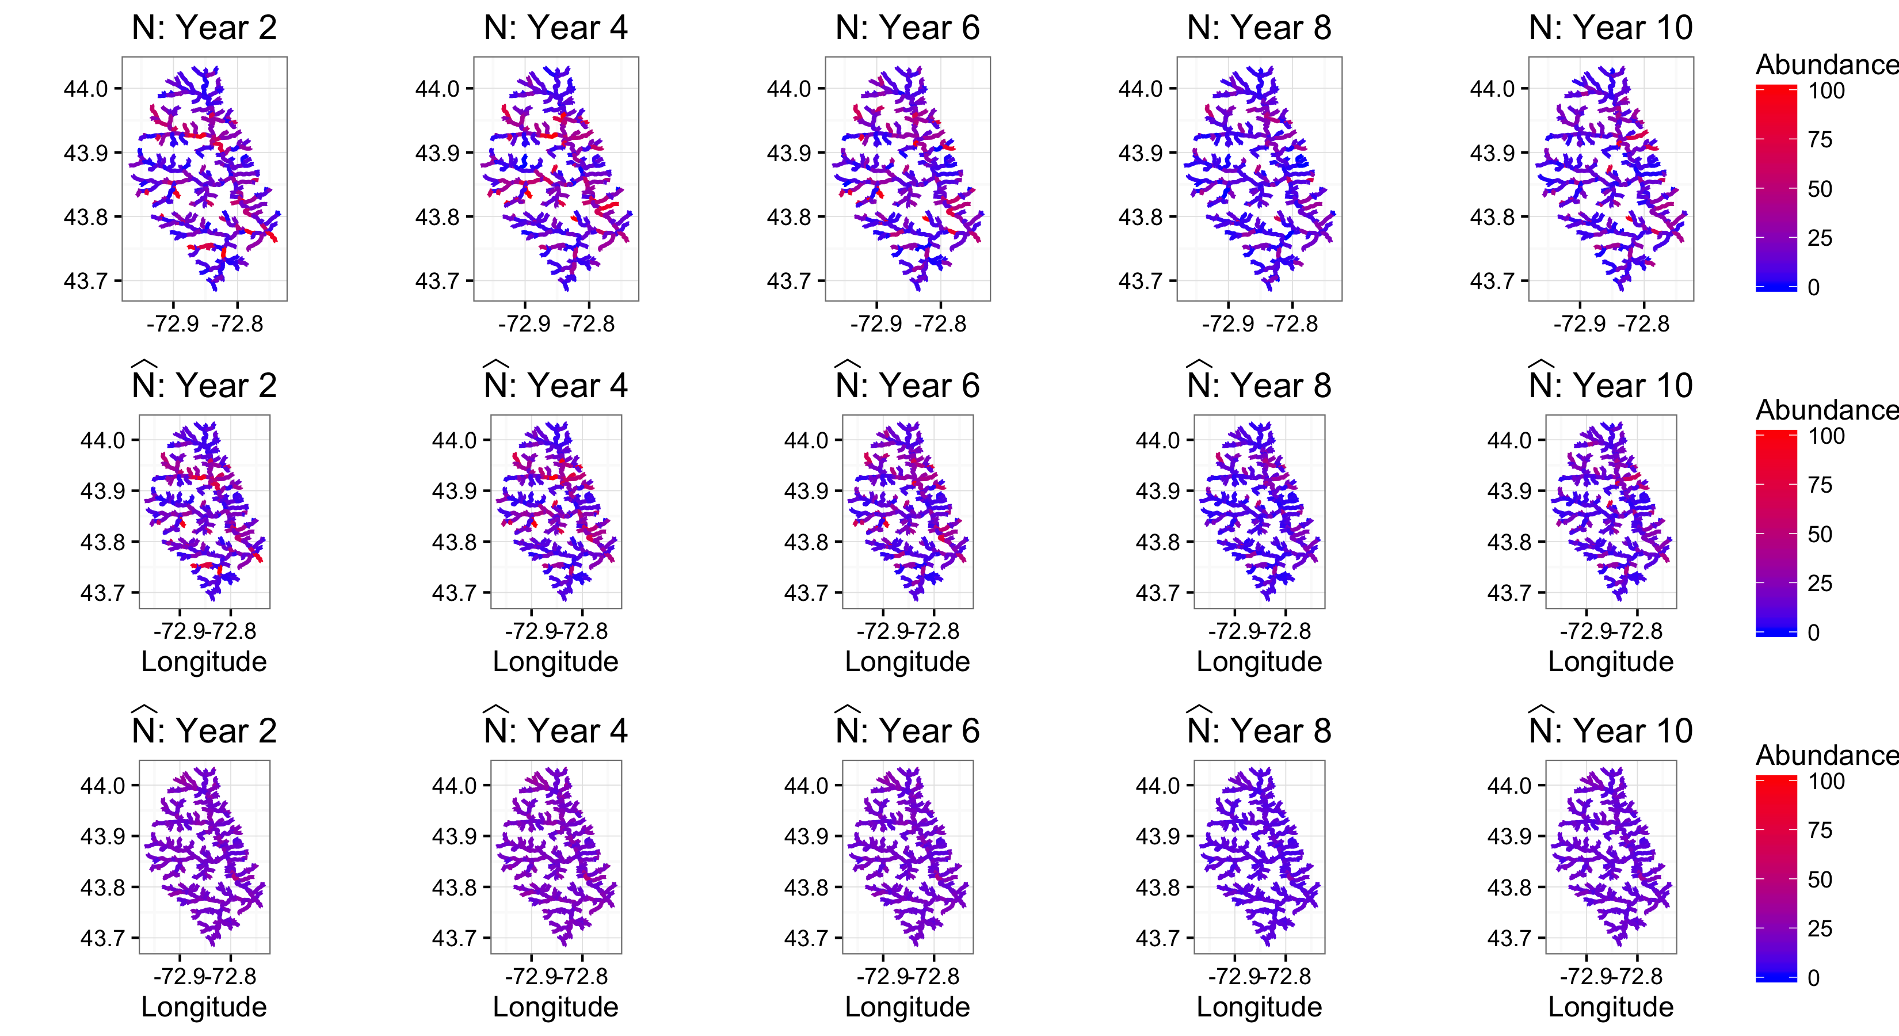

Figure 7. Decay curves with distance for adult and YOY Brook Trout in the West Susquehanna watershed for the model including temporal and spatiotemporal components. rho_nu(s) is the expected correlation between parent and child nodes for a given distance.

