**Manuscript 1: Expert elicitation of salamanders**

**Authors:**

Rachel A. Katz1,2,3, Daniel J. Hocking2, Evan H. Campbell Grant3

1Department of Environmental Conservation, University of Massachusetts-Amherst

2U.S. Geological Survey, SO Conte Anadromous Fish Research Branch

3U.S. Geological Survey, Patuxent Wildlife Research Center

Contributing salamander experts:

|  |  |  |
| --- | --- | --- |
| **last** | **first** | **affiliation** |
| Barrett | Kyle | Department of Forestry and Environmental Conservation, Clemson University, Clemson, SC 29634, USA |
| Bourne | John | U.S. Fish and Wildlife Service/ Patuxent Research Refuge |
| Cecala | Kristen | University of the South |
| Consentino | Brad | Department of Biology, Hobart and William Smith Colleges, Geneva, NY 14456, USA |
| Crawford | John | National Great Rivers Research and Education Center, East Alton, IL 62024, USA |
| Hocking | Daniel | USGS, SO Conte Anadromous Fish Laboratory, Northeast Amphibian Research and Monitoring Inititative, Turners Falls, MA ZIP, USA |
| Lowe | Winsor | Division of Biological Sciences, University of Montana, Missoula, MT 59812, USA |
| Peterman | Bill | School of Environment and Natural Resources, The Ohio State University, Columbus, OH 43210, USA |
| Price | Steve | Department of Forestry, University of Kentucky, Lexington, KY 40546, USA |
| Richter | Stephen | Department of Biological Sciences, Eastern Kentucky Unversity, Richmond, KY 40475, USA |
| Rocco | Gian | Department of Geography, Pennsylvania State Unversity, University Park, PA 16802, USA |
| Snodgrass | Joel | Department of Fish and Wildlife Conservation, Virginia Tech, Blacksburg, VA 24061, USA |
| Tilley | Stephen | Department of Biological Sciences, Smith College, Northampton, MA 01063, USA |
| Willison | JD | Department of Biological Sciences, University of Arkansas,Fayetteville, AR 72701, USA |

**Title:**

* Predicting salamander occurrence when data is lacking using expert opinion

**Journal:**

* Conservation Evidence (see Meredith et al. 2016)
* Conservation Biology (see Martin et al. 2012, Addison et al. 2015)
* Diversity and Distributions (see Adams-Hosking 2016)

**Overview:** Elicit expert opinions to build a predictive model and estimate effects of climate, land use, and brook-trout presence on catchment-level occupancy of three stream-salamander species occurring throughout the northeastern US. Use this predictive model to forecast the distribution of salamanders under current and future climate scenarios and compare to existing published distributions using other methods.

**Steps:**

1. build a catchment-level salamander occupancy model for the NE (based on NHDplus high resolution flow lines – see ice.ecosheds.org)
2. create expert elicitation survey to build a predictive model (elicit means only, use 10+ experts to get variance in mean expected effects or elicit within expert confidence directly)
3. compare expert opinions and host webinar/call to confirm responses or identify alternative hypotheses or predictors that should be included.
4. forecast salamander occupancy across their range (where we have catchment-data) based on the expert model.
5. conduct sensitively analysis for major uncertainties (hold all constant at the mean and vary one parameter at a time)
6. forecast salamander occupancy under future climate change and compare to existing literature (i.e., Sutton – Maxent?)

**Abstract**

[motivation, approach, major results/take homes, importance]

**Introduction**

**Why use expert knowledge and formal elicitation in conservation?**

Expert knowledge is widely used in ecology and conservation because of a lack of substantial empirical data in complex ecological systems and the impending nature of natural resource management decisions (Martin et al. 2012). Typically, expert knowledge takes the form of mental models by expressing opinions in a qualitative and non-transparent way, leading to biased and unrealistic estimates of population responses (Fazey et al. 2006, Kuhnert et al. 2010). As a result, the use of formal expert elicitation methods is growing as a tool for synthesizing diverse sources of information into a reliable representation of the current state of scientific knowledge, including its uncertainties when elicited with the same level of rigor in the collection and use of empirical data (Speirs-Bridge et al. 2010, Runge et al. 2011, Martin et al. 2012, Adams-Hosking et al. 2016). Expert judgments can be particularly useful when empirical data is not available or possible future conditions (i.e., climate or land use changes) have not yet been observed, and populations are subject to multiple, possibly synergistic, threats to local persistence. Using expert elicitation to build plausible predictive models of species responses to environmental change can prove especially valuable to understanding the urgency of decision-making for declining species or species with unknown trends and can result in consolidated knowledge to assist setting management goals (Lindenmayer & Burgman, 2005).

**Why use expert elicitation for building predictive models (esp. occupancy)?**

When observational data is not available or are otherwise limited, costly to obtain or subject to design and quality concerns, resulting predictive models can bias predictions (Manel et al., 2001), and in these cases, expert knowledge can provide a valuable contribution by addressing information gaps. Expert elicitation has successfully used expert knowledge in a probabilistic framework that accounts for uncertainty (confidence) both within and among diverse experts to parameterize models in the absence of data or as Bayesian priors to supplement sparse data to improve confidence in predictions (Yamada et al., 2003; Martin et al., 2005; Denham and Mengersen, 2007; Griffiths et al., 2007; Mac Nally, 2007; O’Neill et al., 2008; Low Choy et al., 2009; O’Leary et al., 2009; Murray et al., 2009; James et al., 2010). Expert opinions have been used to parameterize Bayesian belief networks to evaluate population viability (Johnson et al. 2010), identify alternative hypotheses (Runge et al. 2011), quantifying potential range of effects of climate change (O’Neill et al. 2008), and predict suitable habitats (Smith et al. 2007).

Predicting species occupancy and distributions is worth doing…

Challenges with current approaches (limited data, presence-only = bias?). Predicting species occupancy is often conducted with presence-only data, large data sets of presence-absence data, which are both subject to bias due to imperfect detection? (or maxent + habitat suitability models) – main reasons why theses can be biases/inaccurate?

Correlative models (SDM – MaxEnt (probability) + logistic regression (probability))

vs. mechanistic models (effects of covariates)

Use of expert elicitation for predicting occupancy and species distributions of widely distributed species based on local, population-level factors (motivation and examples?) (influence of mgt actions = not this paper, but that’s why we’re eliciting riparian vs. upland and fish effects on salamanders).

**What are the steps for expert elicitation?**

In order for expert opinions to result in useful predictions, an expert must possess substantive information on a particular topic not widely known by others, is often deferred to for their knowledge and interpretation, and is distinguished from non-experts by having training or experience with respect to a topic of interest (Fazey et al., 2006, Martin et al. 2012). Additionally, the expert elicitation analysts must determine what to elicit, create a statistical model, design the elicitation process, perform the elicitation, and translate the elicited information into quantitative statements that be used to build ecological models (Martin et al. 2012). Multiple expert judgments can then be combined and if there are considerable measurable differences in expert judgments, unequal expert weights in opinion pooling or hierarchical approaches, which can account for non-independence among experts, can be used to improve estimation (Clemen & Winkler 1999; O’Hagan et al. 2006, Cooke 1991; Armstrong 2001, Soll & Larrick 2009; Aspinall 2010). Although generating an expert consensus may appear important for accurate predictive modeling, it is critical that differences in judgments be retained and explored to identify important sources of variation, such as structural uncertainty, parameter uncertainty and environmental variability, which can help guide cost-effective monitoring and research efforts and communicated to conservation practioners and decision-makers to (Keith 1996; Morgan et al. 2001, Regan et al. 2002).

**Why conduct expert elicitation for predicting/forecasting stream salamander occupancy?**

Global amphibian biodiversity crisis (cite).

Recent studies suggest region-wide declines in abundance? and occupancy? in the US potentially due to climate and land use change (cite), resulting in shrinking ranges?

Stream salamanders are diverse group of vertebrates in the US (cite), many (how many?) of which widely distributed across the eastern US (cite).

Publications have to make lots of assumptions, we hope experts are considering these assumptions and relaxing them, thus providing a more realistic understanding of drivers of occurrence.

Three common stream salamander species occur across the northeastern streams (i.e., relevant for NECSC) and are known to co-occur in streams with fishes (brook trout; cite), an important predictor/competitor affecting salamander populations, and are sensitive to buffer and upland forest cover, stream temperature and discharge (and network structure).

Increasing threat of climate change (temp and flow alterations)

Range-wide assessments are lacking (studies are patchy in mostly forested landscapes with low forest loss, flow-impacts).

Knowledge of that status and potential declines is needed to identify mangagement actions that can be implemented to reduce population declines in the future (act now to mitigate climate/land use threats)

Current data on these species is patchy?

No consistent monitoring method or field-studies across their range

Thus they have high levels of uncertainty when extrapolating to even huc 10 (lowest level of mgt), state, or regional scales.

Significant geographical gaps in estimates and trend in occupancy (need to come up with a list of current studies).

Need address occupancy, trends, threats and effects of potential land-potection (buffer vs. upland) so that headwater stream mgt actions can be confidently employed to impact local and minimize species declines.

Also, there are diverse experts opinions on occupancy/threats in various regions.

Current data availability:

Direct threats include:

Indirect threats include:

Potentially competing hypotheses?

Management-relevance (land-protection near buffer or upland?)

* + riparian vs. upland land protection is better for instream biota (downstream). Evidence that upland land protection can influence downstream habitat and species occurrence, yet conservation efforts are largely focused on riparian mgt first, then upland (we'll explore this in decision paper)
  + fish-interaction is strong or weak (brook trout-salamander interactions)
  + species-specific responses (how much do species vary?)
  + stream-network impacts on species-responses? some watersheds are more vulnerable than others (i.e., network structure, buffer vs. upland effects?)

A call for experts to aid in identifying important parameters and their relative impacts on stream salamander populations to be used in predictive and decision models that evaluate the risk of declines and potential effectiveness of management actions (i.e., riparian and forest protection).

**Objectives of this elicitation/study:**

* Overall Motivation: To use a structured, expert elicitation methods for species in which empirical data are limited and expert opinions may vary (conflict among experts?), such that effectiveness of alternative mgt strategies may vary.
* Conduct expert elicitation for Plethedontide (stream obligate for at least some stage of life-history?): Desmognathus, Gyrinophilus, and Eurycea
* Specifically, G. porphyriticus; spring salamander, D. fuscus; dusky salamander, and E. bislineata; two-lined salamander
* These species occur across the northeastern streams (i.e., relevant for NECSC) and are known to co-occur in streams with fishes (brook trout; cite), an important predictor/competitor affecting salamander populations.
* Use insights from experts to build predictive co-occurrence models under climate change (Hocking et al. forecasting paper), and evaluate land-protections strategies (Kate et al. optimization paper).
* Questions:
  + How much do expert opinions agree with field-observations (do we have any? – see publication list that we’ll be sending to experts)
  + How variable are expert opinions (mean and confidence)? Where is the disagreement?
  + Which uncertainties are driving forecasts of occurrence (sensitivity analysis; tornado diagram)?
  + Does expert knowledge agree with recent field-observations / occupancy / distribution estimates? (why or why not? do we have any? – see publication list that we’ll be sending to experts for potential comparisons).
* Compare across experts
* Use for predictions

**Methods:**

*Expert Elicitation (overview)*

We used a structured elicitation process (i.e., Delphi method and four-point elicitation; Speirs-Bridge et al., 2010; McBride et al., 2012) to question experts (Table 2 and Table 3), which improves the accuracy of estimates (Burgman et al., 2011), promotes the pooling of individual knowledge, and reduces overconfidence (Speirs-Bridge et al., 2010; McBride et al., 2012).

This indirect approach to elicitation aims to elicit accurate information by asking experts about concrete observable quantities (Kadane et al., 1980; Kynn, 2008; Low Choy et al., 2009a).

(selection of experts)

Stream salamander experts were identified based on their level of regional knowledge of the focal species. We used the snowball method to identify additional experts. Experts had to have local knowledge of at least one species in at least one region (southern, mid-atlantic, northern; Figure 1), with primary focus on field ecology, natural history, or field experiments (not phylogenetics, physiology, etc). Experts were self-selected in comparison to the broader community of stream salamander ecologists (survey – q1 and q9).

(first survey)

We used an indirect elicitation method, with requires experts to answer questions that relate to their experiences (instead of direct elicitation of parameters distributions; Kuhnert et al. 2010). Responses are then encoded into the parameters of interest for the analysis (i.e., question: what is the expected site occupancy under specific habitat conditions? parameter: the effect (mean and variance) of one unit change in habitat conditions on the probability of occupancy within a site). In this study, we asked experts “under the abiotic and biotic conditions specified, how many 500-reaches (site-level) out of 100 randomly, but evenly, selected from across a specific region (northeast, mid-atlantic, or southeast), would contain a population of stream salamanders for each focal species?” We conducted region-specific elicitation because of well-established understanding of interspecies interactions on the occurrence of our focal species (cite), and that the number and identify of other salamanders present varies across regions (i.e., total northeast = 0 to 4 species, mid-atlantic = 0 to 6 species, and southeast = 0 to 10 species within a given 500-m reach). We conducted an initial survey based on our assessment of major factors (Table 1) expected to influence stream salamander occupancy. We matched scale of actions (catchment-level) with scale of salamander response (occupancy of a 500-m reach within the catchment). In the first round of elicitation, participants provided their best estimates for all questions and optimistic and pessimistic estimates with their confidence for a subset of questions using an emailed survey (Table 2; Appendix A; four-point elicitation approach; Speirs-Bridge et al. 2010).

Asking the expert at the outset to specify the upper and lower bounds on the plausible values for the probability of presence helps broaden their thinking initially, and thus helps to avoid over-conservatism arising from anchoring biases (Kynn, 2008; LowChoy et al., 2009a).

Martin et al. 2005 (Eco Apps) only elicited the mean, and calculated the mean and precision using mean values across experts (did not elicit lowest, highest and confidence).

(webinar and second-survey) (from Adams-Hosking)

4-hr webinar led by a facilitator (RK) with assistance of (EHG, DJH). Each expert’s first-round answers from the email questionnaire were displayed anonymously to the group by the facilitator. During webinar, the first round of elicited answers was discussed in detail within the group, with experts sharing knowledge from their respective regions of expertise. All experts were given the opportunity to participate in the discussion of each region and, in particular, to query experts with local knowledge. The experts agreed that this information was influential in guiding their revisions of their estimates in cases where they did not possess knowledge.

Identify new factors or hypotheses? Change baseline conditions?

After the webinar and the survey questions were added/changed, experts were asked to reconsider their previous assessments in the light of the group discussions. They were given the opportunity to anonymously revise their first-round answers and all questions additionally included optimistic and pessimistic estimates, and their confidence (four-point elicitation approach for all questions?). These revised estimates were used in the estimation of the probability of occupancy for each focal stream salamander across regions (Figure 2).

Table 1. List of abiotic and biotic factors hypothesized to influence stream salamander occupancy in a 500-m stream reach.

|  |  |  |  |
| --- | --- | --- | --- |
| Variable | Description | Unit | Interpretation |
| Regional occupancy (RO) | Mean probability of occupancy within a region | 0-1 | Mean occupancy varies among regions (northeast, mid-atlantic, southern) (due to variation in the occurrence of other stream-salamanders) |
| Stream size (SS) | Upstream drainage area (km2) | Mean = 28 sq-km  Range = 0.75–200 sq-km  Baseline = 2 sq-km | Occupancy declines with increasing stream size (drainage area = stream size) |
| Stream temperature (ST) | Summer mean monthly temperature (C) | Mean = 18O C  Range = 10O–26O C  Baseline = 14 O C | Occupancy declines with increasing stream temperatures |
| Upland forest (UF) | Percent forested land in the local catchment (non-riparian) | Mean = 50  Range = 0–100%  Baseline = 100% | Occupancy declines with decreasing upland forest cover |
| Riparian forest (RF) | Percent forested land in riparian zone (30-m) | Mean = 50  Range = 0–100%  Baseline = 100% | Occupancy declines with decreasing upland forest cover |
| Upland (UF) x Riparian (RF) |  |  | The effect of increasing forest cover in the riparian decreases the effect of upland forest cover on occupancy. |
| Streamflow (SF) | Summer mean monthly precipitation x drainage area = streamflow index / average summer flow conditions | Percent of long-term (X-year) average flow,Mean = 100  Range = 10-190%  Baseline = 100 | Occupancy declines within increasing frequency of exceedingly dry years. |
| Streamflow (SF) x stream size (SS) |  | Small = 2 km2 | Effect of exceedingly dry years is larger in smaller streams compared to medium (and large) |
| Flow frequency (FF) |  |  | Occupancy declines with increasing frequency of exceedingly dry years. |
| Fish Presence (FP) | Presence of a brook trout population | 0 or 1  Baseline = not present (0) | Occupancy is high if a brook trout population is absent |
| Salamander Presence (SP) | Presence of other focal-salamander species | 0 (absent) or 1 (present) | Occupancy of DFUS is not influenced by EBIS or GPOR presence.  Occupancy of EBIS increases when DFUS or GPOR are absent.  Occupancy of GPOR increases when DFUS is present, but decreases with GPOR is present? |
| Network Position (NP) | Stream network structured (get metrics from evan/will) | ? | Stream network structure influence occupancy, but the effect varies by species (what metrics/directions?) |

Table 2. The structured elicitation procedure (after Adams-Hosking et al. 2016 and McBride et al., 2012).

|  |  |  |  |  |
| --- | --- | --- | --- | --- |
| **Pre-elicitation** | **Elicitation** | | | **Post-elicitation** |
| **Estimate** | **Feedback** | **Estimate** |
| Occupancy model framework outlined with NEARMI co-authors | All experts individually answer email survey | All experts shown anonymous answers and discuss over webinar | All experts individual make second and final anonymous estimates | Mean and median of all experts’ final estimates are calculated. |
| Covariates for each catchment calculated (CONTE/NEARMI) |  |  |  | Experts review individual and group estimates via email, provide feedback, and make individual estimates, sign off on final results |

Table 3 (from Adams-Hosking). Parameters elicited for each focal salamander species. Experts provided assessments for the number of reaches, based on 100 evenly and randomly selected 500-m reaches across each region, that contain a population of stream salamanders under various combinations of factors (see Appendix B).

|  |  |
| --- | --- |
| **Elicitation question** | **Value** |
| What is your best estimate (the most likely value)? | between 0 and 100 |
| Realistically, what is the lowest value it could be? | between 0 and 100 |
| Realistically, what is the highest value it could be? | between 0 and 100 |
| How confident are you that the interval you provided contains the truth? | between 50 and 100% |

*Data analysis*

Estimate betas:

Combine the data from all experts into a single data set.

Estimate betas (without confidence intervals)

Estimate betas (with confidence intervals – see Adams-Hosking: Uncertainty = (Upper – Lower) / Upper * 100

definitions:

s = species [1:3] # one model for each species (should we just use a single model with species-specific intercept *and* slopes?)

r = region [1:3] # one model for each region? (intercept or model for each region?)

i = 500-m stream reach

model 1 (use names in table1):

logit (poccsi)) = ROsr + log(SSsi*β1sr) + STsi*β2sr + UFsi*β3sr + RFsi*β4sr + UFsi*RFsi*β5sr + SFsi*β6sr + FFsi*β7sr + SFsi*FFsi*β8sr + (SF*FF*SS? +) FPsi*β9sr + SP1si*β10sr + SP2si*β11sr + NPsi*β12sr

Functional relationships (mostly linear) will be determined by expert data (i.e., exponential decline with stream size = log(SS), or quadratic relation with stream temp (ST2), etc)?

Comparisons across experts (second round; Adams-Hosking): Coefficients of variation were higher for estimates of upper and lower bounds than for best estimates, and higher for the first- round estimates than for second- round estimates, indicating a shift towards agreement among experts (von der Gracht, 2012).

*Salamander predictions*

Calculate catchment covariates (cite SHEDS)

**Results**

(Overview): Number of experts (n = 28; Appendix A)

Comparisons across experts (similar, different)

Betas

* Comparisons across experts (what was consistent and what wasn’t)
  + Plot of raw values?
  + Plot of mean and sd (assume equal weight)
* Weighted averages across experts
* Which uncertainties influenced occupancy predictions the most?
* New hypothesis/insights from experts

**Discussion**

Some chance that expert opinions alone (w/ no data) may not be as useful? Yet, when lacking data, expert opinion does not necessarily offer an improvement (Cox, 2000; Pearce et al., 2001; Seoane et al., 2005).

**Literature**

Adams-Hosking, C. *et al.* Use of expert knowledge to elicit population trends for the koala (*Phascolarctos cinereus*). *Divers. Distrib.* 249–262 (2016). doi:10.1111/ddi.12400

Ban, S. S., Pressey, R. L. & Graham, N. A. J. Assessing the Effectiveness of Local Management of Coral Reefs Using Expert Opinion and Spatial Bayesian Modeling. *PLoS One* **10,** e0135465 (2015).

Burgman, M.A., McBride, M., Ashton, R., Speirs-Bridge, A., Flander, L., Wintle, B., Fidler, F., Rumpff, L. & Twardy, C. (2011) Expert status and performance. PLoS ONE, 6, e22998

Charney, N. D. Evaluating expert opinion and spatial scale in an amphibian model. *Ecol. Modell.* **242,** 37–45 (2012).

Fazey, I., Fazey, J.A., Salisbury, J.G., Lindenmayer, D.B. & Dovers, S. (2006) The nature and role of experiential knowledge for environmental conservation. Environmental Conservation, 33,1–10.

James, A., Choy, S.L., Mengersen, K., 2010. Elicitator: an expert elicitation tool for regression in ecology. Environmental Modelling & Software 25, 129–145

Lindenmayer, D. & Burgman, M. (2005) Practical conservation biology. CSIRO Publishing, Vic., Australia.

Low Choy, S., O’Leary, R. & Mengersen, K. Elicitation by Design in Ecology : Using Expert Opinion to Inform Priors for Bayesian Statistical Models. *Ecology* **90,** 265–277 (2016).

Krueger, T., Page, T., Hubacek, K., Smith, L. & Hiscock, K. (2012) The role of expert opinion in environmental modelling. Environmental Modelling and Software, 36,4–18.

Kuhnert, P. M., Martin, T. G. & Griffiths, S. P. A guide to eliciting and using expert knowledge in Bayesian ecological models. Ecol. Lett. **13,** 900–14 (2010).

Martin, T. G., Kuhnert, P. M., Mengersen, K. & Possingham, H. P. Power of Expert Opinion in Ecological Models Using Bayesian Methods : Impact of Grazing on Birds. Ecol. Appl. 15, 266–280 (2005).

Martin, T. G. et al. Eliciting Expert Knowledge in Conservation Science. Conserv. Biol. **26,** 29–38 (2012).

McBride, M.F., Fidler, F. & Burgman, M.A. (2012b) Evaluat- ing the accuracy and calibration of expert predictions under uncertainty: predicting the outcomes of ecological research. Diversity and Distributions, 18, 782–794.

Kuhnert, P. M., Martin, T. G. & Griffiths, S. P. A guide to eliciting and using expert knowledge in Bayesian ecological models. Ecol. Lett. **13,** 900–14 (2010).

Smith, C., A. L. Howes, B. Price, and C. A. McAlpine. 2007. Using a Bayesian belief network to predict suitable habitat of an endangered mammal – the Julia Creek dunnart (Sminthopsis douglasi). Biological Conservation 139:333–347.

Speirs-Bridge, A. et al. Reducing overconfidence in the interval judgments of experts. Risk Anal. **30,** 512–23 (2010).

Runge, M. C., Converse, S. J. & Lyons, J. E. Which uncertainty? Using expert elicitation and expected value of information to design an adaptive program. Biol. Conserv. **144,** 1214–1223 (2011).

Table 3. List of relevant literature provided to experts:

*Suggested References Papers:*

Non-forest impacts (urban, agriculture):

Barrett, K. & Price, S. J. Urbanization and stream salamanders: a review, conservation options, and research needs. *Freshw. Sci.* **33,** 927–940 (2014).

Grant, E. H. C., Green, L. E. & Lowe, W. H. Salamander occupancy in headwater stream networks. *Freshw. Biol.* **54,** 1370–1378 (2009). Summary: Eurycea complex mean occupancy = 0.99 (0.03 SE) branched streams, 0.90(0.07 SE) unbranched streams. Two regions: National Capitol Region (3 national park units surrounded by urban) and VA (3 units surrounded by forest; Shenandoah National Park and George Washing and Jefferson National Forest) sites. Lower occupancy in NCR than VA.

Price, S. J., R. A. Browne, and M. E. Dorcas. 2012a. Evaluating the effects of urbanisation on salamander abundances using a before-after control-impact design. Freshwater Biology 57: 193–203.

Price, S. J., K. K. Cecala, R. A. Browne, and M. E. Dorcas. 2011. Effects of urbanization on occupancy of stream salamanders. Conservation Biology 27:547–555.

Price, S. J., M. E. Dorcas, A. L. Gallant, R. W. Klaver, and J. D. Willson. 2006. Three decades of urbanization: estimating the impact of land cover change on stream salamander pop- ulations. Biological Conservation 133:436–441.

Climate-niche models:

Sutton, W. *et al.* Predicted Changes in Climatic Niche and Climate Refugia of Conservation Priority Salamander Species in the Northeastern United States. *Forests* **6,** 1–26 (2014).

Milanovich, J. R., Peterman, W. E., Nibbelink, N. P. & Maerz, J. C. Projected Loss of a Salamander Diversity Hotspot as a Consequence of Projected Global Climate Change. *PLoS One* **5,** e12189 (2010).

Streamflow impacts:

Price, S. J., R. A. Browne, and M. E. Dorcas. 2012b. Resistance and resilience of a stream salamander to supraseasonal drought. Herpetologica 68:312–323.

Fish-salamander studies:

Barr, G. & Babbitt, K. Effects of biotic and abiotic factors on the distribution and abundance of larval two-lined salamanders ( Eurycea bislineata ) across spatial scales. *Oecologia* **133,** 176–185 (2002).

Lowe, W. H., Nislow, K. H. & Bolger, D. T. Stage-Specific and Interactive Effects of Sedimentation and Trout on a Headwater Stream Salamander. **14,** 164–172 (2004).

Supplemental Materials A. Initial Survey (see SalamanderElicitationSurvey_03142016)

Supplemental Materials B. Summary of Initial Survey Results

Table 1. Experience (number of years researching stream salamanders) and expertise (number of publications that included focal species and current state of knowledge) among stream salamander experts (self-ranking; 1 = none, 2 = less, 3 = similar, 4 = most, 5 = most). Green = most knowledge, red = least knowledge.

Question 1: Based on your knowledge and experience, please tell us what your current state of knowledge of stream salamander ecology by placing an “X” in either category below: none, less, similar, more, or most knowledge compared to the ***broad community of salamander ecologists***. For example, if you consider yourself to have more knowledge about riparian effects on stream salamanders compared to the broader community of salamander ecologists, place an “X” under “more”. If you have no knowledge about a particular topic, place an “X” under “none”.

|  |  |  |  |  |  |  |  |  |  |  |  |  |
| --- | --- | --- | --- | --- | --- | --- | --- | --- | --- | --- | --- | --- |
| **last** | **first** | **no. years salamander research** | **no. publications on focal species** | **general ecology** | **landuse** | **riparian** | **stream temp** | **streamflow** | **fish on sal** | **sal on fish** | **Occ models** | **N-models** |
| Fields | Will | 4 | 2 | 4 | 3 | 3 | 3 | 3 | 3 | 3 | 5 | 5 |
| Rocco | Gian | 7 | 0 | 2 | 3 | 3 | 3 | 3 | 1 | 1 | 1 | 3 |
| Snodgrass | Joel | 20 | 4 | 3 | 4 | 4 | 2 | 2 | 3 | 1 | 3 | 4 |
| Consentino | Brad | 9 | 4 | 3 | 3 | 3 | 2 | 2 | 4 | 2 | 4 | 4 |
| Hocking | Daniel | 3 | 2 | 3 | 4 | 4 | 3 | 2 | 3 | 1 | 4 | 5 |
| Lowe | Winsor | 25 | 25 | 3 | 4 | 4 | 3 | 4 | 4 | 3 | 3 | 3 |
| Tilley | Stephen | 50 | 44 | 5 | 2 | 2 | 2 | 2 | 2 | 2 | 2 | 2 |
| Barrett | Kyle | 11 | 5 | 3 | 4 | 3 | 4 | 4 | 3 | 1 | 4 | 3 |
| Bourne | John | 3 | 1 | 3 | 4 | 3 | 3 | 3 | 2 | 2 | 3 | 3 |
| Cecala | Kristen | 11 | 5 | 3 | 3 | 4 | 4 | 2 | 3 | 2 | 3 | 3 |
| Crawford | John | 13 | 8 | 3 | 4 | 4 | 2 | 2 | 3 | 2 | 4 | 2 |
| Peterman | Bill | 11 | 2 | 4 | 5 | 5 | 4 | 4 | 4 | 3 | 5 | 5 |
| Price | Steve | 12 | 18 | 3 | 5 | 4 | 3 | 4 | 3 | 2 | 4 | 4 |
| Richter | Stephen | 20 | 2 | 4 | 4 | 3 | 2 | 3 | 3 | 2 | 3 | 4 |
| Willison | JD | 5 | 4 | 3 | 4 | 4 | 2 | 4 | 3 | 2 | 4 | 4 |
|  | median | 11 | 4 | 3 | 4 | 4 | 3 | 3 | 3 | 2 | 4 | 4 |
|  | total | 204 | 126 |  |  |  |  |  |  |  |  |  |

|  |  |  |  |  |  |
| --- | --- | --- | --- | --- | --- |
| **last** | **first** | **northern_region** | **midatlantic_region** | **southern_region** | **survey region** |
| Fields | Will | 3 | 4 | 3 | midatlantic |
| Rocco | Gian | 1 | 3 | 2 | midatlantic |
| Snodgrass | Joel | 2 | 4 | 3 | midatlantic |
| Consentino | Brad | 4 | 3 | 2 | northern |
| Hocking | Daniel | 4 | 3 | 4 | northern |
| Lowe | Winsor | 5 | 2 | 2 | northern |
| Tilley | Stephen | 4 | 4 | 5 | southern |
| Barrett | Kyle | 2 | 2 | 3 | southern |
| Bourne | John | 2 | 3 | 4 | southern |
| Cecala | Kristen | 2 | 3 | 4 | southern |
| Crawford | John | 2 | 3 | 4 | southern |
| Peterman | Bill | 2 | 4 | 5 | southern |
| Price | Steve | 2 | 3 | 4 | southern |
| Richter | Stephen | 1 | 1 | 4 | southern |
| Willison | JD | 2 | 1 | 4 | southern |
|  | median | 2 | 3 | 4 |  |

Figure 1. Conceptual catchment from initial survey

For each survey question below, consider 100 randomly selected 500-m stream reaches (each composed of 5 x 100-m stream reaches) each located within a catchment with the following characteristics:

* 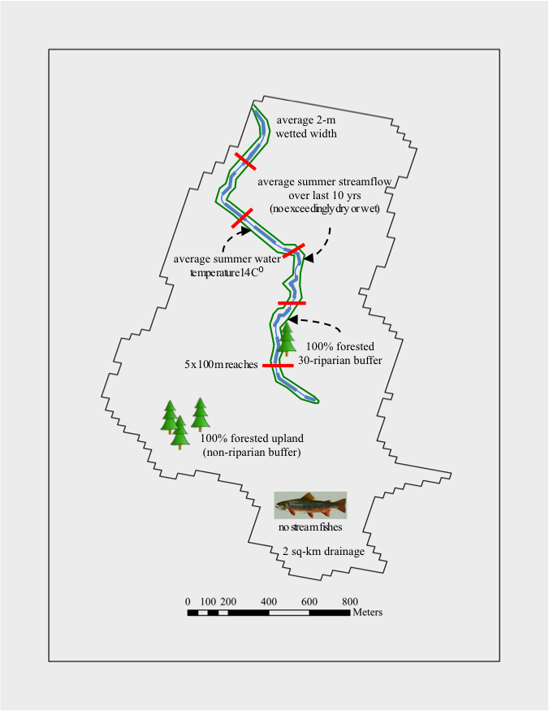upstream drainage area of 2 km2 (average 2-m wetted width)
* average summer (June, July, August) water temperature of 14O C
* near average summer (June, July, August) streamflow every year over last 10 years (zero exceedingly wet or dry years)
* 100% forest cover within a 30-m riparian buffer
* 100% forest cover within the upland (non-riparian buffer)
* no stream fishes present (no competition or predation)
* no reaches are located at the edge of a range (non-peripheral or edge population effects).
* Also, assume that each randomly selected from across the range of salamander communities within each region, which naturally range in the number of co-occurring salamander species within a 500-m each.

For example:

* southern region reaches may contain 0 to 10 co-occurring salamander species
* mid-atlantic region reaches may contain 0 to 6 co-occurring salamander species
* northern region reaches may contain 0 to 4 co-occurring salamander species

Figure 2. Survey responses by each expert by reaction and species (dot = at least one response for the survey question, no dot = expert indicated “NA”).

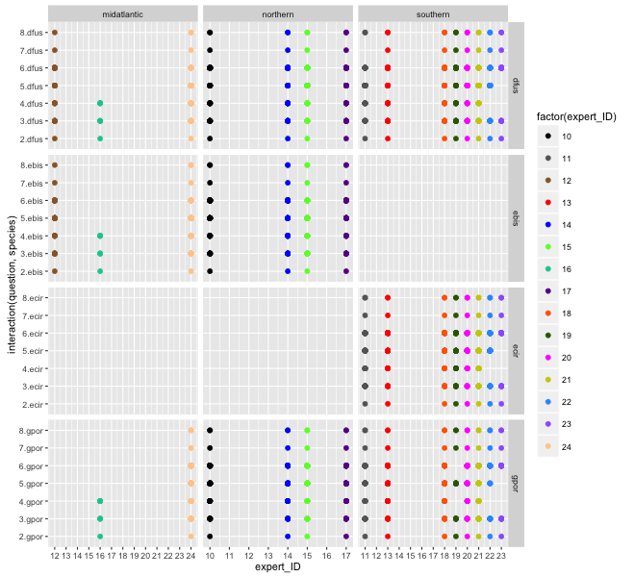

Figure X. Boxplots for the number of reaches occupied indicated across all survey questions for each expert (10-24) by species and region.

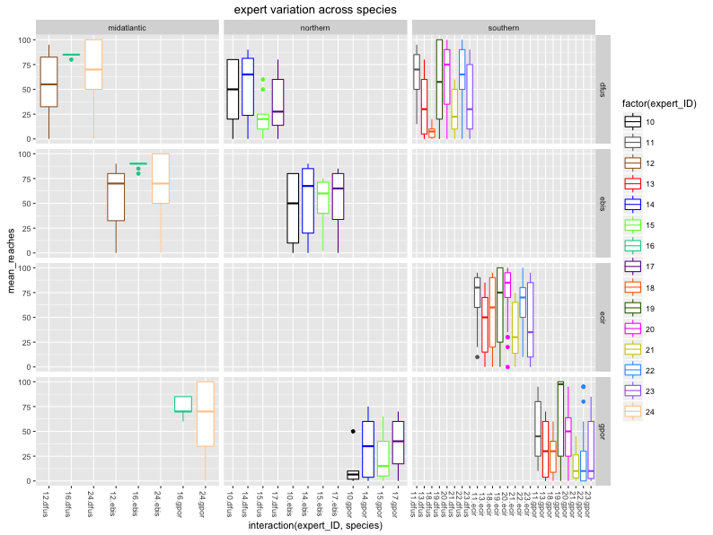

Figure X. Expected number of reaches occupied within a region, with lower and upper limits (line) and confidence intervals (value), for each expert by species and region. (question 2 – overall average occupancy)

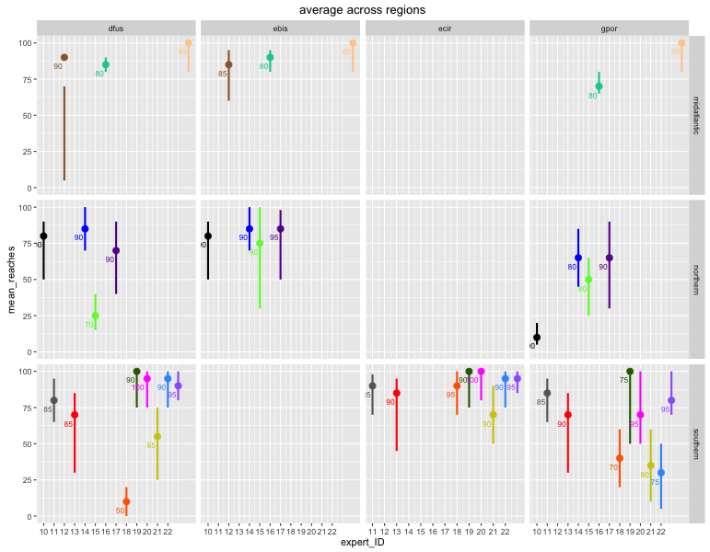

Figure 4. Number of reaches occupied (out of 100) in relation to stream size (sqkm) and log(stream size; sqkm) (question 4) for each expert by species and region (question 3)

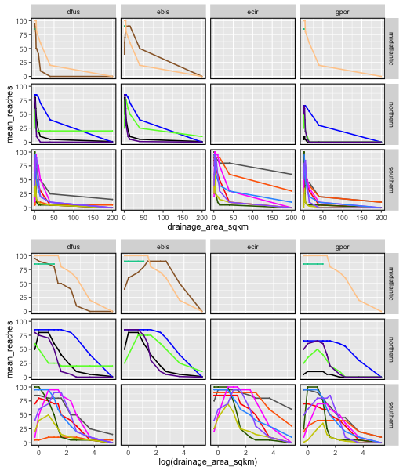

Figure 5. Number of reaches occupied (out of 100) in relation to mean summer (June, July, August) stream temperature (C) for each expert by species and region (question 4).

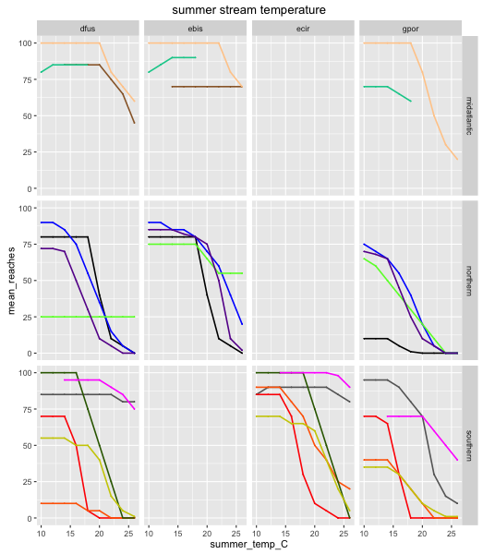

Figure 6. Number of reaches occupied (out of 100) in relation to exceedingly dry (10% average flow) and exceedingly wet (190% average flow) for small (2-m) and large (4-m) streams for each expert by species and region (question 5).

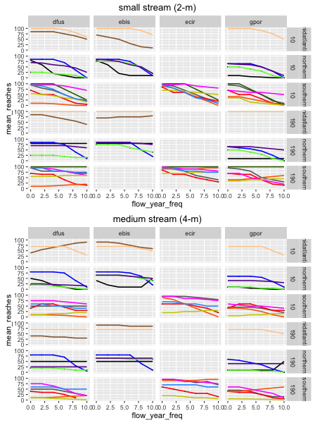

Figure X. Number of reaches occupied (out of 100) in relation to increasing riparian (x-axis; 0, 25, 50, 75, 100%) and upland forest cover (y-axis; 0, 25, 50, 75, 100%) for each expert (color) by species and region (question 6).

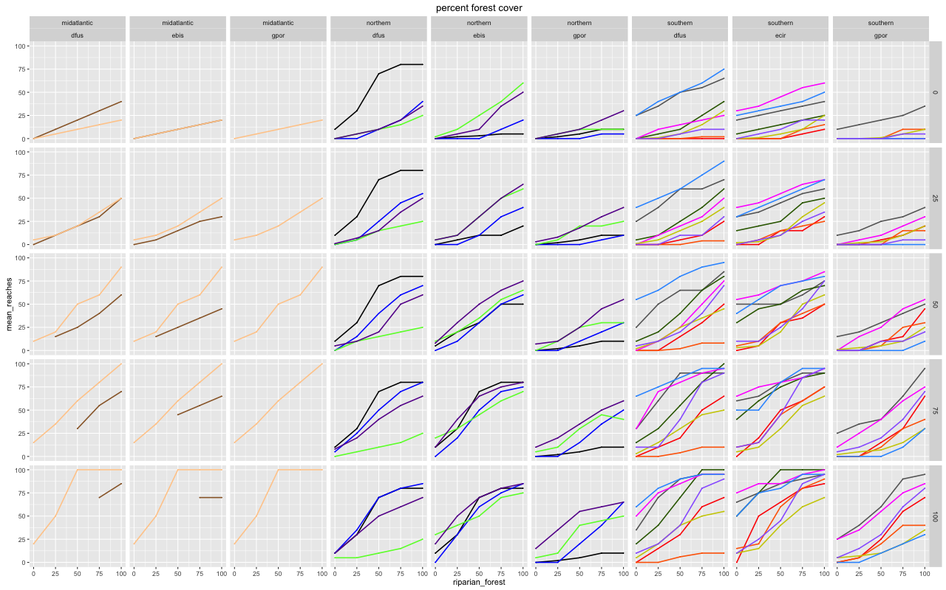

Figure X. Expected number of reaches occupied within a region with and without brook trout (0 = absent, 1 = present), with lower and upper limits (line) and confidence intervals (value), for each expert (color) by species and region (question 7).

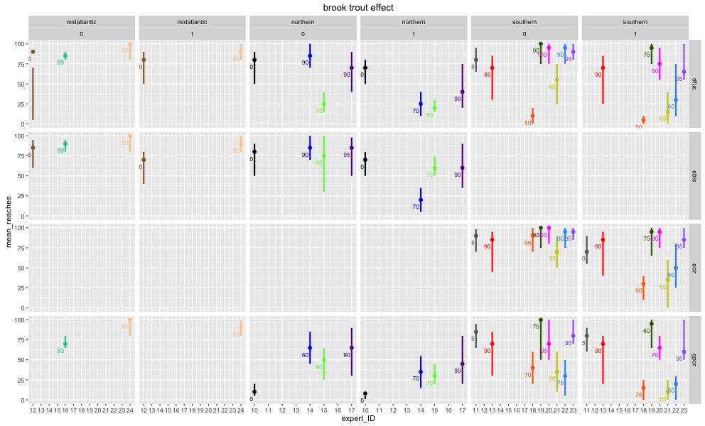

Figure X. Expected number of reaches occupied within a region for each focal species (y axis) with and without a focal salamander species present (x-axis, none = absent), with lower and upper limits (line) and confidence intervals (value), for each expert (color) by region (question 8).

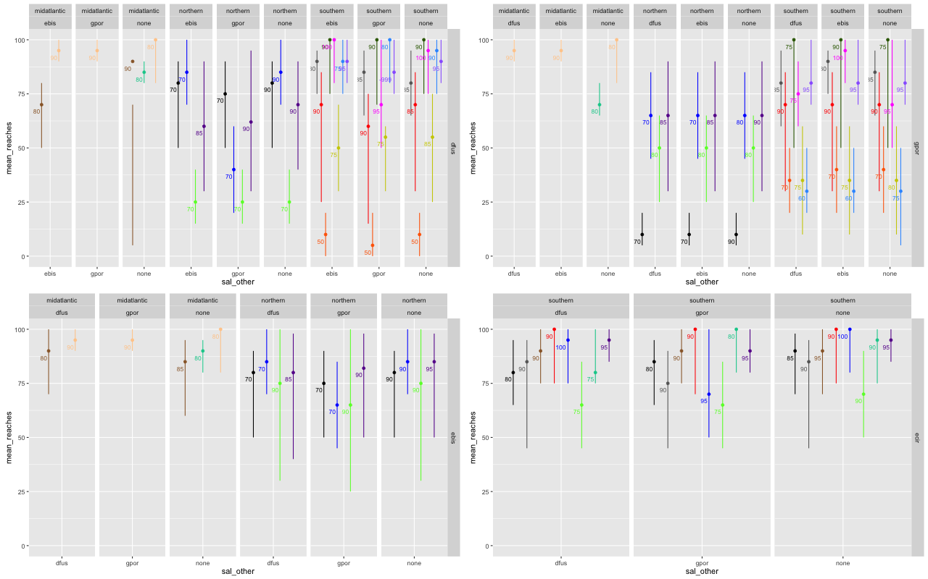

Table 2. Binomial Generalized Linear Mixed Effects Model (successes = reaches occupied, failures = no. reaches unoccupied). Residuals indicated non-independence within experts for average occupancy, temperature and stream size effects, thus included as random effects). Data was centered based on the baseline-scenarios (mean = baseline conditions in the catchment).

glmer1.species<-glmer(cbind(qall. species $mean_reaches,qall. species $failure_reaches) ~ c.log.drainage + I(c.log.drainage^2) + c.temp + c.flow + c.freq + c.perc.ripa*c.perc.upla + trout_presence + ebis_presence + gpor_presence + (1+c.temp+ I(c.log.drainage^2)|expert_ID),data = qall.species,family=binomial)

Figure 8. Residuals

Figure 9. Predicted vs. observed

Figure 10. Example of mean predicted occupancy (Deerfield – show them ice.sheds.org)