**Description:**

Stream salamanders are vulnerable to decline across their range due to increasing number of threats associated with climate change and land use development. Multiple management agencies and conservation organizations are interested in protecting these species through managing riparian and upland habitats and barriers that influence predatory fish dispersal. Regional data sets useful for predicting both local and broad-scale salamander occupancy in relation to changing abiotic and biotic factors are limited. As a result, management agencies are turning to stream salamander experts to help inform the potential benefits of alternative conservation actions using expert elicitation methods –an approach increasingly used to improve conservation of data-scare speices (Martin, .

The purpose of this survey is to utilize salamander expertise to understand the effects of a variety of factors hypothesized to influence occupancy of several species of stream salamanders at the local stream-reach scale. Using information across multiple experts can allow for estimation of uncertainty in predictions of occupancy under alternative climate and land management strategies.

Specifically, we are interested predicting the effects of climate and land use and interspecies interactions on three species of stream salamanders: northern dusky salamander (*Desmognathus fuscus*; *DFUS*), northern two-lined salamander (*Eurycea bislineata*; *EBIS*) and spring salamander (*Gyrinophilus porphyriticus*; *GPOR*).

**Directions:**

**STEP 1. TAKE THIS SURVEY (DUE MARCH 25, 2016, ~ 1 hr).**

To the best of your ability, please answer the survey questions below. We strongly encourage you to review and consider any relevant literature (publications, reports, and unpublished data) in your response. Please email your completed survey to [rakatz@umass.edu](mailto:rakatz@umass.edu) by March 25, 2016.

**STEP 2: PARTICIPATE IN FOLLOW-UP WEBINAR (END MARCH/EARLY APRIL, ~ 4 hr).**

We will follow up two weeks after the survey with a webinar (March 29-April 6) to share and discuss the range of expert responses. We will be able to 1) answer any questions concerning the survey 2) encourage discussion of each survey response (similar and divergent responses) to assess degree of agreement and descent among experts and 3) identify additional relevant factors or hypotheses relevant to the survey. If needed, we will schedule additional follow-up discussion for experts on relevant topics identified during the webinar. Please indicate all of the times available here asap:

**STEP 3: AMEND SURVEY RESPONSES (DUE APRIL 15, ~ 1 hr).**

After the webinar, experts will amend their survey responses and indicate their confidence in their responses. We will follow up with experts after synthesizing results to ensure an accurate representation of the current state of the knowledge.

**Question 1:** **Biographical Information**

**Name:**

**Email:**

**Affiliation:**

**Graduation Year (Ph.D.):**

**Years conducting research on stream salamanders:**

**Estimated number of publications that have included stream salamanders:**

In your opinion, please tell us what your current state of knowledge of stream salamanders by placing an “X” in each category below to indicate if you have no knowledge (1), less knowledge (2), similar knowledge (3), more knowledge (4), or the most knowledge compared to the ***broader community of salamander ecologists***. For example, if you consider yourself to have more knowledge about riparian effects on stream salamanders compared to the broader community of salamander ecologists, place an “X” under “more”. If you have no knowledge about a particular topic, place an “X” under “none”.

|  |  |  |  |  |  |
| --- | --- | --- | --- | --- | --- |
| **Level of knowledge** | **none** | **less** | **similar** | **more** | **most** |
| General salamander ecology |  |  |  |  |  |
| Land use effects on stream salamanders |  |  |  |  |  |
| Riparian effects on stream salamanders |  |  |  |  |  |
| Stream temperature effects on stream salamanders |  |  |  |  |  |
| Streamflow effects on stream salamanders |  |  |  |  |  |
| Fish effects on stream salamanders |  |  |  |  |  |
| Stream salamander effects on fish |  |  |  |  |  |
| Salamander occupancy modeling |  |  |  |  |  |
| Salamander abundance modeling |  |  |  |  |  |

**Question 2: Average occupancy across the species range**

Consider the hypothesized current distributions for each stream salamander (Figure 1), and a stream reach with the particular characteristics listed below (Figure 2).

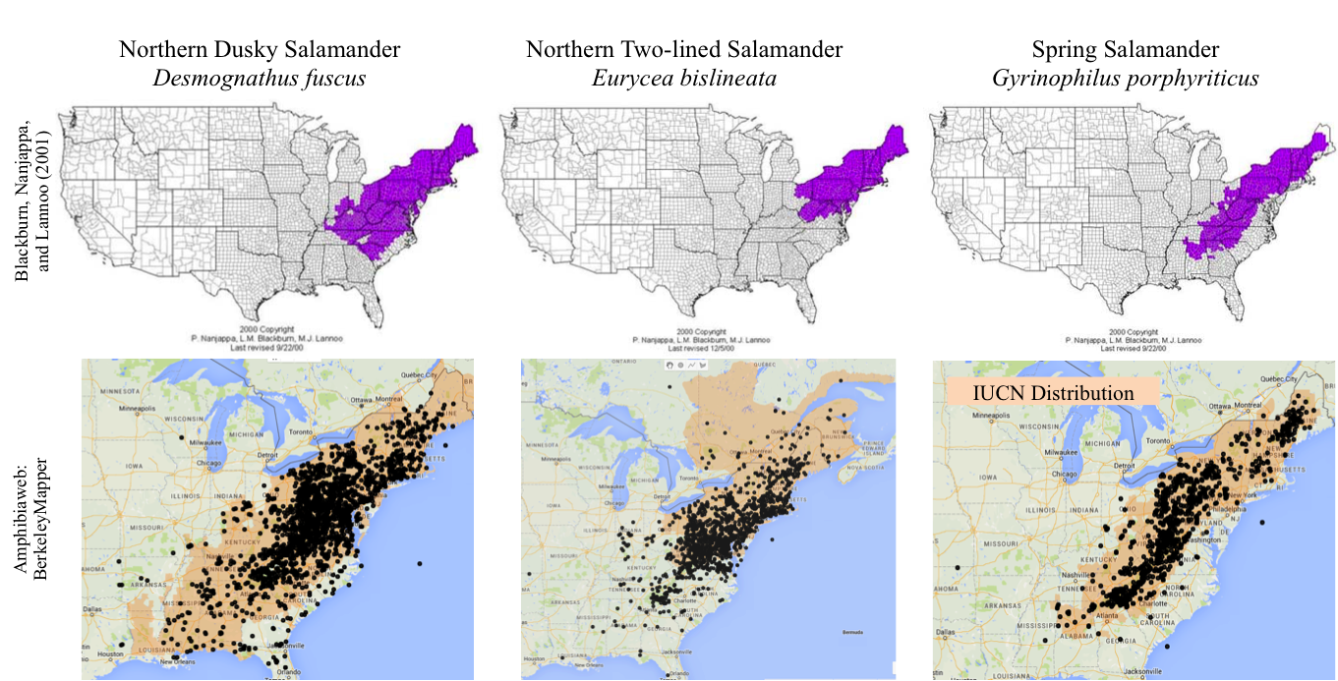

Figure 1. Hypothesized current distribution for each stream salamander species. Upper panel taken from Blackburn, Nanjappa, and Lannoo (2001) US Amphibian Distribution Maps and lower panel taken from Amphibiaweb.org Berkeley Mapper, with positive sample locations indicated by black dots and the IUCN distribution for each species shaded orange.

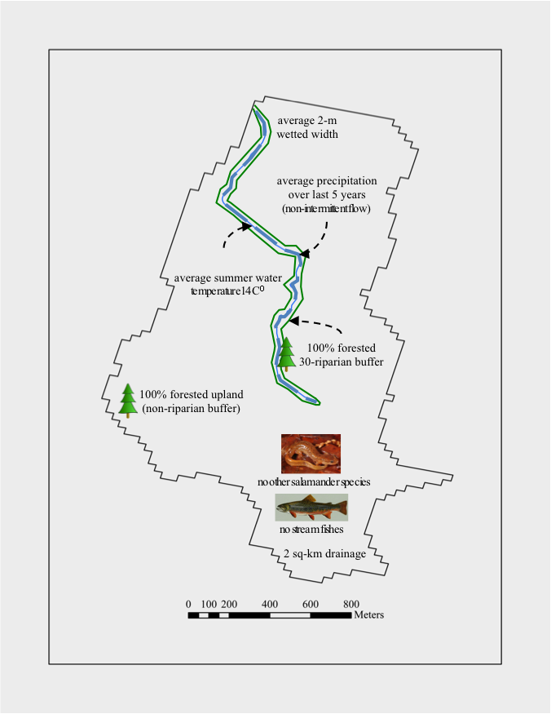Figure 2. Each 500-m stream reach is located within a catchment with the following characteristics:

* upstream drainage area of 2 km2 (average 2-m wetted width)
* average summer (June, July, August) water temperature of 14O C
* average precipitation over last 5 years (non-intermittent flow, zero exceedingly wet or dry years)
* 100% forest cover within a 30-m riparian buffer
* 100% forest cover within the upland (non-riparian buffer)
* no stream fishes present (no competition or predation)
* no other stream salamanders present (no competition or predation)

***In your opinion, how many stream reaches (each 500-m long) out of 100 possible reaches selected across the species range would you expect a population of salamanders to exist for each species?***

|  |  |  |  |  |
| --- | --- | --- | --- | --- |
| **Reaches within center of range** | **Value** | ***DFUS*** | ***GPOR*** | ***EBIS*** |
| What is your best estimate (the most likely value)? | between 0 and 100 |  |  |  |
| Realistically, what is the lowest value it could be? | between 0 and 100 |  |  |  |
| Realistically, what is the highest value it could be? | between 0 and 100 |  |  |  |
| How confident are you that the interval you provided contains the truth? | between 50 and 100% |  |  |  |

|  |  |  |  |  |
| --- | --- | --- | --- | --- |
| **Reaches within edge of range** | **Value** | ***DFUS*** | ***GPOR*** | ***EBIS*** |
| What is your best estimate (the most likely value)? | between 0 and 100 |  |  |  |
| Realistically, what is the lowest value it could be? | between 0 and 100 |  |  |  |
| Realistically, what is the highest value it could be? | between 0 and 100 |  |  |  |
| How confident are you that the interval you provided contains the truth? | between 50 and 100% |  |  |  |

**Question 3.** **Stream size effect on occupancy**

***In your opinion, how many stream reaches (each 500-m long) out of 100 possible reaches selected across the species range with a particular STREAM SIZE (drainage area; km2) would you expect a population of salamanders to exist for each species?***

Note change in stream size units.

|  |  |  |  |  |  |
| --- | --- | --- | --- | --- | --- |
| **Drainage area (km2)** | **Stream width (m)** | **Number of possible**  **stream reaches** | ***DFUS***  **(0-100)** | ***GPOR***  **(0-100)** | ***EBIS***  **(0-100)** |
| 0.75 | 0.5 | 100 |  |  |  |
| 1.00 | 1.0 | 100 |  |  |  |
| **2.00** | **2.0** | **100** |  |  |  |
| 3.00 | 2.5 | 100 |  |  |  |
| 4.00 | 3.0 | 100 |  |  |  |
| 5.00 | 3.5 | 100 |  |  |  |
| 10.00 | 4.0 | 100 |  |  |  |
| 15.00 | 5.0 | 100 |  |  |  |
| 40.00 | 8.0 | 100 |  |  |  |
| 200.00 | 20.0 | 100 |  |  |  |

Use the figure below if needed:

Assume all reaches have:

* ~~upstream drainage area of 2 km~~~~2~~ ~~(average 2-m wetted width)~~
* average summer (June, July, August) water temperature of 14O C
* average precipitation over last 5 years (non-intermittent flow, zero exceedingly wet or dry years)
* 100% forest cover within a 30-m riparian buffer
* 100% forest cover within the upland (non-riparian buffer)
* no stream fishes present (no competition or predation)
* no other stream salamanders present (no competition or predation)

**Question 4.** **Stream temperature effect on occupancy**

***In your opinion, how many stream reaches (each 500-m long) out of 100 possible reaches selected across the species range with a particular AVERAGE SUMMER (June, July, August) STREAM TEMPERATURE (C) would you expect a population of salamanders to exist for each species?***

Note change in stream temperature unit of 2 degrees C.

|  |  |  |  |  |
| --- | --- | --- | --- | --- |
| **Mean summer**  **stream temperature (C)** | **Number of possible stream reaches** | ***DFUS***  **(0-100)** | ***GPOR***  **(0-100)** | ***EBIS***  **(0-100)** |
| 10 | 100 |  |  |  |
| 12 | 100 |  |  |  |
| **14** | **100** |  |  |  |
| 16 | 100 |  |  |  |
| 18 | 100 |  |  |  |
| 20 | 100 |  |  |  |
| 22 | 100 |  |  |  |
| 24 | 100 |  |  |  |
| 26 | 100 |  |  |  |

Assume all reaches have:

* upstream drainage area of 2 km2 (average 2-m wetted width)
* ~~average summer (June, July, August) water temperature of 14~~~~O~~ ~~C~~
* average precipitation over last 5 years (non-intermittent flow, zero exceedingly wet or dry years)
* 100% forest cover within a 30-m riparian buffer
* 100% forest cover within the upland (non-riparian buffer)
* no stream fishes present (no competition or predation)
* no other stream salamanders present (no competition or predation)

**Question 5.** **Streamflow effect on occupancy**

***In your opinion, how many stream reaches (each 500-m long) out of 100 possible reaches selected across the species range with a particular FLOW REGIME (last 5-yrs) would you expect a population of salamanders to exist for each species?***

Note: Change in stream size and recent precipitation

|  |  |  |  |  |
| --- | --- | --- | --- | --- |
| *DFUS* |  | Precipitation | | |
|  |  | 5-yrs severe drought years | 5-yrs average flow | 5-yrs flow years |
| Stream size | 1 km2 ~ 1 m |  |  |  |
| 10 km2 ~ 4 m |  |  |  |
| 50 km2 ~ 10 m |  |  |  |
| *GPOR* |  | Precipitation | | |
|  |  | 5-below average drought years | 5-near average drought years | 5-above average flow years |
| Stream size | 1 km2 ~ 1 m |  |  |  |
| 10 km2 ~ 4 m |  |  |  |
| 50 km2 ~ 10 m |  |  |  |
| *EBIS* |  | Precipitation | | |
|  |  | 5-below average drought years | 5-near average drought years | 5-above average flow years |
| Stream size | 1 km2 ~ 1 m |  |  |  |
| 10 km2 ~ 4 m |  |  |  |
| 50 km2 ~ 10 m |  |  |  |

Assume all reaches have:

* upstream drainage area of 2 km2 (average 2-m wetted width)
* average summer (June, July, August) water temperature of 14O C
* ~~average precipitation over last 5 years (non-intermittent flow, zero exceedingly wet or dry years)~~
* 100% forest cover within a 30-m riparian buffer
* 100% forest cover within the upland (non-riparian buffer)
* no stream fishes present (no competition or predation)
* no other stream salamanders present (no competition or predation)

**Question 6.** **Riparian and upland forest cover effects on occupancy**

***In your opinion, how many stream reaches (each 500-m long) out of 100 possible reaches selected across the species range with a particular PERCENT FOREST COVER (in the 30-m riparian buffer and upland) would you expect a population of salamanders to exist for each species?***

Note change in percent upland and riparian for each species.

|  |  |  |  |  |  |  |  |
| --- | --- | --- | --- | --- | --- | --- | --- |
| ***DFUS*** | | | | | | | |
|  |  | | **Percent upland (non-riparian) forest cover** | | | | |
| **Value (0-100 reaches)** |  | | **0** | **25** | **50** | **75** | **100** |
| **Percent riparian**  **(30-m buffer) forest cover** | **0** | |  |  |  |  |  |
| **25** | |  |  |  |  |  |
| **50** | |  |  |  |  |  |
| **75** | |  |  |  |  |  |
| **100** | |  |  |  |  |  |
| ***GPOR*** | | | | | | | |
|  | |  | **Percent upland (non-riparian) forest cover** | | | | |
| **Value (0-100 reaches)** | |  | **0** | **25** | **50** | **75** | **100** |
| **Percent riparian**  **(30-m buffer) forest cover** | | **0** |  |  |  |  |  |
| **25** |  |  |  |  |  |
| **50** |  |  |  |  |  |
| **75** |  |  |  |  |  |
| **100** |  |  |  |  |  |
| ***EBIS*** | | | | | | | |
|  | |  | **Percent upland (non-riparian) forest cover** | | | | |
| **Value (0-100 reaches)** | |  | **0** | **25** | **50** | **75** | **100** |
| **Percent riparian**  **(30-m buffer) forest cover** | | **0** |  |  |  |  |  |
| **25** |  |  |  |  |  |
| **50** |  |  |  |  |  |
| **75** |  |  |  |  |  |
| **100** |  |  |  |  |  |

Assume all reaches have:

* upstream drainage area of 2 km2 (average 2-m wetted width)
* average summer (June, July, August) water temperature of 14O C
* average precipitation over last 5 years (non-intermittent flow, zero exceedingly wet or dry years)
* ~~100% forest cover within a 30-m riparian buffer~~
* ~~100% forest cover within the upland (non-riparian buffer)~~
* no stream fishes present (no competition or predation)
* no other stream salamanders present (no competition or predation)

**Question 7:** **Fish presence effect on occupancy**

***In your opinion, how many stream reaches (each 500-m long) out of 100 possible reaches selected across the species range with a RESIDENT BROOK TROUT FISH POPULATION PRESENT would you expect a population of salamanders to exist for each species?***

|  |  |  |  |  |
| --- | --- | --- | --- | --- |
| **Fish population present** | **Value** | ***DFUS*** | ***GPOR*** | ***EBIS*** |
| What is your best estimate (the most likely value)? | between 0 and 100 |  |  |  |
| Realistically, what is the lowest value it could be? | between 0 and 100 |  |  |  |
| Realistically, what is the highest value it could be? | between 0 and 100 |  |  |  |
| How confident are you that the interval you provided contains the truth? | between 50 and 100% |  |  |  |

Assume all reaches have:

* upstream drainage area of 2 km2 (average 2-m wetted width)
* average summer (June, July, August) water temperature of 14O C
* average precipitation over last 5 years (non-intermittent flow, zero exceedingly wet or dry years)
* 100% forest cover within a 30-m riparian buffer
* 100% forest cover within the upland (non-riparian buffer)
* ~~no stream fishes present (no competition or predation)~~
* no other stream salamanders present (no competition or predation)

**Question 8:** **Salamander presence effect on occupancy**

***In your opinion, how many stream reaches (each 500-m long) out of 100 possible reaches selected across the species range with another STREAM SALAMANDER POPULATION PRESENT would you expect a population of salamanders to exist for each species?***

|  |  |  |  |
| --- | --- | --- | --- |
| ***DFUS population present*** | **Value** | ***GPOR*** | ***EBIS*** |
| What is your best estimate (the most likely value)? | between 0 and 100 |  |  |
| Realistically, what is the lowest value it could be? | between 0 and 100 |  |  |
| Realistically, what is the highest value it could be? | between 0 and 100 |  |  |
| How confident are you that the interval you provided contains the truth? | between 50 and 100% |  |  |

|  |  |  |  |
| --- | --- | --- | --- |
| ***GPOR population present*** | **Value** | ***DFUS*** | ***EBIS*** |
| What is your best estimate (the most likely value)? | between 0 and 100 |  |  |
| Realistically, what is the lowest value it could be? | between 0 and 100 |  |  |
| Realistically, what is the highest value it could be? | between 0 and 100 |  |  |
| How confident are you that the interval you provided contains the truth? | between 50 and 100% |  |  |

|  |  |  |  |
| --- | --- | --- | --- |
| ***EBIS population present*** | **Value** | ***DFUS*** | ***GYPO*** |
| What is your best estimate (the most likely value)? | between 0 and 100 |  |  |
| Realistically, what is the lowest value it could be? | between 0 and 100 |  |  |
| Realistically, what is the highest value it could be? | between 0 and 100 |  |  |
| How confident are you that the interval you provided contains the truth? | between 50 and 100% |  |  |

Assume all reaches have:

* upstream drainage area of 2 km2 (average 2-m wetted width)
* average summer (June, July, August) water temperature of 14O C
* average precipitation over last 5 years (non-intermittent flow, zero exceedingly wet or dry years)
* 100% forest cover within a 30-m riparian buffer
* 100% forest cover within the upland (non-riparian buffer)
* no stream fishes present (no competition or predation)
* ~~no other stream salamanders present (no competition or predation)~~

**Question 9: Additional factors and experts**

In your opinion, are there other experts who could provide insights into the effects of any of these (average occupancy in center or edge of range, effects of stream size, summer temperatures, streamflow, riparian land use, upland land use, fish or other stream salamander presence) on the occupancy of the three focal species in this survey? Please indicate relevant experts and abiotic or biotic factors:

Expert: _________________________________ Factor: _________________________________

Expert: _________________________________ Factor: _________________________________

Expert: _________________________________ Factor: _________________________________

Expert: _________________________________ Factor: _________________________________

Expert: _________________________________ Factor: _________________________________

List of experts requested to take this survey.

[NEARMI opinions]

enter 1 = yes considered expert for this study

|  |  |  |  |  |  |  |  |  |  |  |  |
| --- | --- | --- | --- | --- | --- | --- | --- | --- | --- | --- | --- |
| last | first | affiliation | Use? (1= yes,  (0 = no) | gen_eco | landuse | riparian | temp | fish | flow | occ | abun |
| Adams | Mike | USGS |  | 0 | 0 | 0 | 0 | 0 | 0 | 0 | 0 |
| Apodoca | JJ |  |  | 0 | 0 | 0 | 0 | 0 | 0 | 0 | 0 |
| Baily | Larissa | ColoradoState |  | 0 | 0 | 0 | 0 | 0 | 0 | 0 | 0 |
| Barrett | Kyle | Clemson | 1 | 0 | 0 | 0 | 0 | 0 | 0 | 0 | 0 |
| Beachy | Chris |  |  | 0 | 0 | 0 | 0 | 0 | 0 | 0 | 0 |
| Bonett | Ron |  |  | 0 | 0 | 0 | 0 | 0 | 0 | 0 | 0 |
| Bruce | Dick |  |  | 0 | 0 | 0 | 0 | 0 | 0 | 0 | 0 |
| Calhoun | Aram |  |  | 0 | 0 | 0 | 0 | 0 | 0 | 0 | 0 |
| Camp | Carola |  |  | 0 | 0 | 0 | 0 | 0 | 0 | 0 | 0 |
| Cecala | Kristen | Sewanee |  | 0 | 0 | 0 | 0 | 0 | 0 | 0 | 0 |
| David | Robert |  |  | 0 | 0 | 0 | 0 | 0 | 0 | 0 | 0 |
| Earl | Julia |  |  | 0 | 0 | 0 | 0 | 0 | 0 | 0 | 0 |
| Fields | Will | USGS |  | 0 | 0 | 0 | 0 | 0 | 0 | 0 | 0 |
| Gorman | Tom |  |  | 0 | 0 | 0 | 0 | 0 | 0 | 0 | 0 |
| Graham | Sean |  |  | 0 | 0 | 0 | 0 | 0 | 0 | 0 | 0 |
| Grant | Evan | USGS | 1 | 0 | 0 | 0 | 0 | 0 | 0 | 0 | 0 |
| Greenwald | Katie |  |  | 0 | 0 | 0 | 0 | 0 | 0 | 0 | 0 |
| Green | Linda |  |  |  |  |  |  |  |  |  |  |
| Harper | Elizabeth |  |  | 0 | 0 | 0 | 0 | 0 | 0 | 0 | 0 |
| Highton | Dick |  |  | 0 | 0 | 0 | 0 | 0 | 0 | 0 | 0 |
| Hill | Pierson |  |  | 0 | 0 | 0 | 0 | 0 | 0 | 0 | 0 |
| Hocking | Dan | USGS | 1 | 0 | 0 | 0 | 0 | 0 | 0 | 0 | 0 |
| Homyack | Jessica |  |  | 0 | 0 | 0 | 0 | 0 | 0 | 0 | 0 |
| Houck | Lynne |  |  | 0 | 0 | 0 | 0 | 0 | 0 | 0 | 0 |
| Hunter | Malcom |  |  | 0 | 0 | 0 | 0 | 0 | 0 | 0 | 0 |
| Jaeger | Bob |  |  | 0 | 0 | 0 | 0 | 0 | 0 | 0 | 0 |
| Kozak | Ken |  |  | 0 | 0 | 0 | 0 | 0 | 0 | 0 | 0 |
| Kroll | AJ |  |  | 0 | 0 | 0 | 0 | 0 | 0 | 0 | 0 |
| Lips | Karen | UMaryland |  | 0 | 0 | 0 | 0 | 0 | 0 | 0 | 0 |
| Lowe | Winsor |  | 1 | 0 | 0 | 0 | 0 | 0 | 0 | 0 | 0 |
| Maerz | John | UGA |  | 0 | 0 | 0 | 0 | 0 | 0 | 0 | 0 |
| Mendelson | Joe |  |  | 0 | 0 | 0 | 0 | 0 | 0 | 0 | 0 |
| Milanovich | Joe |  |  | 0 | 0 | 0 | 0 | 0 | 0 | 0 | 0 |
| Miller | David | PennState |  | 0 | 0 | 0 | 0 | 0 | 0 | 0 | 0 |
| Muths | Erin | USGS |  | 0 | 0 | 0 | 0 | 0 | 0 | 0 | 0 |
| O’Connell | Katie |  |  | 0 | 0 | 0 | 0 | 0 | 0 | 0 | 0 |
| Patrick | David |  |  | 0 | 0 | 0 | 0 | 0 | 0 | 0 | 0 |
| Pauley | Tom |  |  | 0 | 0 | 0 | 0 | 0 | 0 | 0 | 0 |
| Peterman | Bill |  |  | 0 | 0 | 0 | 0 | 0 | 0 | 0 | 0 |
| Pierson | Todd |  |  | 0 | 0 | 0 | 0 | 0 | 0 | 0 | 0 |
| Price | Steven |  | 1 |  |  |  |  |  |  |  |  |
| Rissler | Leslie |  |  | 0 | 0 | 0 | 0 | 0 | 0 | 0 | 0 |
| Scott | David |  |  | 0 | 0 | 0 | 0 | 0 | 0 | 0 | 0 |
| Steen | David | Auburn |  | 0 | 0 | 0 | 0 | 0 | 0 | 0 | 0 |
| Stuart | X |  |  | 0 | 0 | 0 | 0 | 0 | 0 | 0 | 0 |
| Sutton | Bill |  |  | 0 | 0 | 0 | 0 | 0 | 0 | 0 | 0 |
| Tilley | Stephen |  |  | 0 | 0 | 0 | 0 | 0 | 0 | 0 | 0 |
| Titus | Valorie |  |  | 0 | 0 | 0 | 0 | 0 | 0 | 0 | 0 |
| Trauth | Stan |  |  | 0 | 0 | 0 | 0 | 0 | 0 | 0 | 0 |
| Wake | David |  |  | 0 | 0 | 0 | 0 | 0 | 0 | 0 | 0 |
| Walls | Susan |  |  | 0 | 0 | 0 | 0 | 0 | 0 | 0 | 0 |
| Welsh | Hartwell |  |  | 0 | 0 | 0 | 0 | 0 | 0 | 0 | 0 |