**Description:** Stream salamanders are vulnerable to decline across their range due to the increasing number of threats associated with climate change and land use development. Multiple management agencies and conservation organizations are interested in protecting these species through managing riparian and upland habitats and barriers that influence dispersal of stream fishes. Regional data sets useful for estimating and predicting local and broad-scale salamander occupancy in relation to changing abiotic and biotic factors are limited. As a result, management agencies are turning to stream salamander experts to help inform the potential benefits of alternative conservation actions using expert elicitation methods –an approach increasingly used to improve conservation of species with limited empirical data (see Martin et al. 2005, Kuhnert et al. 2010, Speirs-Bridge et al. 2010, Runge et al. 2011, Martin et al. 2012, Adams-Hocking et al. 2016).

The purpose of this survey is to utilize salamander expertise to assess the effects of biotic and abiotic factors on several species of stream salamanders occurring within the northeastern US. Gathering opinions from multiple experts allows us to include both variability and uncertainty in scientific understanding in predictions of salamander occupancy under a range of alternative climate and land management scenarios. Specifically, this survey aims to use expert knowledge to predict the effects of climate (temperature and streamflow), land use (riparian and upland habitats) and interspecies interactions (fish and salamanders) on three focal species of stream salamanders: northern dusky salamander (*Desmognathus fuscus*; *DFUS*), northern two-lined salamander (*Eurycea bislineata*; *EBIS*) and spring salamander (*Gyrinophilus porphyriticus*; *GPOR*) to help inform management decisions.

**Directions:** To obtain unbiased expert knowledge, authors must be willing to engage in the following steps: take this survey, participant in a follow-up webinar, amend survey responses, and approve publication.

**STEP 1. TAKE THIS SURVEY (BY MARCH 28, 2016 ~ 1-2 hr).**

To the best of your ability, please answer survey questions below. We strongly encourage you to review and consider any relevant literature (publications, reports, and unpublished data) in your responses. **E-mail** your survey to [rakatz@umass.edu](mailto:rakatz@umass.edu) (as docx or scanned pdf) or **mail** a copy to P.O. Box 796, One Migratory Way, SO Conte Anadromous Fish Research Laboratory, Turners Falls MA 01376).

**STEP 2: PARTICIPATE IN FOLLOW-UP WEBINAR (BY EARLY APRIL ~ 3-4 hrs).**

We will follow up within two weeks after the survey with a webinar (April 4-6 or 13-15) to share and discuss the range of expert responses. During the webinar we will 1) answer any questions concerning the survey 2) discuss survey response (similar and divergent responses) to assess degree of agreement and descent among experts (specific responses will be anonymous) and 3) identify additional relevant factors or hypotheses of importance for the focus species. If needed, we will schedule additional time for discussion relevant topics identified during the webinar. Please indicate your availability for the webinar ASAP here: <http://www.needtomeet.com/meeting?id=6owa0s54V>.

**STEP 3: AMEND SURVEY RESPONSES (BY LATE APRIL, ~ 1-2 hr).**

After the webinar, experts will amend their initial survey responses and additionally indicate their confidence-level in responses identified as important during the webinar.

**STEP 4: APPROVE PUBLICATION (BY LATE MAY, ~ 1 hr).**

After synthesizing amended survey responses, we will share findings with co-authors to ensure an accurate representation of the current state of the knowledge for publication.

**Contact us if you have any questions or concerns:**

Rachel Katz1,2,3 [rakatz@umass.edu](mailto:rakatz@umass.edu) Evan Grant2 [ehgrant@usgs.gov](mailto:ehgrant@usgs.gov) Dan Hocking3 [dhocking@usgs.gov](mailto:dhocking@usgs.gov)

1University of Massachusetts-Amherst, MA Cooperative Fish and Wildlife Research Unit, 2US Geological Survey, Patuxent Wildlife Research Center, 3US Geological Survey, SO Conte Anadromous Fish Laboratory

Funding: US Geological Survey, Northeast Climate Science Center, University of Massachusetts-Amherst

**Question 1:** **Biographical Information**

**Name:**

**Email:**

**Affiliation:**

**Last degree and year (BS, MS, PhD):**

**Number of years conducting research on stream salamanders:**

**Number of publications including focal stream salamander species (approximate):**

Based on your knowledge and experience, please tell us what your current state of knowledge of stream salamander ecology by placing an “X” in either category below: none, less, similar, more, or most knowledge compared to the ***broad community of salamander ecologists***. For example, if you consider yourself to have more knowledge about riparian effects on stream salamanders compared to the broader community of salamander ecologists, place an “X” under “more”. If you have no knowledge about a particular topic, place an “X” under “none”.

|  |  |  |  |  |  |
| --- | --- | --- | --- | --- | --- |
| **Level of knowledge** | **none** | **less** | **similar** | **more** | **most** |
| General salamander ecology |  |  |  |  |  |
| Land use effects on stream salamanders |  |  |  |  |  |
| Riparian effects on stream salamanders |  |  |  |  |  |
| Stream temperature effects on stream salamanders |  |  |  |  |  |
| Streamflow effects on stream salamanders |  |  |  |  |  |
| Fish effects on stream salamanders |  |  |  |  |  |
| Stream salamander effects on fish |  |  |  |  |  |
| Salamander occupancy modeling |  |  |  |  |  |
| Salamander abundance modeling |  |  |  |  |  |
| Northern (NY, RI, CT, MA, VT, NH, ME, Canada) salamander species, populations and communities |  |  |  |  |  |
| Mid-Atlantic (OH, PA, DE, NJ, MD, DC) salamander species, populations and communities |  |  |  |  |  |
| Southern (VA, WV, KY, TN, NC, SC, GA, AL, MS) salamander species, populations and communities |  |  |  |  |  |

**For the survey questions below (Q2-Q9), please give your responses for the region that you have the MOST knowledge for the focal species.**

Circle one: northern region mid-atlantic region southern region

If you are knowledgeable about the focal-species in **multiple** regions, please complete a survey for **each** region (download or print a new survey for each region).

**Question 2: Regional average stream salamander occupancy**

Consider the distributions for each focal stream salamander species (Figure 1) and a stream reach with characteristics listed below (Figure 2).

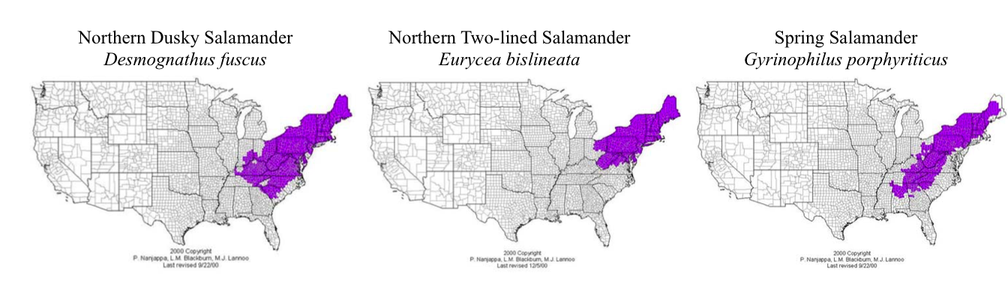

Figure 1. Distributions for three focal salamander species taken from Blackburn, Nanjappa, and Lannoo (2001) US Amphibian Distribution Maps (Amphibianweb.org).

Figure 2. For each survey question below, consider **100 randomly selected 500-m stream reaches** (each composed of 5 x 100-m stream reaches) each located within a catchment with the following characteristics:

* 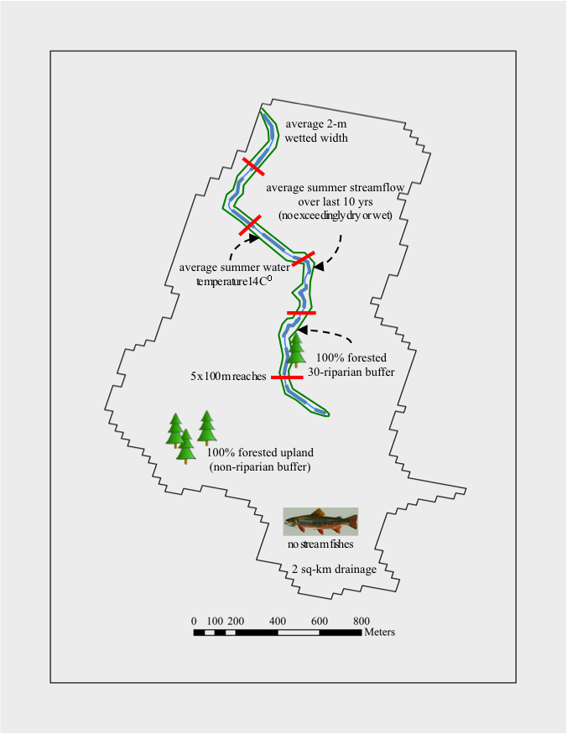upstream drainage area of 2 km2 (average 2-m wetted width)
* average summer (June, July, August) water temperature of 14O C
* near average summer (June, July, August) streamflow every year over last 10 years (zero exceedingly wet or dry years)
* 100% forest cover within a 30-m riparian buffer
* 100% forest cover within the upland (non-riparian buffer)
* no stream fishes present (no competition or predation)
* no reaches are located at the edge of a range (non-peripheral or edge population effects).
* Also, assume that each randomly selected from across the range of salamander communities within each region, which naturally range in the number of co-occurring salamander species within a 500-m each. For example:
* **southern region reaches may contain 0 to 10 co-occurring salamander species**
* **mid-atlantic region reaches may contain 0 to 6 co-occurring salamander species**
* **northern region reaches may contain 0 to 4 co-occurring salamander species**

***Q2 continued.***

***Based on your knowledge and experience, how many stream reaches (each 500-m long) out of 100 reaches selected randomly from across the region you selected (i.e., vary in other biotic and abiotic conditions) would you expect a population of salamanders to exist for each species? Place an “NA” where you have no knowledge to guide your response.***

|  |  |  |  |  |
| --- | --- | --- | --- | --- |
| **Region-specific average occupancy** | **Value** | ***DFUS*** | ***GPOR*** | ***EBIS*** |
| What is your best estimate (the most likely value)? | between 0 and 100 |  |  |  |
| Realistically, what is the lowest value it could be? | between 0 and 100 |  |  |  |
| Realistically, what is the highest value it could be? | between 0 and 100 |  |  |  |
| How confident are you that the interval you provided contains the truth? | between 50 and 100% |  |  |  |

**Question 3.** **Stream size effects on stream salamander occupancy**

***Based on your knowledge and experience, how many stream reaches (each 500-m long) out of 100 reaches selected randomly from across the region you selected (i.e., vary in other biotic and abiotic conditions) with a particular STREAM SIZE (drainage area; km2) would you expect a population of salamanders to exist for each species? Place an “NA” where you have no knowledge to guide your response.***

Note change in stream size units.

|  |  |  |  |  |  |
| --- | --- | --- | --- | --- | --- |
| **Drainage area (km2)** | **Stream width (m)** | **Number of possible**  **stream reaches** | ***DFUS***  **(0-100)** | ***GPOR***  **(0-100)** | ***EBIS***  **(0-100)** |
| 0.75 | 0.5 | 100 |  |  |  |
| 1.00 | 1.0 | 100 |  |  |  |
| 2.00 | 2.0 | 100 |  |  |  |
| 3.00 | 2.5 | 100 |  |  |  |
| 4.00 | 3.0 | 100 |  |  |  |
| 5.00 | 3.5 | 100 |  |  |  |
| 10.00 | 4.0 | 100 |  |  |  |
| 15.00 | 5.0 | 100 |  |  |  |
| 40.00 | 8.0 | 100 |  |  |  |
| 200.00 | 20.0 | 100 |  |  |  |

Use the figure below as a guide if needed (print or draw elsewhere):

Assume all reaches have:

* ~~upstream drainage area of 2 km~~~~2~~ ~~(average 2-m wetted width)~~
* average summer (June, July, August) water temperature of 14O C
* near average summer (June, July, August) streamflow every year over last 10 years (zero exceedingly wet or dry years)
* 100% forest cover within a 30-m riparian buffer
* 100% forest cover within the upland (non-riparian buffer)
* no stream fishes present (no competition or predation)
* no reaches are located at the edge of a range (non-peripheral or edge population effects)
* natural range of co-occurring species

**Question 4.** **Stream temperature effects on stream salamander occupancy**

***Based on your knowledge and experience, how many stream reaches (each 500-m long) out of 100 reaches selected randomly from across the region you selected (i.e., vary in other biotic and abiotic conditions) with a particular AVERAGE SUMMER (JUNE, JULY, AUGUST) STREAM TEMPERATURE (C) would you expect a population of salamanders to exist for each species? Place an “NA” where you have no knowledge to guide your response.***

Note changes in summer stream temperature are 2 degrees C.

|  |  |  |  |  |
| --- | --- | --- | --- | --- |
| **Mean summer**  **stream temperature (C)** | **Number of possible stream reaches** | ***DFUS***  **(0-100)** | ***GPOR***  **(0-100)** | ***EBIS***  **(0-100)** |
| 10 | 100 |  |  |  |
| 12 | 100 |  |  |  |
| 14 | 100 |  |  |  |
| 16 | 100 |  |  |  |
| 18 | 100 |  |  |  |
| 20 | 100 |  |  |  |
| 22 | 100 |  |  |  |
| 24 | 100 |  |  |  |
| 26 | 100 |  |  |  |

Use the figure below as a guide if needed (print or draw elsewhere):

Assume all reaches have:

* upstream drainage area of 2 km2 (average 2-m wetted width)
* ~~average summer (June, July, August) water temperature of 14~~~~O~~ ~~C~~
* near average summer (June, July, August) streamflow every year over last 10 years (zero exceedingly wet or dry years)
* 100% forest cover within a 30-m riparian buffer
* 100% forest cover within the upland (non-riparian buffer)
* no stream fishes present (no competition or predation)
* no reaches are located at the edge of a range (non-peripheral or edge population effects)
* natural range of co-occurring species

**Question 5.** **Streamflow effects on stream salamander occupancy**

***Based on your knowledge and experience, how many stream reaches (each 500-m long) out of 100 reaches selected randomly from across the region you selected (i.e., vary in other biotic and abiotic conditions) with a particular SUMMER (JUNE, JULY, AUGUST) STREAMFLOW (i.e., DISCHARGE) OVER THE PREVIOUS 10-YEARS would you expect a population of salamanders to exist for each species? Place an “NA” where you have no knowledge to guide your response.***

***Exceedingly dry years represent flow years with ≤ 10% of the long-term average flow (90% below average) and exceedingly wet years represent flow years with ≥ 190% of the long-term average flow (90% above average). Assume all other years are near average flow conditions.***

Note change in stream size and frequency of exceedingly dry and wet years.

|  |  |  |  |  |
| --- | --- | --- | --- | --- |
|  | ***Small stream: 2km2 = 2-m width*** | | ***Medium stream: 10km2 = 4-m width*** | |
| **Number of years** | ***exceedingly***  ***dry year*** | ***exceedingly***  ***wet year*** | ***exceedingly***  ***dry year*** | ***exceedingly***  ***wet year*** |
|  | *DFUS* | | *DFUS* | |
| 0/10 |  |  |  |  |
| 2/10 |  |  |  |  |
| 4/10 |  |  |  |  |
| 6/10 |  |  |  |  |
| 8/10 |  |  |  |  |
| 10/10 |  |  |  |  |
|  | *GPOR* | | *GPOR* | |
| 0/10 |  |  |  |  |
| 2/10 |  |  |  |  |
| 4/10 |  |  |  |  |
| 6/10 |  |  |  |  |
| 8/10 |  |  |  |  |
| 10/10 |  |  |  |  |
|  | *EBIS* | | *EBIS* | |
| 0/10 |  |  |  |  |
| 2/10 |  |  |  |  |
| 4/10 |  |  |  |  |
| 6/10 |  |  |  |  |
| 8/10 |  |  |  |  |
| 10/10 |  |  |  |  |

**Q5 continued:**

Use the figure below as a guide if needed (print or draw elsewhere):

Assume all reaches have:

* upstream drainage area of 2 km2 (average 2-m wetted width)
* average summer (June, July, August) water temperature of 14O C
* ~~near average summer (June, July, August) streamflow every year over last 10 years (zero exceedingly wet or dry years)~~
* 100% forest cover within a 30-m riparian buffer
* 100% forest cover within the upland (non-riparian buffer)
* no stream fishes present (no competition or predation)
* no reaches are located at the edge of a range (non-peripheral or edge population effects)
* natural range of co-occurring species

**Question 6.** **Riparian and upland forest cover effects on stream salamander occupancy**

***Based on your knowledge and experience, how many stream reaches (each 500-m long) out of 100 reaches selected randomly from across the region you selected (i.e., vary in other biotic and abiotic conditions) with a particular PERCENT FOREST COVER (in the 30-m riparian buffer and upland) would you expect a population of salamanders to exist for each species? Place an “NA” where you have no knowledge to guide your response.***

Note change in percent upland and riparian.

|  |  |  |  |  |  |  |  |
| --- | --- | --- | --- | --- | --- | --- | --- |
| ***DFUS*** | | | | | | | |
|  |  | | **Percent upland (non-riparian) forest cover** | | | | |
| **Value = 0-100 reaches** |  | | 0 | 25 | 50 | 75 | 100 |
| **Percent riparian**  **(30-m buffer) forest cover** | 0 | |  |  |  |  |  |
| 25 | |  |  |  |  |  |
| 50 | |  |  |  |  |  |
| 75 | |  |  |  |  |  |
| 100 | |  |  |  |  |  |
| ***GPOR*** | | | | | | | |
|  | |  | **Percent upland (non-riparian) forest cover** | | | | |
| **Value = 0-100 reaches** | |  | 0 | 25 | 50 | 75 | 100 |
| **Percent riparian**  **(30-m buffer) forest cover** | | 0 |  |  |  |  |  |
| 25 |  |  |  |  |  |
| 50 |  |  |  |  |  |
| 75 |  |  |  |  |  |
| 100 |  |  |  |  |  |
| ***EBIS*** | | | | | | | |
|  | |  | **Percent upland (non-riparian) forest cover** | | | | |
| **Value = 0-100 reaches** | |  | 0 | 25 | 50 | 75 | 100 |
| **Percent riparian**  **(30-m buffer) forest cover** | | 0 |  |  |  |  |  |
| 25 |  |  |  |  |  |
| 50 |  |  |  |  |  |
| 75 |  |  |  |  |  |
| 100 |  |  |  |  |  |

Assume all reaches have:

* upstream drainage area of 2 km2 (average 2-m wetted width)
* average summer (June, July, August) water temperature of 14O C
* near average summer (June, July, August) streamflow every year over last 10 years (zero exceedingly wet or dry years)
* ~~100% forest cover within a 30-m riparian buffer~~
* ~~100% forest cover within the upland (non-riparian buffer)~~
* no stream fishes present (no competition or predation)
* no reaches are located at the edge of a range (non-peripheral or edge population effects)
* natural range of co-occurring species

**Q6 continued.**

Use the figure below as a guide if needed (print or draw elsewhere):

**Question 7:** **Fish presence effect on stream salamander occupancy**

***Based on your knowledge and experience, how many stream reaches (each 500-m long) out of 100 reaches selected randomly from across the region you selected (i.e., vary in other biotic and abiotic conditions) with a RESIDENT BROOK TROUT FISH POPULATION PRESENT would you expect a population of salamanders to exist for each species? Place an “NA” where you have no knowledge to guide your response.***

|  |  |  |  |  |
| --- | --- | --- | --- | --- |
| **Fish population present** | **Value** | ***DFUS*** | ***GPOR*** | ***EBIS*** |
| What is your best estimate (the most likely value)? | between 0 and 100 |  |  |  |
| Realistically, what is the lowest value it could be? | between 0 and 100 |  |  |  |
| Realistically, what is the highest value it could be? | between 0 and 100 |  |  |  |
| How confident are you that the interval you provided contains the truth? | between 50 and 100% |  |  |  |

Assume all reaches have:

* upstream drainage area of 2 km2 (average 2-m wetted width)
* average summer (June, July, August) water temperature of 14O C
* near average summer (June, July, August) streamflow every year over last 10 years (zero exceedingly wet or dry years)
* 100% forest cover within a 30-m riparian buffer
* 100% forest cover within the upland (non-riparian buffer)
* ~~no stream fishes present (no competition or predation)~~
* no reaches are located at the edge of a range (non-peripheral or edge population effects)
* natural range of co-occurring species

**Question 8:** **Salamander presence effect on stream salamander occupancy**

***Based on your knowledge and experience, how many stream reaches (each 500-m long) out of 100 reaches selected randomly from across the region you selected (i.e., vary in other biotic and abiotic conditions) with a POPULATION OF ANOTHER STREAM SALAMANDER would you expect a population of the focal stream salamanders to exist? Place an “NA” where you have no knowledge to guide your response.***

|  |  |  |  |
| --- | --- | --- | --- |
| ***DFUS population present*** | **Value** | ***FOCAL*** | |
| ***GPOR*** | ***EBIS*** |
| What is your best estimate (the most likely value)? | between 0 and 100 |  |  |
| Realistically, what is the lowest value it could be? | between 0 and 100 |  |  |
| Realistically, what is the highest value it could be? | between 0 and 100 |  |  |
| How confident are you that the interval you provided contains the truth? | between 50 and 100% |  |  |

|  |  |  |  |
| --- | --- | --- | --- |
| ***GPOR population present*** | **Value** | ***FOCAL*** | |
| ***DFUS*** | ***EBIS*** |
| What is your best estimate (the most likely value)? | between 0 and 100 |  |  |
| Realistically, what is the lowest value it could be? | between 0 and 100 |  |  |
| Realistically, what is the highest value it could be? | between 0 and 100 |  |  |
| How confident are you that the interval you provided contains the truth? | between 50 and 100% |  |  |

|  |  |  |  |
| --- | --- | --- | --- |
| ***EBIS population present*** | **Value** | ***FOCAL*** | |
| ***DFUS*** | ***GPOR*** |
| What is your best estimate (the most likely value)? | between 0 and 100 |  |  |
| Realistically, what is the lowest value it could be? | between 0 and 100 |  |  |
| Realistically, what is the highest value it could be? | between 0 and 100 |  |  |
| How confident are you that the interval you provided contains the truth? | between 50 and 100% |  |  |

Assume all reaches have:

* upstream drainage area of 2 km2 (average 2-m wetted width)
* average summer (June, July, August) water temperature of 14O C
* near average summer (June, July, August) streamflow every year over last 10 years (zero exceedingly wet or dry years)
* 100% forest cover within a 30-m riparian buffer
* 100% forest cover within the upland (non-riparian buffer)
* no stream fishes present (no competition or predation)
* no reaches are located at the edge of a range (non-peripheral or edge population effects)
* ~~natural range of co-occurring species~~

**Question 9: Additional factors and experts**

***Based on your knowledge and experience, are there other salamander experts (not listed in table 1) who could also provide insights into the effects of any of these abiotic or biotic factors (e.g. effects of stream size, summer temperatures, streamflow, riparian land use, upland land use, fish or other stream salamander presence, or other relevant factors) on the occupancy of any of the three focal species in this survey?***

Expert: ____________________ Factor: _____________________ Species: ______________________

Expert: ____________________ Factor: _____________________ Species: ______________________

Expert: ____________________ Factor: _____________________ Species: ______________________

Expert: ____________________ Factor: _____________________ Species: ______________________

Expert: ____________________ Factor: _____________________ Species: ______________________

Table 1. List of stream salamander experts contacted for this survey.

|  |  |
| --- | --- |
| **last** | **first** |
| Babbitt | Kim |
| Barr | Garrett |
| Barrett | Kyle |
| Bourne | John |
| Bruce | Richard |
| Connette | Grant |
| Consentino | Brad |
| Crawford | John |
| Dodd | Ken |
| Dorcas | Mike |
| Fields | Will |
| Forrester | John |
| Grant | Evan |
| Hocking | Daniel |
| Lowe | Winsor |
| Moseley | Kurtis |
| Niemiller | Matt |
| Osbourne | Mike |
| Pauley | Tom |
| Peterman | Bill |
| Petranka | Jim |
| Price | Steve |
| Resetarits | William |
| Richter | Stephen |
| Snodgrass | Joel |
| Southerland | Mark |
| Tilley | Stephen |
| Willison | JD |

**Question 10: Comments or questions regarding this survey**

***We value your expertise and time allocated to this survey. Please feel free to leave us any comments, questions, or concerns regarding the survey below (This information will remain confidential and will not be shared with other experts).***

Comments or questions:

Thank you for your participation!

**References**

Adams-Hosking, C., Mcbride, M.F., Baxter, G. Burgman, M., de Villiers, D., Kavanagh, R., Lawler, I., Lunney, D., Melzer, A., Menkhorst, P., Molsher, R., Moore, B.D., Phalen, D., Rhodes, J.R., Todd, C., Whisson, D., Mcalpine, C.A. Use of expert knowledge to elicit population trends for the koala (*Phascolarctos cinereus*). *Diversity and Distributions* 249–262 (2016).

Kuhnert, P.M., Martin, T.G. & Griffiths, S.P. A guide to eliciting and using expert knowledge in Bayesian ecological models. *Ecology Letters* 13, 900–914 (2010).

Martin, T.G., Burgman, M.A., Fidler, F., Kuhnert, P.M., Low-Choy, S., Mcbride, M., Mengersen, K.. Eliciting Expert Knowledge in Conservation Science. *Conservation Biology.* 26, 29–38 (2012).

Martin, T.G., Kuhnert, P.M., Mengersen, K. & Possingham, H.P. Power of Expert Opinion in Ecological Models Using Bayesian Methods : Impact of Grazing on Birds. *Ecological Applications* 15, 266–280 (2005).

Runge, M.C., Converse, S.J. & Lyons, J.E. Which uncertainty? Using expert elicitation and expected value of information to design an adaptive program. *Biological Conservation* 144, 1214–1223 (2011).

Speirs-Bridge, A., Fidler, F., McBride, M., Flander, L., Cumming, G., Burgman, M. Reducing overconfidence in the interval judgments of experts. *Risk Analysis* 30, 512–23 (2010).