How to use David’s ToDo Application
Link to website: https://davids-firebase-todo.firebaseapp.com/home
The home page will greet you.
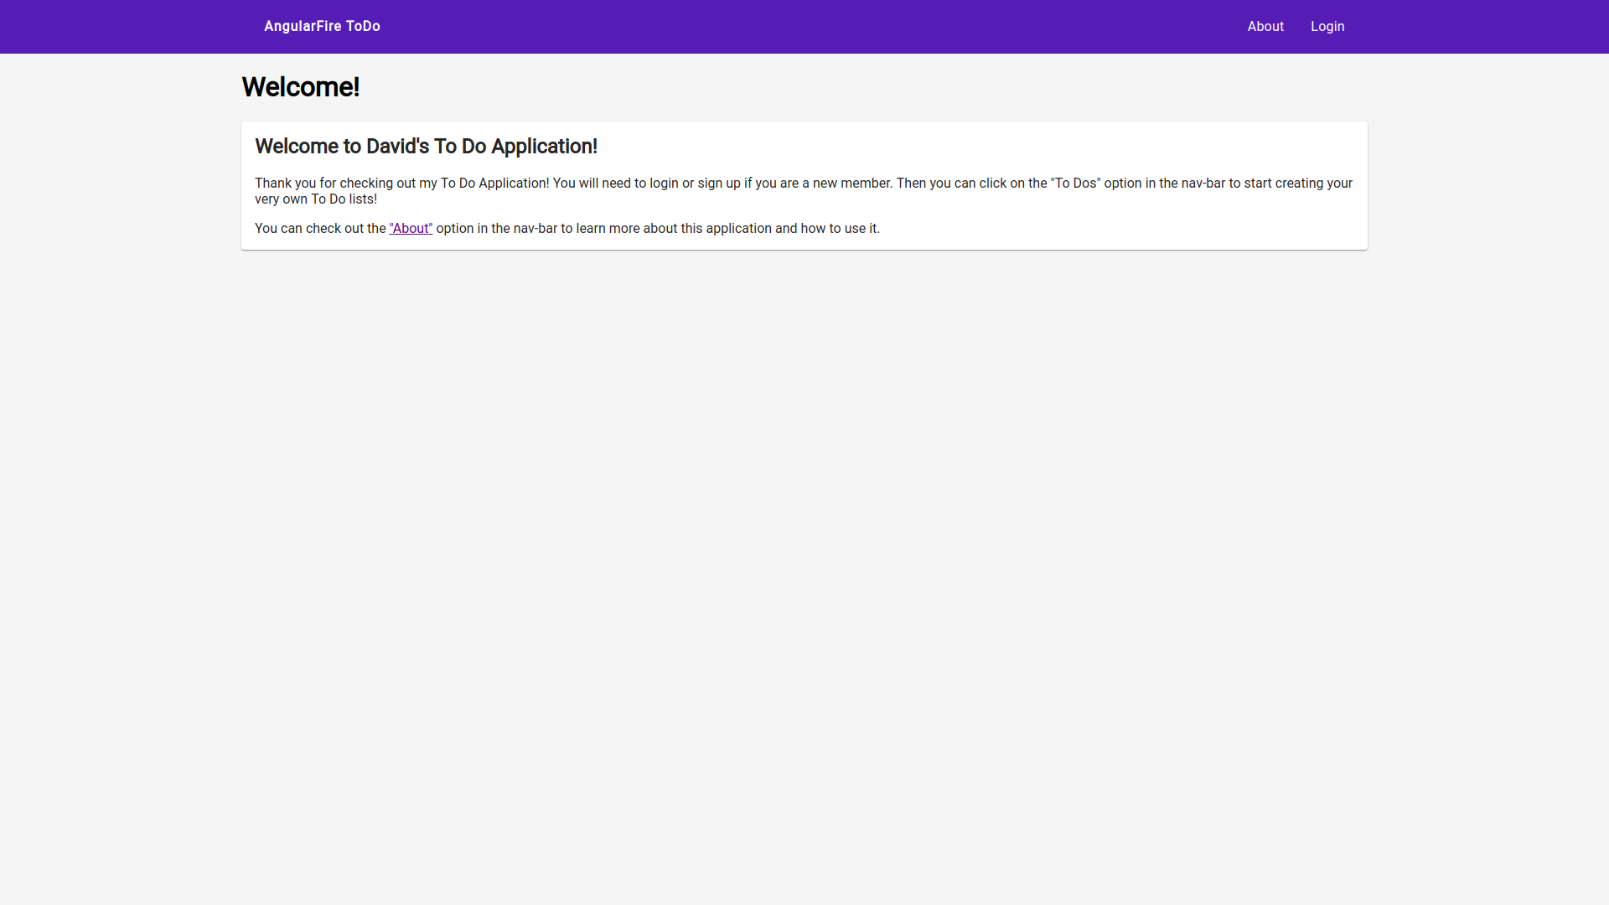
You will then need to create an account by clicking on the “Login” button at the top-right of the screen. Type in your email and a password. If you are a new user, you will need to make sure it says “Sign Up” at the top of the page’s content.
Once you have signed up or logged in, you will be redirected to the ToDo List page where you will see all your todos. To create your first todo, click on the message in the center of the screen, or click the pink button in the bottom right hand corner.
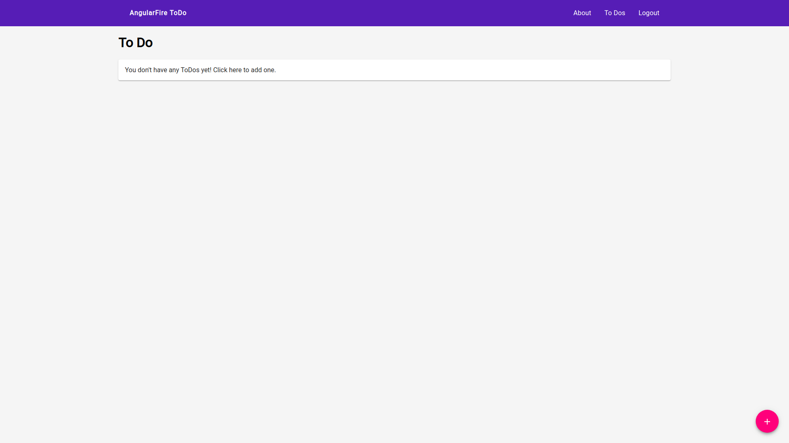
Give your todo a title and click the black “+” icon to add an item to the list. You can check off the items as you complete them. Or you can remove the items by clicking the “trash” icon to the right of the item.

Clicking the “save” or “delete” button will redirect you back to your todo list page where you will see your newly created todo.
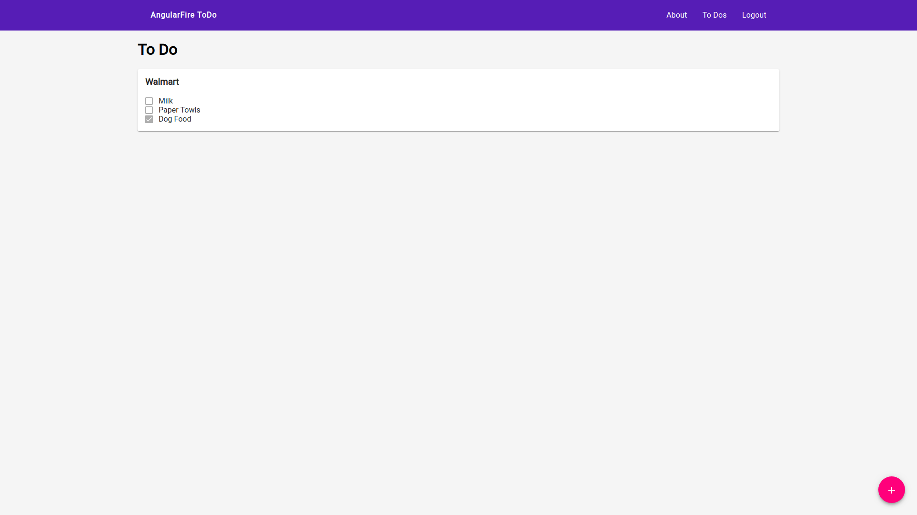
When you are done, you can go ahead and click the “Logout” button. I hope you enjoy the application!

