INSTRUCTIONS:
To start, open the index.html file (in a modern browser like a new version of Chrome) in the projects root directoryThe game will start automatically once you open the file.
To move your paddle, press the UP and DOWN arrow keys on your keyboard.
Try to hit the ball past the AI’s paddle to earn a point.
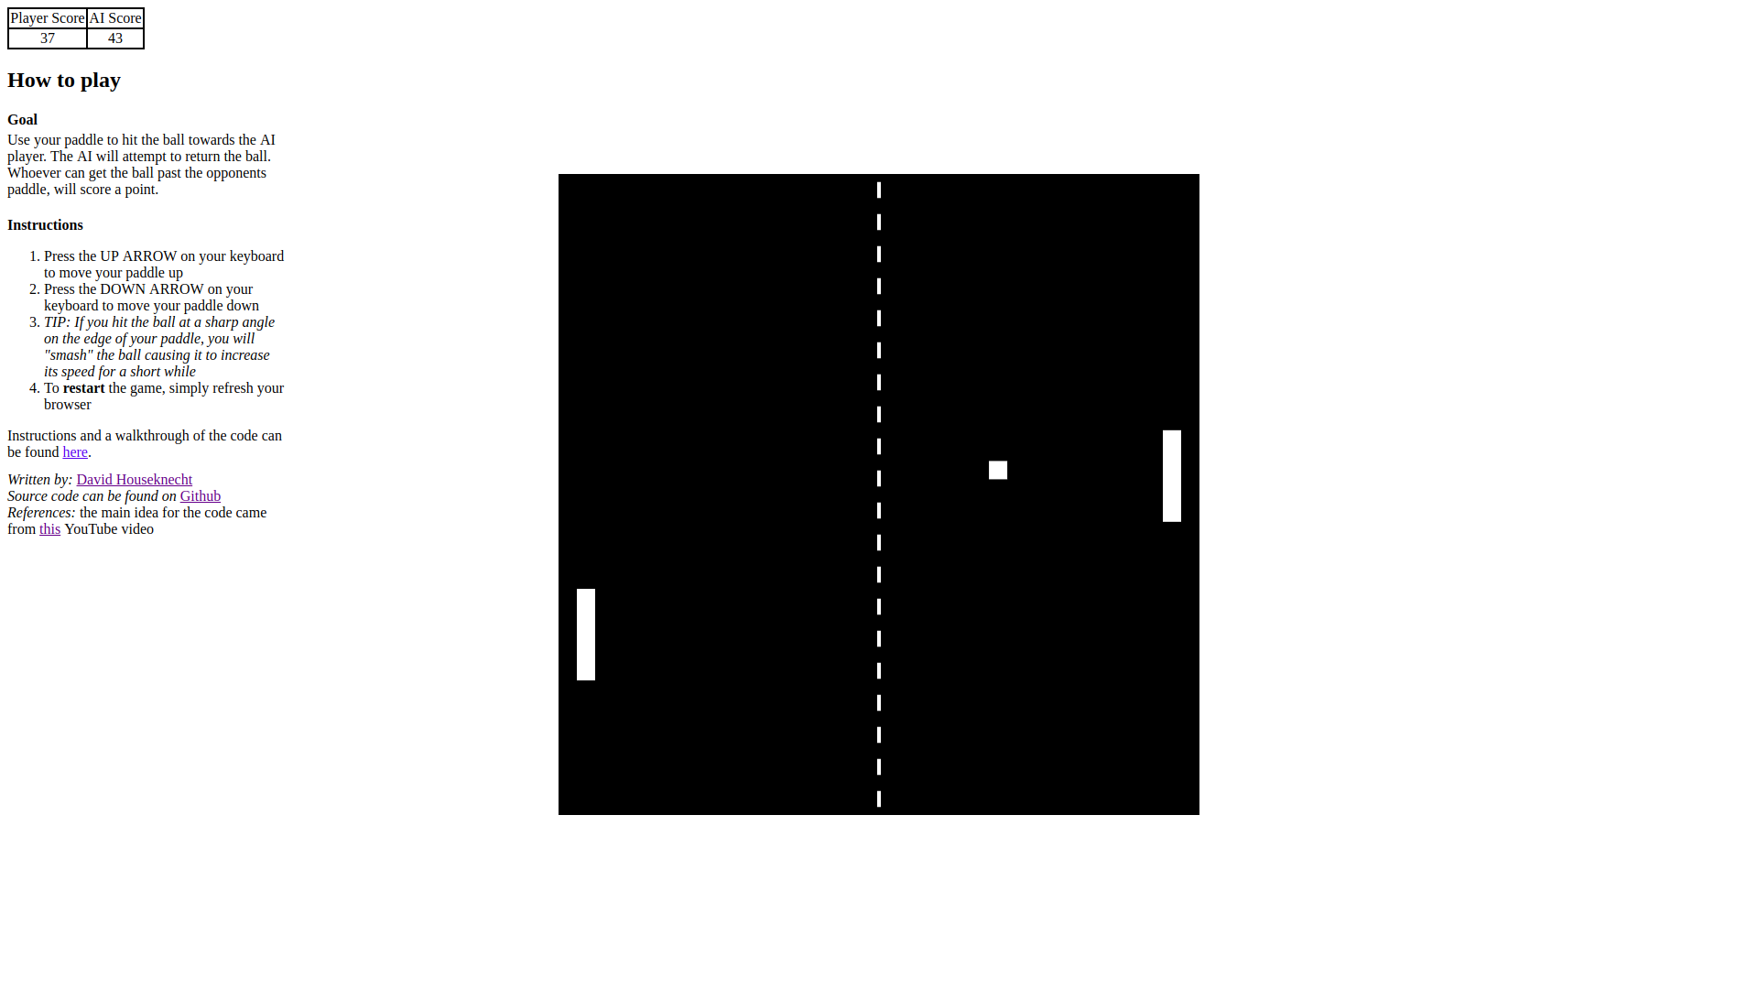
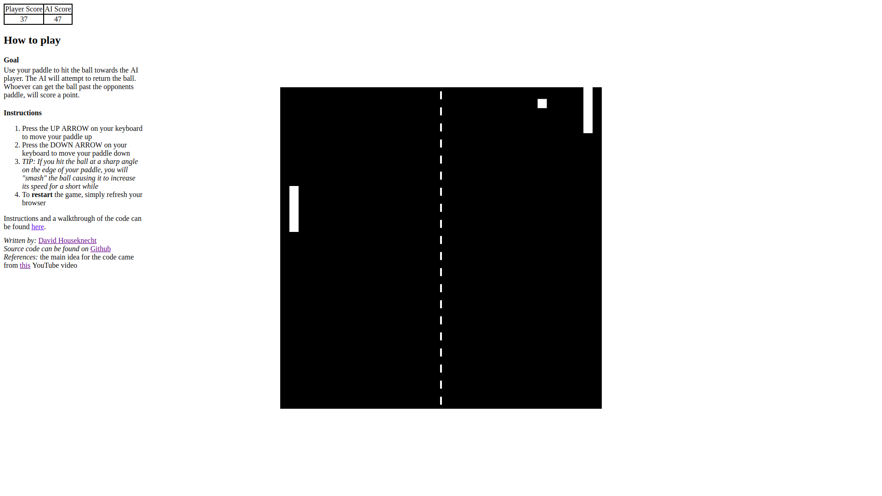
Press DOWN key
Press UP key

CODE WALK THROUGH:
The code is written in HTML, CSS, and JavaScript. The main file is the index.html file. Open the file in a new version of google chrome to see the results.

Index.html
The index.html file contains the standard HTML 5 markup for a html file. It pulls in the styles.css sheet to format a few of the elements. In the body of index.html is the table to hold the score of the current game, the instructions on how to play, and the import of the JavaScript file that bootstraps and runs the game.
Styles.css
This is a basic style sheet that contains styles for the canvas, table, and a few other items.
Pong.js
This file bootstraps the game. It creates the following:
- It creates variables and constants that the code will use throughout the file that determine game board size, paddle/ball sizes, paddle/ball speed, and keystate (UP and DOWN keys)
- It creates an object for the player and ai paddles. These objects have x and y positions, size of the paddle, player’s score, and other functions to update them and draw them on the canvas.
- It creates a ball object that has the same x, y, size, update, and draw properties/functions as the paddles. It has a velocity and speed as well which determines the direction and speed of the ball. It also has a function to serve the ball at the beginning of the game or after a point is scored. In its update method it also checks to see if a point was scored or if the ball hit a paddle or a wall (which will change the direction of the ball’s movement).
- There is a function to update the score board on the index.html. This will be called at the beginning and after each point is scored.
- There is a main() function that creates the canvas to play on, adds EventListeners to move the human player’s paddle, call the inti() method (next bullet point), and create a loop function to request animation frames for the canvas calling the global update() and draw() functions (explained later).
- The init() method initializes the human and ai player’s paddles, updates the score board for the first time, and serves the ball to start the game.
- The global update() function simply calls the human, ai, and ball’s update() function.
- The global draw() function draws the canvas; calls the human, ai, and ball’s draw() function; and draws the net for the game.
- At the very end of the file after all functions, variables, and constants are declared, the main() function is called to start the game.

References:
I used this youtube video for most of the code. I typed it all myself and added a few features and updates. (https://www.youtube.com/watch?v=ju09womACpQ).

