BNU2018 Template for a Contributed Paper
Jānis Lapiņš¹ and Mārtiņš Liberts²
¹Bank of Latvia, e-mail: janis.lapins@bank.lv
²Central Statistical Bureau of Latvia, e-mail: martins.liberts@csb.gov.lv
Abstract
This is a Microsoft Word template for a contributed paper or lecture for the Workshop of Baltic-Nordic-Ukrainian Network on Survey Statistics 2018 in Jelgava, Latvia.
Keywords: BNU2018, template, contributed paper

1 Introduction
The length of a contributed paper should be maximum 4 pages. Do not put page numbers. Please use the styles defined in the template. There are 14 styles defined in the template:
- Abstract – for the text in abstract,
- Abstract Title – for abstract title,
- Affiliation – for authors’ affiliations,
- Authors – for authors’ names,
- Equation – for display equations,
- Figure Table Title – for figure and table titles,
- Heading 1 – for the 1st level heading,
- Heading 2 – for the 2nd level heading,
- Keywords – for keywords,
- Normal – for normal text,
- Reference – for references,
- Table – for tables,
- Table header row – for table header row (column names),
- Title – for the title.

2 Formatting

2.1 Equations
The equation numbers should be given at the right-hand side, if referred:
${\hat{t}}_{π}=\sum_{s}{\frac{y_{k}}{π_{k}}}$ (1)

2.2 Citations
The citations in the text should be given according to the Harvard System.
We consider the well-known estimator for the population total defined by by Särndal et al. (2003, p. 42). The estimator (1) is also discussed by Ardilly & Tillé (2006). Alternative expression of (1) is ${\hat{Y}}_{π}=\sum_{k∈S}{\frac{Y_{k}}{π_{k}}}$ (Ardilly & Tillé, 2006).
This is a textual citation of the book by Särndal et al. (2003). This is a parenthetical citation (Särndal et al., 2003). This is a citation of the article in a journal (Lavallée & Rivest, 2012).

2.3 Graphics and Tables
Please add titles for graphics and tables.
Figure 1: A histogram
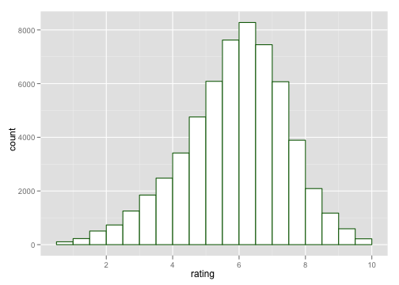
A histogram drawn by the R package ggplot2 (Wickham, 2009).
Table 1: A simple table
Variable 1 | Variable 2 | Variable 3
1 | 2 | 3
4 | 5 | 6

References
Ardilly, P. & Tillé, Y. (2006). Sampling methods: exercises and solutions. Springer Verlag.
Lavallée, P. & Rivest, L.-P. (2012). Capture–recapture sampling and indirect sampling. Journal of Official Statistics 28, 1 - 27.
Särndal, C., Swensson, B. & Wretman, J. (2003). Model assisted survey sampling. Springer Verlag.
Wickham, H. (2009). ggplot2: elegant graphics for data analysis. Springer New York.

