*Demonstration of the smallest tip equals to the minimum of the eigenvalues by a simple 3 taxon case*

$X Y Z$

$$b$$

$$a$$

The tip lengths for species $X, Y$ and $Z$ are $b, b$, and $a+b$, respectively. So the shortest tip branch length is $b$ (for species $X$ and $Y$). The length matrix for the tree can be represented as following

$X Y Z$

$G=\begin{matrix}X \\ Y \\ Z\end{matrix}\left[\begin{matrix}a+b & a & 0 \\ a & a+b & 0 \\ 0 & 0 & a+b\end{matrix}\right]$

Claim: $b$ is the smallest eigenvalues.

Proof: Let $λ$ be an the eigenvalue for $G$, then we have $\det\left(G-λI\right)=0$ where $I$ is an 3 by 3 identity matrix. Solving the equation step by step, we have

$$\det\left(\left[\begin{matrix}a+b & a & 0 \\ a & a+b & 0 \\ 0 & 0 & a+b\end{matrix}\right]-\left[\begin{matrix}λ & 0 & 0 \\ 0 & λ & 0 \\ 0 & 0 & λ\end{matrix}\right]\right)=0$$

$$⟹det\left(\left[\begin{matrix}a+b-λ & a & 0 \\ a & a+b-λ & 0 \\ 0 & 0 & a+b-λ\end{matrix}\right]\right)=0$$

$${⟹(a+b-λ)}^{3}-a^{2}\left(a+b-λ\right)=0$$

$$⟹\left(a+b-λ\right)\left( {\left(a+b-λ\right)}^{2}-a^{2}\right)=0$$

$$⟹λ=a+b, a+b-λ=±a$$

then we have 3 eigenvalues $λ=2a+b, a+b, b$.

Obviously the smallest eigenvalue is $b$ which is the shortest tip length.

*General proof: smallest tip is the minimum of the eigenvalues.*

Note that given an ultrametric tree $T$ of $n$ tips, there exists a unique strictly ultrametric matrix (Nabben and Varga 1994) $G$ to represent the species relationships.

Again let $b$ be the smallest tip length. Then $G-bI$ has at least two identical columns or rows where $I$ is an $n$ by $n$ identity matrix. This implies that

$det(G-bI)=0$ which implies that $b$ is an eigenvalue of $G$. The next step is to show that $b$ is the smallest eigenvalue for the eigenvalue set of $G$.

*Claim*: $b= \min_{ λ}{\{det{(G-λI)}=0}\}$

*Proof*: If $λ_{0}$ is an eigenvalue of $G$ satisfying $\det{(G-λ_{0}I)}=0$, it suffices to show that $λ_{0}≥b$. Suppose to the contrary that $λ_{0}<b$. Consider the matrix $G_{0}=G-λ_{0}I$, then $G_{0}$ is still an strictly ultrametric matrix which is always invertible (see Nabben and Varga 1994, and Corollary 6.2.27 in Horn and Johnson 1985). We have ${det⁡(G}_{0})≠0$ which implies $\det{(G-λ_{0}I)}≠0$. This consequence indicates that $λ_{0}$ can not be an eigenvalue of $G$ which contradicts to the assumption of $λ_{0}<b.$ Therefore, $b$ is the smallest eigenvalue of $G$.

*Why tiny branch lengths cause ill-condition matrix*

The problem of having ill-conditioned matrix comes from the tiny branch lengths.

We can illustrate this issue using a simple example of two taxa shown in the following

$X Y$

$$ε$$

1

The matrix is

$X Y$

$G=\begin{matrix}X \\ Y\end{matrix}\left[\begin{matrix}1+ε & 1 \\ 1 & 1+ε\end{matrix}\right]$

$G$ has two eigenvalues $ε$ and $2+ε$ and the condition number of $G$ defined by the ratio of the largest eigenvalues to the smallest eigenvalues is $κ=\frac{2+ε}{ε}=1+\frac{2}{ε}=O(ε^{-1})$ where $O\left(∙\right)$ is the big O notation that describes the limit behavior of a function. When we have tiny tip branch (very small $ε$), the value of $κ$ will be fairly large which indicates the matrix is more of ill-condition. For instance, with $ε=0.1$, $κ=21$ while with $ε=0.001$, we have $κ=2001$. The problem becomes serious as $ε$ is very closed to zero as we have a matrix of two almost identical columns/rows which makes $G$ a singular matrix with $κ=∞$. In general, for a tree of arbitrary taxa that includes a clade of sub tree described in this case, we will face the ill-condition problem. We can define a measure using the fraction $ω=\frac{ε }{t+ε}$ to quantify the ill condition of the tree where $t+ε$ is the tree height, $ε$ is the smallest tip length and $t$ is the branch lengths from the root to the most recent common ancestor of the tips with smallest tip lengths. When $ε$ approaches to zero, the fraction $ω$ approaches to zero. In this case, as two columns/rows in the matrix are almost the same, the matrix will suffer an ill condition of order $O(ε^{-1})$. We use a simulated 100 taxa birth-death tree. For a good tree ($κ<500$), $ω$ = 1.45 ${×10}^{-2}$, while for the bad tree ($κ>1.5×{10}^{6}$) , $ω=3.96{×10}^{-6}$. From here the tree condition can be seen of order $O(ω)$.

*Drop the shortest tip can lead a better kappa*

We will show that the new tree obtained from dropping the shortest tip of the original tree has a better (lower) kappa. Let $G$ be the $n$ by $n$ strictly ultrametric matrix and $0<{λ }_{1}≤λ_{2}≤⋯{≤λ}_{n}$ eigenvalues of $G$. Let $G_{1}$ be the matrix obtained by dropping the shortest tip from the tree. $G_{1}$ is still an strictly ultrametic matrix of size $(n-1)$ by $(n-1)$ with eigenvalues $0<τ_{1}≤τ_{2}≤⋯{≤τ}_{n-1}$. By a special case of the Cauchy’s interlacing theorem ( Ch. 10.1 in Parlett 1980), we have $0<λ_{1}≤τ_{1}≤λ_{2}≤τ_{2}≤⋯≤λ_{n-1}{≤τ}_{n-1}{≤λ}_{n}$. The condition number, defined as the ratio of the largest eigenvalue to the smallest eigenvalue are computed as $κ=λ_{n}/λ_{1}$ and $κ_{1}=τ_{n-1}/τ_{1}$ for $G$ and $G_{1}$, respectively. From some algebra calculation, we have $κ-κ_{1}=\frac{λ_{n}}{λ_{1}}-\frac{τ_{n-1}}{τ_{1}}=\frac{τ_{1}λ_{n}-τ_{n-1}λ_{1}}{λ_{1}τ_{1}}≥\frac{τ_{1}τ_{n-1}-τ_{n-1}λ_{1}}{λ_{1}τ_{1}}=\frac{τ_{n-1}{(τ_{1}-λ}_{1})}{λ_{1}τ_{1}}≥0$. This implies that $κ≥κ_{1}$. From above, we can conclude that a lower $κ$ can be achieved by dropping the smallest tips.

*A simulation on comparing the two condition numbers*

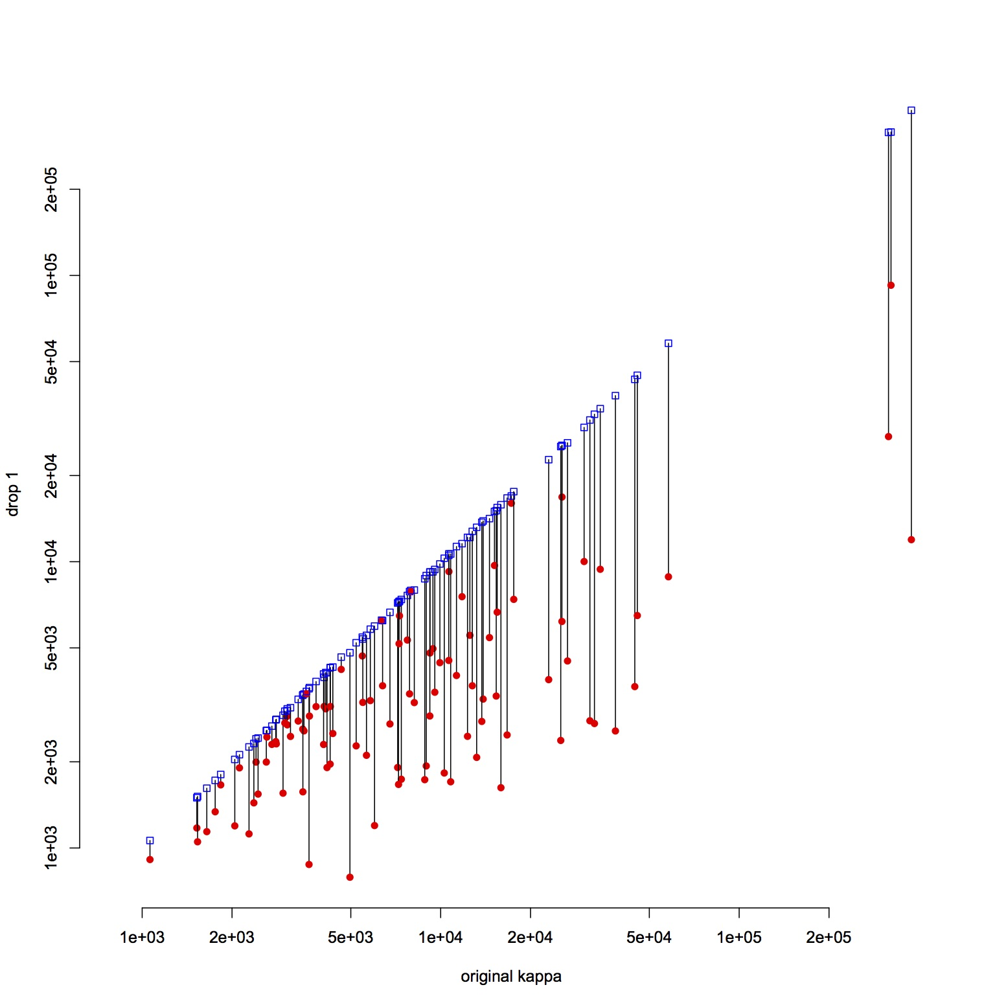  
In the above plot, the x-axis is the original kappa, and the lines connect points corresponding to that given tree, but with one taxon removed: the blue square is removing a taxon at random, and the red dot removing the taxon with the shortest branch tip length. Either removal tends to help, but removing the taxon with the shortest branch helps more.

*References*

Nabben R. and Varga R.S. (1994) A linear algebra proof that the inverse of a strictly ultrametric matrix is a strictly diagonally dominant Stieltjes matrix. SIAM J. Matrix Anal. Appl. 15(1) 107-113.

Parlett B. (1980) The symmetric eigenvalue problem. Prentice-Hall, Englewood Cliffs, N.J.

Roger A.H. and Charles R.J. (1985) Matrix Analysis, Cambridge University Press. The Press Syndicates if the University of Cambridge ISBN 0-521-38632-2