This is an instruction only for windows 10 x64. Won’t work on other operating systems.

* As this sdk need python 2.7 and in order to keep you happy. Installing anaconda is recommended. Please download anaconda for python 3.X.

Link to download page: <https://www.anaconda.com/distribution/>

1. Start anaconda and create a new environment. Name the new environment ‘Tello’, select version 2.7 for python.

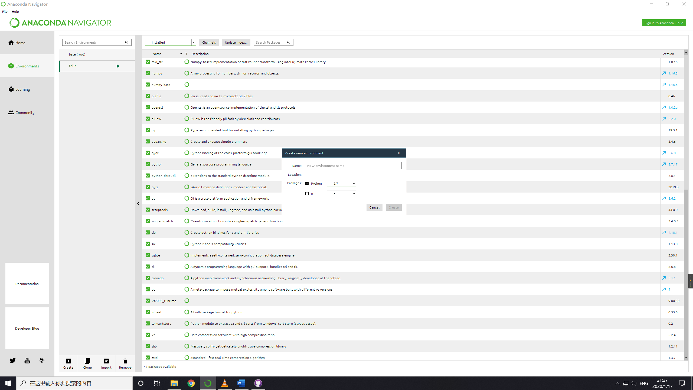

1. Change the filter to not installed.

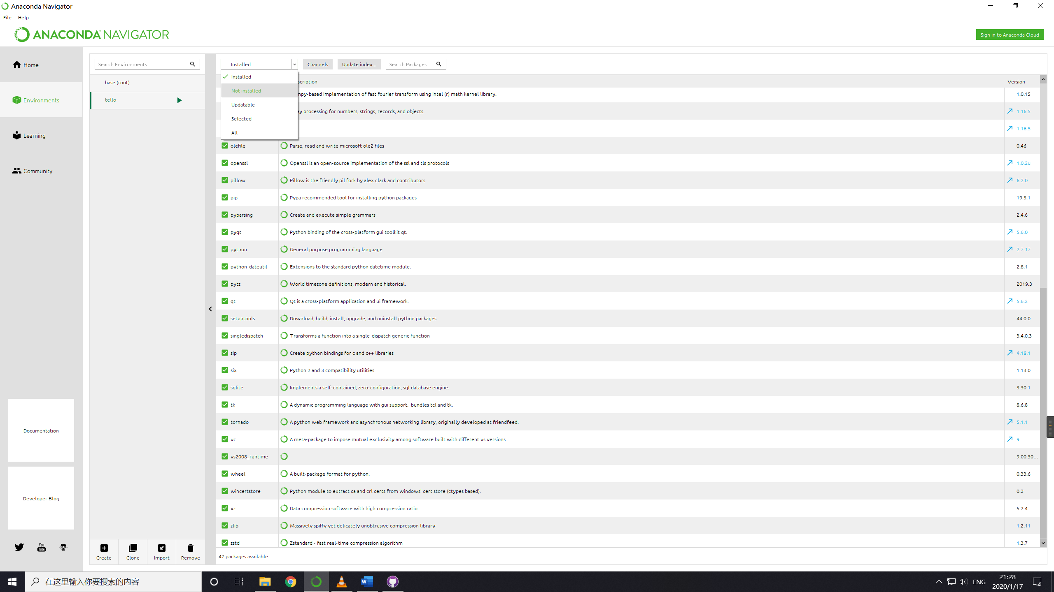

1. Search numpy in packages and install it.

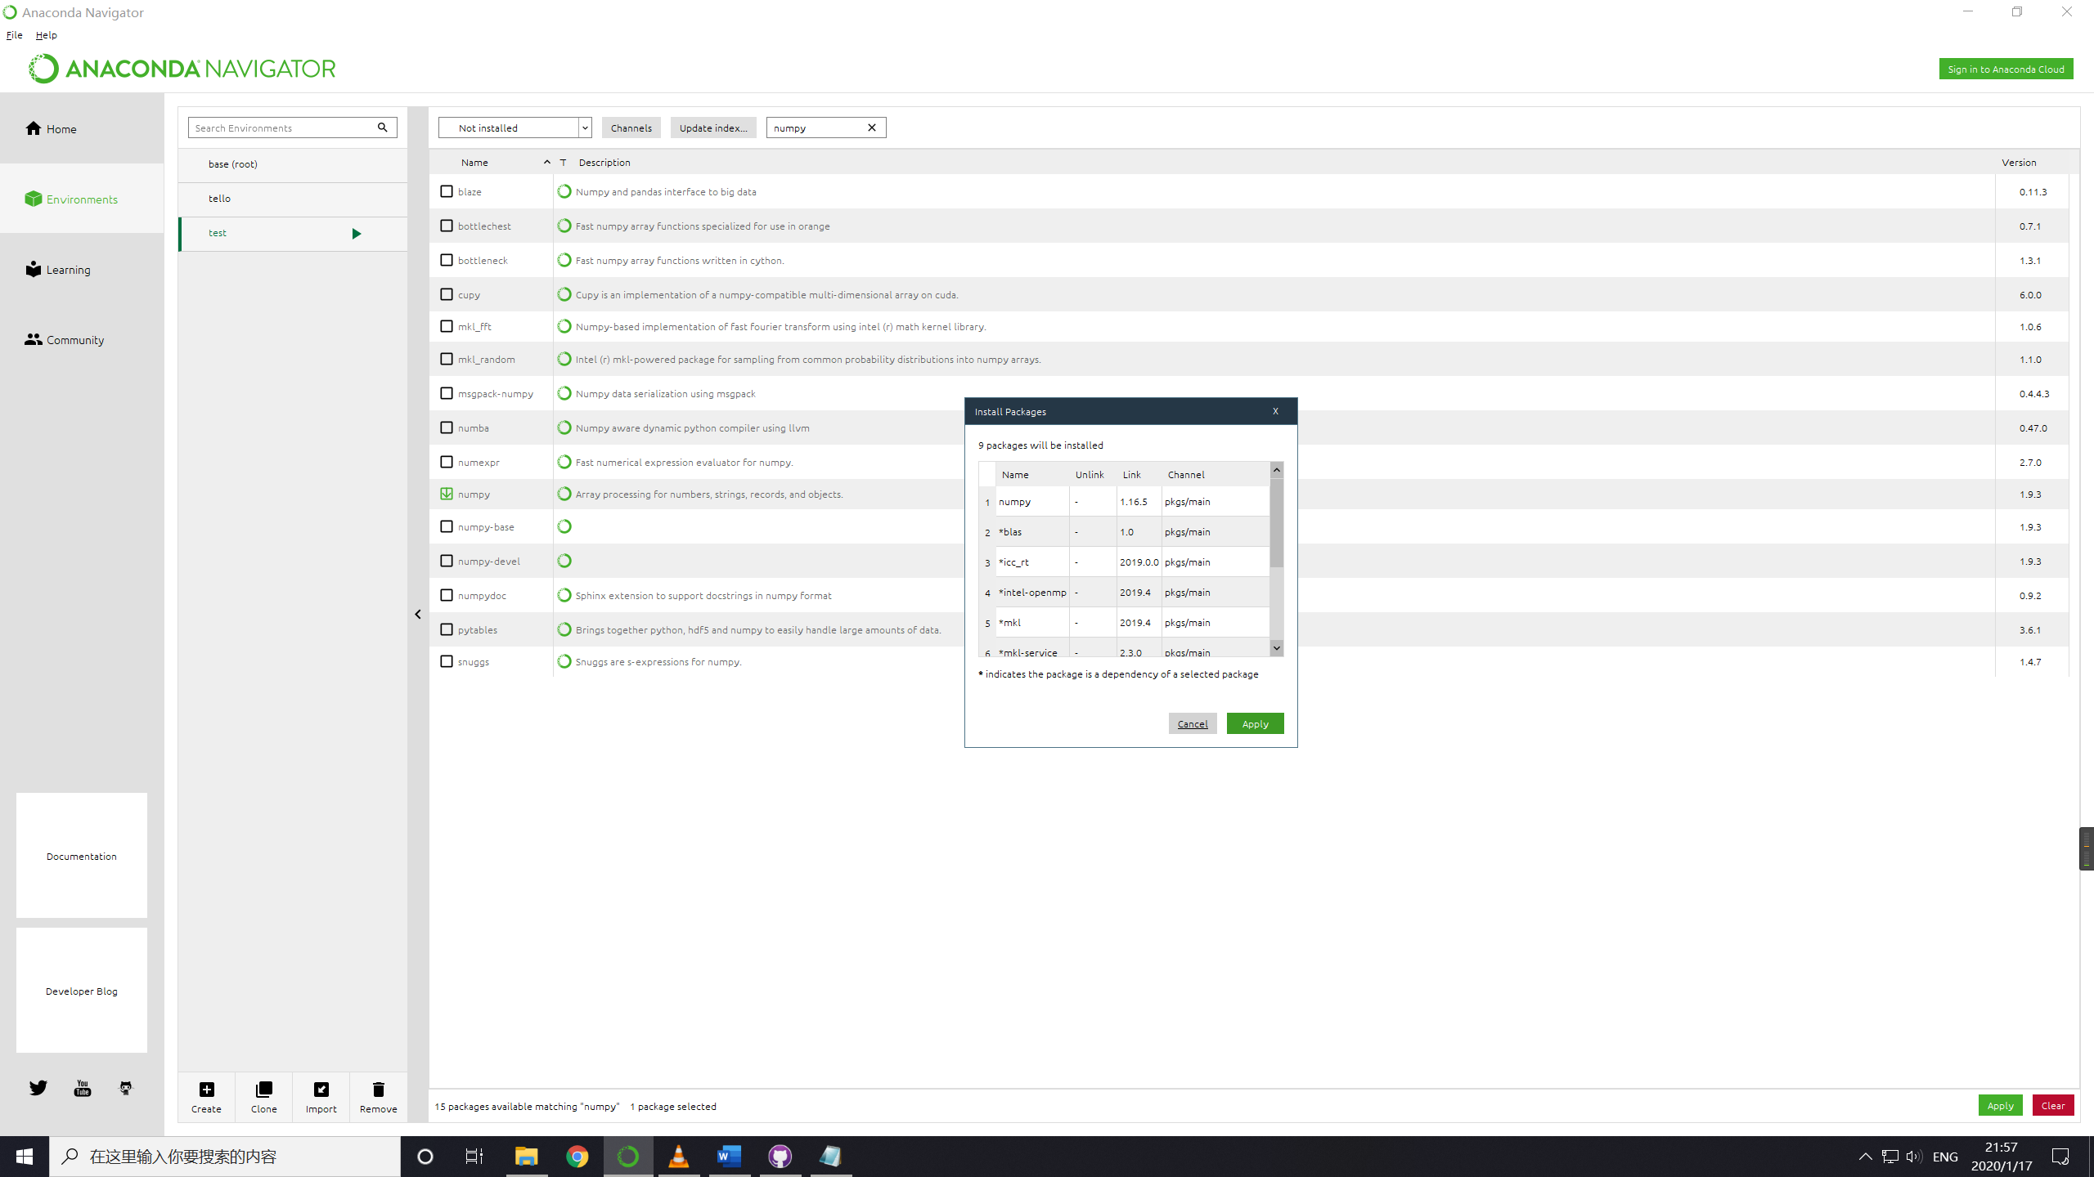

1

3

2

1. Then search matplotlib and repeat the same steps.
2. After that, search pillow and repeat the same steps.
3. Press the little triangle near the environment ‘Tello’ and select Open Terminal.

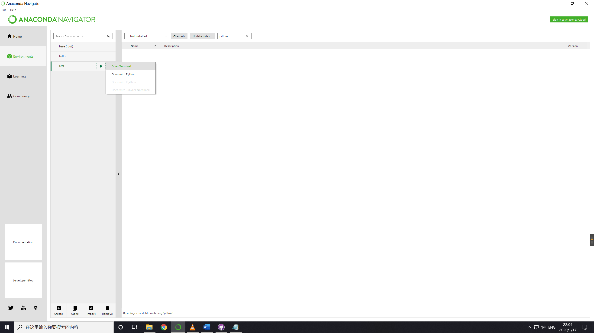

1. Input ‘pip install opencv-python’ and press enter.

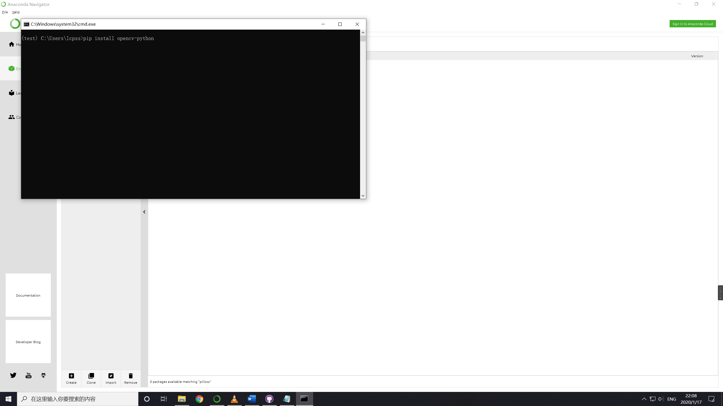

1. Close the tab and enter the ‘tello_video_dll(ForWin64)’File and copy all those to the

C:\Users\Depends on your users name which can be found in the terminal\.conda\envs\tello\Lib\sites-packages\



1. Back to ‘tello_video_dll(ForWin64)’File and double click vcredist_x64.exe and install the application if you haven’t.

The preparation is done.

Q@A

Q: How to run the app?

A: Start anaconda and select that environment that you had prepared. Press the little triangle beside it and select open in terminal. Then enter to the path that contains the main.py and input ‘python main.py’ Then that should work. Remember to connect the computer to tello’s Wi-Fi.

Q: Is station mode (AP mode)of tello edu supported?

A: No, ap mode is not supported.

Q: What should I do if it still doesn’t work.

A: Contact tech support nearby and study the offical SDK at that time. XDDDD