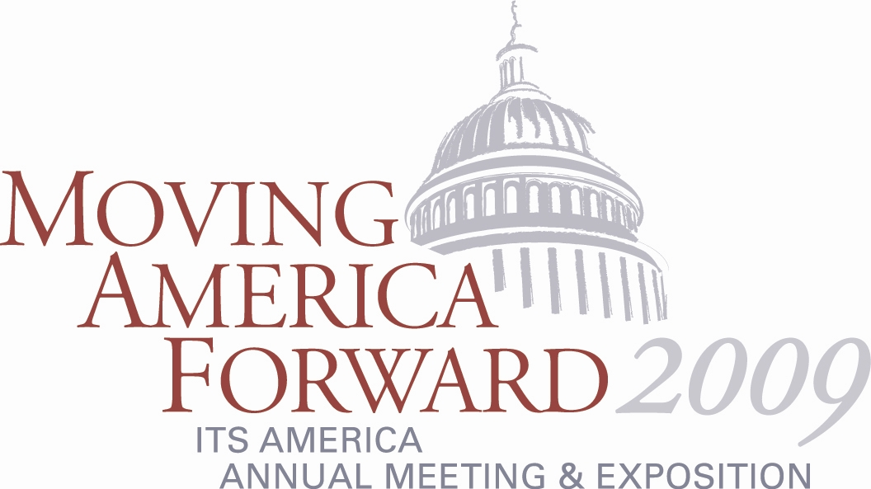

Meet and Engage Key Transportation Legislators at the
Capitol Hill Day and Special Closing Reception

ITS America’s 2009 Annual Meeting and Exposition takes place during a critical transportation authorization debate and is ideally located to provide attendees with access to key transportation officials.

On June 3, attendees can attend Capitol Hill Day which will feature speeches by senior Members of Congress, technology demonstrations, Congressional fact-finding sessions, and meetings on Capitol Hill followed by a special reception at the Capitol Hill Visitor Center.

You don't want to miss this opportunity to interact directly with senior Members of Congress and connect with leaders around the country to discuss ITS research and deployment and how technology will play a key role in the next transportation bill as well as climate change and energy legislation.

For more information on the Annual Meeting and Exposition, visit www.itsa.org/annualmeeting.html.

