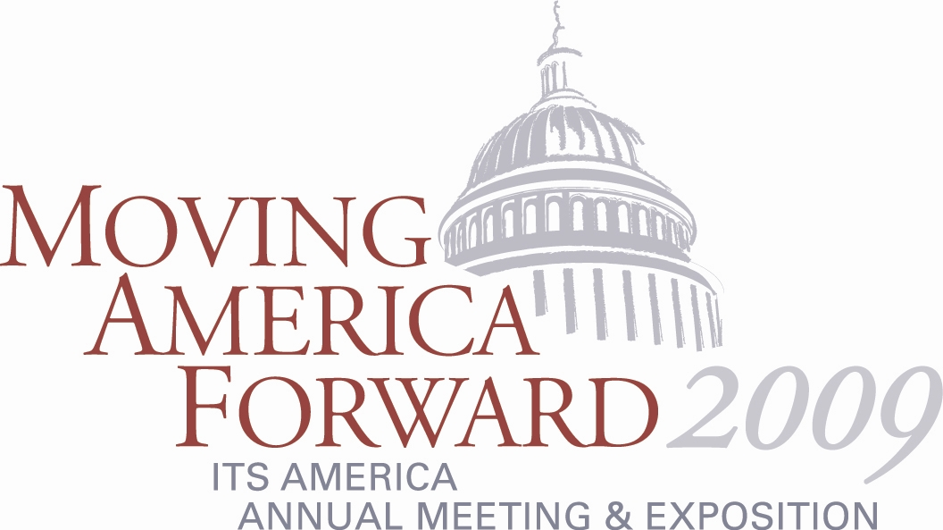

ITS America’s Annual Meeting Congressional Fact-Finding Sessions
Offer Unique Opportunity to Provide Testimony to Congress

The Annual Meeting will feature Congressional fact-finding sessions that will provide Annual Meeting participants with opportunities to serve as panelists and provide testimony on topics of interest to Congress as it works to pass a new surface transportation authorization bill and address other issues including energy and climate change.

The sessions will be moderated by key staff members from Congressional committees and caucuses with jurisdiction over transportation and technology-related legislation. Topics will include a vehicle miles traveled (VMT)-based user fee and other innovative financing alternatives, ITS solutions for improving energy efficiency and reducing emissions, advanced safety and mobility technologies, and more.

The Congressional fact-finding sessions will be an exciting opportunity to share your expertise with Congressional officials who will be writing the next transportation bill and other key legislation, and to engage in a meaningful discussion with policymakers about how ITS solutions can play a critical role in advancing the future of our nation’s transportation system.

If you are interested in participating in these fact-finding sessions, please contact Paul Feenstra at 202-721-4237 or by e-mail at pfeenstra@itsa.org so he can share your areas of interest and expertise with the Congressional organizers.

For more information on the Annual Meeting and Exposition, visit www.itsa.org/annualmeeting.html.

