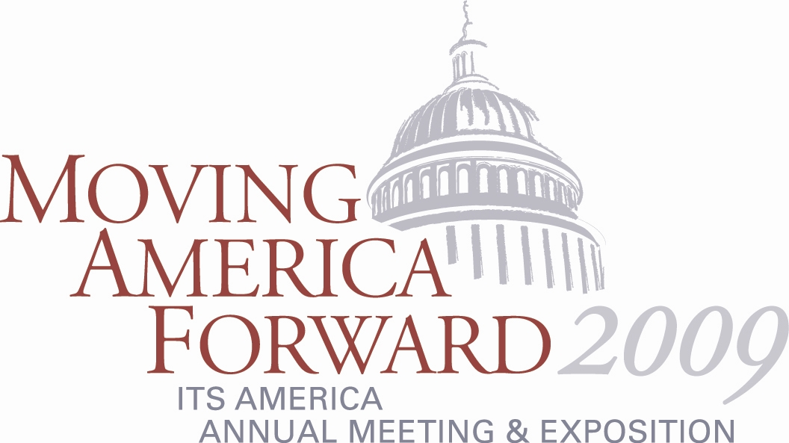

ITS America’s Annual Meeting Forum Showcases to Examine Mobility of Goods, Mobility of People, Safety, Sustainability, and Cross Cutting Issues

ITS America’s Annual Meeting Forum Showcases are a great way to learn more about your specific business area. You will engage in interesting discussions on hot industry topics and ongoing projects and enjoy a networking exchange with others who share your passion for a specific area of ITS. These specialized, content-driven sessions will help you ensure you leave armed with knowledge and contacts to bring innovative solutions to your organization.

ITS America’s new Forums present an opportunity for the ITS community to frame the importance of intelligent transportation solutions in achieving the important outcomes our transportation systems aspire to: safety, mobility of people and goods, and sustainability. Each of these Forums—as well as a cross-cutting advisory group that is looking closely at the topics that do not quite so neatly fit into any of the four “outcome-based” Forums—will present its initial plan for the year ahead: a proposed list of activities and products that benefit from ITS America member participation.

Annual Meeting attendees are invited to attend one or more Forum Showcases and learn more about their area of interest. These sessions and your involvement in an ITS America Forum throughout the year will help equip you with knowledge and contacts to enhance your effectiveness to address the challenges of mobility, public safety, traveler information, policy evaluation, and advocacy.

For more information on the Annual Meeting and Exposition, visit www.itsa.org/annualmeeting.html.

