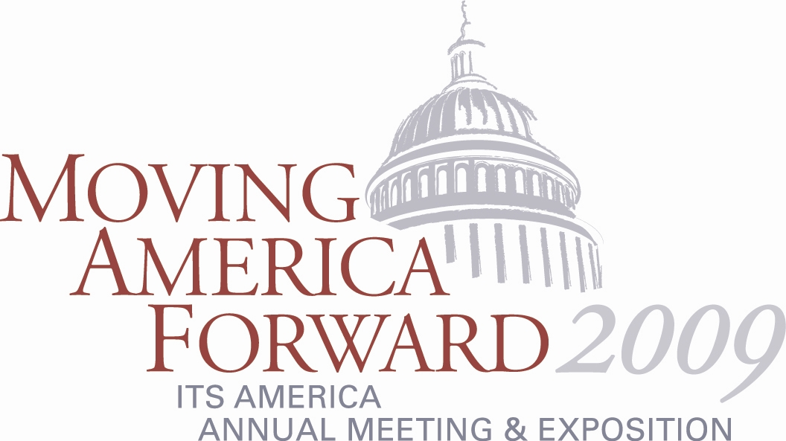

Technical Tours to Offer Close-Up Look at Capitol Region’s Top ITS Facilities

If you are planning to attend ITS America’s 2009 Annual Meeting and Exposition, June 1-3, in National Harbor, Maryland, you will want to take advantage of the many highly relevant and informative technical tours. The Washington, DC metropolitan area is a recognized leader in the deployment of ITS technologies and practices and the conference’s technical tours will enable you to experience them and hopefully bring ideas home to your own region.

- Washington Metropolitan Area Transit Authority Control Center
- District DOT’s Transportation Management Center and Washington DC Metropolitan Police Department’s Joint Operations Command Center
- Maryland State Highway Administration Statewide Operations Center
- University of Maryland’s Center for Advanced Transportation Technology Laboratory
- DC Bike Sharing System, Zipcar, and DC Circulator
- FAA Air Traffic Control System Command Center
- Virginia MegaProjects Bus Tour
- Montgomery County Public Safety Communications Center
- Woodrow Wilson Bridge Boat Tour
- McConnell Public Safety and Transportation Operations Center
- Potomac Consolidated TRACON
- Potomac and Rappahannock Transportation Commission Transit Operations Center
- Maryland State Highway Administration Statewide Operations Center, Prince George’s County TRIP Center & FedEx Field (Redskins Stadium) Command

For details on each of these tours, please visit www.itsa.org/amtechnicaltours.html.

For more information on the Annual Meeting and Exposition, visit www.itsa.org/annualmeeting.html.

