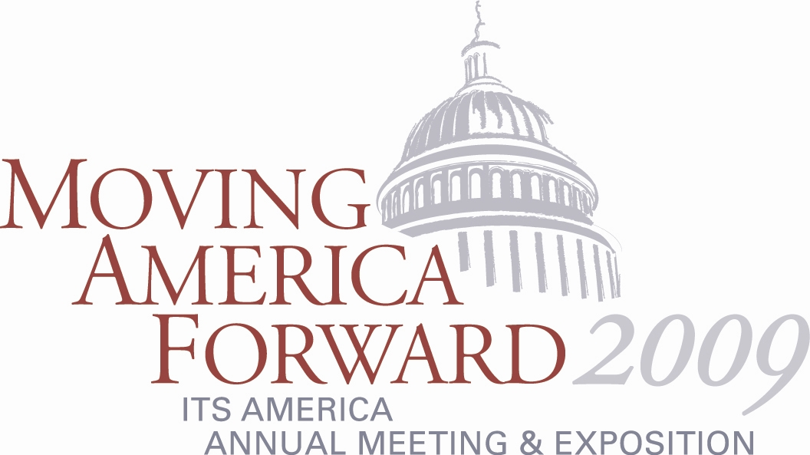

ITS America’s Annual Meeting to Feature Outdoor Technology Showcase

ITS America will present a “City Streets” Technology Showcase staged on the streets of National Harbor. Only a 30-second walk from the 150,000 square feet exhibit hall, the outdoor technology showcase will show Annual Meeting attendees the latest advances in tolling and mobile payments, freight security, intersection safety, travel advisory, and traffic information.

The IntelliDriveSM (formerly Vehicle-Infrastructure Integration) utilizing 5.9GHz short range communication will be demonstrated.

The following companies and organizations are contributing to the planning, development, and conduct of the Annual Meeting Technology Showcase.

- CoVal Systems
- Daktronics
- Kapsch
- NazTec Inc.
- Prince George’s County
- TransCore
- Virginia Department of Transportation

For more information on the Annual Meeting Technology Showcase, visit www.itsa.org/annualmeeting.html.

