Beyond a Bag of Concepts: does J-Lens recover relational binding?
MATS 12.0 application — Neel Nanda stream
Jason Day
September 2026
Table of Contents

Executive summary

What problem am I trying to solve?

High-level takeaways

Experiment 1 — Does J-Lens beat the logit lens at binding?
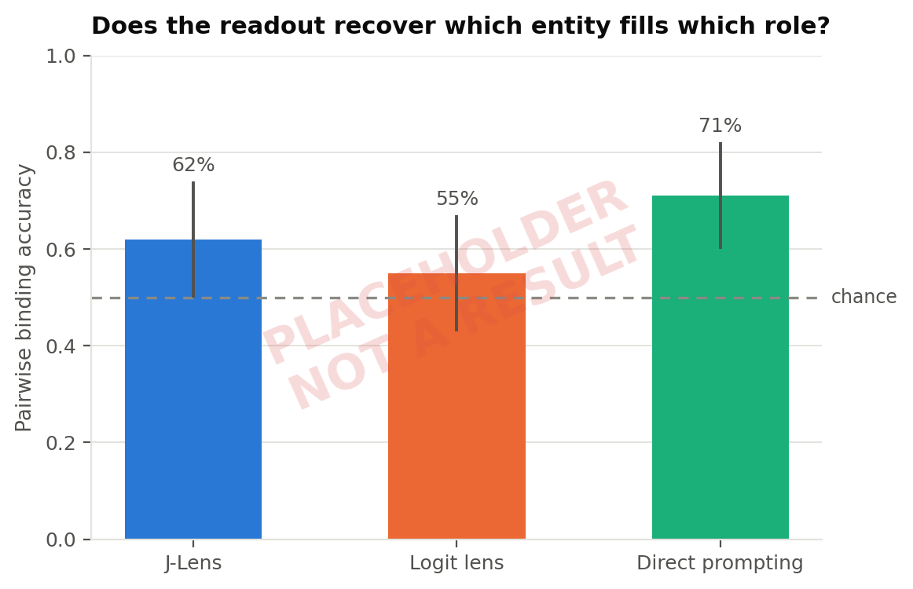
Pairwise binding accuracy by method, with bootstrap 95% CIs. Chance is 50%.

Experiment 2 — Do the controls hold?
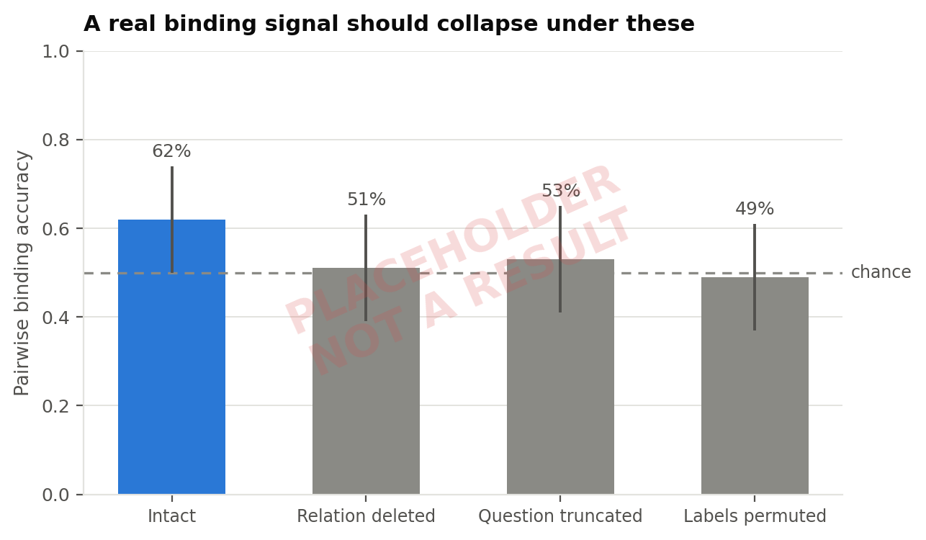
Binding advantage under relation deletion, question truncation, and label permutation.

Experiment 3 —
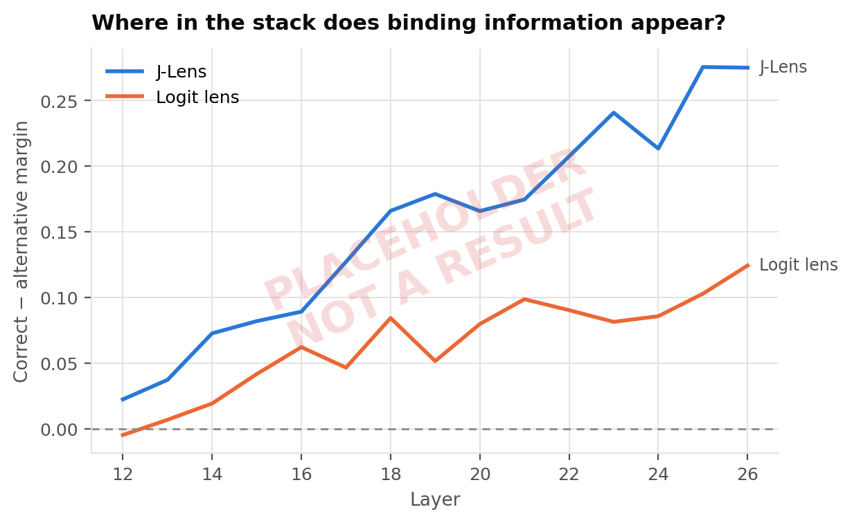

Biggest limitation

Randomly selected raw examples
Examples below are drawn with seed=1337 from the held-out set; they are randomly selected, not chosen.

1. Motivation and research question
Question. When two prompts contain the same entities and concepts but assign them different relational roles, does J-Lens identify the correct hidden intermediate — and does changing that representation causally change the model’s answer?

1.1 What J-Lens is, briefly

1.2 The gap

2. Method

2.1 Dataset construction
 | Prompt | Correct intermediate | Correct answer
Variant A | Arin lives in Luma. Bex lives in Nori. Luma uses zent. Nori uses vark. What is used where Arin lives? | Luma | zent
Variant B | Arin lives in Nori. Bex lives in Luma. Luma uses zent. Nori uses vark. What is used where Arin lives? | Nori | vark

2.2 Model, lens, and environment
Model | Qwen/Qwen3.5-4B — 32 layers, d_model 2560, vocab 248320
Lens | neuronpedia/jacobian-lens, revision qwen-n1000, commit 16a01f3
Lens provenance | fit by Neuronpedia against this exact model on Salesforce/wikitext
Hardware | Virginia Tech ARC, NVIDIA L40S (47.7 GB); peak allocation 8.51 GB
Precision | bfloat16

2.3 Observation point and layer band

2.4 Metrics

2.5 Baselines and controls
# | Control | What it rules out
1 | Logit lens (same code path, Jacobian disabled) | The advantage is the lens, not the pipeline
2 | Direct prompting | The task is not already legible without an internal method
3 | Pair alternative, not arbitrary tokens | Scoring against an equally relevant distractor
4 | Relation deletion | The readout tracks the binding, not mere co-occurrence
5 | Question truncation | Selectivity depends on knowing the target entity
6 | Label permutation | Attractive token lists that do not depend on the learned mapping
7 | Norm-matched random direction | Causal effects that any perturbation would produce
8 | Prompt-template robustness | A result specific to one phrasing

3. Preregistration and what was frozen when

4. Results

4.1 Behavioral eligibility

4.2 Primary result: binding recovery

Pairwise binding accuracy by method, with bootstrap 95% CIs. Chance is 50%.

4.3 Layerwise structure

Correct-minus-alternative margin across the layer band, J-Lens vs logit lens.

4.4 Controls

Binding advantage collapses under relation deletion and label permutation.

4.5 Causal arm

5. Error analysis

6. Sanity checks and red-teaming
# | How this could be false | What I checked | Verdict
1
2
3

7. Limitations

8. What I would do next

9. Reproducibility
Repository
Commit
Environment manifest | results/design-verification/environment-manifest.md
Figure registry | results/figures/FIGURE-REGISTRY.md
Dataset
Batch scripts | experiments/

10. Time accounting
Bucket | Hours
Experiments, code, analysis
Project-specific reading
Write-up
Total (limit 20)
Executive summary (separate +2)

Appendix A — Additional figures

Appendix B — Full result tables

Appendix C — Further raw examples

