P6-EXAMS (Bulgaria)
Introduction
The EXAMS – Module is suposed to be used whenever Erasmus students have courses in arrears, for which there are no interchange options in the host institution, they can request to take the exam on that course at the host institution.

Technical Decisions

PHP
The aplication is created via PHP programming language. PHP is a general-purpose scripting language originally designed for web development to produce dynamic web pages. For this purpose, PHP code is embedded into the HTML source document and interpreted by a web server with a PHP processor module, which generates the web page document. It also has evolved to include a command-line interface capability and can be used in standalone graphical applications. PHP can be deployed on most web servers and as a standalone interpreter, on almost every operating system and platform free of charge. A competitor to Microsoft's Active Server Pages (ASP) server-side script engine.

MySQL
MySQL is a relational database management system (RDBMS) that runs as a server providing multi-user access to a number of databases. The SQL phrase stands for Structured Query Language.

Plonk livrary
For basic application workflow, the application uses the Plonk library - a subset of the Spoon library. - that automates functionalities like page routing, session handling and page templating.

Interfaces
There are the interfaces listet on the screens below:
Student inteface:

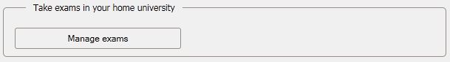

Coordinators view:

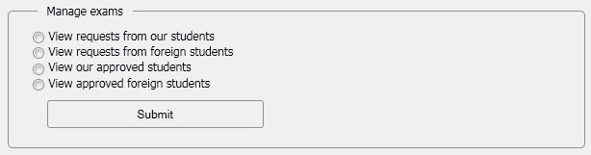
Students have possibility to manage their exams. Here are the steps that one student must pass to declare that wants to take an exam:
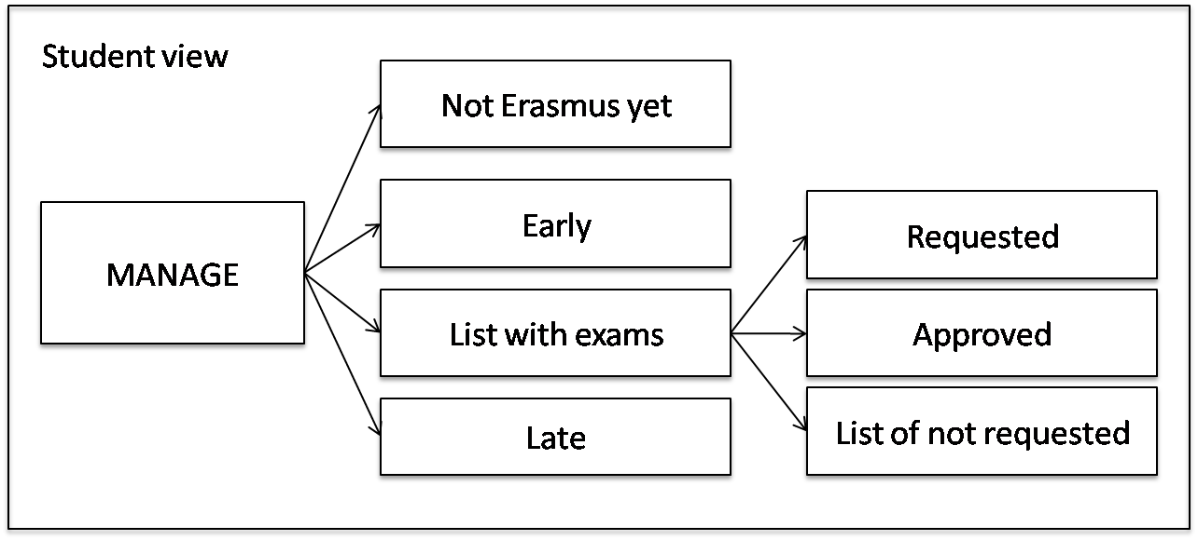
And the steps for approving of the exam by the coordinator:
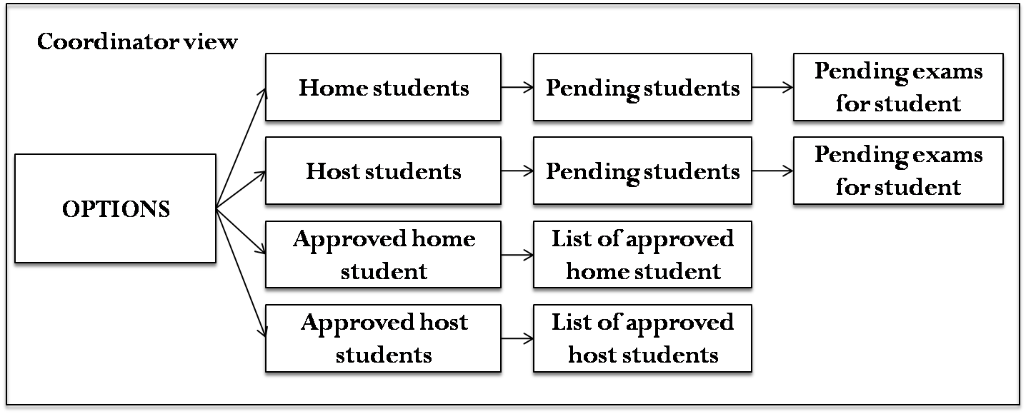

http://en.wikipedia.org/wiki/PHP
http://en.wikipedia.org/wiki/MySQL
http://www.spoon-library.com/

