Technical Report
Register
The first thing students need to do when they arrive at the application is sign up to be able the login and fill in their precandidate form.

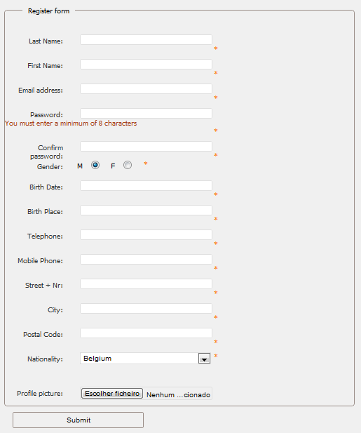

This registration form is just for students. They can register themselves by filling in this form. Afterwards they get an email with a link, so we can verify that the filled in a correct email address.
Since not only students have to use this application, but also lecturers, Erasmus coordinators and so on, there’s a different register form available for the administrator of the application, so he can add these people to the database, with their own user level.
Login Functionality

Since Plonk didn’t have a login-method on board and we didn’t want to have to rewrite the login functions on each page, we made a little adjustment to Plonk so we only had to write the login functions one time en we are able to use them over the complete web application.
Collecting the different forms

The first step in the implementation of the P4-out module was collecting all the forms that need to be filled when participating in Erasmus. We got most forms from our university from our International Office, but we still needed to get all the forms from the other partners.
There are 3 different types of forms.
ECTS-forms: These are official forms which are used by all the institutions.
Common-forms: These forms are the same in all institutions.
Non-Common forms: These forms are not the same in all the institutions, so we had to try to make a common form for all these forms, or make a form per institute.
Once we had all the forms, which took a bit longer than expected, we could start implementing all the forms.
Implementing the forms
Introduction
While we were waiting for the other forms, we already started with implementing the ECTS- and common forms for the application. And afterwards we tried to build common forms of the non-common ones, so we could one application which would be the same at all the partners.
JavaScript form-checking
For the client side form-checking of our forms, we used the jQuery Validation Engine. The big advantage of this library unlike the other libraries we have investigated is that this library uses instant form checking instead of checking the whole form when it is submitted. So the user is immediately informed if he inserts a fault value.
Another advantage of this library is that it’s very easy to implement it in your code. Also there’s the possibility to add extra rules to the library.
<input type=”text” class=”validate[required,custom[email]]” name=”email” />

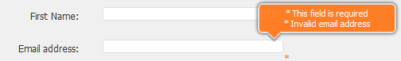

PHP form-checking
For the server side form-checking, we used the benjaminkeen.com PHP validation library.
We chose this library because it’s easy to implement and extend it with our own rules. Also this library provides form persistence when the server marks a fault in the filled in form.
$rules[] = “required,email, Please enter your email address.”;
$rules[] = “valid_email,email,Please enter a valid email address.”;
Store the forms in the database
To store the different forms in the database, we had several solutions.
One table for each form
The first solution was to create a table for each form in the Erasmus process. In that case, we could create a table with all the important fields of the form and the student ID and it would be easy to find a form of a student. On the other hand, this solution would have made our database design a lot more extended.
One table for all the forms
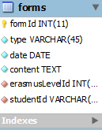
The second solution, and the one we have used in our application, was to make one table for all the forms. As you can see in the image we store all the content of the forms in a string (Json) and with the type of the form and the student ID we can easily find each form of each student back.

Signatures

Digital signatures
The first option we had in implementing the signatures for the application was to completely do the signing of the forms digitally. In the spirit of this project, namely digitalizing the Erasmus process, this would be the ideal solution, because almost no forms would have to be printed out.
The first option we had with this solution was add a signature field to our forms, and the user would then be able to sign this form by either dragging an image of their signature in that box, confirming this with his password. Or we would let the user upload his signature at registration, so when he has to sign a form, the image would already be available at the signature field and he would just have to insert his password to confirm the signature.
The second option we examined was whether it was possible to let the users sign (and even register) with their Electronic ID. But since not all participating countries already use Electronic ID, we didn’t implement this solution.
Eventually, after doing some research with the other partners, we noticed that completely digitally signing the forms wasn’t feasible, because not all partners agreed with this solution.
Printing and scanning
The solution we finally used in the web application, which was actually against the objective of the whole project, was that the first person we needs to sign a form would print out the form from the application, and manually hand it over to each person who needs to sign that form in his own institution. Afterwards, if every one of the home institution has signed, the last person would then scan the signed form into the application and send it to the host institution.
Using this solution, there’s still some paperwork involved in the application, but we tried to reduce it to the minimum.
Flow

Register – Precandidate
The first step in starting the Erasmus process is to register on the web application. Here a student (all others users, for example coordinators, are added by an admin) has to fill in some general information. Afterwards the student gets an email send to the address that he has filled in. The email contains a link to confirm his email address.
After confirming his email address, the student is now able to login to the website and fill in his precandidate form. Here the student has to choose three countries and he has to fill in his motivation to go on Erasmus. Also the student is able upload his CV, transcript of Record or Certificate of Foreign Language here.
When he has filled in his precandidate, the student has to wait for the confirmation of the Erasmus Coordinator before he can continue on the website.
Student-Application Form - Learning Agreement
After the confirmation of the Precandidate, the student is now able to fill in his Student-Application Form and Learning Agreement. This was the hardest part to implement for our module, because once the student has filled in both forms, there are several possibilities, it is not as straight forward as approving or disapproving the precandidate form.
These forms have to be send at the same time to the host institution, but each form can be accepted/denied separately.
For this reason, we have solved this problem by using different codes for each possible state in this process.
30) Student-Application filled in, Learning Agreement not filled in yet.
00) Student-Application rejected, Learning Agreement rejected
01) Student-Application rejected, Learning Agreement approved
02) Student-Application rejected, Learning Agreement pending
10) Student-Application approved, Learning Agreement rejected
11) Student-Application approved, Learning Agreement approved
12) Student-Application approved, Learning Agreement pending
20) Student-Application pending, Learning Agreement rejected
21) Student-Application pending, Learning Agreement approved
22) Student-Application pending, Learning Agreement pending
These codes are used to show/hide the forms on the home page or to be able to decide what the next step in the Erasmus process is for this student.

Coordinators
If a coordinator logs in to the application
he isredirect to a different home page than if a
student logs in.
At this home page, the coordinator can view
all the forms that are currently pending
for his conformation.
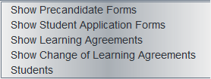
If he for example clicks on “show precandidate forms” (for a home coordinator) he can view all the precandidate forms that still need to be approved/denied. From here on he is able to read the forms, give his motivation about the form and approve/deny it.
Residences

Once a student is registered on the application and he has filled in his precandidate form with his preferred countries, he can start looking for a residence at these countries. Off course, since he isn’t sure at which country he will be going, that’s only certain after the confirmation of the precandidate, he isn’t able to sign up for the residence, but we thought that it was a good idea to make the option available so he can already start searching the database of the residences.

Information Exchange

The Infox module provided by the German team is very important for our module. They have provided us with some sort of an API which we can use to transfer database data between the different institutions. There are two mayor groups of information that need to be synchronized. The first one is info about the institutions and the second about users.
Institutions: This information is being fully synchronized between the institutions which are partners. The information that is being synchronized consists of information about the institutions itself, educations and courses. This is done every time information is changed in a particular institute.
Users: Information about students and the different coordinators is only copied when it’s certain that a student goes on Erasmus. In that way it is possible to minimize traffic and comply with the privacy policies of the different partners. So info is sent in JSON format every time a student fills in a form that requires approval of the host institution. Together with this JSON string the form is also sent in PDF. This is necessary because the forms need to be printed, signed and scanned in order to cope with the signature problem.

