P5 - INCOMING STUDENTS

This package refers to the forms that have to be completed by the students that are planning to use the Erasmus program and by their coordinators. In the report below, we will explain all the themes and problems that had to be solved from the beginning of the project and how did they finally come to a solution.

Forms to be filled

The forms that this package includes are the Learning Agreement Change, the Registration the Certificates of stay / arrival / departure and the Transcripts of Records. The first one must be completed by the student but not necessarily. It is used only when the student wants to add, remove or make any change to the learning agreement form they have already filled in the beginning. The registration form is the last form to be filled by the student, and it includes the information about whether the student wants to rent a room through the Institution or not. The other forms are programmed to pull data from the database, so the coordinators have to fill only a few gaps.

Process / Workflow

The Learning agreement Change form is send to the local coordinator , who approves it or not. Whether it is approved, it is sent to the host Institution, where they also have to approve it. The student also fills the Accommodation Registration form where he/she applies for accomodation via the partner Institution. After the student arrives to the partner University, the coordinator of that University has to fill the first certificate of arrival. This form (as all the certificates plus the Transcript of Records) are programmed to pull all the necessary data ( eg student's and coordinator's data) from the tables in the database. So, the coordinator has actually only to complete the date when the student arrived. At the end of the accomodation period, the coordinator also completes and sends the certificate of departure and the Transcripts of Records to the home institution. The certificate of stay is automatically filled by the database when the other two certificates are send.

Design of the forms

The first thing we had to do was to make easily understandable but in the same time appealing forms to the user of the website. The Belgian partners of the project have created their own framework on which we are all based to work , and the Netbeans software were the first two tools we had in our hands for designing the forms. We used the HTML programming language and the CSS style sheet language to succeed a harmonic combination. The final style of the forms ofcourse had to be harmonized with the general style of the website, so we knew from the start that the CSS would probably face some changes.
We collected all the corresponding forms that are now used for the Erasmus program from our University because we had to make sure that all the necessary data will be enclosed in our electronic forms.

Functionality of the forms

The second step was to make the forms functional, in other words working correctly. That turned out to be the hardest part, since a lot of code was needed and many other programming languages. Apart from that, the framework we used is totally new, so we had no tutorials or any other help from internet to walk through.
The problems we had to face were much enough. First of all, the variables which consitute the tables of the database had to change all the time, because there were always some new data to be implemented. So, others were added, others were removed and as a result, the code was changing all the time. In addition, we had to cooperate with the belgian partners in order to make similar forms and functionalities. Ofcourse, communicating via internet is not the easiest way to solve a problem. Time was also our enemy since the project had to finish throughout 3 months.
Despite that facts, we managed to make the forms functional and appealing. Continuing, we present the languages we used and the results of our work.

Javascript – PHP for checking

We used javascript for checking the validity of the forms. Javascript is a programming language which is used in the client -side and it makes the website valid. For instance, if someone forgets to fill one field or write numbers in a field for letters, then the code which includes javascript is running and usually messages are thrown on the screen pinpointing the wrong which deterred the website to work correctly. One example is the picture below. We set javascript on the Accommodation Registration Form. When the student is going to fill this form and he/she forgets one field, then the message “ This field is required” is thrown on the screen. There is also one more message which is for the departure and arrival date, and it shows to the student the correct format for writing down the date.
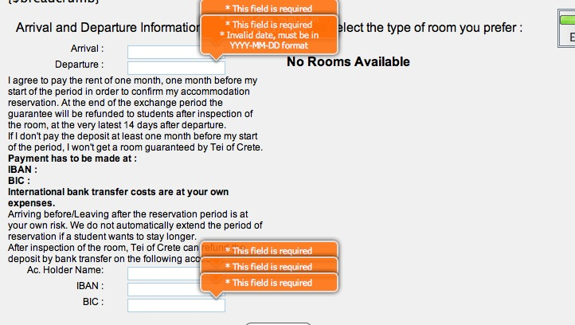

We also used PHP programming language for checking the forms in the server-side. These two languages have ofcourse different way of coding. The picture shows the message which is thrown on the top of the website when someone is going to fill the departure certificate before the arrival one.

PHP for validation

PHP is written and integrated into HTML code and it is useful for the server side by a PHP processor module which generates the web page document. It is compatible for every framework, and it is necessary for the proper functionality of a web page. So, we used php for including the functions in the codes.

Store – Pull Data

All the data that are filled in every field must be stored somewhere in order to keep a database and make the correct process for executing the Erasmus program. To succeed that, we had to use database tools which create tables and store our data with the appropriate commands. We first had created a database in the beginning of the project and we were planning to follow that one, but there were some themes that occurred afterwards so we changed our plans. The database tool we used was MySQL that runs as a server providing multi user access to a number of databases. There were many options about how to create the database, such as creating a separate table for every form, but that would extend too much the general database. So, we concluded in creating one table for all the forms.
As we mentioned before, the half of the forms that had to be created in this package must be programmed to pull the stored data from the database. That means in the HTML code, we had to write the aproppriate code in order to pull the data and show it in he correct side. In the picture below, we present the Transcript of Records form which is a very good example of pulling data , but still there are some fields to be filled by the coordinator.
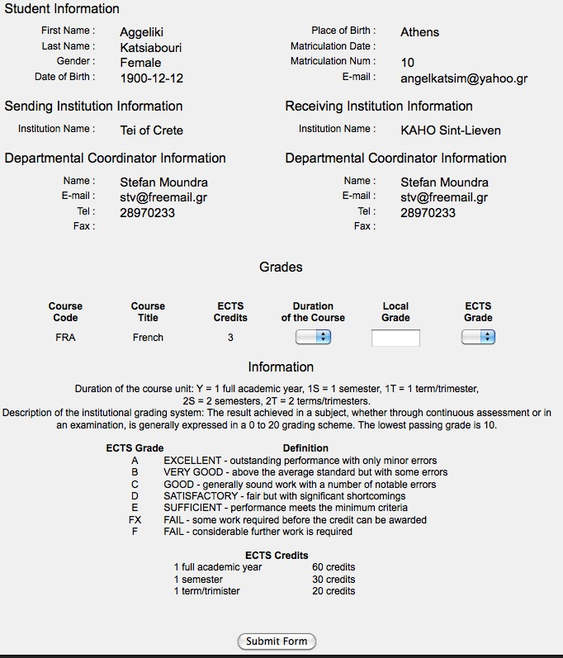

We also decided that it would be better to have first a general table which will show all the matriculation numbers, names and surnames of the students which use the Erasmus program, so it would make things easier for the coordinator to check the certificates that must be sent and those which have already be sent. The table has also the choice to search every student by name or the matriculation number.
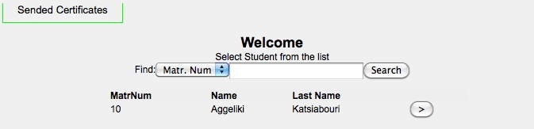

When the coordinator finds the correct student, there is a button next to the name which takes you to the certificates.
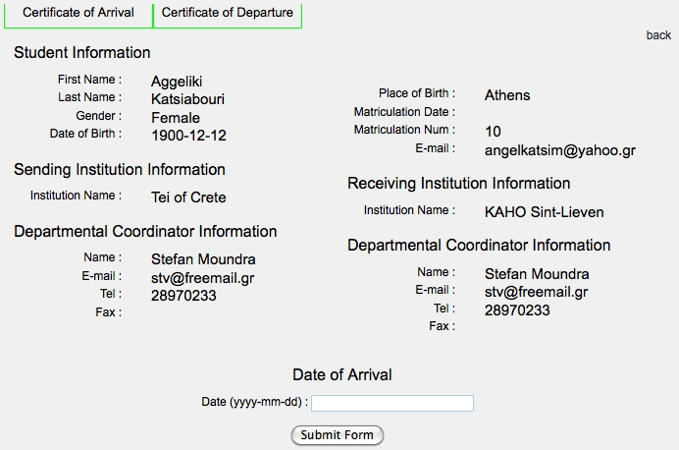

And when both are filled and sent, the certifacate of stay is also automatically completed, as it pulls the data from the other two certifications.
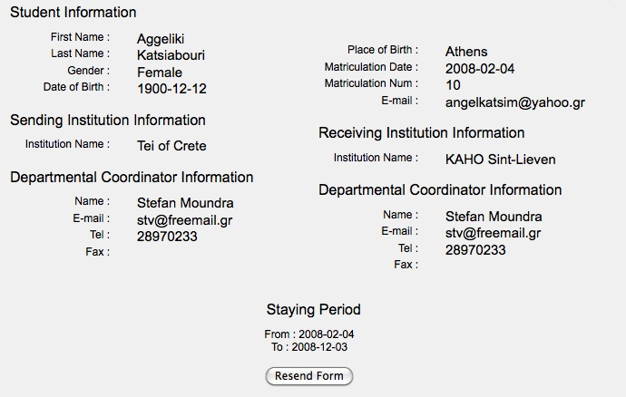

Finally, for the Accomodation Registartion form, we decided that it should be better to have the choice of wanting to book a rrom or not. In case someone wants to book, then after he/she picks that choice on the form, goes to the next page where other fields have to be filled. We must point here that this form also pulls data from the database.

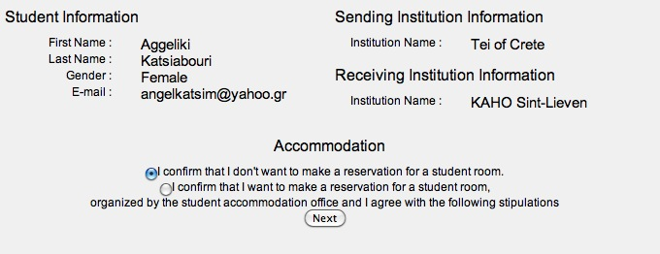
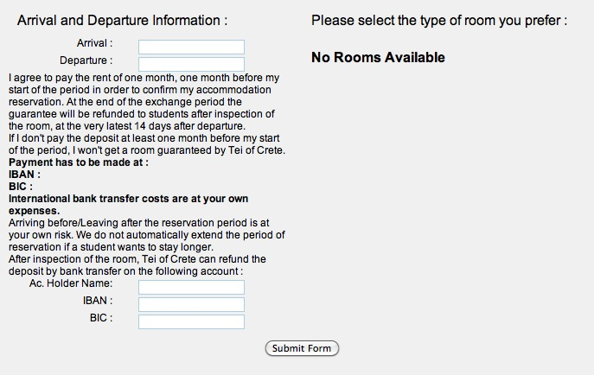

Exchanging Information

The last part of the package is the exhanging information part. The data that are filled in any institution which uses this website must be accessible from the other Universities. That was a mixture of the package P2 and the database we used.
Technically, the forms of this package are ready for use.

