ErasmusLine
The Orange Team

EIS Installation
and User Manual

P8-STATS Package Team
June 2011

Table of Contents
Introduction 3
Installation 4
Setting up communication with the Master Server 5
Daemons Monitoring 6
Application Logs 6
Crash control 6
User Manual 7
The Sidebar 9
The Toolbar 11
Other Outputs 12
Charts 12

Introduction
This manual contains basic instructions on how the Systems Administrator can install the Erasmusline P8-STATS package application on a Linux system and to setup the Executive Information System.
This manual will also demonstrate how a regular user can consult the Executive Information System by using it's online User Interface.

Installation
The Erasmusline application may be distributed as an archive download or the System's Administrator can simply clone the SourceForge Git repository, as explained in the Erasmusline Project Report.
Here are the instructions to make an installation in a Linux system using the Git repository – for this example we will use the Ubuntu Linux distribution.
- First it is necessary to have a basic LAMP stack installed – Linux, Apache, MySQL and PHP. Enter the following command in an opened terminal window:
sudo apt-get install lamp-server^
This command will install all the servers needed for the Erasmusline application to run.

- If you don't have Git or curl installed in the system use the following command:
sudo apt-get install git curl

- Next clone the SourceForge Git repository to your machine with this command:
git clone git://mutworange.git.sourceforge.net/gitroot/mutworange/mutworange
You will notice a newly created directory called mutworange/. This directory contains all the documentation and the Erasmusline application itself.

The example form now on will be executed from the user's home directory.
If there is a particular release version to use, you can issue the following commands:
cd $HOME/mutworange/
git tag -l # lists all tags
git checkout release-1.0 # example release version

Before executing the automatic install script, the Administrator needs to setup the database user. This can be done by executing the following command:
cd $HOME/mutworange/erasmusline/scripts/
mysql -uroot -p******* < create_user.sql # creates the default db user for the # application. Needs root user permissions.

After this step the Administrator can use the automated installation to create databases and run the ErasmusLine P8-STATS master and slave servers:
cd $HOME/mutworange/erasmusline/bin/
./install.sh

Now the administrator need to run the application on the Apache Server. The Administrator create a symbolic link to the default Apache Server www documents directory:
cd /var/www
sudo ln -s $HOME/mutworange/erasmusline/WEBSITE/ erasmusline

The ErasmusLine application can now be accessed through the url:
http://localhost/erasmusline
After logging in as Administrator you can access the EIS through the interface or directly through this url:
http://localhost/erasmusline/index.php?module=stats

Setting up communication with the Master Server
If the machine's installation is not meant for the Master server, the administrator will need to remove the master daemon installation and configure the slave server to communicate with a remote master server.
- Let's start by removing the master server in the machine by typing these commands in the terminal window:
rm -rf $HOME/mutworange/erasmusline/stats/daemons/statsd_master

- To configure the slave daemon to communicate with the remote master, the Administrator needs to edit the slave configuration file:
cd $HOME/mutworange/erasmusline/stats/daemons/statsd_slave
cp config.json config.inc.json # do not alter the main config file for backup
# purposes
vim config.inc.json # use vim, nano or emacs to edit the file

The relevant part of the configuration file will look like the following:
"master_serverconfig" : {
"sockType" : "unix",
"sockFile" : "/tmp/erasmusline/statsd_master/statsd_master.sock",
"serverIP" : "0.0.0.0",
"serverPort" : "8118"
},
Alter the socket type and server ip to look like the following example:
"master_serverconfig" : {
"sockType" : "tcp",
"serverIP" : "95.136.101.157",
"serverPort" : "8118"
},
Save the file and restart the slave daemon:
cd $HOME/mutworange/erasmusline/bin
./restart_stats_daemons

If the server address is correct, the local EIS installation will communicate with the proper Master Server.

Daemons Monitoring

Application Logs
The Master and Slave server logs are organized in the /tmp directory can be changed to another directory by editing each daemon's configuration files (see previous example).
To consult the logs, the Administrator can use the following commands in the terminal window:
tail -f /tmp/erasmusline/statsd_master/statsd_master.log
tail -f /tmp/erasmusline/statsd_slave/statsd_slave.log

To alter the verbosity of the logs, the Administrator can edit each daemon's configuration file and for example, reduce the log verbosity level:
"daemonconfig" : {
"appName" : "statsd_slave",
"logVerbosity" : 7
},

Crash control
To assure the daemons are constantly running, the Administrator can install and configure a process supervision tool like Monit:
sudo apt-get install monit
sudo vim /etc/monit/monitrc

User Manual

After the installing and setting up the Erasmusline application, the users need to login by registering a new user or logging in as an Administrator for example. After logging in, select the EIS tab in the Erasmusline Interface.
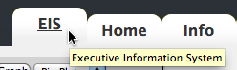The EIS tab on the top-right of the screen

The EIS interface will start by loading the application's libraries, taking a few seconds to be ready.
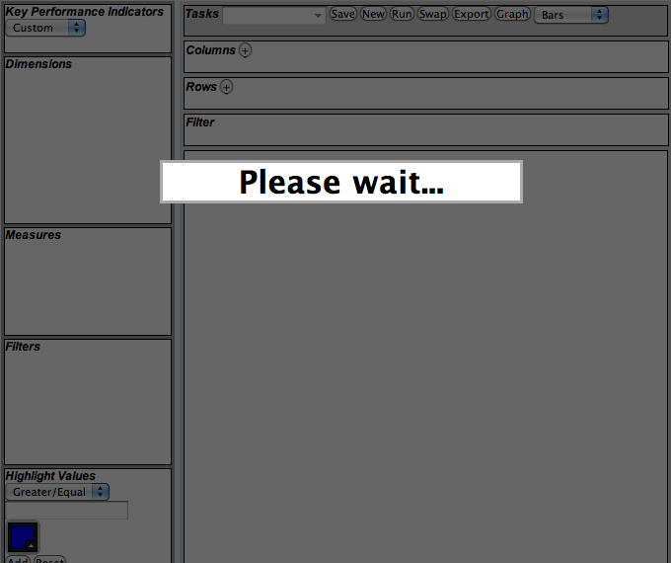The EIS interface loading screen
When the loading is completed, the users have access to the EIS interface and can begin creating new analysis scenarios right away.
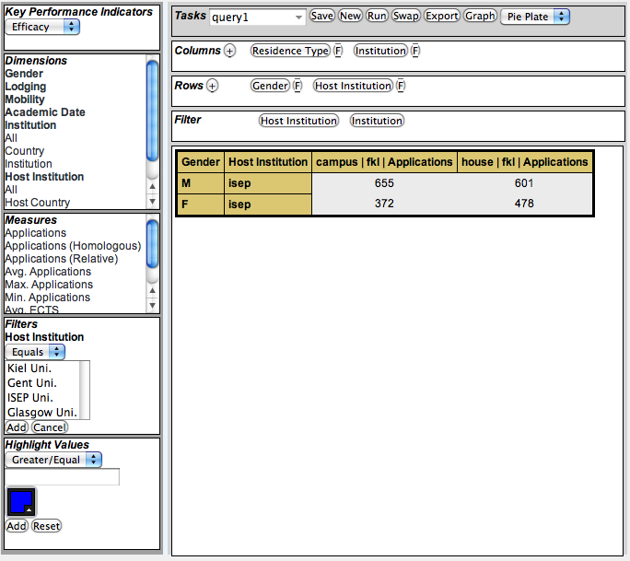The EIS interface in action

The Sidebar
The sidebar on the left of the screen enables the users to select which Key Performance Indicators to measure and analyze. To begin, select the KPI to load the available Dimensions and Measures.

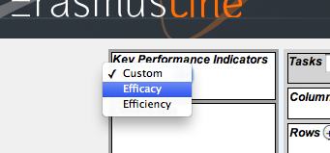Selecting the preferred Efficacy

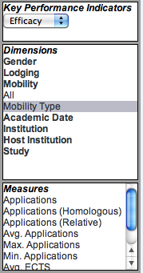Sidebar displaying KPI's, Dimensions and Measures
To generate an output Pivot Table, the users must select the Dimensions and Measures they wish to add to the Columns and Rows in the middle Toolbar. If a Measure is not selected, the default is always the first item in the Measure list.
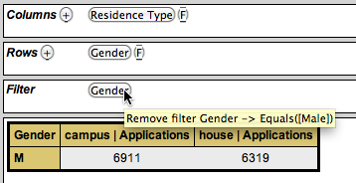The middle Toolbar, displaying Columns and Rows with the selected attributes
If the Dimensions have an available filter option, press the 'F' button to display the filter options in the left sidebar:

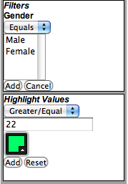The filter options for the Gender Dimension
Another option in the sidebar is the possibility to highlight values from the result Pivot Table. The users select the numeric values, the color and the condition in which to paint the table cells' background. This allows the users a better comprehension of large Pivot Tables.

The Toolbar

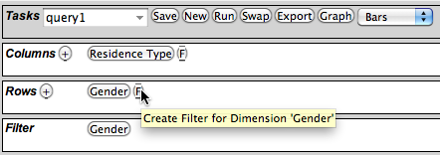The middle Toolbar running a previously saved Scenario called 'query1'
The toolbar consists of four functional elements: the Tasks bar, the Columns bar, the Rows and Filter bar.
In the previous example, the users select Dimensions and Measures and distributes them between Columns and Rows. Pressing the 'Run' button in the Tasks bar generates a Pivot Table bellow the main Toolbar. The user can swap Column elements by Rows using the 'Swap' button, a new table is then generated.
The user can alter the table's Columns and Rows by pressing the selected Dimension and Row buttons, thus removing them from the toolbars – “Drill-down and Roll-up” operations - or create a new filter as previously shown in the previous section.
To load this Scenario next time the users' login, the users can enter a description on the select box in the Tasks bar and press the 'Save' button. The scenario will be available to be loaded – the Columns, the Rows, the Filters and the Highlighted values – by choosing it from the select box.

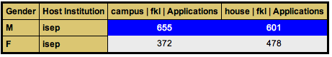Pivot Table with Highlighted values superior to 500

Other Outputs
In the Tasks bar, the users can press the 'Export' button to generate a downloadable version of the pivot table in CSV file format. In this format the users can open these files in any modern spreadsheet application available in every Office software suite.
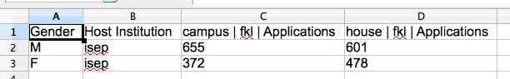CSV file displayed in a spreadsheet tool

Charts
The Google Chart Tools API provides a series of tools to generate various types of Charts and Graphs suited for the EIS interface.
The EIS interface can generate Bars, Lines and Pie Charts based on the loaded scenario settings and can extend to other types of Chart using the Chart Tools API. Users can choose the preferred graph from the select box on the Tasks bar and press the 'Graph' button to display a screen with the generated.
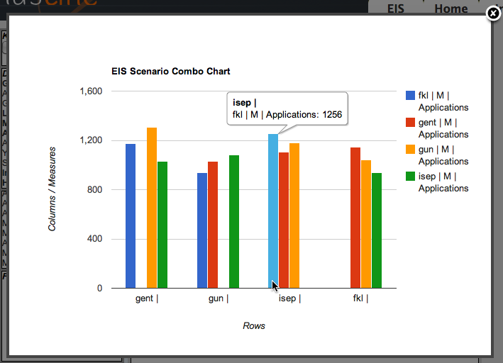Generated scenario Bar Chart output
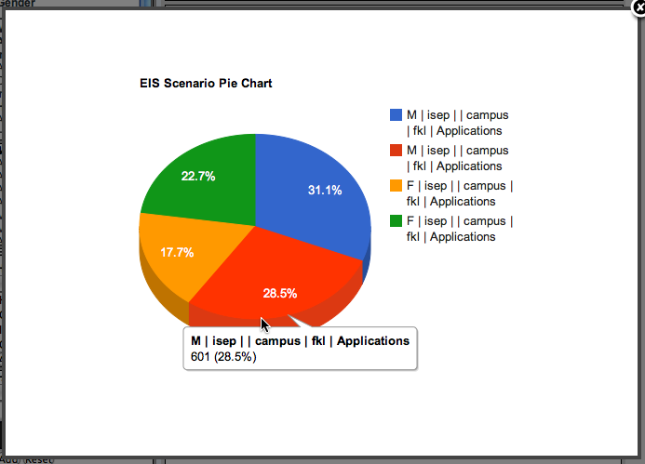Pie Chart generated graphic

http://mmonit.com/monit/
http://en.wikipedia.org/wiki/Pivot_tables
http://en.wikipedia.org/wiki/Comma-separated_values
http://code.google.com/apis/chart/

