P8-STATS (Portugal)
The next sections explain the objectives of this package, demonstrates the requirements gathering and Business Rules definition for the package as well as the more technical aspects of the package such as deployment, communications and decisions that shaped it's development.

Executive Information Systems
Executive Information Systems (EIS) are Information Systems that access large amounts of business information from various sources - internal and external to the organization - and provides decision support mediums to the organization's senior executives.
These mediums permit the executive managers to highlight patterns in the business process by analyzing, comparing and determining trends in the provided mediums - spreadsheets, graphic charts, pivot tables, reports, etc.

As an example of EIS use, consider the following scenario:
Erasmus administrators can do a weekly check on student enrollment information. Using a web browser, they can access that information in a personalized fashion by presenting subsets of the information - views. These views can be "drilled-down" to minute levels of information or "rolled-up" to display a broader view.

Since executive users are not necessarily data analysts, the EIS user interface must be as simple as possible, but without sacrificing presentation dynamics.

With these criteria in mind, the following key requirements for an EIS where identified:

- Cross Platform
- Ease of Use
- Limited Training
- Quick Response
- Process Large Volumes of Data
- Deployment Through the Web
- Easy Graphical Presentation Options
- Ability to Access Subsets of Data (Drill Down)

Architecture

An EIS can be divided into three main levels of architecture, that covers the technology used to extract, analyse and visualize information from other data sources with a friendly and flexible user interface. The levels discussed in the next sections are the following:

- Data Management
- Model Management
- Data Visualization

The architectural levels will be explained in the following sections.

Data Management Level

The Data Management Level deals with the extraction, analysis and processing of the internal and external data sources and passes that data through an ETL process - Extract, Transform and Load - that organizes and aggregates the data into the Data Warehouse. The use of ETL and Data Warehouses can be more efficient to the EIS due to it's data treatment and Warehouse data model schema.

ETL

The ETL process parses the data and performs these possible operations:

- Translation into database compatible rows / columns
- Translate code values
- Remove / Add / Translate code values
- Change data encoding
- Sorting
- Data validation
- Summarize data
- Join data from various sources
- Generating surrogate keys

Also, ETL process can make use of temporary database tables for intermediate processing, called Operational Data Stores (ODS). These tables hold historical data that can me mined for statistical information to be included in the Data Warehouse.
For the P8STATS package, the ETL process will be executed either by an event trigger - saving data in the ODS’s when a certain workflow phase is reached - and periodically - part of the data refreshment process to aggregate new information to the Data Warehouse.

Data Refreshment

This phase of the ETL process is comprised of design choices, like data structures, techniques to update and optimize the flow of information from the data sources to the Data Warehouse and update cycle.

The process begins with the loading of information from the Operational Data Stores.

Loading

The information sent to the ETL component will be fetched from the application data sources while other subsets of information are already stored in the ODS’s or Metadata tables - these hold information previously gathered by the business requisites - which is going to be processed by the ETL component and integrated into the Data Warehouse.

To aggregate and integrate data to be viewed in the EIS, we must determine an update cycle for the Data Warehouse. The information models that need to be gathered over time are noted in the following table:

Model | Update cycle
Erasmus Process Efficiency | Every Semester
Erasmus Process Efficacy | Every Semester (after Efficiency process)
Table 1: EIS update cycle for the Data Refreshment phase

After the Process Efficiency data is integrated into the Institution’s local Data Mart - a local database, part of the Data Warehouse - the Efficacy process gathers the data from the various Institution’s Data Marts and additional data to aggregate and integrate new data into the central Data Mart.
More on this discussion in the Deployment sections of this report.

Aggregation

The aggregation process of Student Application data fetches the information from the ODS database and integrates those values in the Data Warehouse database.

Some technical aspects have to be considered in the loading and aggregation of data sources:
- Keep an historical record of information already loaded, so as not to fetch the same data twice. This is a achieved with a caching mechanism, to prevent repetitive DB queries for example.
- The Data Warehouse Database Schema must be optimized for query performance, that includes
  - Which indices are needed
  - Index type vs Data type
  - Database/Table engine

The technical considerations and decision are explained in detail the next sections.

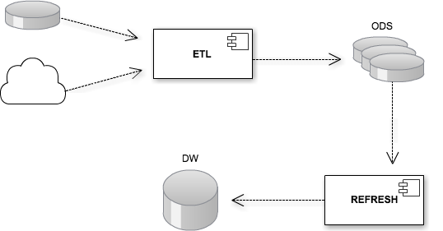Illustration 1: ETL Process Workflow

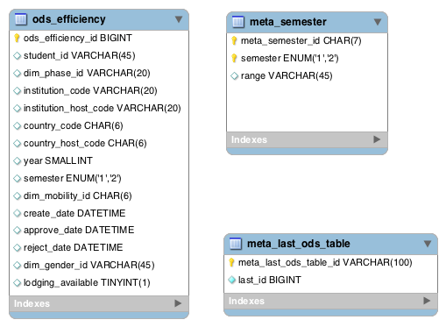Illustration 2: ODS and Metadata DB Schema

Data Warehousing

A Data Warehouse holds the processed information into a database designed properly for the retrieval of large amounts of data. The database structure is composed of fact tables and dimension tables, connected by their keys in a Star or Snowflake schema.
A fact table holds facts - an aggregation of contextualized fields and numerical values for measurement.
A Dimension table holds the various combinations of a given dimension, often identified by a part of the composite key in the fact table and serves as a means to restrict and summarize the information contained in the fact table ("roll-up" and "drill-down" operations).

Data Warehouse Statistical Specifications

Objectives:

- Efficacy
- Efficiency

Indicators:

- Efficiency:
  - Response time between Process phases
  - Student participation
  - Lodging availability

- Efficacy:
  - Applications
  - Student credits
  - Student grades

Measure Table

Ref / Measure | Description | Example
M1: Real Value | The current value | # Applications current month;  # Declined applications current month
M2: Accumulated | Accumulated value | # Applications in a year;  # Applications in a semester
M3: Homologous | Current value comparison with previous value | # Applicants in the previous year
M4: Relative | Real value compared to accumulated value % | Percentage of applicants in January
M5: Average | Average of the accumulated value | Average of applicants in January
M6: Maximum | Maximum pick of the accumulated value | Maximum # of applicants in January
M7: Minimum | Minimum pick of the accumulated value | Minimum # of applicants in January
M8: Relative HEI | Relative percentage against the total number of students in the HEI | Percentage of applicants against the total number of students
Table 2: Defined Measures for the Data Warehouse

Indicator vs Measure Table

Ref / Indicator | Ref / Measure
I1: Response time | M5 / M6 / M7
I2: Participation | M2 / M4 / M8
I3: Lodging Availability | M2 / M4
I4: Applications | M1 / M2 / M3 / M4 / ...
I5: Student credits | M5 / M6 / M7 / M3,5
I6: Student grades | M5 / M6 / M7 / M3,5
Table 3: Cross referencing KPI's with Measures

Dimensions Table

Ref / Dimension | Ref / Hierarchy | Ref / Example
D1: Gender | H1: Gender | E1: Male | Female
D2: Lodging | H2: Residence Type | E2: Campus
D3: Mobility | H3: Mobility Type | E3: Internship | Exchange | Both
D4: Academic Date | H4: Year / Semester | E4: 2011; 2nd
D5: Institution | H5: Country / Institution | E5: Portugal; ISEP
D6: Study | H6: Area / Degree / Course | E6: Engineering; Informatics; Software Engineering
D7: Phase | H7: Process Phase | E7: Pre-Candidacy
Table 4: The Dimension Classification, their levels of detail and examples

Indicators vs Dimensions Table

Ref / Indicator | Ref / Dimension
I1: Response time | D3 / D4 / D5 / D6 / D7
I2: Participation | D1 / D2 / D3 / D4 / D5 / D6
I3: Lodging Availability | D1 / D2 / D4 / D5
I4: Applications | D1 / D2 / D3 / D4 / D5 / D6
I5: Student credits | D1 / D3 / D4 / D5 / D6
I6: Student grades | D1 / D3 / D4 / D5 / D6
Table 5: Cross reference between KPI's and Dimensions

Database Schema

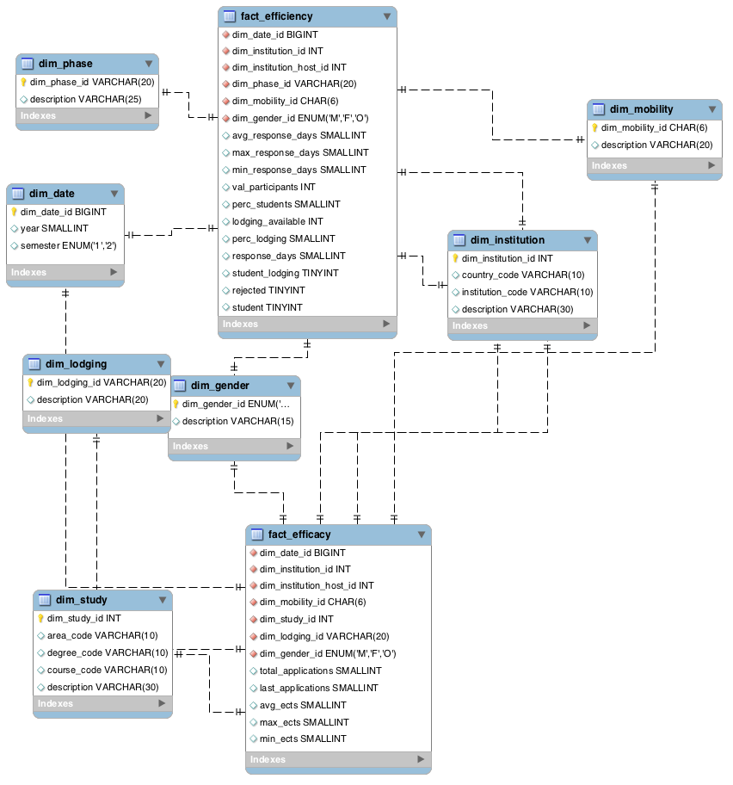
Illustration 3: Data Warehouse Database Schema

Model Management

This level manages and transforms data according to business guidelines and stored metadata by executing several operations explained next.

OLAP

Online Analytical Processing is a set of techniques applied to the Data Warehouse to summarize and visualize business information in a multidimensional perspective across multiple dimensions. Since the Data Warehouse is designed to use a multidimensional data model, information is organized in Data Cubes and thus enabling the EIS users to gain more insight into the data by performing these operations:

- Facts aggregation
- Slice and Dice across multiple Dimensions
- Drill-Down and Roll-Up the data from one hierarchy to another

Here are some examples of OLAP in action in an Accounting context:

- Comparison of sales (fact) of a product (dimension) over years (dimension) in the same region (dimension).
- How may members (fact) have opened a savings account (dimension), in USA branch (dimension), over a period (dimension)?
- How many mortgage loans (fact) have been approved in fixed mortgage (dimension) or Adjustable Rate Mortgage (dimension) in New York City (dimension), over a period (dimension)?
- What is the total sales value (fact) of a particular product (dimension) in a particular grocery store (dimension), over a period (dimension)?
- What is the amount spent (fact) for a particular product promotion (dimension) in a particular branch (dimension) or in a particular city (dimension), over a period (dimension)?

Data Mining

Data mining tools are especially appropriate for large and complex sets of data. Through statistical or modeling techniques, data mining tools make it possible to discover hidden trends or rules that are implicit in a large database. Data mining tools can be applied to data from data warehouses or relational databases. Data discovered by these tools must be validated and verified to become operational data that can be used in the decision process.

Data Visualization

The EIS Web Interface

The interface should be flexible and intuitive enough for users without previous skills to select the indicators they want and operate filters by several dimensions and metrics - this operation can be called a "scenario". Theses "scenarios" can be saved and edited for later used by the user.

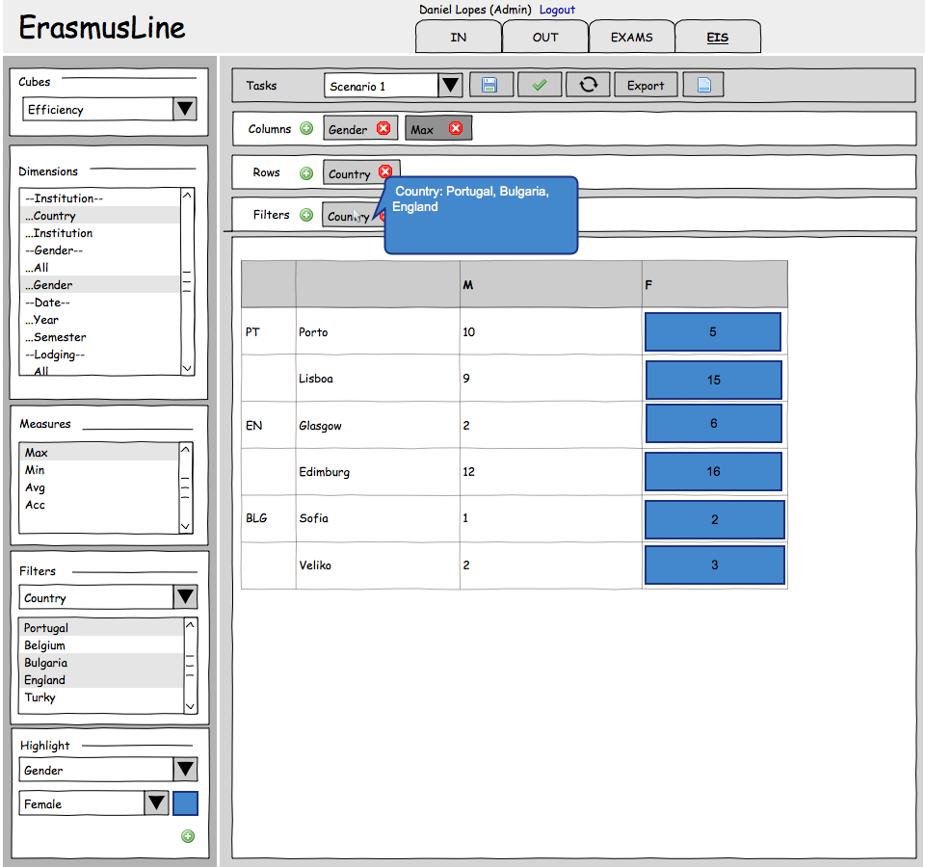Illustration 4: EIS Interface Mockup

Interface Features

As mentioned earlier, each scenario configuration can include the following features:

- Select OLAP cubes - the Objectives - for performance monitoring
- Generate pivot tables
  - Selecting Dimensions for columns and rows
  - Selecting measures for columns and rows
  - “Drill-Down” data by displaying aggregated information for a member of a Dimension
  - “Roll-Up” data by displaying aggregated information from ‘All’ members in a Dimension
  - Swap Columns / Rows
  - Filter Dimensions by Value Type
  - Highlight Dimensions with a different color, depending on Column / Row location
  - Settings Management
    - Create a new scenario
    - Save a scenario
    - Load a previous scenario
  - Export results
    - Spreadsheet
    - Text file (CSV format)

Technical Decisions

MySQL 5.1

MySQL is a RDBMS server that provides storage of information with relational traits, that supports multiple databases and database engines, multiple users and threaded access. It is an open source solution and currently the most popular relational database for small and medium sized projects. For the P8STATS package, we will use the stable release MySQL 5.1 because it is a generally available release and can be installed and found in any mainstream Operating System today.

MyISAM / MERGE Engine

The P8STATS package requires fast access and processing times with low overhead, in order to serve the client as fast as possible given that the amount of data in the Data Warehouse will grow exponentially every semester (in a good scenario). The Data Refreshment phase needs to be executed quickly and in the background so as to allow users to continue using the EIS without any downtime.
For the Dimension tables we use the MyISAM database engine, since up to the 5.1 release offers a fair relation between data consistency and throughput, although consistency could require some configuration on the underlying OS. The kind of data we are housing is not extremely critical that needs to be kept history logs or support for transactions so MyISAM satisfies our objectives.
The Fact tables use the MERGE_MyISAM database engine, allowing us in the Data Refreshment phase to partition our data by refreshment period (Year or Semester) and keep it in separate tables. The main MERGE table houses the union of all the partition tables and their indices thus achieving better performance in some scenarios, for example, querying data from a single semester, which will be a common task in the EIS. Table partitioning also allows the databases’ physical files to be moved to separate disks, allowing better performance by, for example, having the first semester table file in a SSD disk with a btrfs file system partition.
The tables’ indices can also be preloaded to cache on demand, after the Refreshment process is done, to avoid loading indices on database query time.

PHP 5.3

PHP is a popular programming language for the rapid development of Web Sites. It’s fundamentally a dynamically typed language with Object Oriented Programming support and very tightly coupled with server-side scripting of applications.

It was decided to implement the P8STATS package in this programming language to allow academics of any technical level to easily comprehend and extend the application.
PHP permits developing open source applications - one of the project’s requirements. Based on that premise, some components where designed and optimised for POSIX compatible operating systems like GNU/Linux, which are fundamentally open source systems. These components are System Daemons that are active agents in the OLAP and ETL processing.

Daemons

Unix Daemons are processes that run the background, performing all sorts of tasks and intercommunicating with other applications if needed.
The Daemons designed for the P8STATS package generally do the following tasks:

- Periodically executes the ETL process, according to determined refreshment cycles.
- Communicate with the ErasmusLine application - for example saving ODS information
- Save user’s EIS scenarios
- Load EIS scenarios and perform OLAP operations on the Data Warehouse
- Cache EIS query results, product of OLAP operations
- Request data from other daemons - for example retrieve Efficacy data from the central Data Mart

Every Erasmusline installation has a Slave Daemon to perform these tasks. A Master Daemon is deployed with the central Data Mart - that could be on the Slave Daemon’s machine - and can be reached by configuring a simple settings file in JSON format and setting the Master’s IP address. All daemons support BSD-style and TCP-IP socket communication, supported by the PHP socket API. BSD-style sockets allow less overhead in local inter-process communications since it doesn't rely on the TCP-IP layers stack. Remote communications rely only on TCP-IP sockets.

POSIX Compatible Operating Systems

Operating Systems like GNU/Linux, MacOSX, Solaris or BSD follow standards that emulate the functionality of a Unix machine, meaning the OSs' internal API and system utilities follow the same convention that allowed the P8-STATS package to run in a much wider array of systems.
Given the Open Source orientation of this project, this package was optimized to run in Linux and BSD systems like Ubuntu or FreeBSD, given that it enables us to use a more straightforward API for special tasks like concurrent programming and socket communication.
Modern POSIX compliant operating systems like Ubuntu enable a quicker installation and setup of the software needed by the Erasmusline application and subsequently this package, by using pre-configured terminal task commands to group-install a basic LAMP software stack – Linux, Apache, MySQL and PHP – and quickly deploy the application by pulling the latest Erasmusline application release from the SourceForge Git repository.

Deployment Scenario

The architectural deployment of the EIS application can be explained by the following figure:

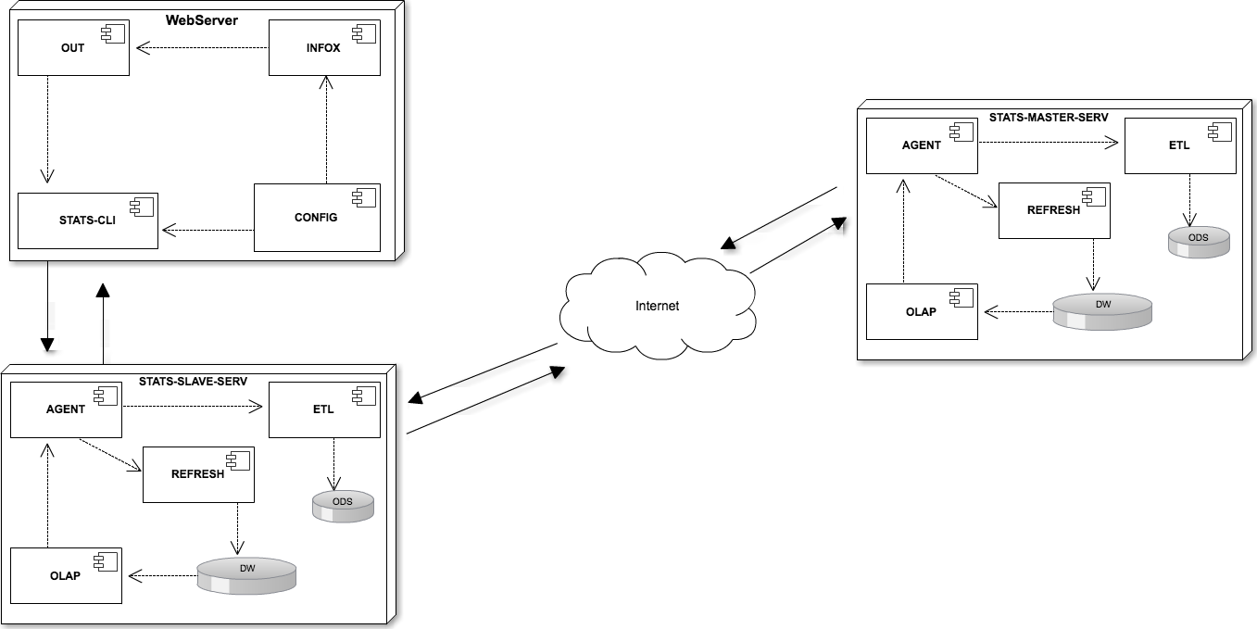Illustration 5: Data Flow between Erasmusline, the slave and master STATS daemon

The deployment components can be separated in three major entities:

- A Master Server
  - Contains the Data Warehouse with the data referent to the Erasmus Process Efficacy (explained in the following sections)
  - Gathers information from the Slave Servers to summarize Efficacy indicators data
  - Communicates with the Slave Servers to deliver summarized Efficacy data
- A Slave Server for each Institution
  - Communicates with the other Erasmusline packages in order to gather Efficiency indicators data - mainly the P4OUT and P1CONFIG packages
  - Communicates with the Master Server to provide the EIS interface with Efficacy data.
  - Delivers the EIS interface the Efficiency data

- EIS Interface and Connector
  - User interface to manage scenarios and display statistical information
  - Connector component that receives event data referent to the Erasmus workflow process - sending that data to the Slave Server

Server Communication

The Slave and Master EIS servers accept text based communications by following the guidelines of the JSON-RPC 2.0 Specifications. This Remote Procedure Call specification is very light weight since it doesn't rely on the verbosity of SOAP RPC messages and allows API extension since it is not a strict API.
Here is an example communication scenario.
The EIS interface requests that a certain scenario may be executed, a JSON message structure is sent to the Slave Server:
{"jsonrpc":"2.0","id":1,
"method":"runScenario",
"params":{"cube":"fact_efficacy",
"columns":["dim_gender.dim_gender_id","dim_institution.institution_code"],
"rows": ["dim_mobility.dim_mobility_id","measure.M1"],"filters":{}}}
The Slave Server realizes the analysis is to be made on Efficacy Performance Indicators so it relays this message to the Master Server who holds the Efficacy Data Mart.

The result of the scenario execution will be delivered to the EIS interface in this format:
{"jsonrpc":"2.0","result":[{"Mobility Type":"both","M | fkl | Applications":1130,"M | gent | Applications":1280,"M | gun | Applications":1075,"M | isep | Applications":943,"F | fkl | Applications":1006,"F | gent | Applications":964,"F | gun | Applications":1092,"F | isep | Applications":1020},
{"Mobility Type":"intern","M | fkl | Applications":1262,"M | gent | Applications":1030,"M | gun | Applications":1356,"M | isep | Applications":967,"F | fkl | Applications":884,"F | gent | Applications":1170,"F | gun | Applications":1035,"F | isep | Applications":997},
{"Mobility Type":"study","M | fkl | Applications":976,"M | gent | Applications":966,"M | gun | Applications":1101,"M | isep | Applications":1144,"F | fkl | Applications":784,"F | gent | Applications":1087,"F | gun | Applications":851,"F | isep | Applications":1121}],"id":1}

If any exception or error occurred we would receive a different response format:
{"jsonrpc": "2.0", "error": {"code": 101, "message": "INVALID_QUERY"}, "id": 1}

Other Key Performance Indicators – Efficiency – are locally processed by the server's OLAP module.

ETL / Data Refreshment Communication
Each server has a scheduling module that triggers server tasks to be executed from time to time or at a specific date.
At the end of each semester the Slave Servers trigger the data refreshment task which in turn runs in the background and gathers new data from the ODS tables to be integrated into the Data Warehouse and it's corresponding Data Marts.
The Master Server however needs to communicate with every running Slave Server to check for new aggregated data to be integrated to it's Data Mart. The Slave Servers periodically check for the Master Server's location and gives it their location. The Master Server in turn saves their locations in the database. When the time comes to refresh the Master Server's Data Mart, it calls every saved Slave Server and asks them for the aggregated data with extra information relevant to other Key Performance Indicators. After saving that data in the local ODS tables, the Master Server triggers it's own data refreshment task and integrates the new data into the Data Warehouse.

http://groups.google.com/group/json-rpc/web/json-rpc-2-0
http://en.wikipedia.org/wiki/SOAP

