P1-CONFIG

In this module the main configuration is set. It can actually split up to three parts: Data management, User management and page-layout.

Data Management
In the data management part we first made a short overview of the data that will be needed for the normal user functionality such as login, selecting institutions and selecting courses.
Next we arranged a meeting to discuss with the other team-members their requirements for the database system. Additionally we came to the conclusion that we will use a MySQL database with UFT8 encoding. So it is made clear that all European partner institutions will be able to store data in their own language characters like it is in Greece, Germany or Turkey.

During the project some groups came up with some adjustments to the database. Actually we decided to make no changes because of side effects to other packages but finally we had no other choice. With getting more and more in touch with the project and the workflow we allowed to make adjustments to the database with the condition to report changes immediately to all team members and acknowledge the changes not until every group has given the ok for their package.
Next figure shows the final database:

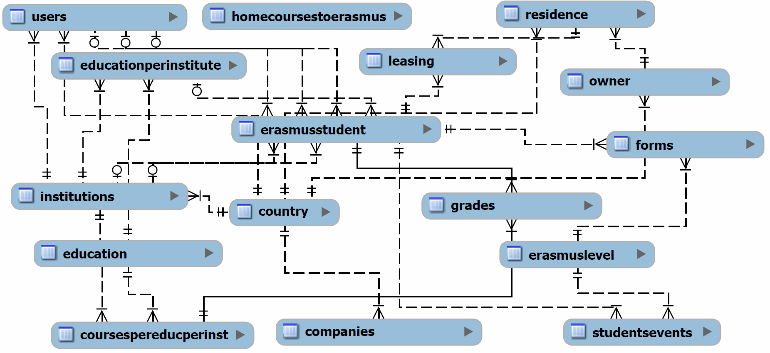

As it is shown in the draft the most important table is the 'erasmusstudent' table. It is the heart of the database and connects most of the other tables. It is necessary for the whole erasmus process, from the start to the beginning. Another important table is called 'erasmuslevel'. Here are the levels defined which a erasmus student will go through. Every level has e next level except the last one.

User Management
The data management plays a big role for the user management. All user data is stored in the database. We have a certain table with all necessary information about the user no matter what its role in the application is because every user has to login first (students or administratives). Another table defines the role of the user. Next figure shows all roles:

Role | Description
Student | An erasmus student who want to participate in the erasmus program
Teaching Staff | Same level as International Relations Office Staff
Erasmus Coordinator | Same level as International Relations Office Staff
Higher Education Institution | Same level as International Relations Office Staff
Industrial Institution | Not used yet in our application
International Relations Office Staff | These users coordinate the whole erasmus process and handle the students events.
Administrator | Special user who can organize the International Relations Office Staff.

We also decided to make a register mask public so that everybody can register and do not have to wait until an administrative will set up the account. Also we want to avoid any mistakes with names etc.

Page Layout
First the team discussed the framework they want to use. We decided to use the Plonk library which was developed by Bramus Vandamme. The Belgium team had a lot of experiences with this framework and they had local access to the developer in case of some problems. Plonk is based on MVC and the code is separated from the layout. Finally it was made to work in separated groups on the same application so it is exactly what we need. After this decision and the team-members started with their package, we tried to set up two different layouts. Both layouts were good enough for the final page so we started to make a vote to see the favorite layout. We decided to give the more discreet but professional layout the chance to present our work. Next figure shows a part of the header a team-member created on his own.

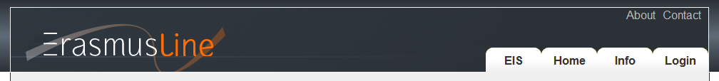
We created an Erasmusline banner on the top left of the site which includes the typical colours of the Erasmus Project. On the right site are a few tabs for the main menu. These tabs have also a hover effect to make a small visual effect.
The main part of the application is in a box with 980 pixel with. This was very important for us that the content will not become wider because a lot of students use small netbooks with a maximum width of 1024 pixel. So the screen will always have a small buffer for the scrollbars e.g.

