Project Management Plan

The Project development was controlled using the software tool OpenProj and editing the existing Gantt Chart, accessible by the team's members in the SourceForge Git repository.
Every package member was responsible for filling out their package Work Breakdown Structure, assign each deliverable time boxes and regularly filling the percentage of their work done.
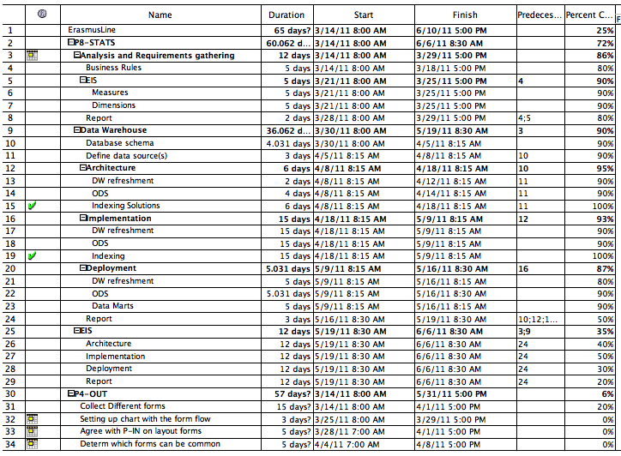The Project's Gantt Chart in OpenProj
Apart from checking our project's and each individual package's performance, the team acted on democratic decision - when selecting the tools, when resolving open ended questions – recurring to presential meetings through the software tool Adobe Connect, IRC channels, direct email and the SourceForge Mailing List system.
Given the democratic nature of the team, each package team would also self-manage their own package planning, using their own tools but always reporting to a general Gantt Chart.

Project Plan Description
This project was developed during the second semester of 2011, between the 21st of March and the 17th of June.
The following tables show each packages main tasks and milestones, each with their corresponding time box.

P1-CONFIG (Germany)

Milestones / Tasks

- Database 21/03 – 29/04
  - Design
  - SQL-Script
  - Installation Script
- Design 25/03 – 15/04
  - Design Mock Templates
  - Integration with Plonk Templating library
- User Account 18/04 – 29/04
  - Login functionality
  - Account page

P2-INFOX (Germany)

- Discussion about communication Protocol 28/03 – 1/04
- Define Security System 04/04 – 29/04
- Programming Outgoing data 02/05 – 13/05
- Programming Incomming data 02/05 – 13/05

P3-ALERT (Bulgaria)

- Research 22/03 – 06/04
- Making the daemon 07/04 – 20/04
- Synchronization with the others part of the project 21/04 – 27/04
- Email sending system 28/04 – 5/04
- Pop-ups 28/04 – 5/04
- GUI 05/05 – 09/05
- Testing 10/05 – 23/05

P4-OUT (Belgium)

- Collect Different forms 14/03 – 01/04
- Setting up chart with the form flow 25/03 – 29/03
- Agree with P-IN on layout forms 28/03 – 01/04
- Determine which forms can be common 04/04 – 08/04
- Implement non/common forms 11/04 – 29/04
- Creating ECTS forms 28/03 – 01/04
- Implement flow of forms 11/04 – 10/05
- Integrate information exchange module 18/04 – 22/04
- Intensive testing of flow 10/05 – 31/05

P5-IN (Greece)

P6-EXAM (Bulgaria)

- Research
- Making the student module
- Making the home coordinator module
- Making the host coordinator module
- Synchronization with other parts of the project
- Testing

P7-MATCH (Iceland)

P8-STATS (Portugal)

- Analysis and Requirements gathering 14/03 – 29/03
  - Business Rules
  - Key Performance Indicators
    - Measures
    - Dimensions
  - Report
- Data Warehouse 30/03 – 19/05
  - Database schema
  - Define data sources
  - Architecture
    - DW ETL / Data refreshment
    - ODS and Metadata structure
    - Indexing Solutions
  - Implementation
    - DW ETL / Data refreshment
    - ODS and Metadata structure
    - OLAP module development

  - Deployment
    - DW ETL / Data refreshment
    - ODS and Metadata tables
    - Data Marts – Local and Remote DW
    - Report
- EIS Interface 19/05 – 06/06
  - Architecture
  - User Stories
  - Implementation
  - Deployment
  - Report

ERASMUSLINE (Orange Team)

- Integration 16/05 - 31/05
  - Integration Tests
  - Debugging
- Final Report 01/06 – 17/06
  - User Manual
- Presentation 08/06 – 17/06
  - Presentation Notes

http://openproj.org/
http://mutworange.git.sourceforge.net/
http://www.adobe.com/products/adobeconnect.html

