Incident handler's journal
This journal is about how I have done multiple incident response reports based on the NIST Incident Response Lifecycle.

Date:  July 22, 2026 | Entry:  #1
Description | A security event happened where an employee downloaded a suspicious file from their email. The suspicious file when opened by the employee a malicious payload was executed on the employee computer.
Tool(s) used | Input capture.
The 5 W's | - A malicious party sent a suspicious email with an attachment do download.  - As soon as the attachment was downloaded and opened a malicious payload was executed.  - The incident occurred on 1:13 p.m. when an employee downloaded the malicious attachment. 1:15 p.m.: Multiple unauthorized executable files are created on the employee's computer.  - The incident happened on an employee’s computer.  - The employee unknowingly downloaded a suspicious attachment and opened it without verifying the source thus 3 malwares were executed.
Additional notes | Some key IOC’s that I have found based on the Pyramid of Pain Concept:  - Hash Value: The malicious Spreadsheet file consists of has other similar MD5 hash values such as “287d612e29b71c90aa54947313810a25” which are Flagged as Trojan or Malware according to VIRUSTOTAL reports.  - IP Addresses: The executed malware contacted over 400+ IP addresses after it got opened. These IP Addresses show US locations and this can be a major IOC. Here are some of the contacted IP addresses according to VIRUSTOTAL:  IP Detections Autonomous System Country  104.115.151.81 0 / 91 20940 US  104.117.234.151 0 / 91 20940 US  104.125.90.151 0 / 91 20940 US  104.86.229.106 0 / 91 20940 US  104.86.245.126 0 / 91 20940 US  108.160.170.33 0 / 91 19679 US  108.177.11.94 0 / 91 15169 US  - Domains: The Malware contacted multiple domains at the same. According to the VIRUSTOTAL reports one domain got contacted over 10 times and was flagged as a backdoor IOC.  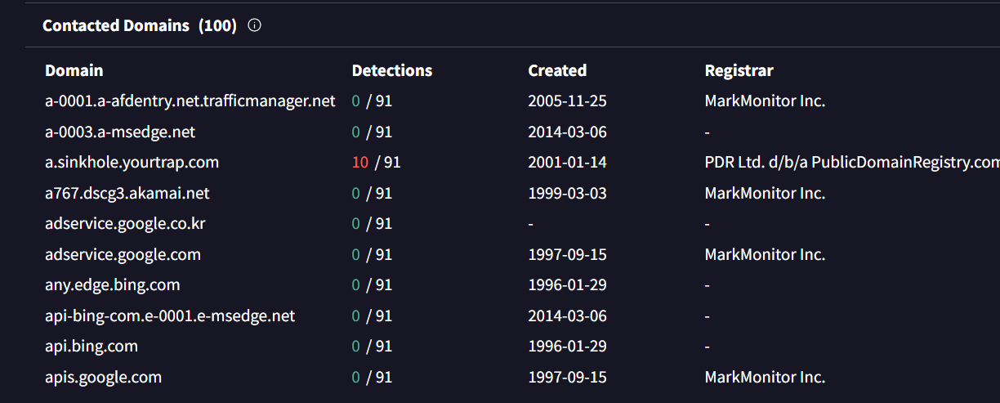  - Tactics, techniques, and procedures (TTPs): The malware ran multiple procedures on the system level and ran multiple bash commands to run internal apps, change systemdir information. This is a major IOC or vulnerability point. According to Reports some of the parent and child Processes that were created are:  - running internet explorer to embed some files and send them to a  destination.  - accessing system32 directory to change file permissions.  These are major flags that need to be further investigated to asses the damage. Here is the report screenshot:  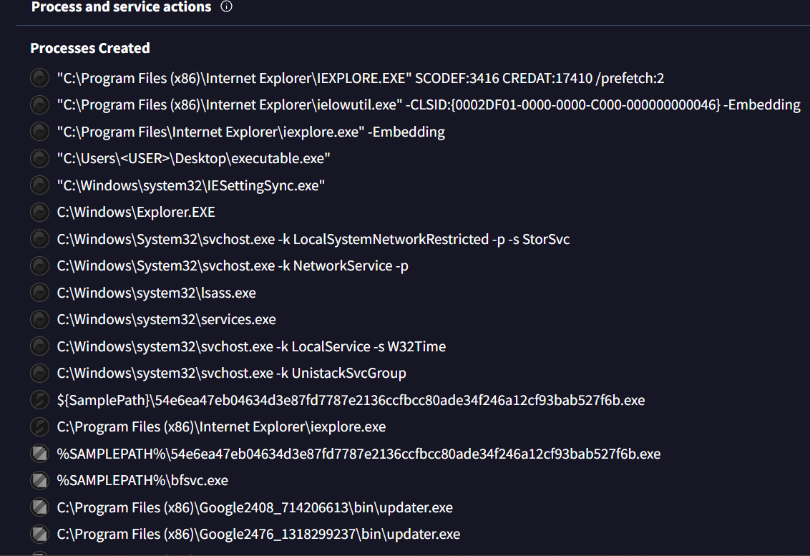  These are some of the IOC’s that I have identified as RISK factors and need further investigation to reduce the overall damage to company system.

Date:  06/18/2026 | Entry:  #2
Description | A ransomware attack happened on a U.S health clinic using a phishing email.
Tool(s) used | Tools like Hashcat, John the Ripper, TCH Hydra was used to create a phishing email with a link that executes malicious codes when clicked.
The 5 W's | - A group of unethical attackers initiated the Attack.  - The attackers targeted employee emails and sent them a link that downloaded a malware and encrypted all their sensitive files.  - The incident occurred on a Tuesday morning, at approximately 9:00 a.m.  - The incident happened on a small U.S. health care clinic specializing in delivering primary-care services.  - The attacker group was known to attack target organizations in healthcare and transportation industries. In exchange for restoring access to the encrypted files. Their motive was to gain money be blackmailing the organization.
Additional notes | The attackers used social-engineering phishing tactics to trick the employees into clicking their fake email link to download the malware onto their system.

Date:  July 29, 2026 | Entry:  #3
Description | A Phishing email incident occurred in an organization when an HR employee opened a suspicious mail attachment. The Security System Flagged the Alert as MEDIUM severity.
Tool(s) used | None.
The 5 W's | - An email from a suspicious sender named Def Communications caused the incident.  - An HR employee within the organization opened a suspicious attachment from an unverified user. The attachment contained a malicious file that executed a lot of processes the moment it got opened on the system.  - The incident occurred at July 20, 2022 09:30:14 AM.  - The incident happened on the HR department employee’s system.  - The lack of caution when opening any kind of attachments from an email is what caused the incident to happen.
Additional notes | From the analysis of the email the email is confirmed as a phishing email. Some indication of malicious was: -  - The sender information on the email says Def Communications and the email body sender name says Clyde West which does not match.  - The email has multiple grammatical errors in the subject part such as “ Subject: Re: Infrastructure Egnieer role And on the beginning part such as,  Dear HR at Ingergy.”  This confirms that the email is a phishing email.  Upon further analysis of the hash of attachment file on VIRUSTOTAL,  I discovered that the File is flagged as malicious by 52 security vendors. Upon execution of the file there was multiple network connection made to a single domain called “a.sinkhole.yourtrap.com”. Which is malicious flagged.  So, the alert needs to be Escalated and Further analyzed for investigation.

Date:  ‎March ‎14, ‎2026 | Entry:  #4
Description | The company faced a DOS attack where the attacker flooded the system with ICMP packets. This enabled the server to be offline for two hours. The network team blocked all the incoming ICM packets and closing all non-critical network ports.
Tool(s) used | None.
The 5 W's | - A group of attackers caused the incident.  - The attack was a ICMP flood attack. Mostly the organizations Network section was affected the most. Their whole network was not responding for two hours.  - The incident Occurred at March ‎14, ‎2026.  - It happened on company servers.  - Lack of proper NIDST tools implementation is why this happened.
Additional notes | The Security team has taken some measures like improving the firewall to prevent ICMP packets form overflowing and implemented IDS and IPS within the network to monitor unusual traffic. I think they should add “Network Segmentation” system so that if another DOS attack happens only some of the network will be affected not the whole network.  The team will need to block the affected network ports to quickly start the recover process.  There are Baseline Configuration Backups in place to quickly return the system back to normal.

Reflections/Notes:
- I have completed several incident response Reports.
- Summerized the causes, highlighted the problems.
- Gave proper solutions what controls can be put to reduce the problems, what frameworks and tools need to in place to prevent future events like these.
- Described if an alert needs to escalated or not for further analysis with effective proof.
- I learned how to manage incidents, how to respond to alerts, how to find proof of event, Manage Alert logs.
- I enjoyed working with Tools like Suricata, Wireshark to monitor network traffics and used Virus total to for concreate evidence on intrusion.
- I loved controls like IDS, IPS, Firewall, Network Segmentation, Least Privilege, Multi-Factor Authorization. I find these controls interesting.

