AudiologyTesting

Table of Contents

Opening the program 2

Menu options 3

New Patient 3

New Test 3

Calibration 3

Report 3

CNC test 4

Setup 4

Test Orientation 5

Selecting Phonemes 6

Finishing a test 8

AzBio Test 9

Setup 9

Test Orientation 10

Selecting Words 11

Finishing a test 13

Reporting 14

Plot Results 14

Export to Tables 15

# Opening the program

You must play the calibration tone before you are able to start a new test.

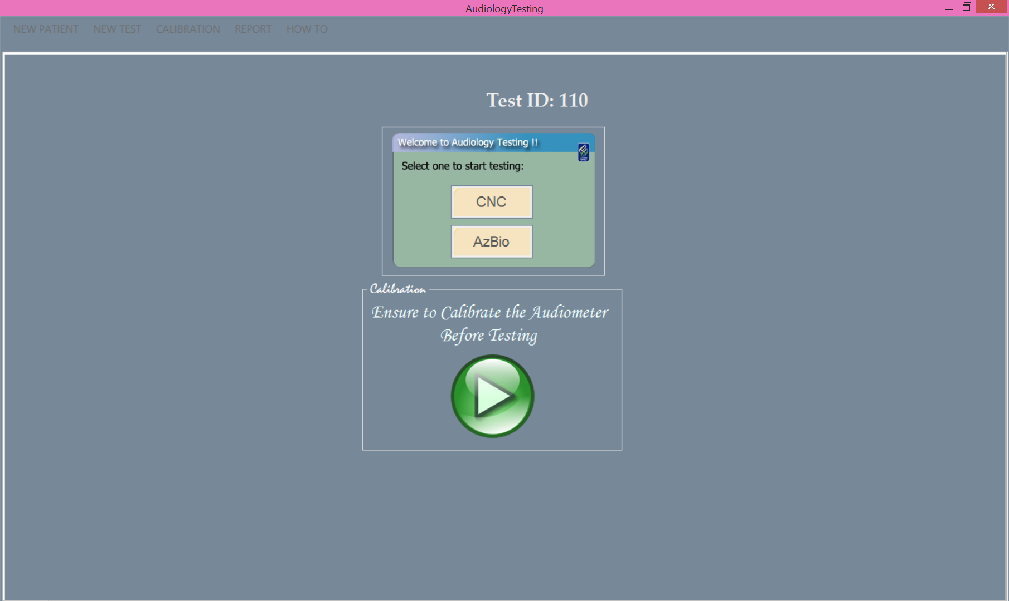

Once calibration tone is played then all of the menu options are unlocked

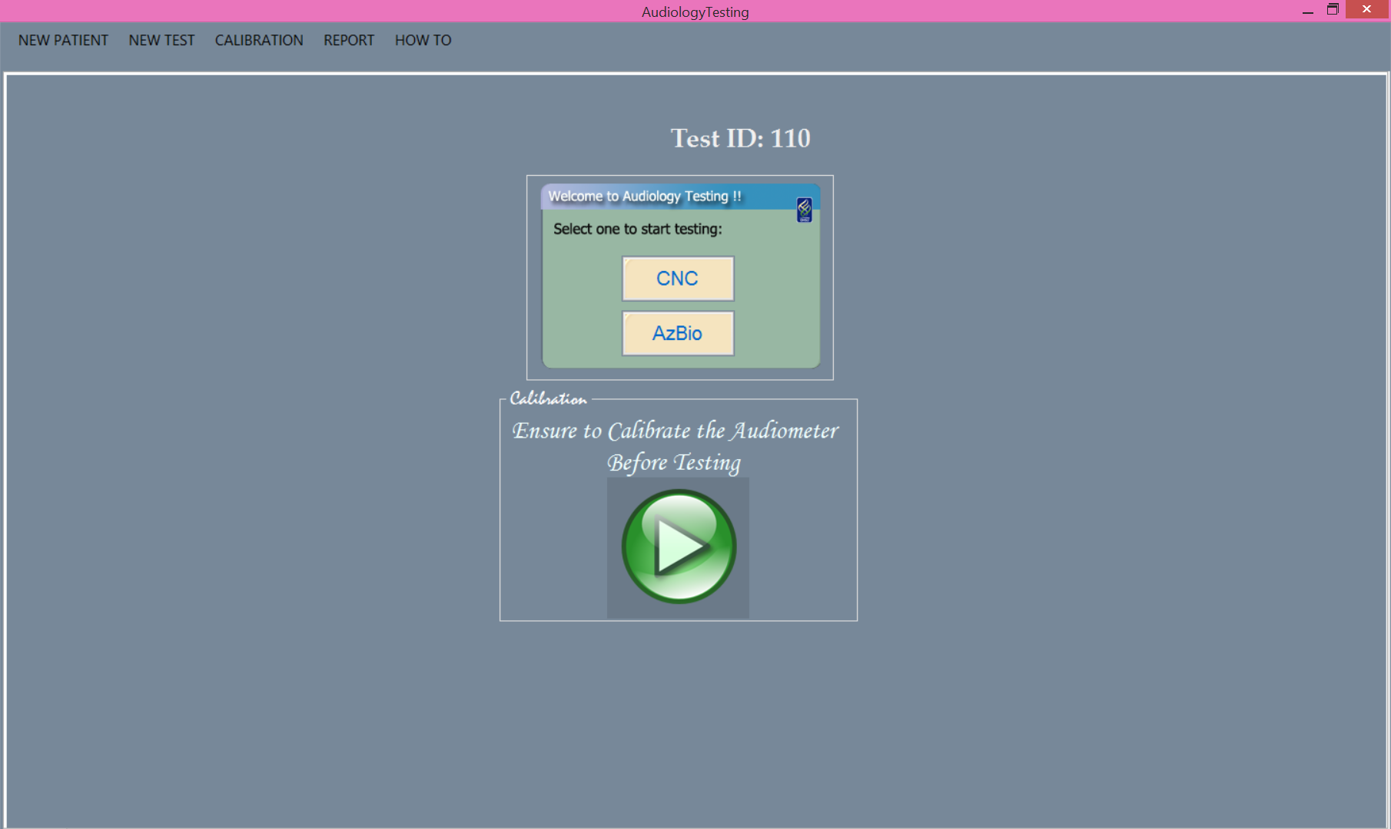

# Menu options

New Patient

Selecting New Patient clears the current report tables

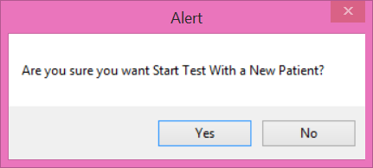

New Test

New Test allows you to select either a CNC or AzBio test from a drop down menu

Calibration

Calibration allows you to play the calibration tone again

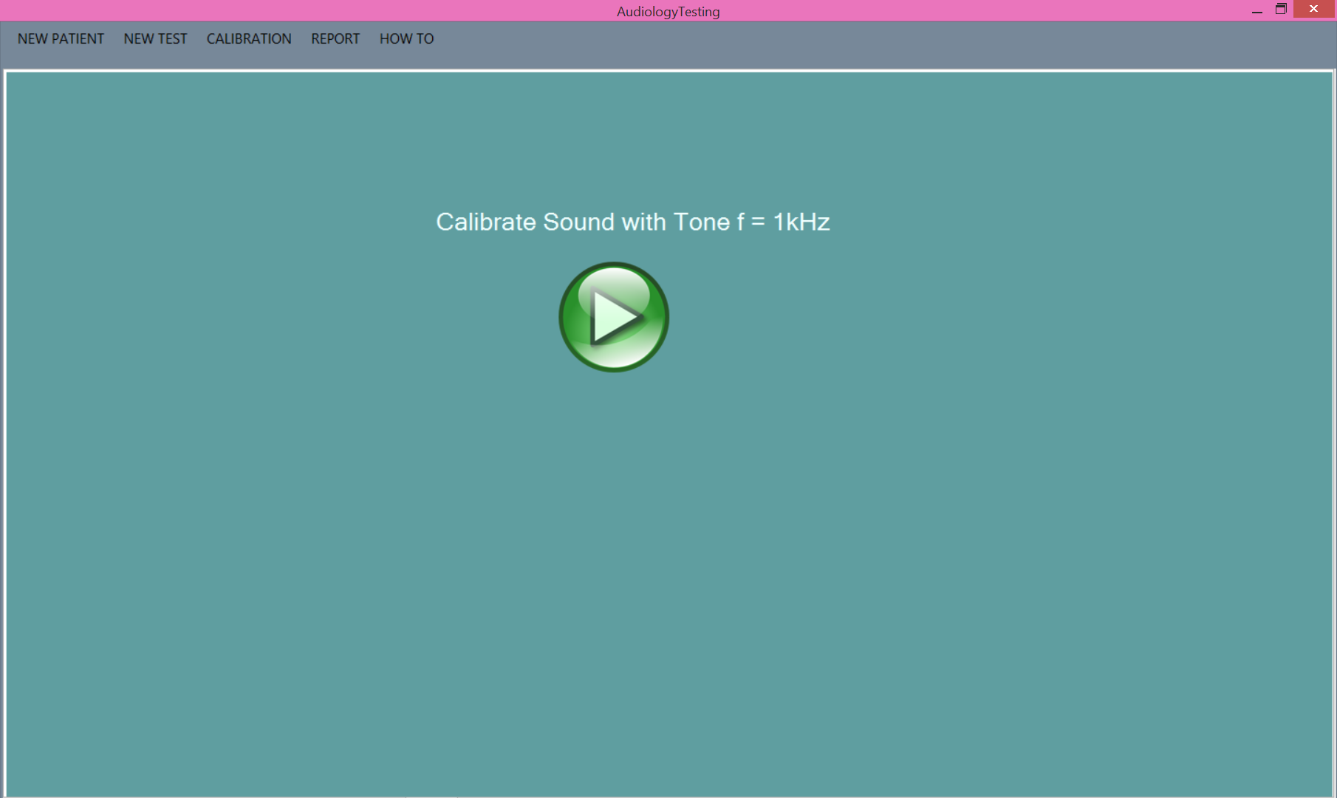

Report

Clicking on the report shows a list of the current tests that have been preformed

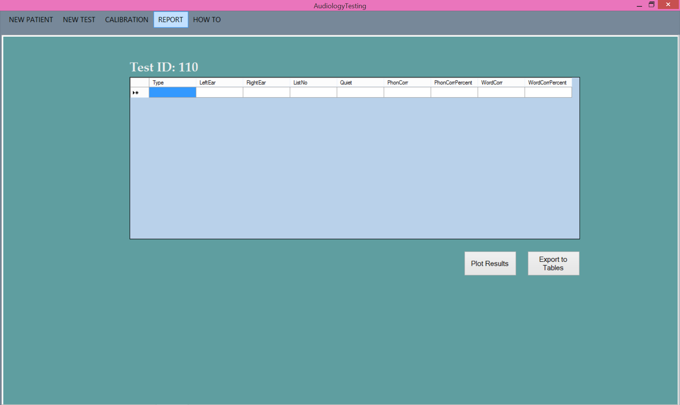

# CNC test

## Setup

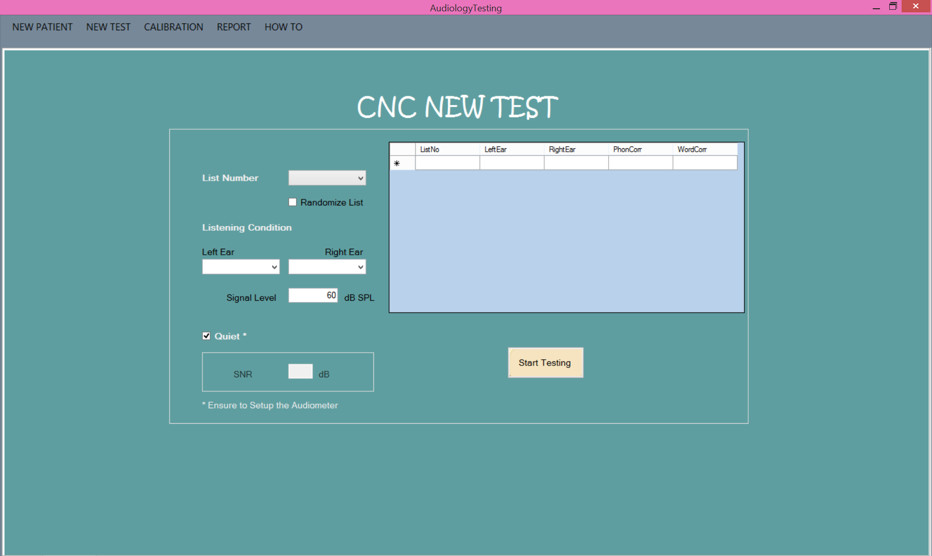

**List Number:** This is a drop down menu that selects from list 1 to list 10. The **Randomize List** box will take the list you select and randomize the order of the list. As you preform tests the lists that show up in the box to the right will be removed as a list option until a new patient is selected.

**Listening Condition:** This is a drop down list for both the left and right ear.

**Signal Level:** By default the signal level is 60 dB SPL. If the test is conducted with a different signal level then the user types in the desired numerical number for dB.

**Quiet:** It is assumed for this test the condition is Quiet. If there is a SNR uncheck the box and enter the desired numerical number for dB.

The table to the right will populate with data as you proceed to conduct more than one CNC test with a patient.

**Start Testing:** Click on this button when all the options have been assigned. Failure to select list number and both left and right ear listening conditions will prevent you from starting a test.

If you accidentally selected CNC instead of AzBio click on the menu option **New Test** at the top and select AzBio.

## Test Orientation

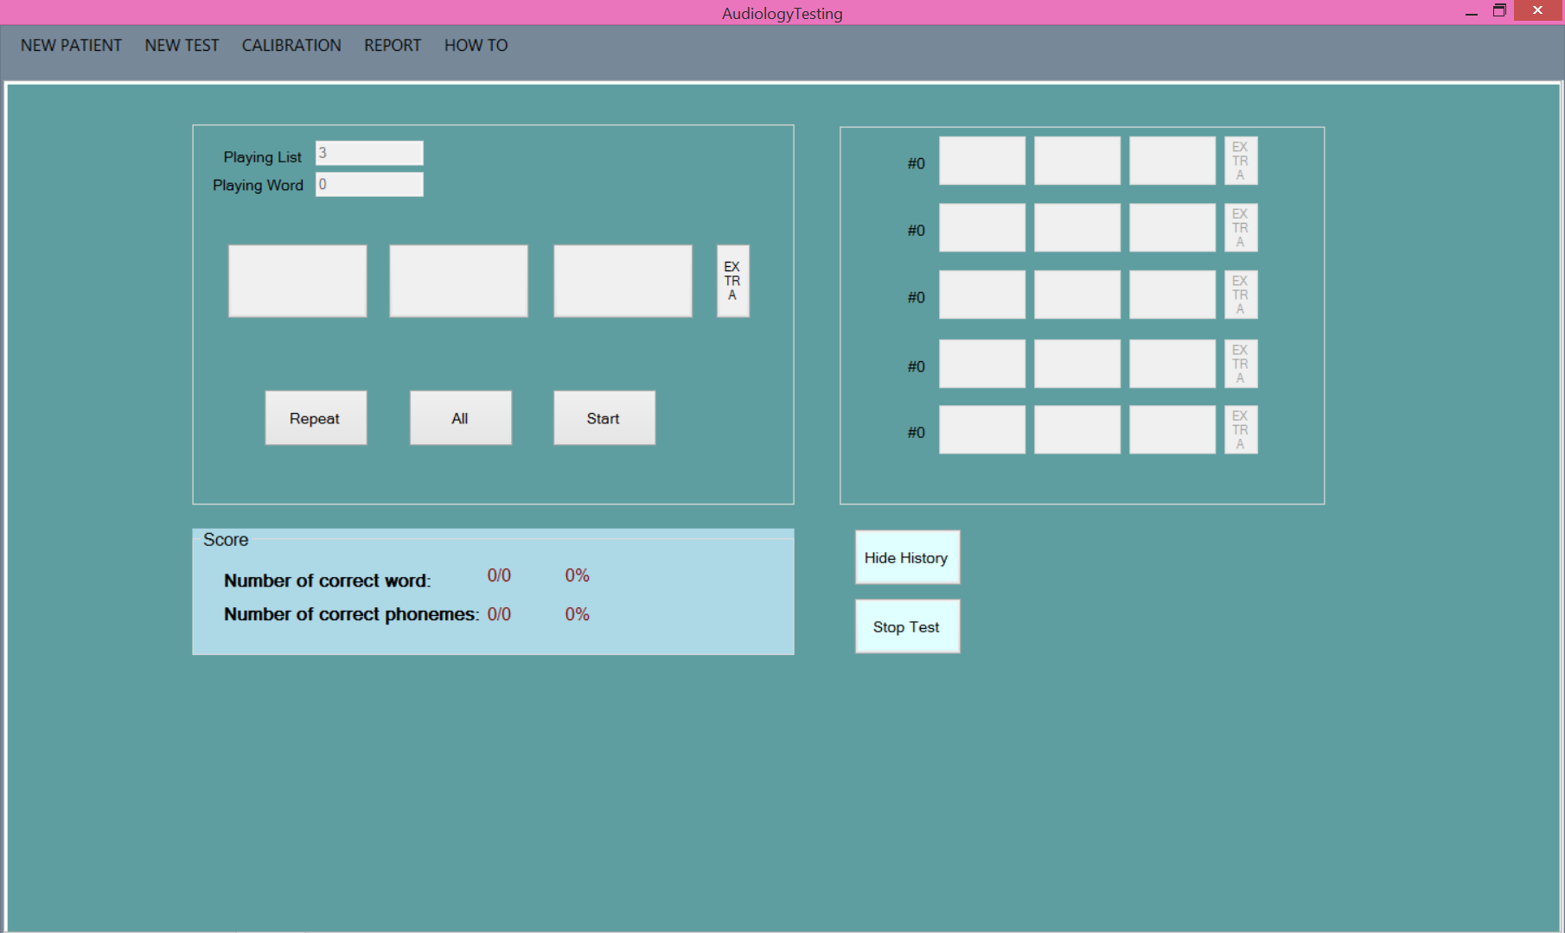

To orientate yourself with this screen note the following. **Playing List** tells you which list you selected. **Playing Word** will increment as each new word is played. Neither of these fields can be modified.

Below these numbers are three buttons that represent the 3 phonemes for the word that will be played. To the direct right of the phonemes buttons is the extra button. This button is for when an additional phoneme is said by the patient which will record the word as wrong even if all three phonemes were annunciated correctly. (Example: cats when word was cat. All three phonemes were correct however the s introduced an extra phoneme making the word wrong.)

Below the phoneme buttons is **Repeat** which replays the word and records the word was replayed. **All** will select all phoneme buttons above. If you select **All** for a second time the buttons will deselect. During the test **Start** will say **Next** indicating you are ready to commit your selected phonemes and move on to the next word.

In the light blue box is the **Score**. This will update as the test progresses showing you the real time results of the correct words and the correct phonemes.

The right side of the testing screen is for **History**. This will populate as the test progresses as well. You will see the word move from the left side to the right. When it moves it will retain your selected phonemes. If you need to correct the phonemes in **History** simply click on the one you wish to correct and it will ask for confirmation before selecting/deselecting the desired phoneme. **Hide History** will make it such that you do not see the history of the list as it progresses. This will also change the name of the button to **Show History**. To see the history again click on this button.

**Stop Test** will terminate the test early retaining the **Score** as it is shown.

To play the first word click Start. You will hear “Ready …” and the first word.

## Selecting Phonemes

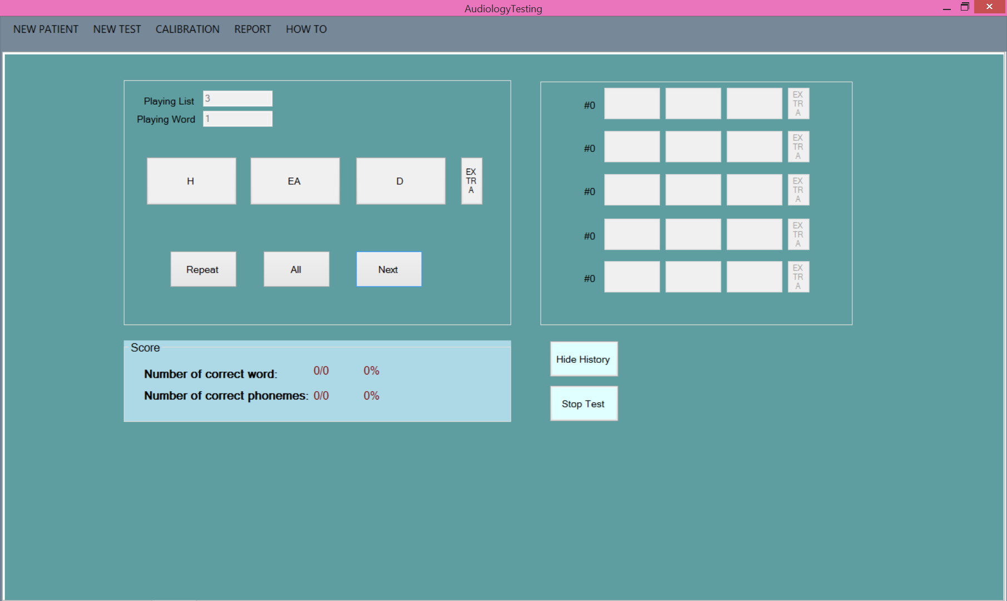

The first word will populate the three boxes designated for each phoneme.

From here you can choose to click on each box separately or select All. Doing so changes the color of the box to indicate the phoneme was correct.

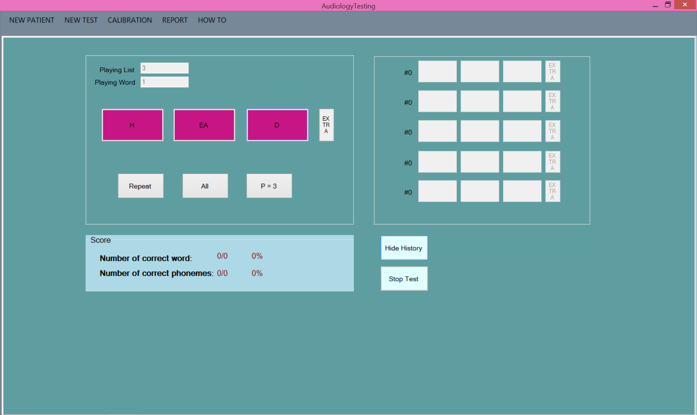

When satisfied with the result click on P=X (either 0,1,2,3) in order to proceed to the next word.

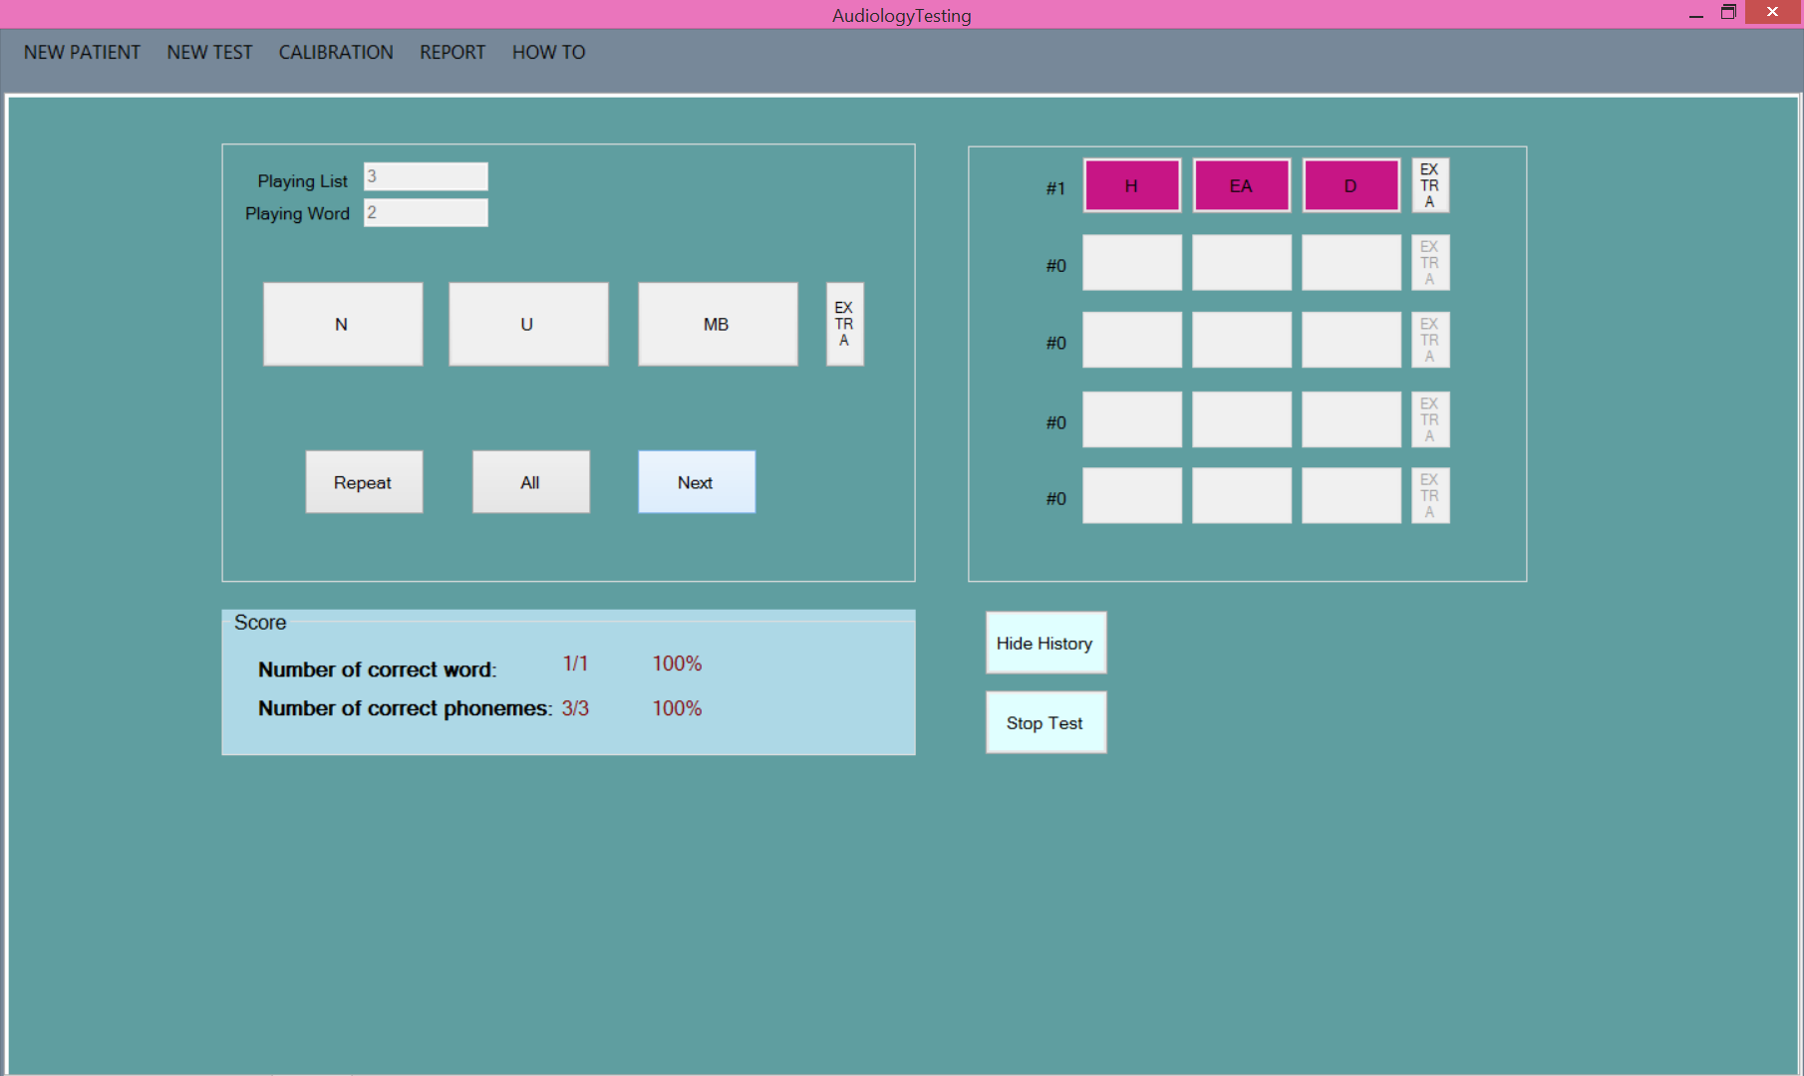

Note that Head moved to **History** retaining the selection of all. Now you can make the selection for word two. Also note that **Score** has incremented -/1 words and -/3 phonemes. This will continue as each word is added.

To make a change to a **History** word click on the button you wish to select/deselect and a warning will pop up to confirm your choice. This allows you to cancel if clicked in error.

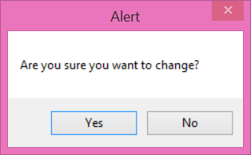

Note the phoneme is now deselected. This can always be changed back if corrected in error.

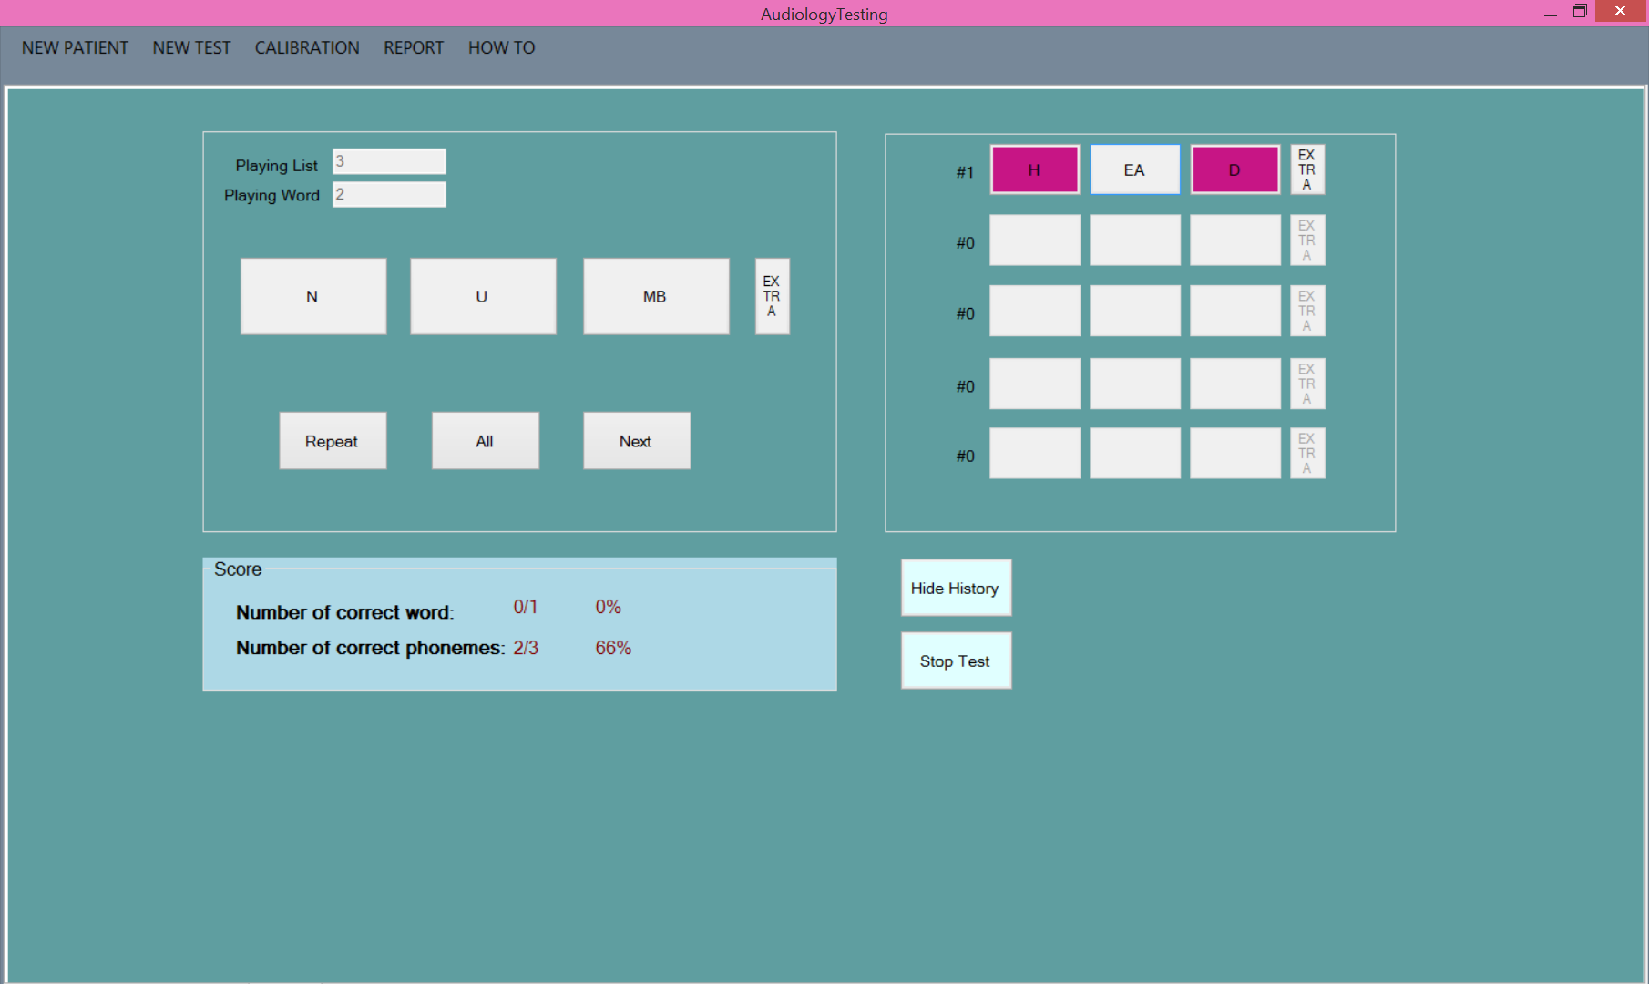

## Finishing a test

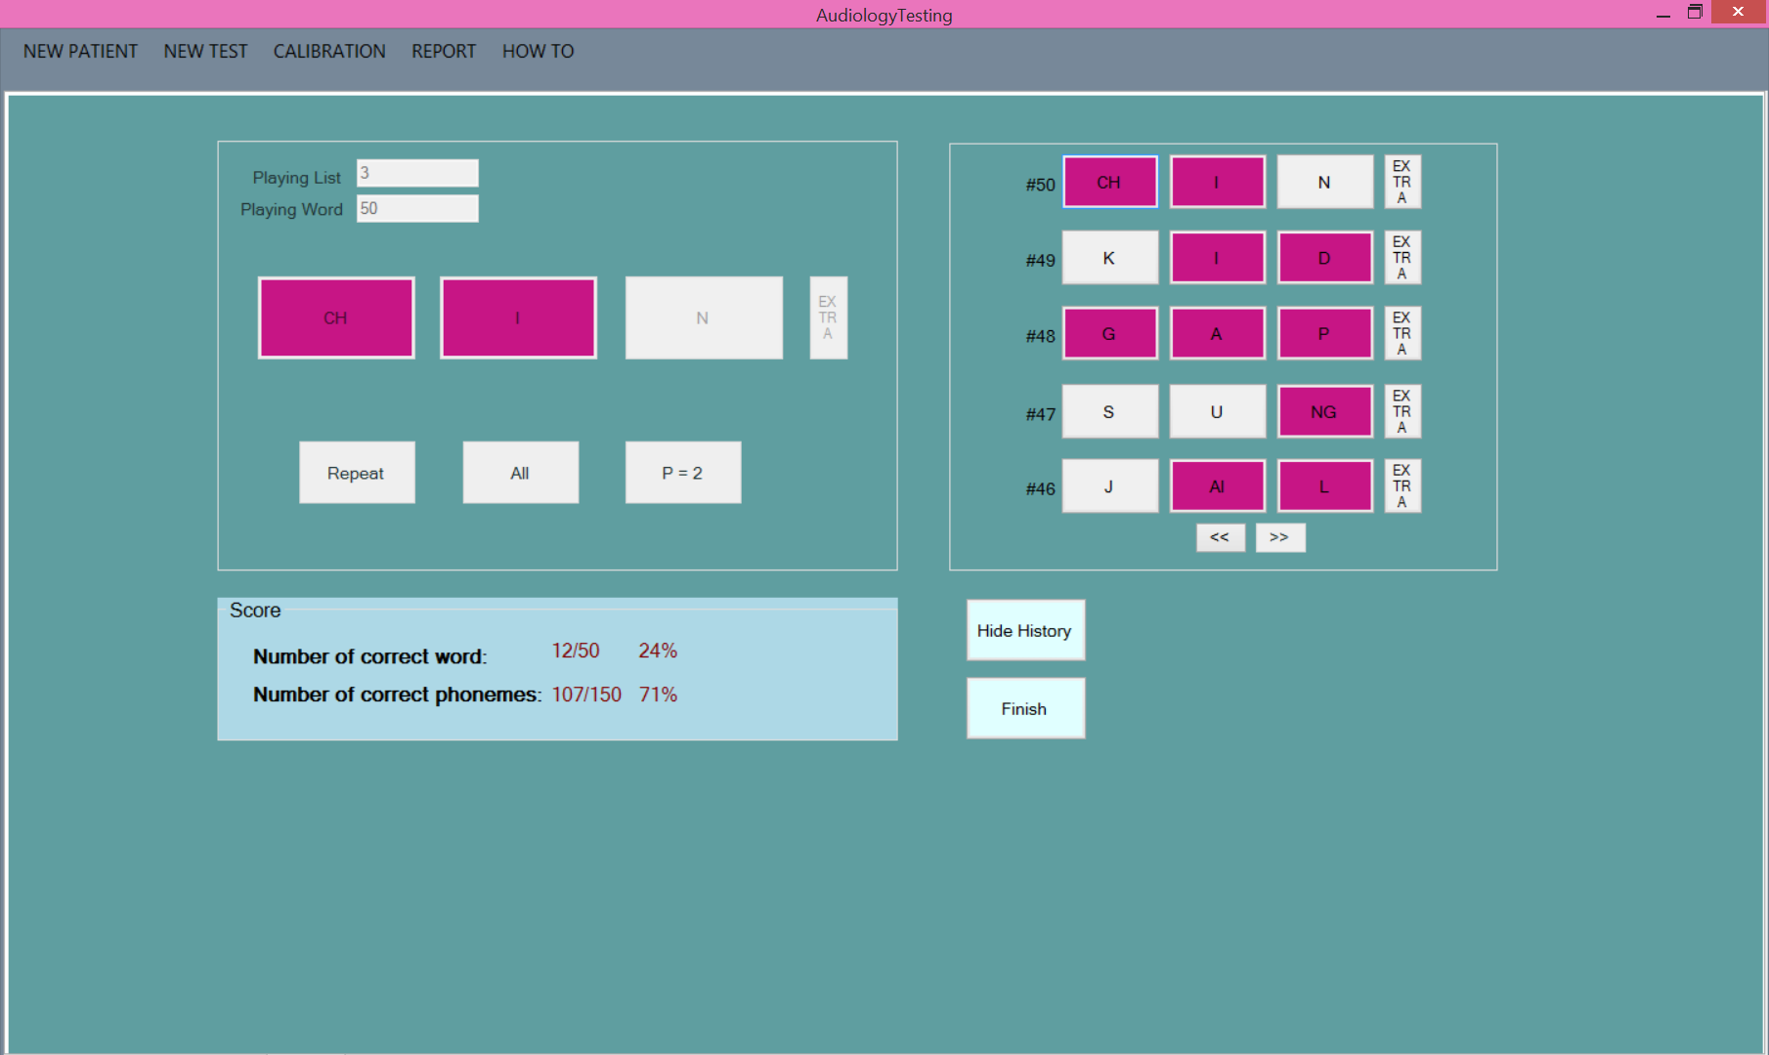

You need to click on P=X before finishing the test to ensure that all 50 words are committed to the list. Note once you do so the **Stop Test** changes to **Finish**. Also note that in History although it only shows the last five words you now have arrow boxes to scroll through the screens if necessary to access an earlier word.

Upon committing to finish the test it takes you back to the home screen.

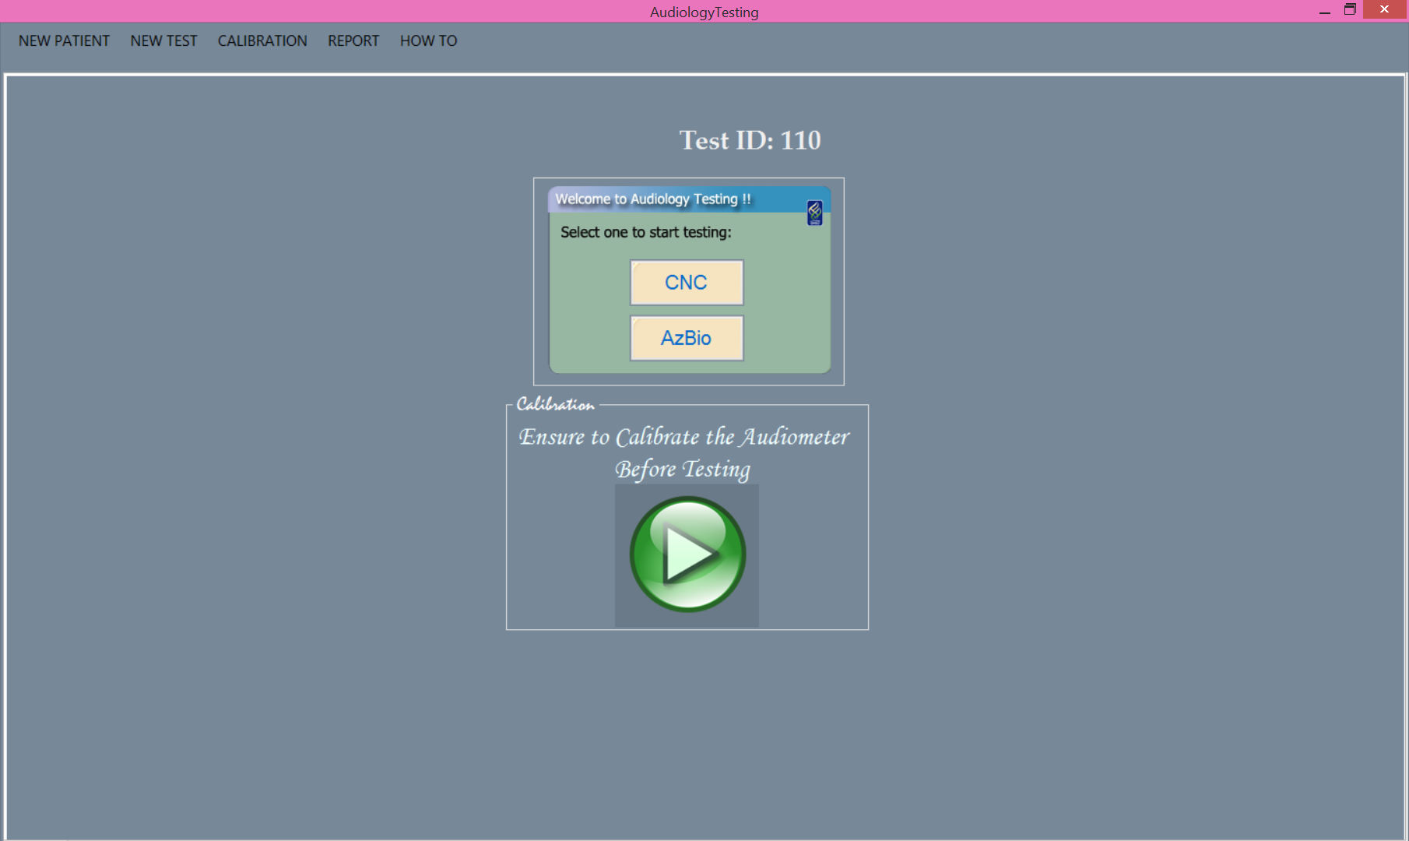

# AzBio Test

## Setup

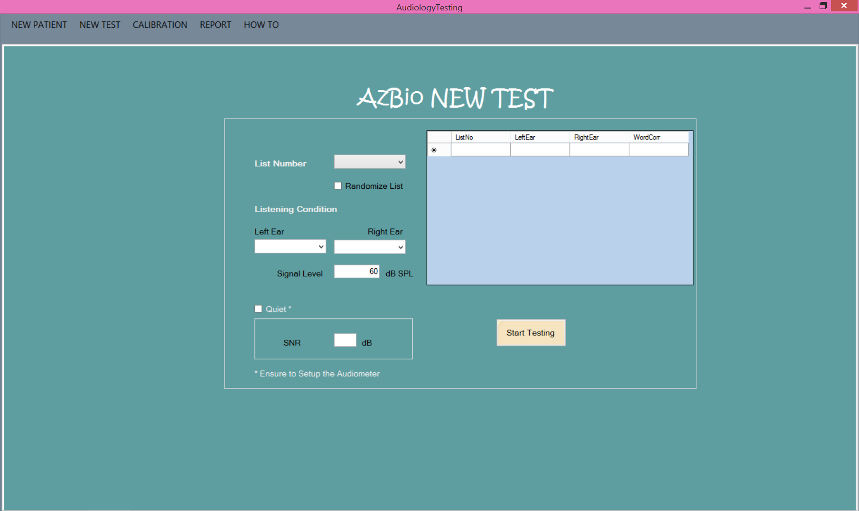

**List Number:** This is a drop down menu that selects from list 1 to list 15. The **Randomize List** box will take the list you select and randomize the order of the list. As you preform tests the lists that show up in the box to the right will be removed as a list option until a new patient is selected.

**Listening Condition:** This is a drop down list for both the left and right ear.

**Signal Level:** By default the signal level is 60 dB SPL. If the test is conducted with a different signal level then the user types in the desired numerical number for dB.

**Quiet:** It is assumed for this test the condition is not quiet. Enter the desired SNR numerical number for dB. If there is zero SNR then **Quiet** can be checked indicating no additional noise.

The table to the right will populate with data as you proceed to conduct more than one AzBio test with a patient.

**Start Testing:** Click on this button when all the options have been assigned. Failure to select list number and both left and right ear listening conditions will prevent you from starting a test.

If you accidentally selected AzBio instead of CNC click on the menu option **New Test** at the top and select CNC.

## Test Orientation

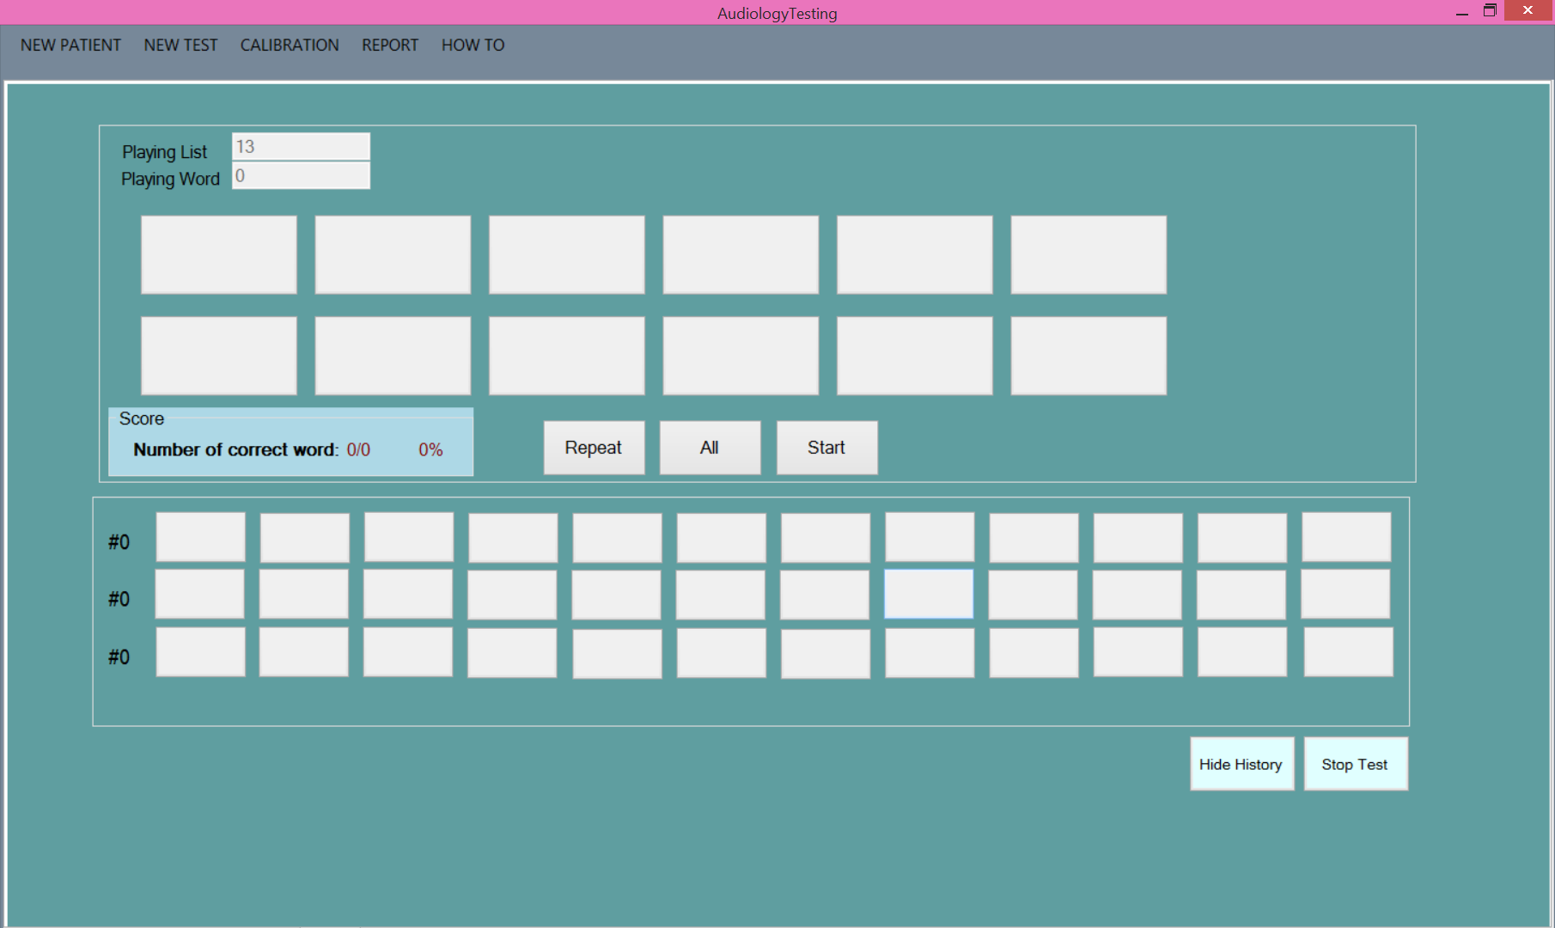

To orientate yourself with this screen note the following. **Playing List** tells you which list you selected. **Playing Word** will increment as each new word is played. Neither of these fields can be modified.

Below these numbers are twelve buttons that represent the maximum number of words played in any given sentence. You will only be able to select/deselect a button if a word is present on the button.

Below the word buttons is **Repeat** which replays the word and records the word was replayed. **All** will select all word buttons above. If you select **All** for a second time the buttons will deselect. During the test **Start** will say **Next** indicating you are ready to commit your selected phonemes and move on to the next word.

In the light blue box is the **Score**. This will update as the test progresses showing you the real time results of the correct words and the correct phonemes.

Below the word buttons is the **History**. This will populate as the test progresses as well. You will see the word move from the top to the bottom. When it moves it will retain your selected words. If you need to correct a word in **History** simply click on the one you wish to correct and it will ask for confirmation before selecting/deselecting the desired word. **Hide History** will make it such that you do not see the history of the list as it progresses. This will also change the name of the button to **Show History**. To see the history again click on this button.

**Stop Test** will terminate the test early retaining the **Score** as it is shown.

To play the first word click Start. You will hear “Ready …” and the first sentence.

## Selecting Words

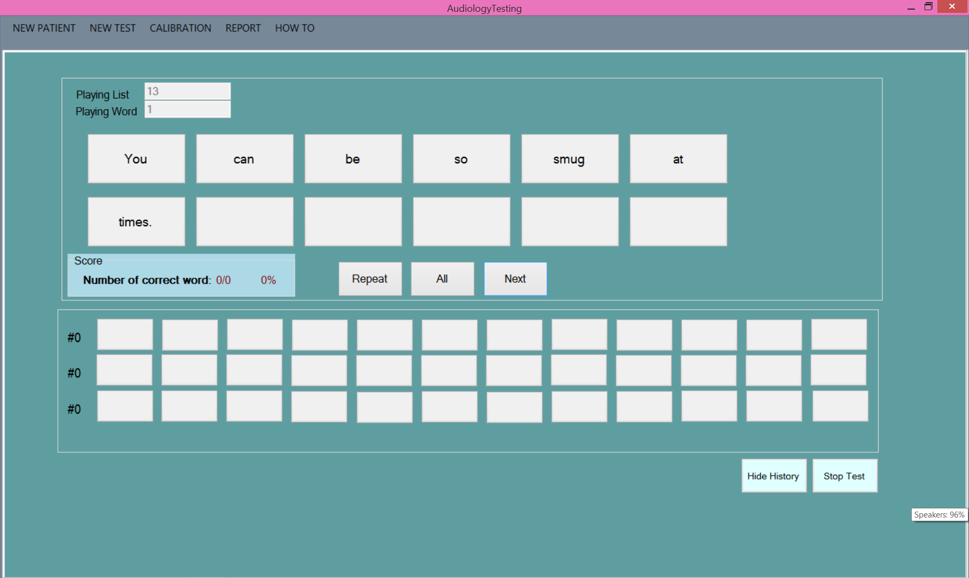

The first sentence will populate the potential twelve boxes designated for each word.

From here you can choose to click on each box separately or select All. Doing so changes the color of the box to indicate the word was correct.

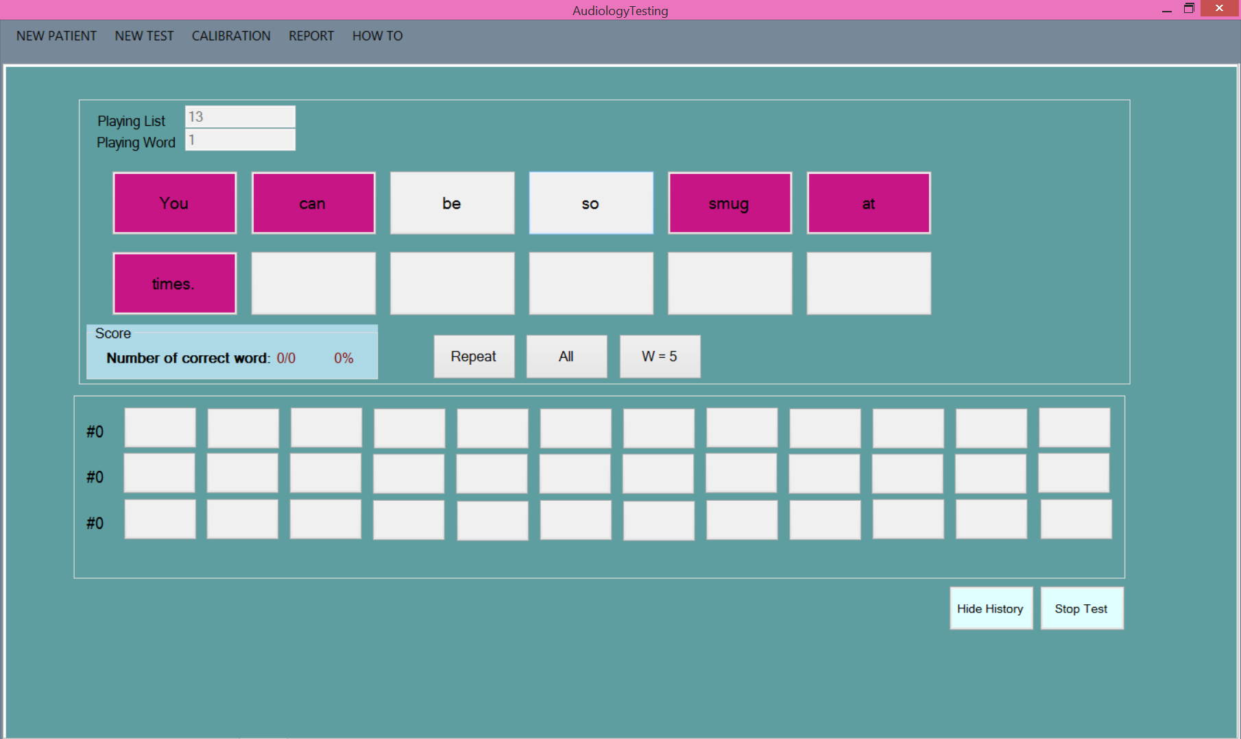

When satisfied with the result click on W=X (0,1,2…12) in order to proceed to the next word.

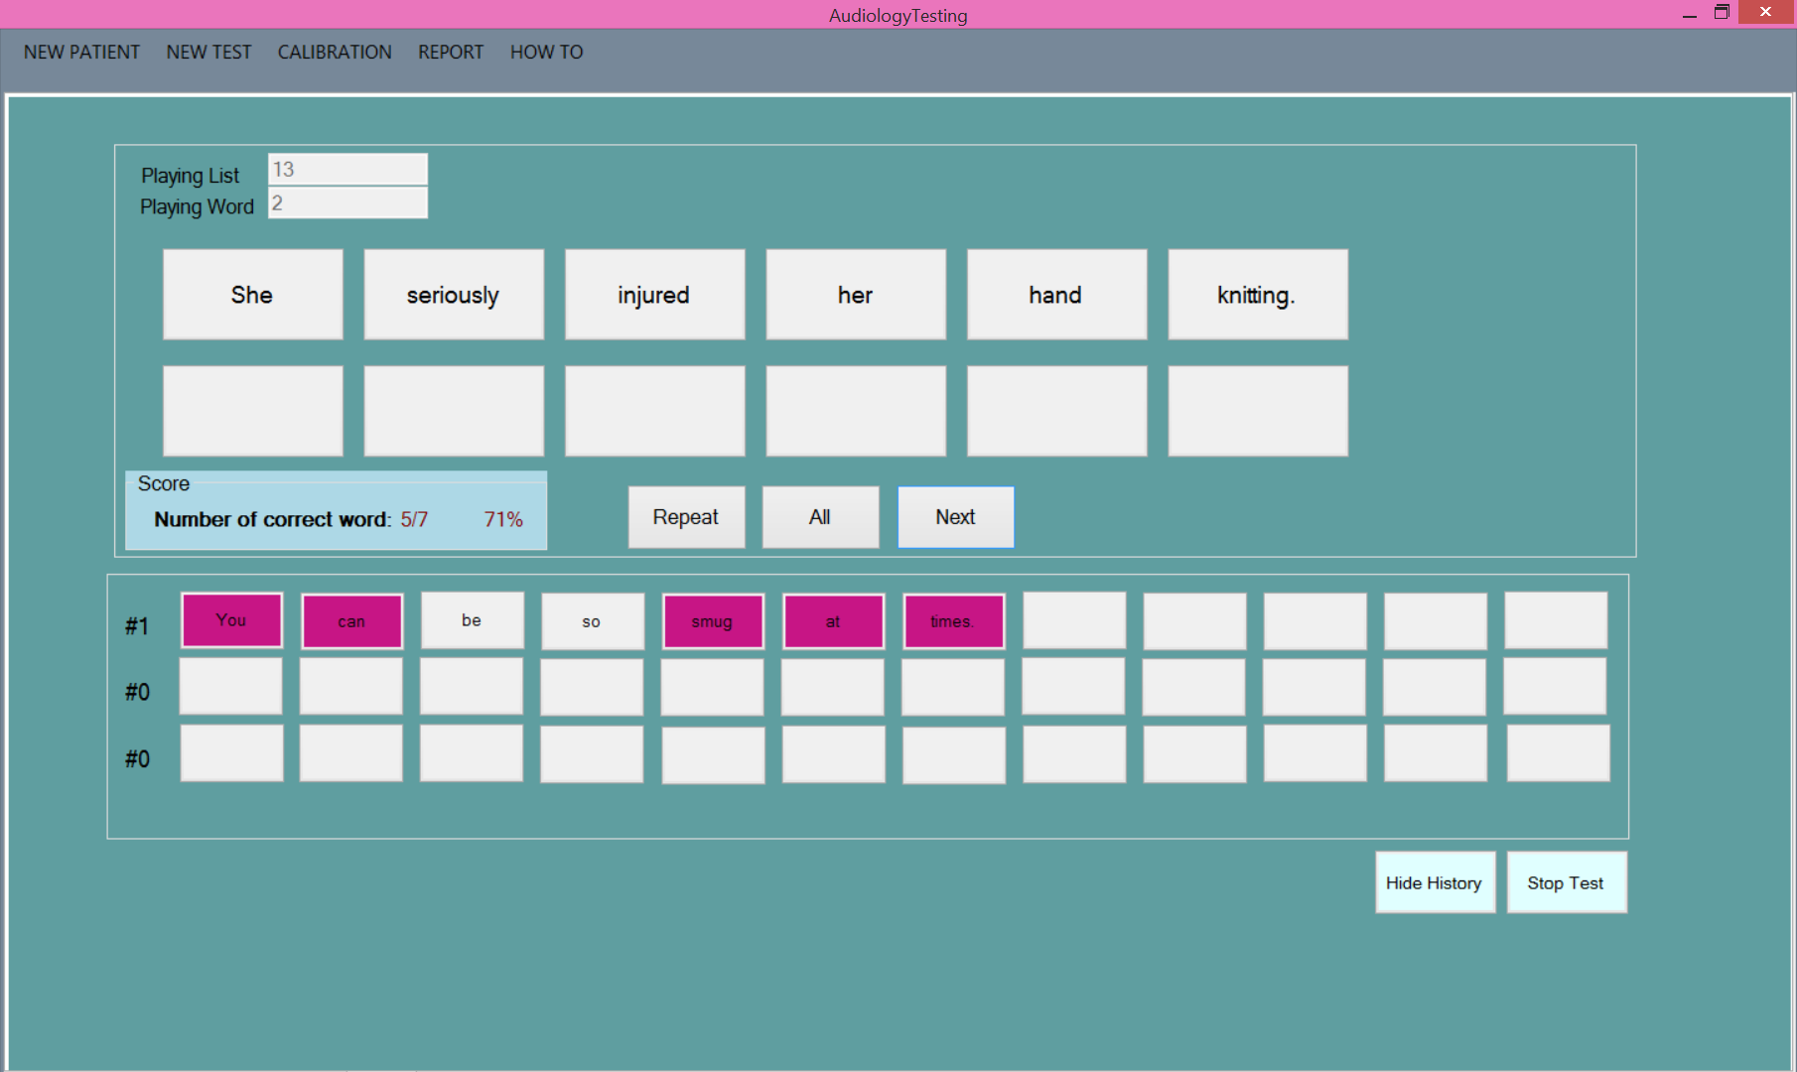

Note that the previous sentence moved to **History** retaining the selection. Now you can make the selection for sentence two. Also note that **Score** has incremented the number of words per the previous sentence. Since each sentence has a different length of words this **Score** will not increment with consistency like the CNC test does. This will continue as each word is added.

To make a change to a **History** word click on the button you wish to select/deselect and a warning will pop up to confirm your choice. This allows you to cancel if clicked in error.



Note the word is now deselected. This can always be changed back if corrected in error.

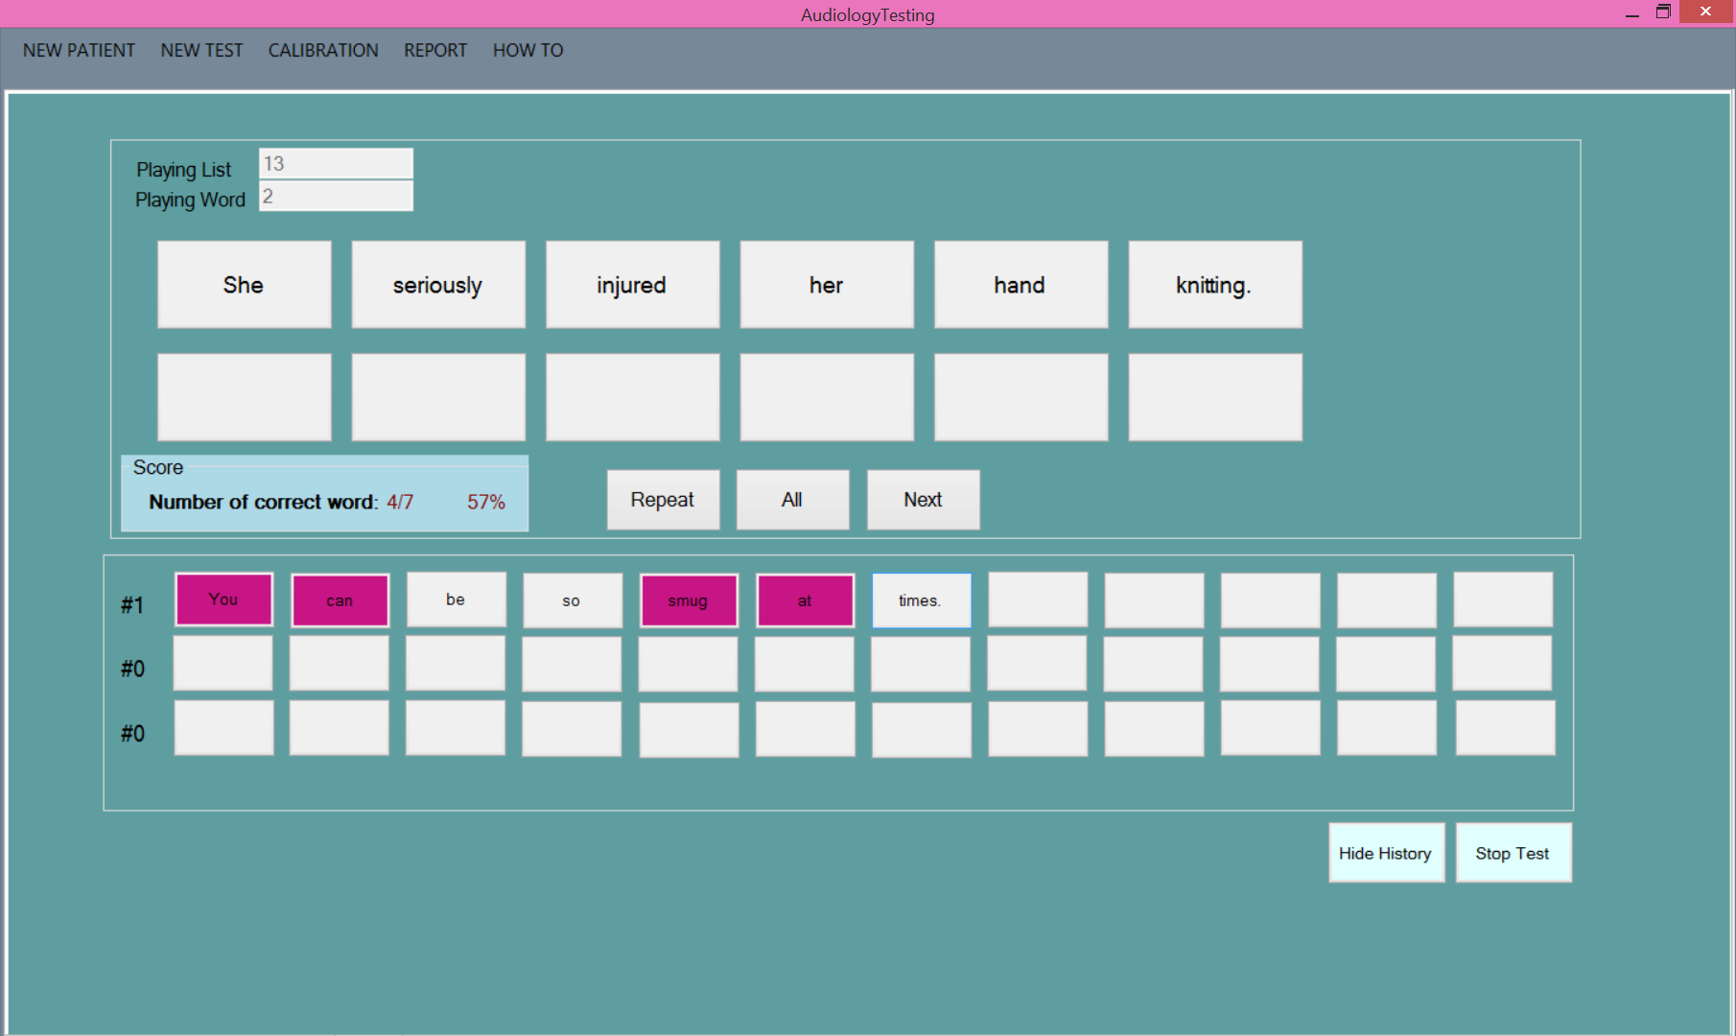

## Finishing a test

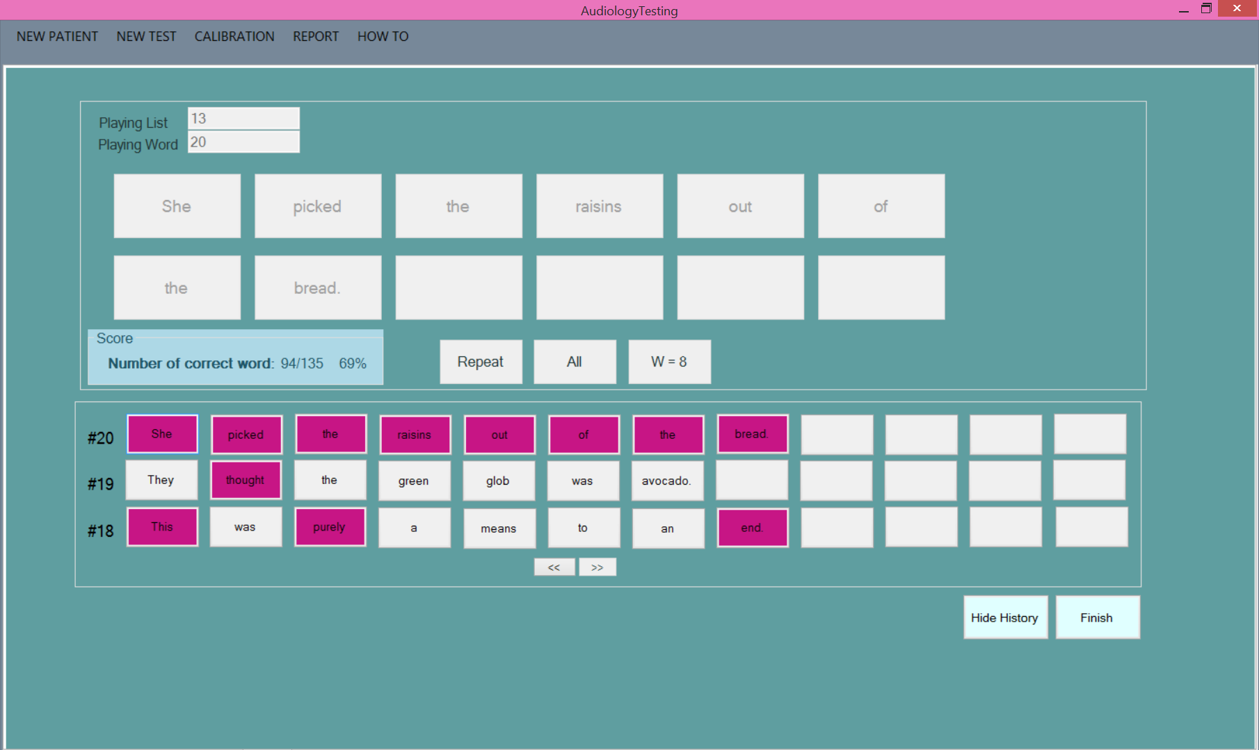

You need to click on W=X before finishing the test to ensure that all 20 sentences are committed to the list. Note once you do so the **Stop Test** changes to **Finish**. Also note that in History although it only shows the last three sentences, you now have arrow boxes to scroll through the screens if necessary to access an earlier word.

Upon committing to finish the test it takes you back to the home screen.

# Reporting

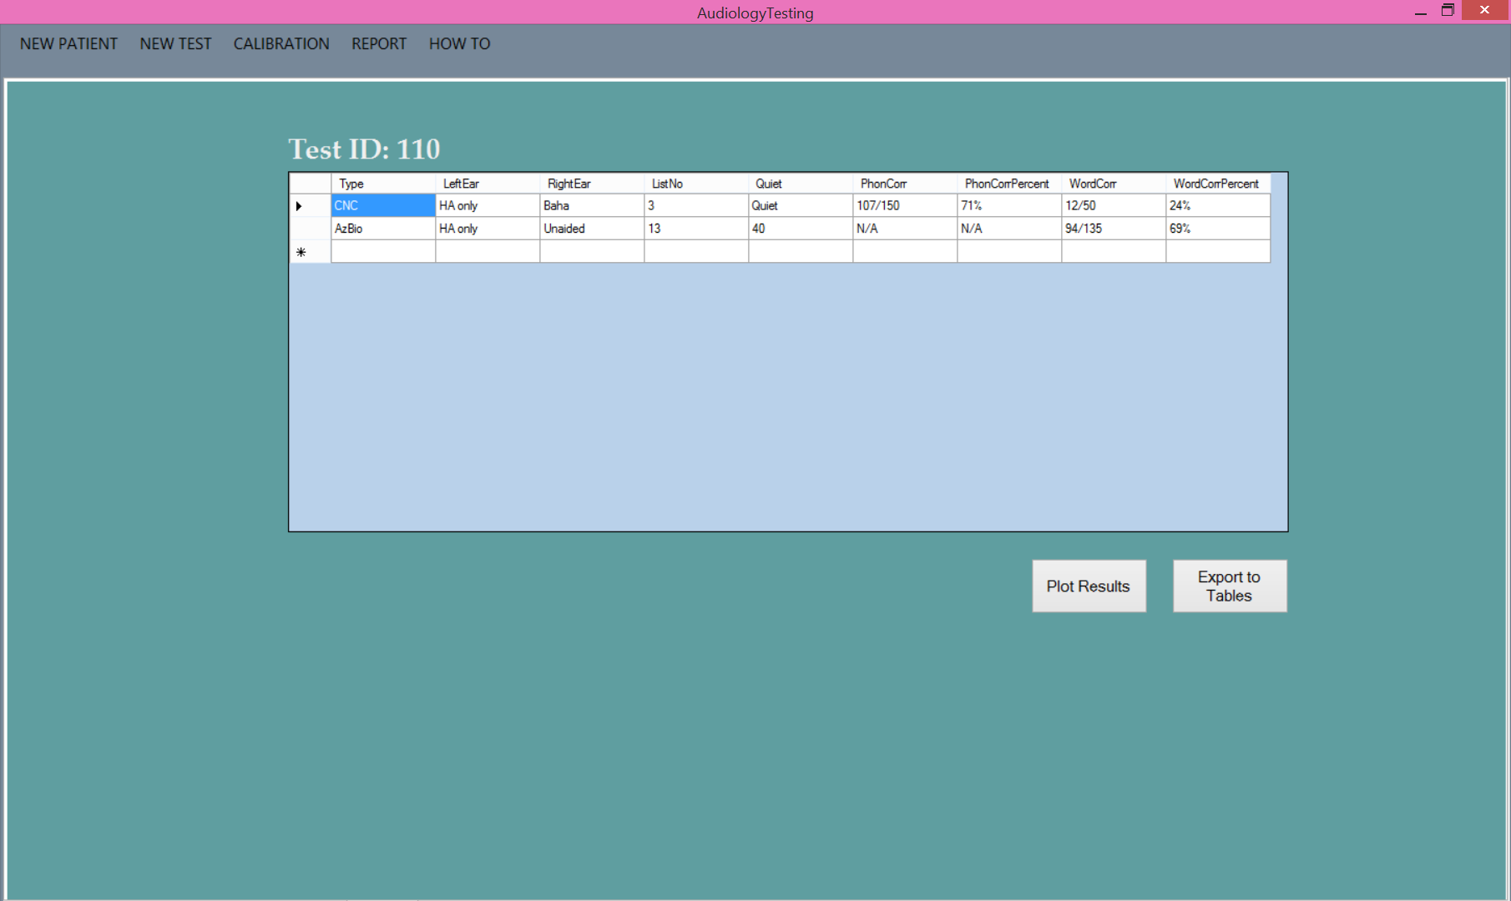

Once you have completed testing for a patient you can now look at the results. Click on the **Report** menu at the top. From here you can **Plot Results** or **Export to Tables**.

When you are done with a patient to clear these records click on **New Patient**.

## Plot Results

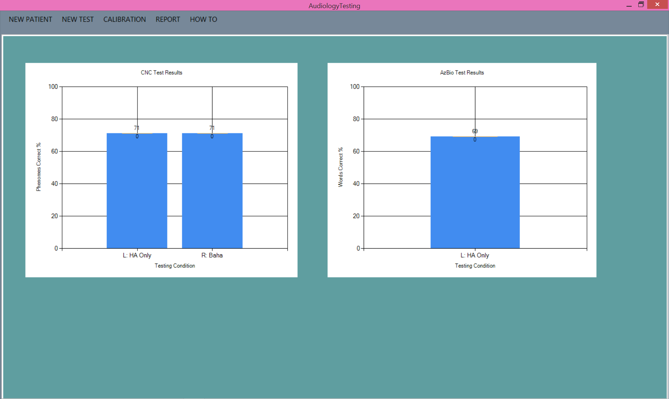

Plotting results will group the test by type and listening condition. CNC plots based on phonemes correct where AzBio plots based on words correct. The more tests that are preformed the more graphs will appear. In order to go back to the **Report** main screen click on **Report** on the top.

## Export to Tables

This feature creates a word file that is to be put into EPIC.

AzBio Results Table

|  |  |  |  |  |  |
| --- | --- | --- | --- | --- | --- |
| **Left Ear** | **Right Ear** | **List No.** | **S/N** | **Word score** | **Word % correct** |
| HA only | Unaided | 13 | 40 | 94/135 | 69% |

CNC Results Table

|  |  |  |  |  |  |  |  |
| --- | --- | --- | --- | --- | --- | --- | --- |
| **Left Ear** | **Right Ear** | **List No.** | **S/N** | **Phoneme Score** | **Phoneme % correct** | **Word score** | **Word % correct** |
| HA only | Baha | 3 | Quiet | 107/150 | 71% | 12/50 | 24% |