Electronic speech testing system for audiology
Requirements Documentation
Version 1.0
2/14/2014

LesliE Eide
Nauvin Ghorashian
Chris Klupenger
han le
Ngan Nguyen

VERSION HISTORY
Version  # | Implemented  By | Revision  Date | Approved  By | Approval  Date | Reason
1.0 | Leslie Eide | 2/14/14 | Nauvin Ghorashian  Chris Klupenger  Han Le  Ngan Nguven |  | Initial Design Definition draft

NOTE TO READER
This is a PDS template obtained from:
http://www2.cdc.gov/cdcup/library/templates/default.htm
Template Name: Product Design
UP Template Version: 12/31/07
TABLE OF CONTENTS
1 Introduction 5
1.1 Needs Identification 5
2 General Overview and Design Guidelines/Approach 5
2.1 Assumptions / Constraints / Standards 5
2.2 Approach 5
2.3 Major Features 5
2.3.1 User 5
2.3.2 Patient Record 6
2.3.3 Testing Parameters 6
2.3.4 Analysis 7
2.3.5 Performance 8
3 Architecture Design 8
3.1 Software Architecture 8
3.1.1 Patient Record 8
3.1.2 User 8
3.1.3 Group 8
3.1.4 Testing Parameters 8
3.1.5 CNC Test 9
3.1.6 AzBio Test 9
3.1.7 Analysis 9
3.2 Performance 10
Product Design Specification Approval 11

Introduction

Needs Identification
This document will be used for all specifications of the audiology assisting testing software in development. It will attempt to provide the readers as well as the engineering design team with the basis with which to develop the final product.

General Overview and Design Guidelines/Approach

Assumptions / Constraints / Standards
This project is to fulfill a request from Lina Reiss, Ph. D., for electronic speech testing system for audiology. This system will replace what is currently being used in the Department of Otolaryngology/Audiology and Oregon Hearing Research Center Oregon Health & Science University. It will be a computer program that will record the responses of patients of two different potential tests (CNC test and AzBio test), replacing pen and paper analysis.

Approach
To satisfy design requirements, a computer program will be structured with a user interface that can assist the test administrator streamline the process of two specific hearing tests; CNC word test and AzBio sentence test. The program starts with a user. After a user is logged in, they will choose a patient record, select test to administer and defined the test parameters. There are two different tests to select from; CNC and AzBio. The user will select which test is to be administrated, subsequently followed by selecting which list to be used. The user will then follow the on screen prompts as lined out below for each test. Basic steps include playing the word/sentence, recording the response, repeating if necessary, then moving on to the next word/sentence. At the conclusion of the test there will be a summary of the test results. This is the final chance the user has to modify the results before the execution of a file for integration. Results will be retained in the program for future analysis.

Major Features

User

Primary Features

Administrator

User (assigned to a group)

Secondary Features

Additional group with specified level of records

Patient Record

Primary Features

Patient first and last name

MRN

Date of Birth

Group association

Hearing Device

Cochlear Implant

Hearing Aid

Baha

Date of Device

Secondary Features

History of testing available prior to initiating new test

Testing Parameters

Primary Features: Setup

Selection of Patient via search or new record

Date of test populated from calendar

Name of tester populated from user login

Selection of test

CNC or AzBio

Selection of list number

Noise background

Signal Level

Default set to 60dB SPL

Listening condition

Selection of CI, CI+HA, HA only

Ear

Selection of right, left or both

Primary Features: Testing

Show list number

Show which word/sentence is currently showing

Selection phonemes/words

Individual phonemes/words

Select All/Deselect all

Repeat feature

Primary Features: Existing Records

Selection of Patient via search or new record

Select Test

Select List (if applicable)

Enter date

Enter total for test

Secondary Features

Randomize word/sentence within selected list

Ability to record the wrong word that was spoken via keyboard

Analysis of sound voice, manner, place on known CNC phonemes

Analysis

Primary Features: Test Results

Percentage Correct

Each word/sentence analysis

Allow for correction (data error) before submission and ending test

Selection of reports to print based on test administered

Primary Features: Search

Search by MRN

Search by Patient Name

Search by Group

Search by Range of Dates

Primary Features: Reporting

CNC: Comparison of testing input and creating standard deviation

CNC: Plot list vs time

AzBio: Plot over time vs testing input

Secondary Features

History over time by list

Display of noise background, signal level, listening condition and/or ear

Text file output

Ability to negate Patient information on Text file for research purposes

Potential Features Analysis

Performance

Primary Features

Program will run on Windows XP, 7 or 8

Runs external of additional software to purchase

Support multiple users

Encryption of file

Secondary Features

Supports congruent testing

Interfaces to EPIC

Offline mode capability

Architecture Design
This testing software will consist of a user, test setup, two tests (CNC and AzBio) and analysis. Each section is lined out in brief below.

Software Architecture

Patient Record
This patient record will include their name, medical record number (MRN), date of birth (DOB) and ear or device condition. The user ID will be used to track answers, which tests have been administered, and analysis for development over time. Patient records are assigned to a group.

User
There will be multiple Users for this software. The User will log into the software using their unique ID and password. A User is assigned a group for permission purposes. This group will allow the User access to each of the Patient Records within the software.

Group
A group is created based on criteria within the Patient Record. These groups are used by the User to give permissions to Patient Records.

Testing Parameters
After selection of the Patient Record, parameters for initial testing conditions are to be entered. Initial testing conditions include: choosing the type of speech test, which list is being used, date, signal-to-noise ratio, test administrator, listening condition and ear.

CNC Test
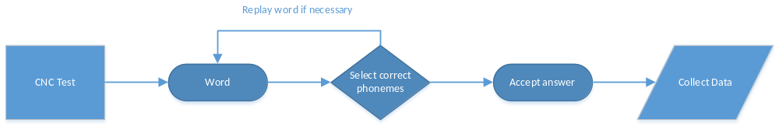
Figure 1 - Process flow of a CNC test
The CNC test consists of 50 words. Each word is broken up into phonemes for each word. During the test the administrator will select a CNC test. It will give the administrator the control to start the test and play the word to the user. There will be a repeat button if necessary, by clicking on that button the test will log that the word was replayed. Upon hearing the word and repeating what the user heard the administrator will click on the phonemes that were correctly articulated. The color of chosen phonemes will be changed to differ from others. By submitting the results of that word, the next word will be selected and prepared for testing.

AzBio Test
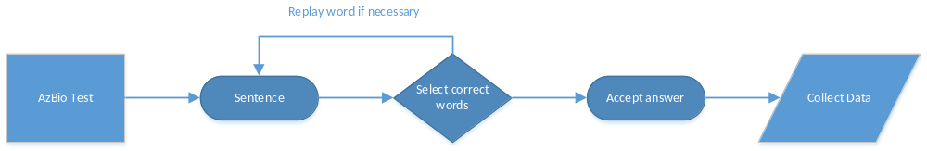Figure 2 - Process flow of a AzBio test
The AzBio test consists of 20 sentences. Each sentence is broken up to each word in the sentence. During the test the administrator will select an AzBio test. Based on a balanced list the computer will randomize the list order. It will give the administrator the control to start the test and play the sentence to the user. The program also allows the test administrator ability to control the Signal Noise Ratio (SNR) for the test. In addition, there will be a repeat button if necessary, by clicking on that button the test will log that the sentence was replayed. Upon hearing the words being repeated in the sentence the administrator will click on the words that were correctly articulated. The color of chosen words will be changed to differ from others. By submitting the results of that sentence, the next sentence will be selected and prepared for testing.

Analysis
Upon conclusion of the test the program will automatically calculate the percentage correct. An output of the test results will be available for the test administrator to correct any given answer prior to submitting the final results. The program potentially includes progression as users repeat testing and have the ability to display various statistical analysis. Analysis of historical data will be developed as a secondary feature. Data from the test will be saved in an encrypted ascii (text) file with the potential to be interfaced to EPIC.

Performance
This should be a robust program that does not crash in the middle of testing. It can support multiple users ideally on a PC with windows XP, 7 or 8. This program is to be used external of additional software (e.g. MATLAB) to save the clinic on cost. Having a networked database implies that testing must be conducted while the computer has access to the server. An offline mode will be developed as a secondary feature.

Product Design Specification Approval

Signature: |  | Date:
Print Name:
Title:
Role:

Signature: |  | Date:
Print Name:
Title:
Role:

Signature: |  | Date:
Print Name:
Title:
Role:

Signature: |  | Date:
Print Name:
Title:
Role:

Signature: |  | Date:
Print Name:
Title:
Role:

