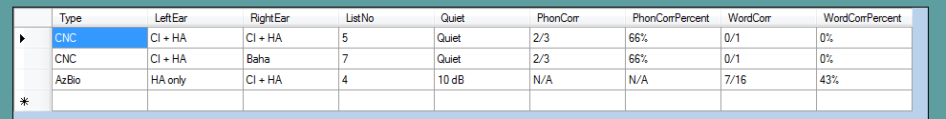

DataTable TestResults = new DataTable();

TestResults.Columns.Add("Type", typeof(string));

TestResults.Columns.Add("LeftEar", typeof(string));

TestResults.Columns.Add("RightEar", typeof(string));

TestResults.Columns.Add("ListNo", typeof(int));

TestResults.Columns.Add("Quiet", typeof(string));

TestResults.Columns.Add("PhonCorr", typeof(string));

TestResults.Columns.Add("PhonCorrPercent", typeof(string));

TestResults.Columns.Add("WordCorr", typeof(string));

TestResults.Columns.Add("WordCorrPercent", typeof(string));

DataRow dtrow = TestResults.NewRow();

dtrow[0] = “CNC”;

dtrow[1] = “Left”;

dtrow[2] = RightEar;

dtrow[3] = 2;

dtrow[4] = Quiet;

dtrow[5] = “23/100”;

dtrow[6] = “23%”;

dtrow[7] = WordCorr;

dtrow[8] = WordCorrPercent;

TestResults.Rows.Add(dtrow);

Separate ResultTable into 2 tables: CNC, AzBio

DataTable cnc_result = null;

DataTable az_result = null;

DataRow[] drs = tb.TestResults.Select("Type = 'CNC'");

cnc_result = drs.CopyToDataTable();

cnc_result.Columns.RemoveAt(0);

DataRow[] drs_az = tb.TestResults.Select("Type = 'AzBio'");

az_result = drs_az.CopyToDataTable();

az_result.Columns.RemoveAt(0);

az_result.Columns.RemoveAt(4);

az_result.Columns.RemoveAt(4);

|  |  |  |  |  |  |  |  |
| --- | --- | --- | --- | --- | --- | --- | --- |
| **Left Ear** | **Right Ear** | **List No.** | **S/N** | **Phoneme Score** | **Phoneme % correct** | **Word score** | **Word % correct** |
| HA only | CI + HA | 1 | Quiet | 2/36 | 5% | 0/12 | 0% |
| BILATERAL | Baha | 6 | Quiet | 3/3 | 100% | 1/1 | 100% |

|  |  |  |  |  |  |
| --- | --- | --- | --- | --- | --- |
| **Left Ear** | **Right Ear** | **List No.** | **S/N** | **Word score** | **Word % correct** |
| CI only | CI only | 4 | 10 dB | 7/16 | 43% |
| HA only | HA only | 8 | 10 dB | 7/16 | 43% |